# General Information

|  |  |
| --- | --- |
| **Position Title:** | Business Analyst |
| **Division/Department:** | Strategy and Performance |
| **Position Reports to:** | Lead Business Analyst |
| **Enterprise/Individual Agreement:** | Individual Agreement |
| **Classification/Grade:** | NA |
| **Location:** | Corporate Office, Richmond |
| **Employment Status:** | Permanent Full Time |
| **Resource Management**  (for Management positions only)  **Number of Direct Reports:**  **Budget under management:** | NA |
| **Key Relationships - internal and external** | CIO  Digitise team IT Team  Group Projects and Change team  Hospital Executive & Management team Senior leaders and respective teams  Key vendors & subcontractors |

1. **Overview of Epworth HealthCare**

Epworth HealthCare is Victoria’s largest not-for-profit private health care group, renowned for excellence in diagnosis, treatment, care and rehabilitation. Epworth is an innovator in Australia’s health system, embracing the latest in evidence-based medicine to pioneer treatments and services for our patients.

Epworth’s values define our approach and our delivery. We pride ourselves on communicating our values and delivering on them in a real and meaningful way. Our Values are Compassion, Accountability, Respect and Excellence. More information can be found on the [Epworth website.](https://www.epworth.org.au/who-we-are/our-values)

Epworth’s purpose is Every Patient Matters.

Our Vision is Delivering another 100 years of exceptional healthcare and innovation to the Victorian community.

# Epworth HealthCare Strategy

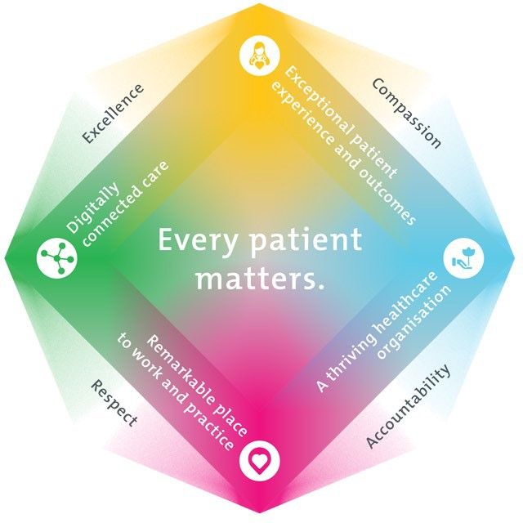

|  |
| --- |
| All roles are linked to the Epworth strategy and are fundamental in achieving its vision and purpose. |
| **Exceptional patient experience and outcomes -** To empower our patients and deliver compassionate, expert and coordinated care. |
| **A thriving healthcare organisation -** To adapt and grow in a changing healthcare landscape by delivering a unique private not-for-profit  healthcare organisation. |

|  |
| --- |
| **Remarkable place to work and practice -** To ensure Epworth is an outstanding place to work and practice through a culture of care and investment in our people. |
| **Digitally connected care -** To innovate and improve the digital experience, interactions and outcomes for our patients, staff and doctors. |

1. **Purpose of the Position**

The Business Analyst position provides an exciting opportunity to work closely with the business and technical teams to deliver solutions that are aligned to Epworth’s strategic objectives. This role will be responsible for analysing, documenting, designing and delivering solutions that achieve business outcomes as well as enhancing the user experience.

The role will establish a working knowledge of business processes, the key drivers and measures of success and the short & long-term direction of their business. This knowledge coupled with a strong understanding of the overall IT architecture and guiding solution design principles will be critical to ensure both business and technology considerations are met.

Reporting to the Lead Business Analyst, this role will involve considerable communication and collaboration with key stakeholders, Executive Sponsors, and fellow project team members.

# Clinical Governance Framework

This role is required to put into practice the Clinical Governance Framework at Epworth as every employee is accountable for ensuring that our patients and community receive safe, high quality and person-centred care in every interaction with Epworth. This is achieved through active participation in the five domains of clinical governance at Epworth:

|  |  |
| --- | --- |
| **Clinical Governance Domain** | **Role** |
| ***Leadership and culture*** | Promote and participate in a supportive, fair and transparent culture where lessons from previous outcomes are learned  and patient safety and quality is a priority at all levels of the organisation. |
| ***Consumer Partnerships*** | Understand and where relevant, ensure that each patient is actively involved in their own care and treatment including  families/carers wherever possible. |
| ***Effective Workforce*** | Develop and maintain one’s own competency, skills and knowledge to ensure high quality service provision and care. |

|  |  |
| --- | --- |
| ***Clinical Safety and Effectiveness*** | Understand and where relevant, ensure, that the right care is provided to the right person at the right time, in the right  place and patient outcomes are monitored and improved. |
| ***Risk Management*** | Be responsible for identifying and reporting risks, hazards and near misses for people in our care and participating in risk  mitigation strategies. |

# Key Accountabilities

|  |  |
| --- | --- |
| **KEY RESPONSIBILITIES** | **MEASURES/KPIs TO BE ACHIEVED** |
| **Business Analysis**   * Plan approach to Business Analysis including stakeholder identification, techniques to extract requirements & template requirements; * Elicit requirements through communicating and liaising with stakeholders to understanding their needs and requirements; * Validate requirements to ensure alignment and technical constraints are identified and worked through; * Produce required requirement documentation including user stories, use cases, process flow diagrams, data models, interface models, business requirement documents, requirement traceability matrix, functional requirement specification and system requirement specifications * Analyse requirements to define and validate prioritisation and inter- dependencies | * Business requirements are documented to a high standard, clear and agreed upon by business stakeholders; * Deliverables are delivered within agreed timeframes; * Delivery teams have clear understanding of business requirements to deliver solutions that achieve anticipated value; |

|  |  |
| --- | --- |
| **Solution Analysis, Design & Planning**   * Engagement and consultation with Business/Product Owners, Business Users and IT to understand the current state of solutions including key metrics, architecture, integrations, pain points and opportunities; * Collaboratively support the definition of the solution user experience aspirations, user stories, solution options and recommended next steps; * Ensure solutions are designed to meet the business objectives and goals whilst aligning to IT guiding design principles; * Ensure solutions are efficient, cost-effective and financially feasible; * Develop solution roadmaps that consider key business strategies and integrate technology lifecycle considerations (where relevant); * Develop solution options that align to agreed roadmaps, that are pragmatic and take into consideration the full lifecycle activities required to manage a technology asset; * Define Business Cases including business drivers, options, cost and benefit modelling; * Keep abreast of emerging technologies and partner solutions that could provide assist achieving strategic objectives. | * Epworth’s technology solutions are achieving desired outcomes and supporting Epworth’s strategic objectives; * Technology solutions have clear and accountable business ownership; * Decision makers have adequate information to make informed technology solution decisions that are aligned to business and technical principles. |
| **Software Development & Project Delivery**   * Work within Project Management and Software Development Methodologies & Frameworks, including Waterfall & Agile; * Work with Project Managers to define project scope to ensure understanding of what is in and out of scope, expected deliverables, acceptance criteria,   constraints and assumptions; | * Project scope and requirements are defined accurately supporting successfully Project Delivery; * Product Backlog flow is stable and defined, ensuring effective prioritisation aligned to business outcomes; |

|  |  |
| --- | --- |
| * Support work required to successfully pass through all relevant project gates; * Support delivery of technology solutions in conjunction with project team(s); * Work with Product Owners, Scrum Masters and Development teams to analyse, define, support prioritisation & delivery of the Product Backlog; * Involvement in testing all solution aspects including, but not limited to user acceptance, security, performance & integration. | * Projects are delivered successfully. |
| **Customer Service**  Epworth is committed to the provision of excellent customer service to all of our people, customers and stakeholders including patients and external suppliers.  Superior patient service leads to improved healing in a trusting, caring environment and creates a safe environment for patients and employees.   * Provide excellent, helpful service to patients, visitors and staff * Communicate with clear and unambiguous language in all interactions, tailored to the audience * Build customer relationships and greet customers and patients promptly and courteously * Actively seek to understand patients' and their family's (customers) expectations and issues | * Patient and customer service satisfaction surveys within agreed targets * Use AIDET principles in all interactions * Issues are escalated to the manager and resolved in a timely manner |
| **Safety and Wellbeing**  Participate actively and positively in the area of health and safety to reduce all hazards and incidents within the workplace   * Report all hazards, incidents, injuries and near misses immediately to your manager and log them in RiskMan | * Adhere to infection control/personal hygiene precautions * Implement and adhere to Epworth OHS policies, protocols and safe work procedures * Mandatory training completed at agreed frequency |

1. **Position Requirements/Key Selection Criteria**

|  |  |
| --- | --- |
| **COMPONENT** |  |
| Qualifications | **Essential**   * Tertiary qualifications in relevant Technology or equivalent work experience * Business Analysis related qualifications or equivalent work experience   **Desirable**   * Relevant Clinical or Business qualifications or equivalent work experience; * Software Development qualifications * Project Management qualifications |
| Previous Experience | **Essential**   * 3+ years experience in Business Analyst roles or similar   **Desired**   * 3+ years Health Industry experience. * Technology experience in one or more of the following – Automation/RPA, Workflow & Customer Relationship Management (CRM), Cloud Technologies, Cyber Security, Data Analytics, Machine Learning, Finance & Enterprise Resource Planning (ERP) and/or Human Resource Platforms; |
| Required Knowledge & Skills | * Demonstrated experience in practical application of business system analysis principles; * Experience working within project management frameworks; * Experienced in continuous delivery of technology solutions across digital platforms that align with business’s strategic goals; * Experience delivering technology with an emphasis on user experience; * Experience in Minimum Viable Product (MVP) solution development and Continuous Delivery approaches; * Demonstrated experience reviewing, documenting and analysing technology environments and business processes; * Proven capability to accurately gather, analyse and interpret data and requirements using varied approaches; * Experience in presenting of business and technical requirements as user stories; * Experience in developing business cases including defining and presenting cost/benefit profiles; * Established risk identification and mitigation skills; |

|  |  |
| --- | --- |
|  | * Demonstrated skills in communication (verbal, written and online) and presentation; * Innovative thinking and awareness of emerging technology trends and their potential impact on Epworth * Ability to function in a dynamic environment subject to changes in schedules and priorities * Prepared to make a commitment to Epworth HealthCare’s mission and values |
| Personal Attributes & Values  All employees are expected to consistently work in accordance with Epworth’s values and behaviours   * Respect * Excellence * Compassion * Community * Integrity * Accountability | * Critical thinking ability * Demonstrates initiative and creative thinking * Attention to detail with a desire to ensure accuracy and quality in their work is achieved * Proactive, self-motivated and hard-working * Energetic, enthusiastic and passionate for the role * Flexible, adaptable and able to multi-task * High level of emotional maturity and personal integrity * Ability to effectively prioritise and execute tasks, while under pressure * Demonstrate initiative, exercises good judgment and has the ability to achieve results * Committed to delivery and customer service * Ability to function in a dynamic environment subject to changes in schedules and priorities * High level of self-motivation and confidence * Excellent communication and interpersonal skills * Excellent time management and organisational skills * Takes responsibility for own professional development * Contributes to an environment of continuous learning and quality improvement * Ability to maintain professional relationships with key stakeholders * Committed to improving patient safety, quality of clinical care and reducing clinical error and risk * Flexibility in working hours |





**Document Control**

|  |  |  |
| --- | --- | --- |
| Date Developed: | Date Last Reviewed: | Developed and Reviewed By (Position Title): |
| October 2020 | December 2024 | Group Director, Projects and Change |

# Employee Position Declaration

I have read and understand the requirements and expectations of the above Position Description. I agree that I have the physical ability to fulfil the inherent physical requirements of the position, and accept my role in fulfilling the Key Accountabilities. I understand that the information and statements in this position description are intended to reflect a general overview of the responsibilities and are not to be interpreted as being all-inclusive.

|  |  |
| --- | --- |
| Employee Signature: | |
| Print Name: | Date: |

Page 9 of 9