- General Information
Position Title: | Hospitality Services Assistant
Division/Department: | Epworth Healthcare – Support Services
Position Reports to: | Hospitality Services Operations Manager
Enterprise/Individual Agreement: | Health and Allied Services Enterprise Agreement 2022
Classification/Grade: | HSA01 – HSA05
Location: | Epworth All Sites – As advertised
Employment Status: | Permanent Full Time, Part Time or Casual
Resource Management  (for Management positions only)  Number of Direct Reports:  Budget under management: | NA
Key Relationships - internal and external | - Hospitality Services Operations Manager  - Food Services Team Leader, General Services Supervisors, Environmental Services Supervisors  - NUMs, ANUMs and Support Services Care team internal service providers i.e. nursing and ward administration staff, food services team and environmental services team, patient transport team.  - Patients, inclusive of family member(s) and visitors
2. Overview of Epworth HealthCare
Epworth HealthCare is Victoria’s largest not-for-profit private health care group, renowned for excellence in diagnosis, treatment, care and rehabilitation. Epworth is an innovator in Australia’s health system, embracing the latest in evidence-based medicine to pioneer treatments and services for our patients.

Epworth’s values define our approach and our delivery. We pride ourselves on communicating our values and delivering on them in a real and meaningful way. Our Values are Compassion, Accountability, Respect and Excellence. More information can be found on the Epworth website.

Epworth’s purpose is Every Patient Matters.

Our Vision is Delivering another 100 years of exceptional healthcare and innovation to the Victorian community
3. Epworth HealthCare Strategy
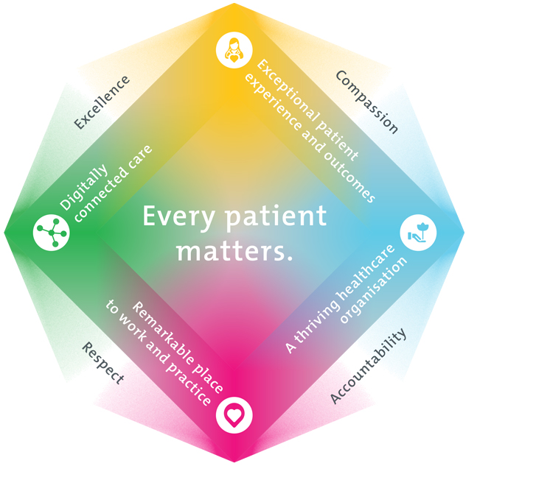
All roles are linked to the Epworth strategy and are fundamental in achieving its vision and purpose.
Exceptional patient experience and outcomes - To empower our patients and deliver compassionate, expert and coordinated care.
A thriving healthcare organisation - To adapt and grow in a changing healthcare landscape by delivering a unique private not-for-profit healthcare organisation.
Remarkable place to work and practice - To ensure Epworth is an outstanding place to work and practice through a culture of care
and investment in our people.
Digitally connected care - To innovate and improve the digital experience, interactions and outcomes for our patients, staff and doctors.
4. Purpose of the Position
The primary function of the Hospitality Services Assistant (HSA) is to provide a broad range of support services as part of the Environmental Services Department, Food Services Department and Patient Transport which can include cleaning; bed making; collection of laundry; distribution of linen; waste disposal; assistance in moving and transporting patients; meal trolley deliveries; setting up and serving at functions; set up and cleaning of function areas, cleaning of kitchen areas; meal plating or other tasks as directed.

You will work as a member of the Hospitality Services team to provide a high quality, clean and safe environment for patient’s, VMOs, tenants, staff and visitors that is consistent with the infection control standards. In particular, to utilise available resources, occupational health and safety equipment, promote and participate in all required standards and quality activities and provide outstanding customer service to ensure a positive patient experience.
You will play an active role within the Epworth Support Services team, participating in building a community-based culture that fosters a spirit of achievement,
capability and development by ensuring consistency with Epworth’s Mission and Values. This will ensure Epworth delivers “Excellence, Everywhere, Everyday
5. Clinical Governance Framework
This role is required to put into practice the Clinical Governance Framework at Epworth as every employee is accountable for ensuring that our patients and community receive safe, high quality and person-centred care in every interaction with Epworth. This is achieved through active participation in the five domains of clinical governance at Epworth:

Clinical Governance Domain | Role
Leadership and culture | Promote and participate in a supportive, fair and transparent culture where lessons from previous outcomes are learned and patient safety and quality is a priority at all levels of the organisation.
Consumer Partnerships | Understand and where relevant, ensure that each patient is actively involved in their own care and treatment including families/carers wherever possible.
Effective Workforce | Develop and maintain one’s own competency, skills and knowledge to ensure high quality service provision and care.
Clinical Safety and Effectiveness | Understand and where relevant, ensure, that the right care is provided to the right person at the right time, in the right place and patient outcomes are monitored and improved.
Risk Management | Be responsible for identifying and reporting risks, hazards and near misses for people in our care and participating in risk mitigation strategies.
6. Key Accountabilities
KEY RESPONSIBILITIES | MEASURES/KPIs TO BE ACHIEVED
- Hospitality Services  - Stripping and making beds as required  - Setting up patient rooms as required  - Restocking supplies as required  - Food Services assistance as required including setting up of functions  - Maintenance of flowers (in-patient areas only)  - Other kitchen and Food Service related tasks as required  - Adhere to safe food handling practices at all times  - Serving food to patients and staff  - Assisting with food preparation, collecting and washing dishes  - General cleaning, restocking, putting stock away.  - Maintaining the highest level of food safety at all times  - Being a dedicated, supportive and quality driven team member  - Delivering an excellent customer experience  - Maintain efficiency in all operational duties | - Clean/waste free environment  - Infection control audits minimum pass rate of 90%  - To comply with Epworth’s Food Safety Program  - Efficient delivery of service to all key stakeholders  - Rooms are ready for patients in a timely manner  - Stock of items are kept at specified levels  - Service and support provided to food functions is friendly and efficient  - Attend team meetings  - Provide feedback on meeting actions or discussions  - Actively take part in planning and implementing projects and changes within the department
Patient Care  - Providing a safe patient transport within operating suites, wards and other areas of the hospital including admissions, discharges and out-patient services, using the appropriate manual handling equipment  - Assisting clinical staff with the moving of patients  - Proactively providing support to patients in relation to provision of services  - Encouraging patients and family members participation in Point of Care usage  - Timely reporting of patient concerns relating to Support Services to Manager, Supervisor or delegate  - Demonstrating empathy and compassion to patients and their families  - Maintaining patient confidentiality as prescribed by the relevant Acts and organisational policies and protocols  - Practices in accordance with Infection Control Standards  - Practice AIDET in all patient interactions | - Safe movement and positioning of patients (in conjunction with clinical staff)  - Compliance with mandatory annual Manual Handling training and Safe Moves  - Utilises manual handling equipment in accordance with training and guidelines wherever possible  - Sound relationships developed and maintained with customers  - Compliance with Information Privacy Act (2000) and the Health Records Act (2000)  - Compliance with Social Medial Policies and Protocols of Epworth HealthCare  - Positive customer and patient feedback  - In conjunction with management, customer complaints resolved within the shift or within 24 hours with complex cases
Cleaning Care  - Efficient and effective delivery of cleaning and waste management services at all campuses of the hospital including scheduled and periodic cleaning of wards, patient rooms, departments and external areas.  - Maintaining designated areas in a clean state in accordance with specified work schedules and cleaning systems  - Safely remove waste and linen from allocated area  - Patient room cleaning including discharge cleaning and infectious room cleans as required  - Patient bathroom cleaning  - Cleaning and maintaining Common areas  - Undertaking other cleaning tasks as directed  - Washing and cleaning utensils and dishes, and ensure stored appropriately  - Cleaning of general equipment (non-clinical) | - Safe and correct operation of cleaning equipment  - A clean and waste free environment for all departments and general areas  - Compliance with Infection Control Standards  - Compliance with external, independent cleaning audit  - Infection control audits are passed within organisational KPIs  - Practice in accordance with chemical handling requirements
Team Work  - Working cooperatively and collaboratively with all members of the team  - Providing positive and constructive feedback and communicating well with other team members  - Actively participating as a member of the team and department | - Attends and actively participates in department and team meetings  - Provides and receives feedback in a positive and professional manner  - Assists new staff and trainees
Quality Improvement  - Strives to consistently improve service delivery and practice  - Provides suggestions, and feedback to Supervisor and Manager on quality activities  - Actively participates in quality improvement activities within the unit or department in accordance with the National Safety and Quality Health Service (NSQHS) Standards | - Evidence of participation in quality activities  - Shows a proactive attitude in reviewing, supporting and implementing relevant initiatives into service improvements
Personal and Professional Development  - Participate in prescribed performance development system annually  - Participate in the orientation of new and casual staff  - Participate in supervision of junior staff (where requested by Supervisor or delegate)  - Participates in and provides as requested by Supervisor (or delegate) training to department staff | - Knowledge and commitment to the Health and Allied Services Enterprise Agreement (as amended from time to time)  - Knowledge and commitment to Epworth HealthCare policies, procedures and staff code of conduct  - Completion of annual performance appraisal and yearly core competencies  - Participation in in-services, department education and meetings  - Completion of objectives outlined in self-development plan (provide evidence of)  - Training of staff in relevant department specific activities (when requested by Supervisor or delegate  - Effective orientation and buddy of staff in relevant department specific activities (when requested by Supervisor or delegate)
Customer Service  Epworth is committed to the provision of excellent customer service to all of our people, customers and stakeholders including patients and external suppliers.  Superior patient service leads to improved healing in a trusting, caring environment and creates a safe environment for patients and employees.  - Provide excellent, helpful service to patients, visitors and staff  - Communicate with clear and unambiguous language in all interactions, tailored to the audience  - Build customer relationships and greet customers and patients promptly and courteously  - Actively seek to understand patients' and their family's (customers) expectations and issues | - Patient and customer service satisfaction surveys within agreed targets  - Use AIDET principles in all interactions  - Issues are escalated to the manager and resolved in a timely manner
Safety and Wellbeing  Participate actively and positively in the area of health and safety to reduce all hazards and incidents within the workplace  - Report all hazards, incidents, injuries and near misses immediately to your manager and log them in RiskMan | - Adhere to infection control/personal hygiene precautions  - Implement and adhere to Epworth OHS policies, protocols and safe work procedures  - Mandatory training completed at agreed frequency
7. Position Requirements/Key Selection Criteria
COMPONENT
Qualifications | Desirable  - Food Handlers Certificate for healthcare  - A relevant cleaning related certificate/qualification  - Working with Children Check
Previous Experience | Desirable  - Experience working in Healthcare  - Cleaning or food handling experience in a similar role  - Experience with patient transport, patient manual handling
Required Knowledge & Skills | Desirable  - Understanding of infection control processes within a healthcare environment  - Understanding of relevant Acts  - Knowledge of OHS requirements in hospital cleaning and waste management  - Knowledge and understanding of cleaning standards for Victorian health facilities 2011  - Understanding of Accreditation processes or a willingness to learn and commit to accreditation processes  - Effective communication skills  - Ability to organise and prioritise tasks  - Ability to work unsupervised but take direction as required  - Effective communication and interpersonal skills
Personal Attributes & Values  All employees are expected to consistently work in accordance with Epworth’s values and behaviours  - Compassion  - Accountability  - Respect  - Excellence | Essential  - Belief in patient centred care  - Committed to providing a safe environment for patients and colleagues  - Professional work ethic  - Practices within the ethos of the Epworth HealthCare Values and Behaviours  - Ability to learn new skills  - Willingness and ability to work within a team environment  - Maintain patient confidentiality  - Sound knowledge of English (both written and verbal)  - Flexibility to work across all rosters as required  - Self-motivated and self-directed

Document Control
Date Developed: | Date Last Reviewed: | Developed and Reviewed By (Position Title):
March 2019 | August 2025 | Group Director of Support Services

8. Employee Position Declaration
I have read and understand the requirements and expectations of the above Position Description. I agree that I have the physical ability to fulfil the inherent physical requirements of the position, and accept my role in fulfilling the Key Accountabilities. I understand that the information and statements in this position description are intended to reflect a general overview of the responsibilities and are not to be interpreted as being all-inclusive.
Employee Signature:
Print Name: | Date:

