- General Information
Position Title: | Technology Support Specialist (Hospital & Clinicians On-Site)
Division/Department: | Information Technology
Position Reports to: | Hospital IT Services & Business Partnering Manager
Enterprise/Individual Agreement:
Classification/Grade:
Location: | Allocated sites across Epworth
Employment Status: | Full time
Number of Direct Reports: | None
Key Relationships - internal and external | Site coordinators and hospital site teams, including Management and VMOs/JMOs/Medical students, Corporate Teams, Information Technology Teams, Vendors, Hospital Executive Team (HET)
2. Overview of Epworth HealthCare
Epworth HealthCare is Victoria’s largest not-for-profit private health care group, renowned for excellence in diagnosis, treatment, care and rehabilitation. Epworth is an innovator in Australia’s health system, embracing the latest in evidence-based medicine to pioneer treatments and services for our patients.

Epworth’s values define our approach and our delivery. We pride ourselves on communicating our values and delivering on them in a real and meaningful way. Our Values are Compassion, Accountability, Respect and Excellence. More information can be found on the Epworth website.

Epworth’s purpose is Every Patient Matters.

Our Vision is Delivering another 100 years of exceptional healthcare and innovation to the Victorian community.

3. Epworth HealthCare Strategy
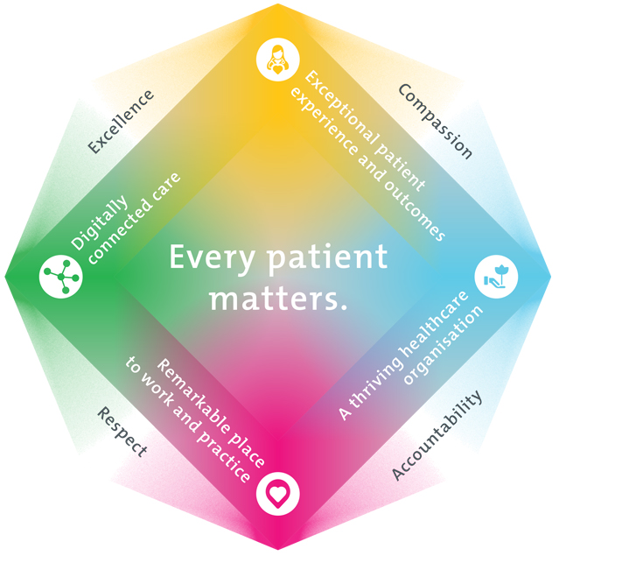
All roles are linked to the Epworth strategy and are fundamental in achieving its vision and purpose.
Exceptional patient experience and outcomes - To empower our patients and deliver compassionate, expert and coordinated care.
A thriving healthcare organisation - To adapt and grow in a changing healthcare landscape by delivering a unique private not-for-profit healthcare organisation.
Remarkable place to work and practice - To ensure Epworth is an outstanding place to work and practice through a culture of care
and investment in our people.
Digitally connected care - To innovate and improve the digital experience, interactions and outcomes for our patients, staff and doctors.
4. Purpose of the Position
The purpose of this position is for full operational accountability for the technology environment across each dedicated site, ensuring that all technology services operate reliably, efficiently, and in alignment with organisational standards. The role provides visible, on‑site support, maintaining a consistent presence across assigned locations to drive service excellence, operational readiness, and rapid response to emerging issues.
A core focus of the role is to deliver exceptional, high‑touch support to doctors, ensuring technology is always ready for surgeries, consultations, and clinical workflows. By anticipating needs, resolving issues quickly, and maintaining strong relationships with VMOs, JMOs, and medical students, the position directly contributes to safe, efficient patient care and zero avoidable clinical disruption.
The role also champions a customer‑centred service culture, ensuring all staff receive timely, professional support and that onboarding experiences for new employees and doctors are seamless and fully prepared. Through strong collaboration with ICT teams, clinical leaders, and internal stakeholders, the position strengthens trust, improves communication, and supports the smooth delivery of technology changes, deployments, and site‑specific improvements.
5. Clinical Governance Framework
This role is required to put into practice the Clinical Governance Framework at Epworth as every employee is accountable for ensuring that our patients and community receive safe, high quality and person-centred care in every interaction with Epworth. This is achieved through active participation in the five domains of clinical governance at Epworth:

Clinical Governance Domain | Role
Leadership and culture | Promote and participate in a supportive, fair and transparent culture where lessons from previous outcomes are learned and patient safety and quality is a priority at all levels of the organisation.
Consumer Partnerships | Understand and where relevant, ensure that each patient is actively involved in their own care and treatment including families/carers wherever possible.
Effective Workforce | Develop and maintain one’s own competency, skills and knowledge to ensure high quality service provision and care.
Clinical Safety and Effectiveness | Understand and where relevant, ensure, that the right care is provided to the right person at the right time, in the right place and patient outcomes are monitored and improved.
Risk Management | Be responsible for identifying and reporting risks, hazards and near misses for people in our care and participating in risk mitigation strategies.
6. Key Accountabilities
KEY RESPONSIBILITIES | MEASURES/KPIs TO BE ACHIEVED
Technology Operations & Site Support  - Provide operational support for assigned sites, ensuring all technology services run reliably, efficiently, and in alignment with organisational standards.  - Maintain the scheduled, rostered presence across dedicated sites, ensuring visible leadership, proactive support, and consistent service delivery.  - Take accountability for the operational performance of each assigned site, ensuring technology readiness, service quality, and rapid response to emerging issues.  - Identify and drive Continuous Service Improvement (CSI) initiatives to enhance service quality, reduce recurring issues, and improve user experience.  - Ensure end user devices, printers, and peripherals remain reliable and meet SLA performance targets.  - Provide clear, proactive communication to staff and leaders regarding technology changes, outages, and impacts.  - Create and maintain a comprehensive knowledge base detailing site-specific processes, end user hardware and best practices for operational efficiency and knowledge sharing | - SLA compliance for incidents, requests, and project deadlines.  - Site operational health indicators trending positively.  - CSI initiatives delivered per quarter with measurable impact – Target to be determined.  - Knowledge base of site operations developed and kept up to date/accuracy – Target to be defined
Doctor Support Across All Sites (VMO, JMO, Medical Students)  - Deliver high‑quality, high‑touch technology support to doctors across all sites, ensuring zero avoidable disruption to clinical duties.  - Provide a seamless onboarding experience for all new VMOs, JMOs, and medical students, ensuring devices, accounts, and clinical system access are fully prepared before their first day.  - Ensure all doctors receive proactive, reliable support for surgeries, consultations, and procedural lists, with all required technology functioning as expected.  - Maintain strong relationships with VMOs and clinical teams, understanding workflows and anticipating technology needs.  - Prioritise and rapidly respond to doctor‑impacting incidents, ensuring issues affecting patient care or surgical readiness are escalated and resolved immediately.  - Oversee the setup, maintenance, and availability of devices used by doctors.  - Partner with theatre and clinical operations teams to ensure technology dependencies are tested and ready ahead of surgical schedules.  - Lead a culture of service excellence, ensuring every interaction with doctors reflects professionalism, urgency, and respect for clinical time.  - Monitor and report trends in doctor support requests and identify improvement initiatives. | - Doctor satisfaction score (VMO/JMO/Medical student feedback) – Target to be defined  - First‑Day Success Rate: 95% of new doctors commence clinical duties with zero technology‑related delays or access issues.  - 100% technology readiness for surgical lists and clinical sessions.  - ≥95% resolution of high‑priority doctor issues within SLA.  - Proactive checks completed per rostered schedule.  - Improvement Initiatives: Minimum of two CSI initiatives per quarter generated directly from trend insights, with documented outcomes.
Service Delivery & Customer Experience  - Champion a customer‑focused service culture across all on‑site technology teams.  - Ensure all new Epworth employees are onboarded with the required device and technology access ready for use on their first day.  - Ensure responsive, professional communication between Technology Services and Epworth staff/Drs.  - Attend to and resolve logged incidents/requests within SLA, ensuring clear communication and follow‑through. | - Staff satisfaction with technology support (survey/ITSM feedback).- Target to be defined.  - First‑Day Success Rate: 95% of new Epworth staff commence work with zero technology‑related delays or access issues.  - Avoidable Escalations: Escalations due to missed follow‑ups, unclear ownership, or communication gaps are kept to a minimum.
Collaboration, Teamwork & Professional Development  - Work collaboratively with internal stakeholders, ICT teams, and clinical leaders to build strong relationships and deliver trusted, seamless technology experiences across the organisation.  - Support deployments of desktop devices and infrastructure changes in a way that minimises disruption for staff and doctors.  - Work collaboratively with Service Desk staff, offering support and knowledge sharing to help develop team capability.  - Provide accurate work estimates and deliver tasks within agreed timelines.  - Engage in ongoing professional development and contribute to team knowledge sharing. | - ≥90% satisfaction from internal stakeholders regarding responsiveness, clarity, and professionalism during joint work.  - Demonstrated positive feedback from Service Desk staff or supervisors.
Customer Service  Epworth is committed to the provision of excellent customer service to all of our people, customers and stakeholders including patients and external suppliers.  Superior patient service leads to improved healing in a trusting, caring environment and creates a safe environment for patients and employees.  - Provide excellent, helpful service to patients, visitors and staff  - Communicate with clear and unambiguous language in all interactions, tailored to the audience  - Build customer relationships and greet customers and patients promptly and courteously  - Actively seek to understand patients' and their family's (customers) expectations and issues | - Patient and customer service satisfaction surveys within agreed targets  - Use AIDET principles in all interactions  - Issues are escalated to the manager and resolved in a timely manner
Safety and Wellbeing  Participate actively and positively in the area of health and safety to reduce all hazards and incidents within the workplace  - Report all hazards, incidents, injuries and near misses immediately to your manager and log them in RiskMan | - Adhere to infection control/personal hygiene precautions  - Implement and adhere to Epworth OHS policies, protocols and safe work procedures  - Mandatory training completed at agreed frequency
7. Position Requirements/Key Selection Criteria
COMPONENT
Qualifications | Essential  - Certificate IV or Diploma in Information Technology, Networking, or a related discipline; or equivalent industry experience.  - Demonstrated experience in end‑user support within a complex, multi‑site environment.  - ITIL Foundation certification or equivalent service management training.  Desirable  - Bachelor’s degree in Information Technology, Computer Science, or related field.  - ITIL Foundation certification or equivalent service management training.  - Vendor or technology‑specific certifications (e.g., Microsoft, Cisco, Apple, Citrix)
Previous Experience | Essential  - Experience providing on‑site technology support in a fast‑paced environment with diverse user groups.  - Hands‑on experience supporting Windows desktop environments, mobile devices, and common enterprise applications.  - Experience coordinating with multiple ICT teams to resolve incidents and deliver technology services.  - Exposure to clinical or operational environments where technology directly supports frontline service delivery.  - Experience supporting the administration and expanding infrastructure in line with organisational requirements.  - Demonstrated adherence to security procedures and protocols.  - Ability to work independently and autonomously, managing workload and priorities with minimal supervision.  - Experience working with external vendors to support issue resolution, maintenance activities, and site‑based technology changes.  Desirable  - Experience with unified communications platforms and end point devices such as POE and DECT phones  - Experience with AV/VC conferencing technologies including Cisco, Crestron, Zoom & Webex  - Training for the use and maintenance of AV & VC equipment, systems, services, and facilities.  - Experience working in healthcare, hospital, or other 24/7 service environments.  - Experience supporting clinical systems, medical imaging workflows.  - Experience contributing to technology deployments, upgrades, or site‑based infrastructure changes.
Required Knowledge & Skills | Essential  - Strong technical troubleshooting skills across desktop, mobile, printer, network, and application environments.  - Ability to manage competing priorities and deliver work within agreed timeframes.  - Administer, maintain, and support system and network infrastructure in partnership with 3rd level support teams.  - Understanding of IT service management processes, including incident, request, and change management, aligned to ITIL principles.  - Clear, professional communication skills with the ability to support clinicians and non‑technical users.  - Understanding of IT service management processes, including incident, request, and change management.  - Ability to maintain accurate documentation, knowledge base (internal and customer facing), and operational procedures.  - Capability to support device provisioning, access setup, and onboarding processes for any new starters (Staff, Drs).  Desirable  - Knowledge of clinical workflows and the technology used in hospitals, theatres, and outpatient settings.  - Familiarity with Active Directory, identity management, and access provisioning processes.  - Understanding of networking fundamentals and site infrastructure components.  - Experience supporting audio‑visual, telehealth, or collaboration technologies.
Personal Attributes & Values  All employees are expected to consistently work in accordance with Epworth’s values and behaviours  - Compassion  - Accountability  - Respect  - Excellence | Essential  - Demonstrated commitment to Compassion, showing empathy and understanding when supporting staff and doctors.  - Strong sense of Accountability, taking ownership of tasks, follow‑through, and quality of service.  - Composure and clarity when supporting staff, clinicians in high‑demand or time‑critical situations.  - Actively contributes to a positive team culture and supports colleagues when workloads peak.  - Respectful communication and behaviour, reflecting Respect for colleagues, clinicians, patients, and visitors.  - Commitment to Excellence, striving for high‑quality service delivery and continuous improvement.  - Customer‑focused mindset with a genuine desire to improve the technology experience for end users.  - Collaborative approach, contributing positively to team culture and cross‑team relationships.  - Adaptability and resilience in a dynamic, clinical environment with changing priorities.  - Looks for opportunities to refine processes, uplift service quality, and enhance user experience.  Desirable  - Interest in ongoing learning and professional development within healthcare technology.

Document Control
Date Developed: | Date Last Reviewed: | Developed and Reviewed By (Position Title):

8. Employee Position Declaration
I have read and understand the requirements and expectations of the above Position Description. I agree that I have the physical ability to fulfil the inherent physical requirements of the position, and accept my role in fulfilling the Key Accountabilities. I understand that the information and statements in this position description are intended to reflect a general overview of the responsibilities and are not to be interpreted as being all-inclusive.
Employee Signature:
Print Name: | Date:

