- General Information
Position Title: | Outpatient Administration Coordinator
Division/Department: | Epworth Geelong
Position Reports to: | Allied Health Manager
Enterprise/Individual Agreement: | Epworth HealthCare Health and Allied Services Enterprise Agreement 2022
Classification/Grade: | COF01 – COF05
Location: | Geelong
Employment Status: | Casual
Key Relationships - internal and external | Patients, AH Therapists, Doctors (Referring and Treating VMO’s), Medical Receptionists, Patient Services Manager

- Overview of Epworth HealthCare
Epworth HealthCare is Victoria’s largest not-for-profit private health care group, renowned for excellence in diagnosis, treatment, care and rehabilitation. Epworth is an innovator in Australia’s health system, embracing the latest in evidence-based medicine to pioneer treatments and services for our patients.

Epworth’s values define our approach and our delivery. We pride ourselves on communicating our values and delivering on them in a real and meaningful way. Our Values are Compassion, Accountability, Respect and Excellence. More information can be found on the Epworth website.

Epworth’s purpose is Every Patient Matters.

Our Vision is Delivering another 100 years of exceptional healthcare and innovation to the Victorian community.

Epworth HealthCare Strategy
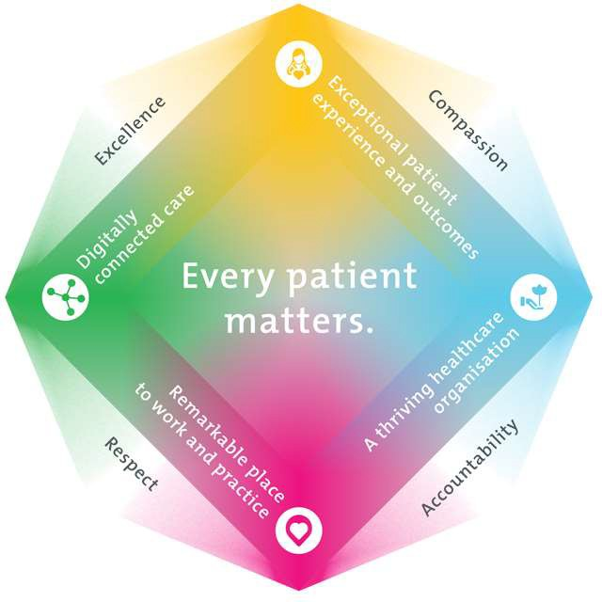
Exceptional patient experience and outcomes - To empower our patients and deliver compassionate, expert and coordinated care.
All roles are linked to the Epworth strategy and are fundamental in achieving its vision and purpose.

A thriving healthcare organisation - To adapt and grow in a changing healthcare landscape by delivering a unique private not-for-profit
healthcare organisation.
Remarkable place to work and practice - To ensure Epworth is an outstanding place to work and practice through a culture of care
and investment in our people.
Digitally connected care - To innovate and improve the digital experience, interactions and outcomes for our patients, staff and doctors.

- Purpose of the Position

The primary function of the Outpatient Coordinator is to provide customer service and administrative support to Epworth staff, patients, visitors, relatives and medical staff. This role is multi-disciplined across outpatient administration department. This role is non-clinical and will incorporate effectively:
- Providing a comprehensive reception service directing patients, visitors and staff to appropriate services
- Management of the administrative processing of patients across all aspects of outpatient pre-admission, admission, service delivery and discharge phases.

Clinical Governance Framework
This role is required to put into practice the Clinical Governance Framework at Epworth as every employee is accountable for ensuring that our patients and community receive safe, high quality and person-centred care in every interaction with Epworth. This is achieved through active participation in the five domains of clinical governance at Epworth:

Clinical Governance Domain Role
Leadership and culture | Promote and participate in a supportive, fair and transparent culture where lessons from previous outcomes are learned  and patient safety and quality is a priority at all levels of the organisation.
Consumer Partnerships | Understand and where relevant, ensure that each patient is actively involved in their own care and treatment including  families/carers wherever possible.
Effective Workforce | Develop and maintain one’s own competency, skills and knowledge to ensure high quality service provision and care.
Clinical Safety and Effectiveness | Understand and where relevant, ensure, that the right care is provided to the right person at the right time, in the right place and patient outcomes are monitored and improved.
Risk Management | Be responsible for identifying and reporting risks, hazards and near misses for people in our care and participating in risk  mitigation strategies.

6. Key Accountabilities
KEY RESPONSIBILITIES | MEASURES/KPIs TO BE ACHIEVED
Reception -  - Answer patient, visitors & staff enquiries.  - Maintain a neat and professional reception area at all times.  - Assist with internal and external inbound & outbound email and mail preparation  - Same day or next day follow up all cancellations and DNAs | - Consistently facilitates the delivery of quality care and service.  - Development of working relationships with other hospital departments  - All correspondence is managed with the highest degree of confidentiality, efficiently and effectively
Administration –  - Management of all outpatient therapy department referrals  - Confirm Health fund eligibility and/or funding arrangements have been conducted prior to each patient’s outpatient admission  - Ensure patient’s outpatient admission and discharge processes are managed with a high degree of accuracy and efficiency  - Provision of daily diary schedules for all treating therapists  - Daily preparation of billing documents for provision to central Billing Department  - Maintain accurate patient records  - Taxi bookings for patient transfers  - Responsible for facilitating and tracking all compensable patients – Work cover and TAC approvals, weekly follow up of funding requests awaiting approval  - Responsible for tracking case conference booking lists  - Responsible for managing iPM system administration  - Co-ordination of all Allied Health Clinic services across Epworth Geelong  - Receiving payments for allied health clinic and facilitating health fund claiming, bookings and invoicing | - Efficient admission to outpatient programs with no delays or adverse impact to patient continuum of care  - Provision of accurate information to patient and family members in relation to hospital charges and general information within the framework of privacy legislation requirements  - Evident focus on high level customer service and patient satisfaction  - Scheduling of all therapy programs for patients that result in publication to AH Staff Diaries  - Scheduling of outpatient programs within funding criteria for all private and compensable insured patients  - Accurate revenue cycle  - Accurate system data integrity that reflects the patient attendances  - Tracking and weekly reporting in regards to referrals and waiting lists
Administration Support -  - Establish and maintain a departmental procedure manual  - Attend meetings on behalf of the department as required  - Produce computer reports as required  - Assist with generating KPIs for outpatient team and allied health manager  - Undertake any general administrative tasks  - Regular liaison and networking with other Epworth OPR sites  - Coordinate admin rosters including regular communication with Allied Health manager and Patient Services manager  - Facilitation of patient flow from EG emergency and inpatient units to EG outpatient services  - Support the development of a multi-disciplinary allied health clinic and further growth of the outpatient rehabilitation programs  - Consultation with OP clinicians around triage of patient referrals, optimise access for patients to outpatient care at EG  - Accurate communication and escalation of optimal timeframes for accessing outpatient care if patients are at risk | - Well trained and fully competent team with full access to comprehensive reference tools to support their roles
Continuous Quality Improvement –  - Actively contribute to continuous improvement of work, standards and methodologies  - Ensure appropriate administrative processes align to administrative governance | - Ensure business requirements are satisfied through efficient administrative support
Customer Service – Staff  Epworth is committed to the provision of excellent customer service to all of our people, customers and stakeholders including patients and external suppliers.  Superior patient service leads to improved healing in a trusting, caring environment and creates a safe environment for patients and employees.  - Provide excellent, helpful service to patients, visitors and staff  - Communicate with clear and unambiguous language in all interactions, tailored to the audience  - Build customer relationships and greet customers and patients promptly and courteously  - Actively seek to understand patients' and their family's (customers) expectations and issues | - Patient and customer service satisfaction surveys within agreed targets  - Demonstrate commitment to Epworth Values and Behaviours  - Issues are escalated to the manager and resolved in a timely manner
Safety and Wellbeing – Staff  Participate actively and positively in the area of health and safety to reduce all hazards and incidents within the workplace  - Report all hazards, incidents, injuries and near misses immediately to your manager and log them in RiskMan | - Adhere to infection control/personal hygiene precautions  - Implement and adhere to Epworth OHS policies, protocols and safe work procedures  - Mandatory training completed at agreed frequency

- Position Requirements/Key Selection Criteria

COMPONENT | Essential/Desirable
Qualifications | - Training in Customer Service principles for a service-oriented environment  - Business Administration Certificate 3
Previous Experience | - Working knowledge in a service-oriented environment  - Working knowledge in a Hospital Administration/Patient Services role
Required Knowledge & Skills | - Strong customer service orientation, focussed on achieving results  - Excellent computer skills  - An aptitude for multi-tasking, prioritise and manage multiple tasks of moderate to high complexity to meet deadlines  - Excellent organisational skills  - Previous working knowledge of hospital Patient Management systems i.e. iPM/BOSSNet
Personal Attributes & Values  All employees are expected to consistently work in accordance with Epworth’s values and behaviours  - Compassion  - Accountability  - Respect  - Excellence | - Proactive and hard-working  - Flexible, adaptable and able to multi-task  - Ability to work autonomously as required but to also work collaboratively and effectively within a team environment  - Committed to delivery of Excellence in Customer Service  - Committed to and role model the organisational Values and Behaviours

Document Control
Date Developed: 4/1/19 | Date Last Reviewed: September 2026 | Developed and Reviewed By (Position Title): Divisional Administration Manager and Allied Health Manager

Employee Position Declaration
I have read and understand the requirements and expectations of the above Position Description. I agree that I have the physical ability to fulfil the inherent physical requirements of the position, and accept my role in fulfilling the Key Accountabilities. I understand that the information and statements in this position description are intended to reflect a general overview of the responsibilities and are not to be interpreted as being all-inclusive.

Employee Signature:
Print Name: | Date:

