# General Information

|  |  |
| --- | --- |
| **Position Title:** | General Services Supervisor |
| **Division/Department:** | Support Services Department |
| **Position Reports to:** | Hospitality Operations Manager |
| **Enterprise/Individual Agreement:** | Health and Allied Services Enterprise Agreement |
| **Classification/Grade:** | GSS01 |
| **Location:** | Richmond |
| **Employment Status:** | Full Time -As advertised |
| **Resource Management**  (for Management positions only)  **Number of Direct Reports:**  **Budget under management:** | Up to 100 N/A |
| **Key Relationships - internal and external** | * Director of Support Services * Environmental Services and Patient Transport Manager * Hospitality Services Assistants, Environmental Services Assistants, Patent Transport Orderlies, Team Leaders and Supervisors * Nursing Unit and Department Managers * Patients, inclusive of family members and visitors * Contractors, Suppliers and Third Party Providers |

1. **Overview of Epworth HealthCare**

Epworth HealthCare is Victoria’s largest not-for-profit private health care group, renowned for excellence in diagnosis, treatment, care and rehabilitation. Epworth is

an innovator in Australia’s health system, embracing the latest in evidence-based medicine to pioneer treatments and services for our patients.

Epworth’s values define our approach and our delivery. We pride ourselves on communicating our values and delivering on them in a real and meaningful way. Our Values are Compassion, Accountability, Respect and Excellence. More information can be found on the [Epworth website.](https://www.epworth.org.au/who-we-are/our-values)

Epworth’s purpose is Every Patient Matters.

Our Vision is Delivering another 100 years of exceptional healthcare and innovation to the Victorian community.

# Epworth HealthCare Strategy

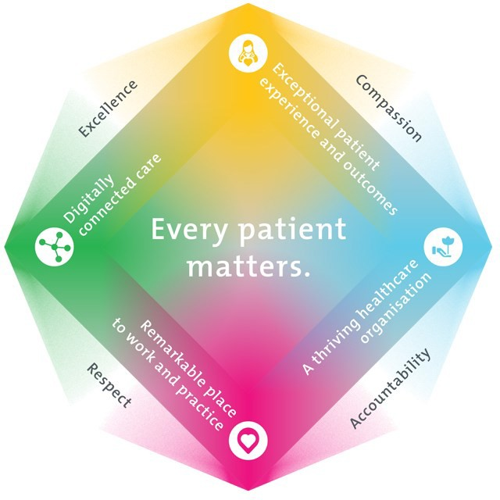

|  |
| --- |
| All roles are linked to the Epworth strategy and are fundamental in achieving its vision and purpose. |
| **Exceptional patient experience and outcomes -** To empower our patients and deliver compassionate, expert and coordinated care. |
| **A thriving healthcare organisation -** To adapt and grow in a changing healthcare landscape by delivering a unique private not-for-profit  healthcare organisation. |
| **Remarkable place to work and practice -** To ensure Epworth is an outstanding place to work and practice through a culture of care  and investment in our people. |
| **Digitally connected care -** To innovate and improve the digital experience, interactions and outcomes for our patients, staff and doctors. |

1. **Purpose of the Position**

The General Services Supervisor is an integral role within the Support Services Division by providing Administrative, Leadership and Compliance support to departments within the division.

This role provides leadership and hands on support to Support Services Supervisors, Team Leaders and Team Members and ensures the efficient and effective day to day functioning and service delivery of the department(s).

The General Services Supervisor also provides administrative and compliance support to Hospitality Services Operations Managers by ensuring departments are efficiently resourced and all departmental KPI’s and compliance targets are met.

This role is a frontline leadership role that will ensure that the departments under supervision are working within the Epworth Values and towards Epworth

Healthcare’s strategic plan.

1. **Clinical Governance Framework**

This role is required to put into practice the Clinical Governance Framework at Epworth as every employee is accountable for ensuring that our patients and community receive safe, high quality and person-centred care in every interaction with Epworth. This is achieved through active participation in the five domains of clinical governance at Epworth:

|  |  |
| --- | --- |
| **Clinical Governance Domain** | **Role** |
| ***Leadership and culture*** | Promote and participate in a supportive, fair and transparent culture where lessons from previous outcomes are learned and  patient safety and quality is a priority at all levels of the organisation. |
| ***Consumer Partnerships*** | Understand and where relevant, ensure that each patient is actively involved in their own care and treatment including  families/carers wherever possible. |
| ***Effective Workforce*** | Develop and maintain one’s own competency, skills and knowledge to ensure high quality service provision and care. |
| ***Clinical Safety and Effectiveness*** | Understand and where relevant, ensure, that the right care is provided to the right person at the right time, in the right place and patient outcomes are monitored and improved. |
| ***Risk Management*** | Be responsible for identifying and reporting risks, hazards and near misses for people in our care and participating in risk  mitigation strategies. |

# Key Accountabilities

|  |  |
| --- | --- |
| **KEY RESPONSIBILITIES** | **MEASURES/KPIs TO BE ACHIEVED** |
| **Connected Care**   * Ensure all interactions with patients, family member(s), and carers is compassionate, respectful and within the connected care principle * Ensure feedback from Patients, VMOs, and Clinical Teams is addressed in a timely and appropriate manner and escalate matters where necessary * Ensure all practices and functions of team(s) under supervision is within legislative and common law requirements and Epworth Healthcare’s policy and protocol framework | * Compliance with infection control standards * Compliance with relevant government health standards * Compliance with all legislative and common law requirements * Compliance with Epworth Healthcare’s Policy and Protocol   Framework   * Patient /customer service satisfaction surveys to be within organisational targets * All patient related feedback and correspondence is documented transparently and escalated/responded to appropriately |
| **Empowered People**   * Maintain a culture of cooperation and collaboration with team members and between departments * Provide training, support and professional development to team members under supervision * Ensure team members under supervision have the required knowledge, skills and equipment to perform their role | * Actively participate / facilitate departmental team meetings * Meet monthlys KPIs and yearly competencies of team members * Participates in yearly professional development program for both self and team members under supervision by conducting annual Professional Develop Plans * Assist in facilitating orientation and training of new team members * Actively seek and provide feedback to team members, managersand clinical teams * Is able to work a variety of shifts, including weekends and after hours as required |

|  |  |
| --- | --- |
| **Innovative Practice**   * Monitors, reviews and develops service delivery to identify continuous improvement opportunities * Actively participate in the Epworth Healthcare’s quality program * Actively participate in the organisation’s accreditation program * Ensure that departments under supervision have the required equipment for to deliver service * Ensures that Departments under supervision are appropriately staffed for delivery of service. * Oversee service delivery in accordance with all relevant standards, guidelines, legislation and Epworth Healthcare’s Policy and Protocol F framework | * Quality improvement activates and projects are documented, monitored and followed up * RiskMan is utilised for reporting, monitoring and following up of incidents, hazards and near misses * Departmental audits are conducted and reported in required timeframes * All required procedural documentation is filed, accessible and completed within required timeframes * All records of training and staff development maintained within required timeframes * Equipment required for service delivery is functional and fit for purpose * Rosters are published in line with Enterprise Agreement guidelines |
| **Sustainability**   * Ensure effective and efficient staffing * Ensure purchasing is managed efficiently * Ensure consumables are managed efficiently * Maintain the facilities recycling and waste management program | * Departmental staffing is in line with occupancy and meets monthly KPIs * Leave is managed in line with Epworth Healthcare’s Policy and Protocol Framework * Stock levels are maintained at appropriate levels to minimise wastage spoilage * Linen is used and managed efficiently and appropriately * Purchasing is conducted in line with the budget approval process and KPI * Waste is managed in line with all legislation, standards, EPA * guidelines and Epworth Healthcare’s waste management policy |

|  |  |
| --- | --- |
| **Customer Service**  Epworth is committed to the provision of excellent customer service to all of our people, customers and stakeholders including patients and external suppliers.  Superior patient service leads to improved healing in a trusting, caring environment and creates a safe environment for patients and employees.   * Role model and actively promote a culture of high quality patient care * Provide excellent, helpful service to patients, visitors and staff * Communicate with clear and unambiguous language in all interactions, tailored to the audience * Build customer relationships and greet customers and patients promptly and courteously * Actively seek to understand patients' and their family's expectations and issues, using multiple strategies * Uses data (such as compliments, complaints and Press Ganey) to identify breakdowns in internal processes and systems that directly impact patient care and customer service * Responds quickly and proactively escalate concerns when necessary * Role model and actively promote a culture of high quality patient care and experience by ensuring that solutions, practices and procedures (such as hourly rounding, leader rounding and bedside handover) are carried out with empathy and compassion | * Patient and customer service satisfaction surveys within agreed targets * Use AIDET principles in all interactions * Compliments to complaints ratios * Completes leader rounding at agreed frequency * Issues are escalated to the manager and resolved in a timely manner |
| **Safety and Wellbeing**  To ensure a safe workplace is provided for all employees and other personnel including contractors, agency staff, volunteers and students.   * All employees and other personnel under the authority of the manager are fully informed of the hazards associated with their work activities, adequately trained and instructed in safe work procedures and appropriately supervised. | * Adhere to infection control/personal hygiene precautions * Implement and adhere to Epworth OHS policies, protocols and safe work procedures * Ensure all hazards, incidents and injuries are reported in Riskman within 24 hours * Ensure all hazards, incidents and injuries are investigated and corrective actions implemented within agreed timeframes * Mandatory training completed at agreed frequency |

|  |  |
| --- | --- |
| Participate actively and positively in the area of health and safety to reduce all hazards and incidents within the workplace   * Integrate and review OHS performance in staff PDPs * Ensure all direct reports are held accountable for safety performance and actions |  |

* 1. **Position Requirements/Key Selection Criteria**

|  |  |
| --- | --- |
| **COMPONENT** |  |
| Qualifications | **Desirable**   * Certificate IV in Leadership and Management / Successful completion of Epworth Healthcare’s Frontline Leadership Program |
| Previous Experience | **Essential**   * Experience in a Housekeeping / Environmental Services type role   **Desirable**   * Experience in a leadership or supervisory role / capacity * Experience in healthcare setting |
| Required Knowledge & Skills | **Essential**   * Strong computer skills including Microsoft office suite (Excel, Outlook, Word) * Understanding of Infection Control and Prevention principles   **Desirable**   * Experience with corporate / professional electronic rostering system(s) * Experience with corporate / professional electronic purchasing system(s) |

|  |  |
| --- | --- |
| Personal Attributes & Values  All employees are expected to consistently work in accordance with Epworth’s values and behaviours   * Compassion * Accountability * Respect * Excellence | **Essential**   * A compassionate and patient centred focus * A focus in working within the Epworth Values and to the Epworth Healthcare strategic plan * An understanding and willingness to strive for continuous improvement * A Health and Safety focus * A hands on leadership approach, leading by example |

**Document Control**

|  |  |  |
| --- | --- | --- |
| Date Developed: | Date Last Reviewed: | Developed and Reviewed By (Position Title): |
| February 2020 | February 2022 | Hospitality Services Operations Manager  People and Culture Advisor |

# Employee Position Declaration

I have read and understand the requirements and expectations of the above Position Description. I agree that I have the physical ability to fulfil the inherent physical requirements of the position, and accept my role in fulfilling the Key Accountabilities. I understand that the information and statements in this position description are intended to reflect a general overview of the responsibilities and are not to be interpreted as being all-inclusive.

|  |  |
| --- | --- |
| Employee Signature: | |
| Print Name: | Date: |