- eneral Information
Position Title: | Group Manager, Change
Division/Department: | Group Projects and Change
Position Reports to: | Director, Group Projects and Change
Enterprise/Individual Agreement: | Individual Agreement
Classification/Grade: | Not applicable
Location: | Epworth Pelaco, 21 Goodwood Street Richmond
Employment Status: | Full time, ongoing
Resource Management  (for Management positions only)  Number of Direct Reports:  Budget under management: | 4 plus
Key Relationships - internal and external | Hospital Operations team, IT, project teams
2. Overview of Epworth HealthCare
Epworth HealthCare is Victoria’s largest not-for-profit private health care group, renowned for excellence in diagnosis, treatment, care, and rehabilitation. Epworth is an innovator in Australia’s health system, embracing the latest in evidence-based medicine to pioneer treatments and services for our patients.

Epworth’s values define our approach and our delivery. We pride ourselves on communicating our values and delivering on them in a real and meaningful way. Our Values are Compassion, Accountability, Respect and Excellence. More information can be found on the Epworth website.

Epworth’s purpose is Every Patient Matters.

Our Vision is Delivering another 100 years of exceptional healthcare and innovation to the Victorian community.
3. Epworth HealthCare Strategy
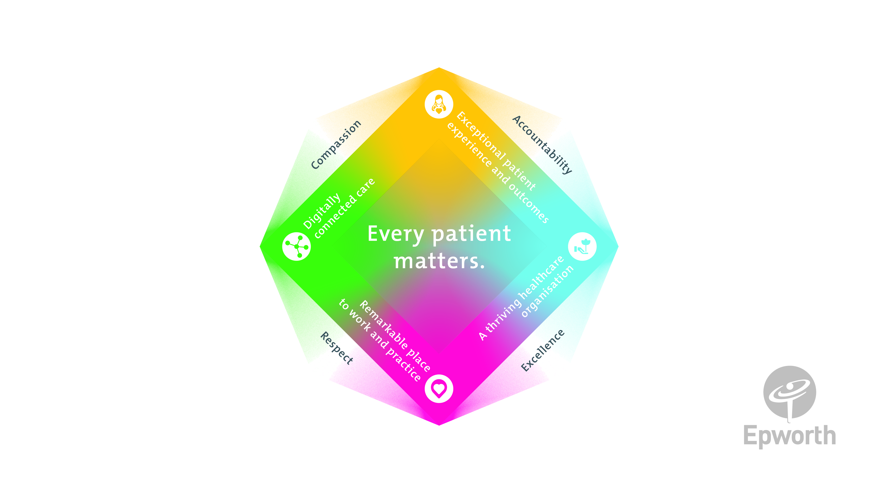
All roles are linked to the Epworth strategy and are fundamental in achieving its vision and purpose.
Exceptional patient experience and outcomes - To empower our patients and deliver compassionate, expert and coordinated care.
A thriving healthcare organisation - To adapt and grow in a changing healthcare landscape by delivering a unique private not-for-profit healthcare organisation.
Remarkable place to work and practice - To ensure Epworth is an outstanding place to work and practice through a culture of care
and investment in our people.
Digitally connected care - To innovate and improve the digital experience, interactions and outcomes for our patients, staff and doctors.

4. Purpose of the Position
The Group Manager – Change is responsible for developing and delivering an organisational wide change management framework and capability to support the change effort across Epworth. The role is expected to provide guidance, tools, and support, as well as helping to build change capability across the Group.
The Position will lead the Change team and provide change management for specific projects across the Group. This role has a key focus on developing the change management capability of the organisation, while continuing to ensure the delivery of strategic and business project. The role will adopt standardised and Epworth appropriate change tools and frameworks.
This role plays an integral role in supporting organisational change activities to ensure that the changes meet the desired business objectives and outcomes. The role will focus on the people side of change, including changes that impact business processes, systems and technology, job roles and structures. The role will work closely with the Projects Office, Strategy, IT, and the business to develop and maintain and organisational wide view and governance of change across stakeholder groups, building the change management capability within leaders, Change Managers, and staff.
5. Clinical Governance Framework
This role is required to put into practice the Clinical Governance Framework at Epworth as every employee is accountable for ensuring that our patients and community receive safe, high quality and person-centered care in every interaction with Epworth. This is achieved through active participation in the five domains of clinical governance at Epworth:

Clinical Governance Domain | Role
Leadership and culture | Promote and participate in a supportive, fair and transparent culture where lessons from previous outcomes are learned and patient safety and quality is a priority at all levels of the organisation.
Consumer Partnerships | Understand and where relevant, ensure that each patient is actively involved in their own care and treatment including families/careers wherever possible.
Effective Workforce | Develop and maintain one’s own competency, skills and knowledge to ensure high quality service provision and care.
Clinical Safety and Effectiveness | Understand and where relevant, ensure, that the right care is provided to the right person at the right time, in the right place and patient outcomes are monitored and improved.
Risk Management | Be responsible for identifying and reporting risks, hazards and near misses for people in our care and participating in risk mitigation strategies.
6. Key Accountabilities
KEY RESPONSIBILITIES | MEASURES/KPIs TO BE ACHIEVED
Change Planning and Leadership  - Develop and deliver Epworth change framework with supporting tools and templates  - Define and shape the change needs of major change programs across the group  - Establish a change management community of practice across Epworth  - Lead the design and delivery of enterprise-wide cultural and people change programs.  - Translate strategic objectives into actionable change plans that foster engagement and adoption.  - Champion a values-led approach to change that supports psychological safety, inclusion, and wellbeing. | - Framework established and delivered  - Change Management community of practice established and functioning
Change Delivery
- Lead change management at the organisational level
- Manage the Epworth change portfolio
- Support and engage senior leaders
- Coach Managers to build their change capability
- Complete key change activities on projects as required
- Providing reporting and other key updates on change
- Evaluate the impact of planned organisational changes
- Identify change risks and develop risk mitigation strategies
- Identify and manage anticipated resistance to change
- Support project teams without a dedicated change resource
Resource management
- Maintain knowledge of the pipeline of current and future project roadmaps as they relate to Change resources required
- Monitor and evaluate the demand and supply of resources required to deliver the agreed program of work
- Manage the performance of your team (both employees and contractors)
Leadership, collaboration and teamwork
- Provide line manager leadership and coaching to the change management team
- Stakeholder management – work with leadership, the Projects office and subject matter experts to build a holistic view of the organisation’s change program
- Demonstrate a commitment to teamwork and the maintenance of a supportive work environment
- Lead change through influence, focusing team efforts on delivering business value, and enhancing the patient and staff experience
Customer Service  Epworth is committed to the provision of excellent customer service to all of our people, customers and stakeholders including patients and external suppliers.  Superior patient service leads to improved healing in a trusting, caring environment and creates a safe environment for patients and employees.  - Role model and actively promote a culture of high quality patient care  - Provide excellent, helpful service to patients, visitors and staff  - Communicate with clear and unambiguous language in all interactions, tailored to the audience  - Build customer relationships and greet customers and patients promptly and courteously  - Actively seek to understand patients' and their family's expectations and issues, using multiple strategies  - Uses data (such as compliments, complaints and Press Ganey) to identify breakdowns in internal processes and systems that directly impact patient care and customer service  - Responds quickly and proactively escalate concerns when necessary  - Role model and actively promote a culture of high quality patient care and experience by ensuring that solutions, practices and procedures (such as hourly rounding, leader rounding and bedside handover) are carried out with empathy and compassion | - Patient and customer service satisfaction surveys within agreed targets  - Use AIDET principles in all interactions  - Compliments to complaints ratios  - Completes leader rounding at agreed frequency  - Issues are escalated to the manager and resolved in a timely manner
Safety and Wellbeing  To ensure a safe workplace is provided for all employees and other personnel including contractors, agency staff, volunteers and students.  - All employees and other personnel under the authority of the manager are fully informed of the hazards associated with their work activities, adequately trained and instructed in safe work procedures and appropriately supervised. Participate actively and positively in the area of health and safety to reduce all hazards and incidents within the workplace  - Integrate and review OHS performance in staff PDPs  - Ensure all direct reports are held accountable for safety performance and actions | - Adhere to infection control/personal hygiene precautions  - Implement and adhere to Epworth OHS policies, protocols and safe work procedures  - Ensure all hazards, incidents and injuries are reported in Riskman within 24 hours  - Ensure all hazards, incidents and injuries are investigated and corrective actions implemented within agreed timeframes  - Mandatory training completed at agreed frequency
7. Position Requirements/Key Selection Criteria
COMPONENT
Qualifications | Essential  - A qualification in change management  - Working with Children check
Required Knowledge & Skills | Essential  - Extensive and broad change management experience across a range of domains  - Familiarity with project management approaches, tools and phases of the project lifecycle  - Experience and knowledge of change management principles, methodologies and tools  - Proven experience in leading large-scale cultural and people change initiatives.  - Strong understanding of organisational behaviour, change management methodologies and employee experience design.  - Exceptional stakeholder engagement, facilitation, and influencing skills.  - Ability to navigate complexity and ambiguity with empathy and strategic clarity.  A solid understanding of how people go through a change process  - Demonstrated capacity to develop a change strategy and translate the strategy into an actionable change plan  - Excellent communication skills  Desirable  - Leading transformational change programs  - Understanding of the private health sector  - Experience in building change capability across a whole organisation
Personal Attributes & Values  All employees are expected to consistently work in accordance with Epworth’s values and behaviours  - Compassion  - Accountability  - Respect  - Excellence | Essential  - Belief in patient centred care  - Committed to providing a safe environment for patients & colleagues  - Professional work ethic  - Flexible and adaptable; ability to work in ambiguous situations

Document Control
Date Developed: | Date Last Reviewed: | Developed and Reviewed By (Position Title):
8 June 2022 | 24 July 2023 | Group Director Projects and Change

8. Employee Position Declaration
I have read and understand the requirements and expectations of the above Position Description. I agree that I have the physical ability to fulfil the inherent physical requirements of the position and accept my role in fulfilling the Key Accountabilities. I understand that the information and statements in this position description are intended to reflect a general overview of the responsibilities and are not to be interpreted as being all-inclusive.
Employee Signature:
Print Name: | Date:

