Page 1 of 8

General Information

Position Title: | Environmental Services Supervisor
Division/Department: | Environmental Services
Position Reports to: | Hospitality Services Operations Manager, General Services Manager
Enterprise/Individual Agreement: | Epworth Healthcare Health and Allied Services Enterprise Agreements 2022
Classification/Grade: | ESS01 – ESS05
Location: | Epworth Geelong
Employment Status: | Permanent Full Time, rotating roster
Resource Management  (for Management positions only)  Number of Direct Reports:  Budget under management: | Up to 80 staff including Full-time, Casual and agency HSAs and Patient Transport
Key Relationships - internal and external | - Hospitality Services Operations Manager, Hospital Coordinator, HSAs, Patient Transport  - NUMs, ANUMs & Patient Care Team, other internal service providers i.e. Nursing and Ward Administration staff, Food Services team, Facilities  - Patients, inclusive of family members & visitors  - External service providers

- Overview of Epworth HealthCare
Epworth HealthCare is Victoria’s largest not-for-profit private health care group, renowned for excellence in diagnosis, treatment, care and rehabilitation. Epworth is an innovator in Australia’s health system, embracing the latest in evidence-based medicine to pioneer treatments and services for our patients.

Epworth’s values define our approach and our delivery. We pride ourselves on communicating our values and delivering on them in a real and meaningful way. Our Values are Compassion, Accountability, Respect and Excellence. More information can be found on the Epworth website.

Epworth’s purpose is Every Patient Matters. We strive to improve health outcomes and experience through compassion, collaboration, learning and Innovation. Our Vision is Caring for People. Innovating for a healthy community.

3. Epworth HealthCare Strategy
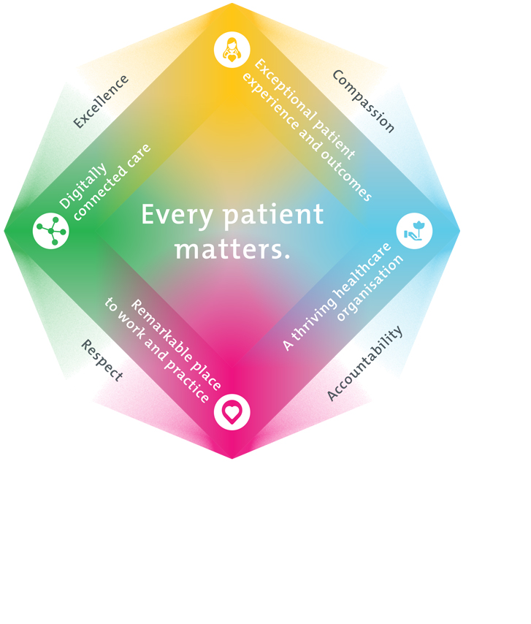
All roles are linked to the Epworth strategy and are fundamental in achieving its vision and purpose.
Exceptional patient experience and outcomes - To empower our patients and deliver compassionate, expert and coordinated care.
A thriving healthcare organisation - To adapt and grow in a changing healthcare landscape by delivering a unique private not-for-profit healthcare organisation.
Remarkable place to work and practice - To ensure Epworth is an outstanding place to work and practice through a culture of care
and investment in our people.
Digitally connected care - To innovate and improve the digital experience, interactions and outcomes for our patients, staff and doctors.

Purpose of the Position
Reporting to the Hospitality Services Operations Manager, the primary purpose of the Environmental Services Supervisor is to promote patient service excellence and a positive, safe work culture. This position exists to drive outstanding service delivery in cleaning, infection control, patient transport, and timely responses to CARPS requests throughout the Hospital. The safety of our patients, VMO’s, tenants, staff and visitors will be maintained by ensuring WH&S and infection control best practices are followed.
You will achieve this by demonstrating strong leadership by guiding, supporting, and developing the Hospitality Service Associates (HSAs) and Patient Transport teams. You will work closely with the Hospitality Services Manager to achieve operational and budget targets and drive patient and key steak holder satisfaction.
Specifically, the role will be responsible for leading a diverse team, ensuring all health and safety protocols and Epworth policy and procedures are adhered to. You will identify equipment and human resource needs and will allocate tasks so that shifts run efficiently without compromising on quality outcomes. This role has direct accountability for staff performance with a main focus on professional development, addressing misconduct, maintaining quality, maintaining efficiencies, ensuring thoroughness and that correct chemical handling and manual handling is followed. The promotion of an ethos of safety first and a culture of respect and team work will underpin this.
The Environmental Supervisor is to:
  - Be a role model in setting the cleaning and behavior standards to achieve optimum patient, staff and key steak holder experiences
  - Provide leadership by rounding on all Environmental Services staff daily and foster an environment of support, approachability and accountability that nurtures performance development through clear and consistent direction.
  - Coordinate timely, safe, patient-centered services that provide exceptional patient experiences
  - Support the Hospitality Operations Manager to build and maintain a patient and customer-focused team
  - Actively identify, document and address human resource improvements (eg, recruitment, training, performance, attendance) to optimise performance and maintain a safe operating environment

Key Accountabilities

KEY RESPONSIBILITIES | MEASURES/KPIs TO BE ACHIEVED
Leadership  Priorities and supports the well-being, safety, growth, and success of staff, fostering a positive and collaborative work environment.  Actively provide leadership by:  - Quickly and proactively address staff concerns in a professional, respectful and fair manner  - Works cooperatively and collaboratively with all members of Environmental Services team  - Proactively manage staff performance to meet expected infection control and safe move standards. i.e. provide feedback (both positive and constructive) when performing daily rounding of all staff on shift  - Conduct performance appraisals in a manner that demonstrates genuine interest in staff development  - Assist in probationary reviews, where required  - Demonstrate high personal hygiene standards and safe work practices  - Promote a clean environment for all patients, visitors and staff  - Demonstrate and Promote timely and high-quality service delivery  - Occupational Health & Safety are provided to staff as required  - Supervision, orientation & provision of training to HSAs and Orderlies  - Managing staff rosters within EBA, budgeted and contractual hours  - Meet People and Culture KPI targets | - Positive and collaborative work culture: Orientation and training of new staff is conducted and progress documented  - Staff satisfaction and engagement: Achieve a score equal to or greater than site average in staff satisfaction surveys  - Staff growth: 100% of PDP’s are up to date  - Safety: 100% of Mandatory training is up to date and SWP competencies are signed off  - Agency usage is within department KPI  - Environmental and Orderly rosters are established & operational within EBA guidelines  - Rosters are managed with integrity. Employee are notified of roster changes, allocation of permanent shifts is transparent and open to all staff to apply.  - People and Culture metrics within organisational KPIs  - Start of shift tool box meetings are conducted and any staff hot spot concerns are documented in shift hand over notes  - Attend and contribute to department team meetings
Cleaning Care  Surface Sanitisation:  - Daily check of surfaces in designated areas are regularly cleaned and sanitised.  - Monitor daily task list when handed in at the end of shift and implement corrective actions if full schedule has not been complete.  - Cleaning policies and procedure:  - Regularly review and update your knowledge of procedures  - Enforce cleaning policies and procedures.  - Chemical Usage and Safety:  - Monitor and control the proper use of cleaning chemicals, ensuring staff are trained in their safe and effective application and handling.  - Keep an inventory of cleaning supplies and ensure they are always adequately stocked.  Infection Control Measures:  - Conduct monthly audits to ensure compliance with infection control standards.  - Collaborate with infection control teams and Hospitality Services Operations Manager to implement and maintain effective cleaning measures to prevent the spread of infections.  Quality Assurance Inspections:  - If problem areas are identified, establish a quality assurance program with regular inspections to assess the cleanliness of problem areas until resolved.  - Develop corrective action plans for any identified deficiencies.  Response to Emergency Cleaning Needs:  - Ensure a rapid response for emergency cleaning situations, such as spills or public area infection cleans.  - Ensure staff are trained and equipped to handle urgent cleaning and infectious cleans.  Feedback Mechanism:  - Document all received feedback from staff, patients, or visitors regarding the cleanliness of the environment in shift handovers.  - Use feedback to identify areas for improvement and recognise staff for successes.  Compliance with Regulatory Standards:  - Ensure compliance with all relevant regulatory standards related to cleanliness and hygiene.  - Prepare for, and when requested, participate in external regulatory inspections related to environmental services.  Sustainability Practices:  - Follow environmentally friendly cleaning practices and products where possible.  - Monitor and report on any identified negative environmental impact of cleaning activities.  Training and Skill Development:  - Encourage continuous improvement and professional development among cleaning personnel. | - Cleaning Audits: Full completion of audits in all functional areas on the CARPS tree. All rectifications addressed and completed within compliance timeframes. Any non-compliances addressed and corrected so the following month is compliant, document all corrective actions. i.e. Actively address any trending problem areas  - Equipment and Cleaning Products: All equipment is operational, and there are adequate stock levels for all cleaning materials and chemicals  - Patient feedback: patient feedback scores are qual to or above the Epworth group average  - Staff training: All current and new staff have received and signed off on correct chemical use and handling and understand SWP of their role. All orderlies have completed both online and practical safe moves training. Assist HSOM in keeping staff accountable for their mandatory training compliance.  - Cleaning response times: Key stakeholders are satisfied  - Infectious cleans: All logged infectious cleans are completed on the shift they are logged  - Demonstrated knowledge and compliance and with all cleaning and infection control standards and procedures.

Patient Service and Care  - Role model and actively promote a culture of high quality patient care and experience by ensuring that solutions, practices and procedures (such as hourly rounding, leader rounding and bedside handover) are carried out with empathy and compassion  - Uses data (such as compliments, complaints and InSync) to identify breakdowns in internal processes and systems that directly impact patient care and customer service  - Consistently meet or exceed the expectations of our patients and customers at all times  - Practice in accordance with legislative and common law requirements  - Participate in a patient care through superior patient focused service. Actively seek to understand patients' and their family's expectations and issues, using effective strategies including leader rounding on patients and team members if key stake holders have raised concerns.  - Demonstrate empathy and compassion to patients and their family, colleagues and VMOs. Respect and uphold the dignity and rights of consumers, relatives, carers, colleagues and members of the community  - Maintain patient confidentiality as prescribed by the relevant Acts and organisational policies and protocols  - Practice AIDET in all patient interactions  - Safe patient transport within operating suites, wards and other areas of the hospital as required with appropriate equipment  - Efficiently coordinate the transport of other items including (but not limited to) pharmacy, samples and test materials, luggage and equipment | - All internal and external key stake holders are met promptly and spoken to with courtesy.  - AIDET principles in all interactions are used  - Patient and customer service satisfaction survey scores to be above, or in line with, agreed targets  - Concerns are responded to quickly and proactively escalate if  required  - 100% completion of Safe moves training for all staff involved in patient transport.  - 100% compliance with mandatory and unit specific competencies every 12 months or as prescribed  - Compliance with government health standard requirements relating to cleaning audits and requirements  - Compliance with legislative and common law requirements  - Compliance with Information Privacy Act (2000) and the Health Records Act (2000)  - Compliance with EEO & Social Medial Policies and Protocols of Epworth HealthCare
Quality Improvement  - Strive to consistently improve the service delivery of the Environmental Service Department  - Provides suggestions, and feedback to Hospitality Services Operations Manager on quality activities  - Actively participates in quality improvement activities within the department in accordance with the National Standards for Clinical Excellence and ACHS Accreditation Standards | - Evidence of participation in quality activities  - Evidence of meeting attendence  - Patient satisfaction scores trend upwards or maintained above agreed level  - Show a proactive attitude in reviewing, supporting and implementing relevant initiatives into service improvements  - Improvement in performance of department and Epworth HealthCare
Personal and Professional Development  - Participates in prescribed performance development system annually  - Evaluates personal performance and plans self-development  - Participates in the orientation of new permanent and casual staff  - Provides training to department staff, ensuring all mandatory training is current  - Follow and document that all staff have read and understand SWP procedures | - Completion of annual performance appraisal, PDP’s  - Participation in in-services, department education and meetings  - Completion of objectives outlined in self-development plan (provide evidence of)  - Training of staff in relevant department specific activities (as requested by Manager)
Safety and Wellbeing  To ensure a safe workplace is provided for all employees and other personnel including contractors, agency staff, volunteers and students.  All employees and other personnel under the authority of the manager are fully informed of the hazards associated with their work activities, adequately trained and instructed in safe work procedures and appropriately supervised. | - Implement and adhere to Epworth OHS policies, protocols and safe work procedures  - Ensure all hazards, incidents and injuries are reported in Riskman within 24 hours  - Ensure all hazards, incidents and injuries are investigated and corrective actions implemented within agreed timeframes  - Integrate and review OHS performance in staff PDPs  - Ensure all direct reports are held accountable for safety performance and actions  - Actively participate in risk management activities

- Position Requirements/Key Selection Criteria

COMPONENT
Qualifications | Desirable  - Leadership Course Certificate  - Cert IV in Cleaning (CPP40421), or Cert IV in Cleaning Management (CPP41011)
Previous Experience | Essential  - Hospital, Residential Aged Care or Hotel Sector based experience  - Experience in a similar leadership role in Environmental Services within the Health or Aged care industry  Desirable  - Rostering for teams of 60+
Required Knowledge & Skills | Essential  - Proven effective Supervisory/Leadership skills  - Resource management in human, equipment and time – Labour hour management  - Sound understanding of performance management and people development  - Knowledge and commitment to Acts, Agreements and Epworth Healthcare directions, policies, procedures and staff code of conduct  - Superior conflict resolution skills  - Demonstrated understanding of principles in customer care  - Knowledge and understanding of cleaning principles to maintain government required health standards  - Computer literacy in Microsoft Applications  - Effective written, oral and verbal communication skills  - Demonstrate role model behavior  Desirable  Understanding of ACHS Accreditation standards or a willingness to learn and commit to accreditation processes
Personal Attributes & Behaviours  All employees are expected to consistently work in accordance with Epworth’s values and behaviours. | Essential  - High standard of personal presentation  - Belief in patient centered care  - Commitment to providing a safe environment for patients, visitors and staff  - Professional work ethic  - Self-motivated and self-directed  Practices within the ethos of the Epworth HealthCare Values & Behaviours

Document Control
Date Developed: | Date Last Reviewed: 23/1/24 | Developed and Reviewed By (Position Title): Paul Hosie
September 2013 | June 2023 | Hospitality Services Operations Manager

Employee Position Declaration
I have read and understand the requirements and expectations of the above Position Description. I agree that I have the physical ability to fulfil the inherent physical requirements of the position, and accept my role in fulfilling the Key Accountabilities. I understand that the information and statements in this position description are intended to reflect a general overview of the responsibilities and are not to be interpreted as being all-inclusive.

Employee Signature:
Print Name: | Date:

