Page 1 of 8



1. **General Information**



|  |  |
| --- | --- |
| **Position Title:** | Executive Assistant |
| **Division/Department:** | Operations |
| **Position Reports to:** | Chief Operating Officer |
| **Enterprise/Individual Agreement:** | Individual Agreement |
| **Classification/Grade:** | N/A |
| **Location:** | Pelaco Building, Richmond (also attend meetings at various Epworth sites) |
| **Employment Status:** | Full Time |
| **Resource Management**  (for Management positions only)  **Number of Direct Reports:**  **Budget under management:** | N/A |
| **Key Relationships - internal and external** | * Clinical Leadership and respective leadership teams * Executive Team and Leadership Teams from Divisions * Executive and Personal Assistants, Epworth HealthCare * Board and Committee Members * Staff and external stakeholders |

1. **Overview of Epworth HealthCare**

Epworth HealthCare is Victoria’s largest not-for-profit private health care group, renowned for excellence in diagnosis, treatment, care, and rehabilitation. Epworth is

an innovator in Australia’s health system, embracing the latest in evidence-based medicine to pioneer treatments and services for our patients.

Epworth’s values define our approach and our delivery. We pride ourselves on communicating our values and delivering on them in a real and meaningful way. Our Values are Compassion, Accountability, Respect and Excellence. More information can be found on the [Epworth website](https://www.epworth.org.au/who-we-are/our-values).

Epworth’s purpose is Every Patient Matters.

Our Vision is Delivering another 100 years of exceptional healthcare and innovation to the Victorian community.

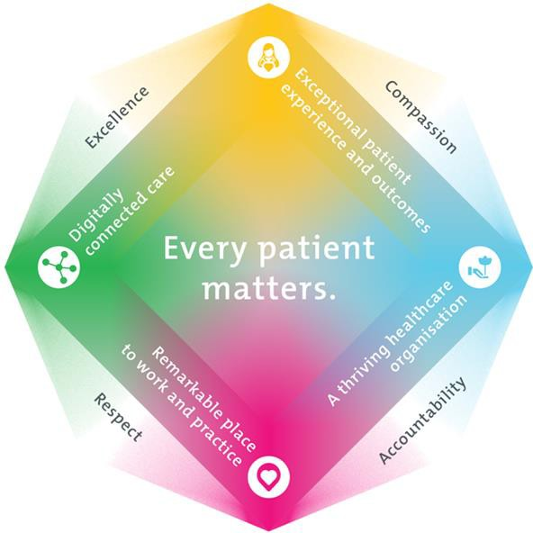

1. **Epworth HealthCare Strategy**

|  |
| --- |
| All roles are linked to the Epworth strategy and are fundamental in achieving its vision and purpose. |
| **Exceptional patient experience and outcomes -** To empower our patients and deliver compassionate, expert and coordinated care. |
| **A thriving healthcare organisation -** To adapt and grow in a changing healthcare landscape by delivering a unique private not-for-profit  healthcare organisation. |
| **Remarkable place to work and practice -** To ensure Epworth is an outstanding place to work and practice through a culture of care  and investment in our people. |
| **Digitally connected care -** To innovate and improve the digital experience, interactions and outcomes for our patients, staff, and doctors. |

1. **Purpose of the Position**

To provide executive administrative and management support to the Chief Operating Officer including email and calendar management, travel and catering arrangements, meeting and committee secretariat, the preparation of presentations, executive reports and general administrative tasks.

1. **Key Accountabilities**

|  |  |
| --- | --- |
| **KEY RESPONSIBILITIES** | **MEASURES/KPIs TO BE ACHIEVED** |
| **Executive and Administrative Support**  Executive administrative support to COO including:   * Effective diary management and monitoring to ensure COO time is structured effectively. * Efficient review of incoming electronic and paper-based correspondence to COO, bringing urgent matters to attention to ensure action and response is timely. * Responding to queries or issues on behalf of the COO where appropriate and in a timely manner.   Administrative support to Leadership Team as and when required, including:   * Responding to issues or actioning tasks where appropriate * Coordination of all conference, travel, and accommodation arrangements for   COO & Leadership Teams in line with Epworth’s Travel Policy   * Other activities as and when required. | * Diary schedules are appropriately and accurately managed and maintained. * Documents are professional and accurate in their production. * Efficient office procedures are appropriately managed, maintained or implemented. * Effectively compile and manage communications to staff. * Reliable and timely delivery of services * Compliance with Policies and Procedures * Provide accurate and timely advice and responses. * Responsiveness in the management of correspondence. * COO notified of decision made on their behalf and any critical issues in a timely manner |

|  |  |
| --- | --- |
| **Executive report writing and coordination**  Drafting and collation of reporting papers for presentation to the Board, Group Executive and other forums as required.   * Coordination and follow-up of relevant papers. * Drafting and editing of core executive and Board papers * Research to support the preparation of proposals, reports, spreadsheets, briefing papers, and other presentation material. * Support to other Committees and Working Groups as required. * Develop resource materials as appropriate | Projects, papers, briefings, letters, and presentations coordinated and prepared in a timely manner with appropriate grammar, formatting and editing. |
| **Committee and Meeting Secretariat**  Drafting and collation of reporting papers for presentation to the Executive meetings, Steering Committees and other forums as required.   * Document and follow-up of Leadership Team meetings and forums:   + Preparation of agendas, minutes and papers as required.   + Tracking and follow up of agreed action items. * Research to support the preparation of proposals, reports, spreadsheets, briefing papers, and other presentation material. * Support to other Committees and Working Groups as required. * Develop resource materials as appropriate | Quality and timeliness of the preparation and distribution of reports and documentation supporting Committees is satisfactory including:   * Minutes prepared in a timely manner. * Agendas are compiled and distributed in a timely manner. * Draft papers are available for review in a timely manner. * Follow-up with key stakeholders * Projects, papers, briefings, letters, and presentations |
| **Project Management and Event Management**   * Co-ordinate or assist in the management and delivery of small to medium projects, supporting the planning and organization of activities as required to ensure the successful implementation of projects. * Assist COO with the collation and presentation of monthly & quarterly project updates and status reports as required. * Assist COO and other stakeholders to develop documentation for project scoping and approvals. * Contribute and participate in larger project initiatives as directed to ensure project objectives are achieved. * Ensure all events are run efficiently and effectively | * Project work is delivered on time and to the agreed standard. * Internal and external events are coordinated from inception to conclusion in a timely manner with all key stakeholders involved |
| **Stakeholder Management**  Establish and maintain effective relationships.   * Build relationships with leadership, corporate departments, all other key staff. * A trusted central contact point for all major stakeholders wanting access to the COO. * Build relationships with staff, vendors, providers, and industry partners. | * Feedback from stakeholders * Positive ability to influence change |

|  |  |
| --- | --- |
| **Customer Service**   * Provide professional, friendly and helpful service to all internal and external customers. * Epworth is committed to the provision of excellent customer service to all of our people, customers and stakeholders including patients and external suppliers. * Superior patient service leads to improved healing in a trusting, caring environment and creates a safe environment for patients and employees. | * Epworth values and behaviours demonstrated. * Negotiate meeting times with other Executive and Personal Assistants * Build customer relationships and greet customers promptly and courteously. * Actively seek to understand customer’s circumstances, expectations and issues * Proactively escalates concerns when necessary to ensure resolution of any current or potential breakdown in processes and systems that impact patient care and customer service. * Consistently meet or exceed patients and customers’   expectations |
| **Safety and Wellbeing**  Participate actively and positively in the area of OHS to reduce all hazards and incidents within the workplace | * Comply with all Epworth’s OHS policies, protocols and safe work procedures at all times. * Ensure your actions do not put yourself or others at risk. * Report all hazards, incidents, injuries and near misses immediately to your manager and log them in RiskMan. * Participate in and complete mandatory safety training on an annual basis and as required. |

1. **Position Requirements/Key Selection Criteria**

|  |  |
| --- | --- |
| **COMPONENT** |  |
| Qualifications | **Desirable**   * A degree in a related field. |
| Previous Experience | **Essential**   * Demonstrated experience as an outstanding executive assistant to a senior executives. * Experience in a large, complex organisation.   **Desirable**   * Experience within a similar role in the health care sector is advantageous. |
| Required Knowledge & Skills | **Essential**   * Proven experience in a similar role * Exceptional planning and organisational skills * Exceptional verbal and written communication skills * Ability to draft correspondence, executive papers and edit committee papers * Ability in supporting committees, including the timely preparation of agendas, minutes, and tracking of actions * Developed computer skills including a comprehensive knowledge of Microsoft Office365 including Teams, Outlook, Word, Excel and PowerPoint * Commitment to excellent customer service and continuous improvement * Strong judgement and discretion * Strong, plain English writing skills (editing of Board papers and minute writing) * Time management skills that enable a range of activities to be organized concurrently. * Ability to work in a demanding and challenging work environment. |

|  |  |
| --- | --- |
| Personal Attributes & Behaviours  All employees are expected to consistently work in accordance with  Epworth’s values and behaviours. | **Essential**   * Self-starter - Demonstrate a high level of self-direction and initiative with an ability. * Proactive, co-operative and enthusiastic approach to responsibilities with an ability to make decisions. * Honesty and integrity. * Strong interpersonal and communication skills. * Logical and analytical. * Ability to promote and support change. * Demonstrated ability to build rapport, negotiate and form relationships with people at all levels. * Ability to work independently & also in teams. * High level of confidentiality and discretion. |

**Document Control**

|  |  |  |
| --- | --- | --- |
| Date Developed: | Date Last Reviewed: | Developed and Reviewed By (Position Title): |
| March 2024 | Aug 2024 | Chief Operations Officer |

**Employee Position Declaration**

I have read and understand the requirements and expectations of the above Position Description. I agree that I have the physical ability to fulfil the inherent physical requirements of the position and accept my role in fulfilling the Key Accountabilities. I understand that the information and statements in this position description are intended to reflect a general overview of the responsibilities and are not to be interpreted as being all-inclusive.

|  |  |
| --- | --- |
| Employee Signature: | |
| Print Name: | Date: |