- General Information
Position Title: | Divisional Administration Support Manager
Division/Department: | Continuing Care and Support Services
Position Reports to: | EGM or other manager as delegated
Enterprise/Individual Agreement: | Individual Agreement
Classification/Grade: | N/A
Location: | Camberwell, Richmond, Hawthorn
Employment Status: | Full-time permanent
Resource Management  (for Management positions only)  Number of Direct Reports:  Budget under management: | 6 Team leaders  $2.4M
Key Relationships - internal and external | - Hospital Executive and Management,  - Administration Team Leaders  - Rehabilitation Consultants, Medical Staff & VMO’s  - Directors of Clinical Services  - Allied Health Manager and Deputy Managers  - Epworth at Home Director and Deputy Manager  - Internal and External service providers and referrers  - Patients and visitors
2. Overview of Epworth HealthCare
Epworth HealthCare is Victoria’s largest not-for-profit private health care group, renowned for excellence in diagnosis, treatment, care and rehabilitation. Epworth is an innovator in Australia’s health system, embracing the latest in evidence-based medicine to pioneer treatments and services for our patients.

Epworth’s values define our approach and our delivery. We pride ourselves on communicating our values and delivering on them in a real and meaningful way. Our Values are Compassion, Accountability, Respect and Excellence. More information can be found on the Epworth website.

Epworth’s purpose is Every Patient Matters.

Our Vision is Delivering another 100 years of exceptional healthcare and innovation to the Victorian community.

- Epworth HealthCare Strategy

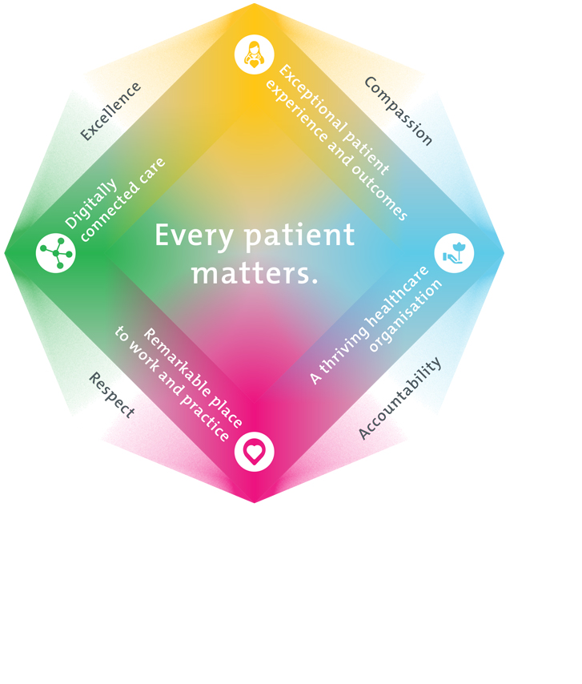

All roles are linked to the Epworth strategy and are fundamental in achieving its vision and purpose.
Exceptional patient experience and outcomes - To empower our patients and deliver compassionate, expert and coordinated care.
A thriving healthcare organisation - To adapt and grow in a changing healthcare landscape by delivering a unique private not-for-profit healthcare organisation.
Remarkable place to work and practice - To ensure Epworth is an outstanding place to work and practice through a culture of care
and investment in our people.
Digitally connected care - To innovate and improve the digital experience, interactions and outcomes for our patients, staff and doctors.
4. Purpose of the Position
To provide and be responsible for the overall administrative functions of the Division including but not limited to:
- Patient administration
- General administration support across CCSS including Epworth at Home administration requirements
- Working collaboratively to drive improvement and support the Continuing Care and Support Services division across all campuses
- Billing and accounts management
- Personnel management
- Growth of division through pursuit of private practice optimisation with Medicare and PHI billing
- IT customer relationship manager to ensure successful implementation of IT solutions across the division
- Promote excellence to our customers and the marketplace and support colleagues by sharing knowledge and expertise.
5. Clinical Governance Framework
This role is required to put into practice the Clinical Governance Framework at Epworth as every employee is accountable for ensuring that our patients and community receive safe, high quality and person-centered care in every interaction with Epworth. This is achieved through active participation in the five domains of clinical governance at Epworth:

Clinical Governance Domain | Role
Leadership and culture | Promote and participate in a supportive, fair and transparent culture where lessons from previous outcomes are learned and patient safety and quality is a priority at all levels of the organisation.
Consumer Partnerships | Understand and where relevant, ensure that each patient is actively involved in their own care and treatment including families/carers wherever possible.
Effective Workforce | Develop and maintain one’s own competency, skills and knowledge to ensure high quality service provision and care.
Clinical Safety and Effectiveness | Understand and where relevant, ensure, that the right care is provided to the right person at the right time, in the right place and patient outcomes are monitored and improved.
Risk Management | Be responsible for identifying and reporting risks, hazards and near misses for people in our care and participating in risk mitigation strategies.
6. Key Accountabilities
KEY RESPONSIBILITIES | MEASURES/KPIs TO BE ACHIEVED
Leadership  - Inspire, develop, lead and manage high performing teams and build strong relationships with key internal and external stakeholders  - Build strong collaborative relationships with peers and executive team to contribute to both division and organisation wide improvement and growth  - Delegate appropriate responsibilities to team leaders and support them through coaching and advice  - Foster a culture that embraces change and encourages innovation  - Professional development of self and team  - Actively develops strategies and implements practices to attract, recruit and retain high performing team members to ensure team effectiveness  - Management of administration labour budget and expenditure  - Management of sessional suites timetable and revenue, setting up the drs in the consulting rooms, work closely with BD manager and management of dr concerns regarding consulting rooms. | - Responsible for recruiting, training, supporting and coaching of staff to ensure the excellence of patient service delivery  - Training, coach and support administrative staff to develop skills required to improve job performance  - Ensure staff mandatory training and Professional Development Plans are current and up to date  - Attendance at Leadership Programs as required  - Ensure effective relationships with Continuing Care and Support Services (CCSS) staff to promote team focused activity and a high-performance work culture.  - Fully engaged, agile and focused administrative support team  - Attendance at CCSS staff meetings as required
Customer Service  Epworth is committed to the provision of excellent customer service to all of our people, customers and stakeholders including patients and external suppliers. Superior patient service leads to improved recovery in a trusting, caring environment and also creates a safe environment for patients and employees.  - Role model and actively promote a culture of high quality patient care  - Provide excellent, helpful service to patients, visitors and staff  - Collaborate with business users and IT teams to identify and plan system deployments and resolve business operational and IT issues  - Communicate with clear and unambiguous language in all interactions, tailored to the audience  - Build customer relationships across the division and broader organisation  - Actively seek to understand key stakeholders expectations and issues, using multiple strategies  - Uses data (such as patient experience feedback) to identify opportunities for improvement in internal processes and systems that directly impact patient care and customer service  - Responds quickly and proactively escalate concerns when necessary  - Set up diaries in iPM  - IT help desk support and IT relationship manager | - Patient and customer service satisfaction surveys within agreed targets  - Use AIDET principles in all interactions  - Issues or concerns are proactively escalated to the manager and resolved in a timely manner  - Feedback or issues recorded on Riskman  - Consistently meet or exceeds the expectations of stakeholders at all times  - Work collaboratively with internal and external stakeholders and customers and perform services with team based professionalism and integrity that is primarily service focused  - Be the key liaison between the CCSS management team and Epworth IT to ensure all requirements and programs of work for the division are understood and implemented in a timely and efficient way
Operational Management  - Work in collaboration with their manager and senior managers to implement the department budget in a manner that ensures all resources are used to deliver high quality service in a cost effective manner. Support end of month reporting  - Review and management of the revenue cycle and work closely with patient revenue team, accounts payable and receivable and payroll  - Seeks input and feedback from managers and teams to develop understanding of unit performance  - Ensure the effective and accurate use of the iPM patient management system by all administrative and clinical staff  - Ensure strong financial management is supported by accuracy and integrity of data within the iPM Patient Management System  - Management of maintenance of the software used by outpatients/consulting (Genie, iPM, 3M transcription software). Including preadmissions pack to iPM.  - Work collaboratively with Administration Team Leaders to develop processes and strategies that enable staff to achieve/exceed department targets  - Work collaboratively with key stakeholders to improve administration department services and determine and fulfil their needs and expectations  - Provide advisory support to all key stakeholders in relation to interpretation of health fund contracts and governance of those contracts across the division  - Pre-admission/admissions data entry | - Direct costs within agreed targets  - Labour costs within agreed targets  - No aged debtors  - Responsible for overall management of accounts ensuring payment is received in a timely manner  - Ensure VMO’s are billed correctly  - Ensure division has adequate administrative support to deliver on business and operational requirements including Epworth at Home
Team Work /Communication  - Actively participate as a member of the department and multidisciplinary team  - Provide positive and constructive feedback to other team members | - Collaborate effectively with all other team members and external agencies, for efficient patient management  - Supportive environment for both patients and staff is provided  - Attendance and active participation in departmental and multidisciplinary team meetings
Continuous Quality Improvement  - Initiate, lead and actively participate in quality activities ensuring opportunities for improvement are actively explored and best practice is achieved  - Provide suggestions and feedback to consistently improve service delivery, clinical practice and patient satisfaction  - Strive to enhance CCSS’s and Epworth’s positive image within the community  - Process development to support with CCSS governance and patient journey including links with Point of Care | - Evidence of participation in quality enhancement activities  - Quality projects are completed within agreed time frame  - Divisional resources, equipment and educational information are maintained and updated  - Representation of division at relevant committees/meetings  - Review of current systems and their effectiveness  - Research, review and implement improved administrative systems to enhance the efficiency of CCSS  - Ensure business requirements are satisfied through efficient administrative management and support
Personal and Professional Development  - Participate in the ongoing professional development of self, colleagues and the wider Epworth HealthCare community by upgrading clinical competencies and knowledge and participating in both internal and external educational opportunities  - Impart clinical knowledge through structured in-service programs, lectures and tutorials  - Actively participate in Performance Development Plan annually and evaluate personal performance and plan self-development | - Training of staff in department meetings and other staff through in-service programs, tutorials, etc  - Participation in in-service and education activities and events  - Completion of performance review and development plan
Safety and Wellbeing  To ensure a safe workplace is provided for all employees and other personnel including contractors, agency staff, volunteers and students.  - All employees and other personnel under the authority of the manager are fully informed of the hazards associated with their work activities, adequately trained and instructed in safe work procedures and appropriately supervised. Participate actively and positively in the area of health and safety to reduce all hazards and incidents within the workplace  - Integrate and review OHS performance in staff PDPs  - Ensure all direct reports are held accountable for safety performance and actions | - Adhere to infection control/personal hygiene precautions  - Implement and adhere to Epworth OHS policies, protocols and safe work procedures  - Ensure all hazards, incidents and injuries are reported in Riskman within 24 hours  - Ensure all hazards, incidents and injuries are investigated and corrective actions implemented within agreed timeframes  - Mandatory training completed at agreed frequency
7. Position Requirements/Key Selection Criteria
COMPONENT
Qualifications | Essential  - Tertiary qualification in Business Administration (Cert 4) or related field.  Desirable  - IT qualifications  - Equivalent work experience
Previous Experience | Essential  - Significant administrative experience in the health sector  Desirable  - Previous management position in a related health industry  - Experience working with Private Health Funds
Required Knowledge & Skills | Essential  - Substantial and demonstrated financial management and business management skills  - Excellent IT skills  - Sound knowledge of outpatient and inpatient billing, health funds and Medicare  - Knowledge of administrative issues as they relate to the health industry  - Proven experience in overseeing the implementation of IT solutions and services  - Good project management skills  - Demonstrated customer service skills  - Excellent administration, organisational and reporting skills  - Demonstrated skill in working as a member of a team and liaising, collaborating and negotiating with other service providers and agencies, patient’s families and carers  - Demonstrated team management experience  Desirable  - Skills in conflict resolution and ability to manage challenging behaviour  - Knowledge of medico-legal environment
Personal Attributes & Values  All employees are expected to consistently work in accordance with Epworth’s values and behaviours  - Respect  - Excellence  - Compassion  - Community  - Integrity  - Accountability | Essential  - Leadership – ability to lead all administrative functions  - Communication – ability to give clear, timely and accurate direction to staff and patients  - Committed to ongoing professional development and learning  - Prepared to commit to Epworth’s mission and values  - Practice within the ethos of the Epworth HealthCare Values and Behaviours  - Act as a role model  - Flexibility to assist others within the division and across sites as required

Document Control
Date Developed: | Date Last Reviewed: | Developed and Reviewed By (Position Title):
August 2016 | August 2025 | Cindy Joffe Director Epworth at Home

Employee Position Declaration
I have read and understand the requirements and expectations of the above Position Description. I agree that I have the physical ability to fulfil the inherent physical requirements of the position, and accept my role in fulfilling the Key Accountabilities. I understand that the information and statements in this position description are intended to reflect a general overview of the responsibilities and are not to be interpreted as being all-inclusive.
Employee Signature:
Print Name: | Date:

