- General Information
Position Title: | Director Perioperative Services
Division/Department: | Epworth Richmond – Management
Position Reports to: | Executive General Manager & Deputy Chief Operations Officer
Enterprise/Individual Agreement: | Individual Agreement
Classification/Grade: | N/A
Location: | Epworth Richmond
Employment Status: | Full Time
Resource Management  (for Management positions only)  Number of Direct Reports:  Budget under management: | 6  TBA
Key Relationships - internal and external | - Richmond & Group Executive and Senior Management Teams  - Perioperative Services Managers at Richmond and other Divisions  - Nurse Unit Managers  - Business Managers, HR, Education, Quality, Senior Business Development Manager.
2. Overview of Epworth HealthCare
Epworth HealthCare is Victoria’s largest not-for-profit private health care group, renowned for excellence in diagnosis, treatment, care and rehabilitation. Epworth is an innovator in Australia’s health system, embracing the latest in evidence-based medicine to pioneer treatments and services for our patients.

Epworth’s values define our approach and our delivery. We pride ourselves on communicating our values and delivering on them in a real and meaningful way. Our Values are Compassion, Accountability, Respect and Excellence. More information can be found on the Epworth website.

Epworth’s purpose is Every Patient Matters.

Our Vision is Delivering another 100 years of exceptional healthcare and innovation to the Victorian community.

3. Epworth HealthCare Strategy
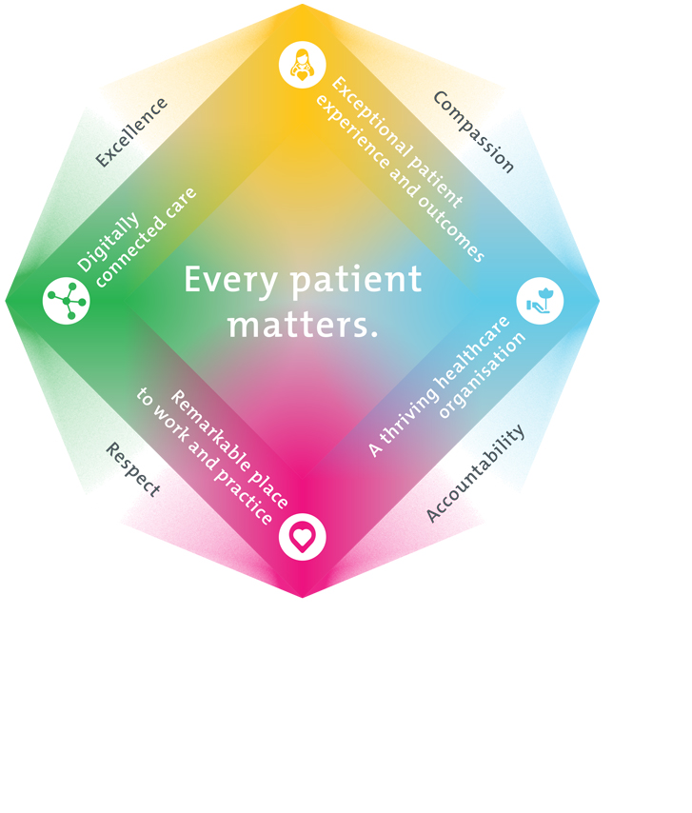
All roles are linked to the Epworth strategy and are fundamental in achieving its vision and purpose.
Exceptional patient experience and outcomes - To empower our patients and deliver compassionate, expert and coordinated care.
A thriving healthcare organisation - To adapt and grow in a changing healthcare landscape by delivering a unique private not-for-profit healthcare organisation.
Remarkable place to work and practice - To ensure Epworth is an outstanding place to work and practice through a culture of care
and investment in our people.
Digitally connected care - To innovate and improve the digital experience, interactions and outcomes for our patients, staff and doctors.
4. Purpose of the Position
Our future success demands new thinking, enhanced care models and innovative approaches. Our strategic intent is expressed through four pillars – Connected Care, Empowered People, Innovative Practice and Sustainability – enabling us to respond to continuous change with agility and focus. The purpose of this role is to manage the operational and business direction of Perioperative Services, within the strategic direction of Epworth Richmond and Epworth Hawthorn Acute to ensure the efficient and effective use of human and financial resources in order to achieve positive clinical outcomes, exceptional customer service and growth of market share.
Hold an active role within the Executive team at Epworth Richmond and focus on continuous improvement theatre growth, business development, risk management, building engaged teams and developing a culture of accountability.
5. Clinical Governance Framework
This role is required to put into practice the Clinical Governance Framework at Epworth as every employee is accountable for ensuring that our patients and community receive safe, high quality and person-centred care in every interaction with Epworth. This is achieved through active participation in the five domains of clinical governance at Epworth:

Clinical Governance Domain | Role
Leadership and culture | Promote and participate in a supportive, fair and transparent culture where lessons from previous outcomes are learned and patient safety and quality is a priority at all levels of the organisation.
Consumer Partnerships | Understand and where relevant, ensure that each patient is actively involved in their own care and treatment including families/carers wherever possible.
Effective Workforce | Develop and maintain one’s own competency, skills and knowledge to ensure high quality service provision and care.
Clinical Safety and Effectiveness | Understand and where relevant, ensure, that the right care is provided to the right person at the right time, in the right place and patient outcomes are monitored and improved.
Risk Management | Be responsible for identifying and reporting risks, hazards and near misses for people in our care and participating in risk mitigation strategies.
6. Key Accountabilities
KEY RESPONSIBILITIES | MEASURES/KPIs TO BE ACHIEVED
People  - Build successful and high performing teams via recruitment, coaching and performance management  - Facilitate interdisciplinary and inter departmental teamwork across Richmond and the wider Epworth group  - Build and maintain strong working relationships with key internal and external stakeholders as well as senior professional colleagues internal and external to the group  - Identify staffing and skill mix models and liaise with the Education Manager to development education and professional development plans to address workforce or skills shortages  - Build leadership capabilities across the POSM, NUM and ANUM groups via training, coaching and other development opportunities as identified in and supported by Performance appraisal and Professional Development Plans  - Direct effective rostering practices and staffing models and provide career development pathways where possible.  - Explore new ways of working and identify staff development opportunities and programmes to ensure a sustainable workforce | People  - Strong leadership and management of Managers.  - Demonstrated processes for validating staff registration and clinical competence.  - HR, recruitment and competency and other KPIs are maintained at the agreed levels  - Maintain or improve on culture of success as measured by staff engagement survey.  - Workforce plans are effective in meeting service needs and implemented on time and on budget.  - Staff education and development programs are undertaken to address workforce and succession planning needs
Business Development  - In conjunction with the Executive General Manager and Group Director Business Development, identify and develop business opportunities  - Regularly monitor and review Theatre Utilisation and identify improvement opportunities  - Explore new business, clinical procedure and technology by fostering relevant professional networks and relationships  - Lead and coordinate redevelopment activities in conjunction with the redevelopment team and plan for workforce and workflow expansions  - Continually search for innovative ways to improve services and grow new service streams consistent with the organisation’s vision and values, through the application of quality improvement principles  - Develop and maintain interdepartmental / cross divisional and other collaborative shared service arrangements to enhance and facilitate the delivery of all aspects of the case continuum  - Participate and/or lead the assembly and execution of new business and service opportunities as agreed by the Executive.  - Identify and implement opportunities to promote Epworth Perioperative Services at a national and international level | Business Development  - Market share is maintained and business development opportunities are identified and converted to new business  - Achievement of revenue, occupancy and theatre utilization targets
Finance  - Annual departmental budgets are prepared and cost reduction measures are identified  - Coaching and supporting cost centre managers to meet targets. Identifying efficiency and cost saving measures  - Financial analysis of cost centres and reporting against budgets to Executive General Manager and Director of Finance  - Exploring and implementing strategies to reduce supply related costs and identifying opportunities to improve or maintain buying power  - Exploring and implementing strategies to improve efficiencies in rostering and staffing models | Finance  - Financial targets are met across all cost centres. These include but are not limited to Labour hours, costs per procedure, agency costs and sick leave targets  - Theatre utilisation and procedure revenue is maintained and maximised where possible.  - Capital expenditure is managed across Periop services, ensure purchases are prioritised and appropriately vetted via a trial process that incorporated VMO feedback wherever possible  - Maintain loan, repair and service contracts for relevant equipment in conjunction with biomedical engineering services and Group contracts group supplies department
Customer Service  Epworth is committed to the provision of excellent customer service to all of our people, customers and stakeholders including patients and external suppliers.  Superior patient service leads to improved healing in a trusting, caring environment and creates a safe environment for patients and employees.  - Promote a commitment to excellence in customer service through the development and implementation of relevant policies and procedures; facilitate a collegial and collaborative relationship with doctors, service providers and internal stakeholders in the provision of excellent patient outcomes  - Communicate with clear and unambiguous language in all interactions, tailored to the audience  - Actively seek to understand patients' and their family's expectations and issues, using multiple strategies  - Uses data (such as compliments, complaints and Press Ganey) to identify breakdowns in internal processes and systems that directly impact patient care and customer service  - Respond quickly and proactively to escalate concerns when necessary  - Role model and actively promote a culture of high-quality patient care and experience by ensuring that solutions, practices and procedures (such as hourly rounding, leader rounding and bedside handover) are carried out with empathy and compassion  - Manage customer complaints as required and investigate all Serious Case Reviews taking appropriate action to maintain quality of services | Customer Service  - Patient and customer service satisfaction surveys within agreed targets  - Compliments to complaints ratios  - Issues are escalated and resolved in a timely manner  - All areas meet customer focus and service delivery to the highest standards in line with Strategic and Operational Plans, as measured through agreed clinical outcomes  - Patient commendations / complaints  - Staff / doctor satisfaction surveys
Safety and Wellbeing  To ensure a safe workplace is provided for all employees and other personnel including contractors, agency staff, volunteers and students.  - All employees and other personnel under the authority of the manager are fully informed of the hazards associated with their work activities, adequately trained and instructed in safe work procedures and appropriately supervised. Participate actively and positively in the area of health and safety to reduce all hazards and incidents within the workplace  - Integrate and review OHS performance in staff PDPs  - Ensure all direct reports are held accountable for safety performance and actions  - Development of Operational and Quality Plans across your area of responsibility ensuring they meet organisational objectives and are in line with the organisation’s strategic plan  - Monitoring and benchmarking of clinical outcomes and quality assurance processes in line with best practice  - Leading the preparation and planning of all components of accreditation cycles relating to your area of responsibility and working with the Epworth Richmond Senior Management and Executive teams in the hospital wide response to these  - Work with the Clinical Governance, Quality and OH&S teams to develop and manage a Risk Register for Epworth Richmond  - Direct activities to support the Epworth Excellence initiative across  - Perioperative and participation in the development of specific excellence initiatives across these areas. | Safety and Wellbeing  - Adhere to infection control/personal hygiene precautions  - Implement and adhere to Epworth OHS policies, protocols and safe work procedures  - Ensure all hazards, incidents and injuries are reported in RiskMan within 24 hours and investigative and corrective actions implemented within agreed timeframes  - Mandatory training completed at agreed frequency  - Clinical outcomes will be on par or favourable to benchmark  - Clinical practice will conform to professional and industry standards  - Leadership and direction of staff development programmes to include mandatory training as well as continuous professional development  - Adverse incidents, near misses and risks are monitored and analysed with appropriate corrective and preventative measures implemented  - Robust clinical audit programmes are implemented and monitored  - Clinical and operational policies and protocols are kept current and in line with industry best practice
7. Position Requirements/Key Selection Criteria
COMPONENT
Qualifications | Essential  - Registered Nurse with current AHPRA registration  - Post graduate qualification in Perioperative nursing and/or management
Previous Experience | Essential  - Experience in a senior leadership or executive role  - Relevant clinical, financial, risk management and human resource management experience
Required Knowledge & Skills | Essential  - The ability to direct, lead and support all aspects of clinical service delivery in accordance with legislated requirements, industry codes of practice and relevant standards and organisational policy and procedures  - Promote a commitment to excellence in customer service through the development and implementation of relevant policies and procedures; facilitate a collegial and collaborative relationship with doctors and other service providers and the provision of excellent patient outcomes  - Provide opportunity for professional development and mentoring of staff, through the utilisation of a performance management feedback system and access to relevant learning opportunities  - Continually search for innovative ways to improve services and grow new service streams consistent with the organisation’s vision and values, through the application of quality improvement principles  - The ability to identify and manage unexpected or sentinel events in the organisation  - Sound understanding of organisational change management principles and practices  - Excellent problem solving, systems and process management and decision-making skills  - Sound computer literacy, including ability to utilise databases  - Experienced in performance management including performance coaching skills
Personal Attributes & Values  All employees are expected to consistently work in accordance with Epworth’s values and behaviours  - Compassion  - Accountability  - Respect  - Excellence | Essential  - Able to engage and empower nurses and provide them with a sense of being valued  - Commitment to both Epworth HealthCare’s Vision and Values and ‘Code of Professional Conduct for Nurses”  - Commitment to customer service and quality outcomes  - Demonstrated ability to contribute positively to team functioning in a multi-disciplinary team  - Excellent interpersonal, oral and written communication skills including presentation and public speaking skills  - Ability to build and maintain rapport and effective relationships with key internal and external stakeholders  - Demonstrated management of human and material resources to meet the organisational requirement for cost efficient service delivery whilst maintaining the safety of patients, visitors and staff VMOs and all patients

Document Control
Date Developed: August 2025 | Date Last Reviewed: | Developed and Reviewed By (Position Title):

8. Employee Position Declaration
I have read and understand the requirements and expectations of the above Position Description. I agree that I have the physical ability to fulfil the inherent physical requirements of the position, and accept my role in fulfilling the Key Accountabilities. I understand that the information and statements in this position description are intended to reflect a general overview of the responsibilities and are not to be interpreted as being all-inclusive.
Employee Signature:
Print Name: | Date:

