- General Information
Position Title: | Central Sterilsing Service Operations Manager
Division/Department: | Perioperative Services
Position Reports to: | Director of Perioperative Services
Enterprise/Individual Agreement: | Epworth Nurses and Midwives Enterprise Agreement
Classification/Grade:
Location: | Richmond
Employment Status: | Full time
Resource Management  (for Management positions only)  Number of Direct Reports:  Budget under management: | 65  TBA
Key Relationships - internal and external | - Richmond Senior Management teams  - Central Sterilising Nurse Managers  - Perioperative Services Managers at Richmond and other divisions  - Perioperative Nurse Managers  - Business Managers, People & Culture, Quality, Senior Business Development Manager  - Visiting Medical Officers (VMOs)s
2. Overview of Epworth HealthCare
Epworth HealthCare is Victoria’s largest not-for-profit private health care group, renowned for excellence in diagnosis, treatment, care and rehabilitation. Epworth is an innovator in Australia’s health system, embracing the latest in evidence-based medicine to pioneer treatments and services for our patients.

Epworth’s values define our approach and our delivery. We pride ourselves on communicating our values and delivering on them in a real and meaningful way. Our Values are Compassion, Accountability, Respect and Excellence. More information can be found on the Epworth website.

Epworth’s purpose is Every Patient Matters.

Our Vision is Delivering another 100 years of exceptional healthcare and innovation to the Victorian community.

3. Epworth HealthCare Strategy
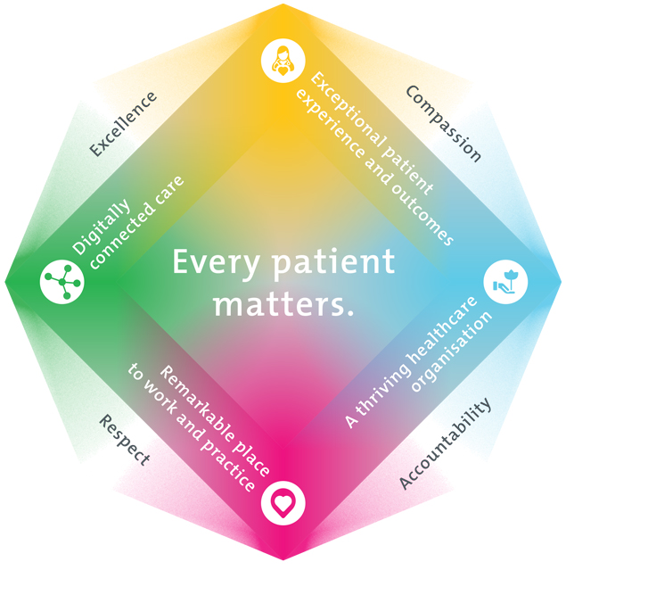
All roles are linked to the Epworth strategy and are fundamental in achieving its vision and purpose.
Exceptional patient experience and outcomes - To empower our patients and deliver compassionate, expert and coordinated care.
A thriving healthcare organisation - To adapt and grow in a changing healthcare landscape by delivering a unique private not-for-profit healthcare organisation.
Remarkable place to work and practice - To ensure Epworth is an outstanding place to work and practice through a culture of care
and investment in our people.
Digitally connected care - To innovate and improve the digital experience, interactions and outcomes for our patients, staff and doctors.
4. Purpose of the Position
To provide leadership, governance and ongoing development of CSSD within the strategic and operational domains. Ensuring safe, efficient and compliant service delivery of reusable medical devices and instrumentation to Epworth to support patient care and ensure positive clinical outcomes by effective use of human and fiscal resources and quality customer service. As a member of the senior management team the CSSD Manager interacts with other clinical support managers to lead the team demonstrating behaviors and attitudes that are consistent with Epworth Visions and Values.
5. Clinical Governance Framework
This role is required to put into practice the Clinical Governance Framework at Epworth as every employee is accountable for ensuring that our patients and community receive safe, high quality and person-centred care in every interaction with Epworth. This is achieved through active participation in the five domains of clinical governance at Epworth:

Clinical Governance Domain | Role
Leadership and culture | Promote and participate in a supportive, fair and transparent culture where lessons from previous outcomes are learned and patient safety and quality is a priority at all levels of the organisation.
Consumer Partnerships | Understand and where relevant, ensure that each patient is actively involved in their own care and treatment including families/carers wherever possible.
Effective Workforce | Develop and maintain one’s own competency, skills and knowledge to ensure high quality service provision and care.
Clinical Safety and Effectiveness | Understand and where relevant, ensure, that the right care is provided to the right person at the right time, in the right place and patient outcomes are monitored and improved.
Risk Management | Be responsible for identifying and reporting risks, hazards and near misses for people in our care and participating in risk mitigation strategies.

6. Key Accountabilities
KEY RESPONSIBILITIES | MEASURES/KPIs TO BE ACHIEVED
Leadership  Leads clinical, professional and operational services in delivery of services provided by the Central Sterilising Service:  - Leading and engaging the instrument technicians, nursing staff and support staff to achieve the delivery of agreed clinical services and outcomes  - Develops strong working relationships with Perioperative Nurse Managers creating a culture of collaboration  - Develops strong working relations with all Visiting Medical Officers  - Building multidisciplinary team function across Richmond’s central sterilising services  - Building and maintaining relationships with key internal and external stakeholders.  - Creating risk management capability in OH&S and Infection Control, including leading and implementing necessary health, safety and wellbeing strategies, plans and initiatives | Performs and is recognised as an effective leader in the following areas:  - Safe and contemporary delivery in the provision of central Sterilising Services  - Operational performance and resource management  - Business Development and Doctor Satisfaction  - Executive Support  - Ongoing investment in personal and professional development  - Research, Education and Training  - Strong and collaborative relationships with support services and other divisions
Operational Management  Ensures the efficient and effective use of human and financial resources to provide high quality service, financial stability, exceptional customer service and high staff satisfaction:  1. Finance  - Reviews annual departmental budgets alongside Perioperative business analyst  - Coaches and supports managers to meet budget targets, ensuring a balance between cost and service delivery  - Delivers timely financial reporting against budget to Director of Perioperative Services  - Manages minor capital expenditure in line with agreed budget  - Explores and implements strategies to reduce expenditure while maintaining safe and effective service delivery and service provision, including strategies to improve efficiencies in rostering and staffing models  - Human Resources  - Maintains a competency based performance management system for leaders and staff  - Undertakes monthly review, and response to, key KPI activity  - Ensures effective staff recruitment/retention, development and workforce planning based on matching staff skill mix with department requirements  - Builds future leadership capacity and capability through effective succession planning | - Labour hours targets are met  - Areas of responsibility perform within budget  - Capital expenditure is managed, ensuring purchases are prioritised and appropriately assessed  - High quality, skilled instrument technicians and nursing staff aligned to Epworth Values are recruited, and practice and behavioural standards are met/managed  - Clinical services workforce plan targets are achieved  - HR report card KPI’s are maintained within target  - Annual registered nurse registration and credentialing requirements are met  - Reliance on Agency resources is < 5%  - Staff Engagement plans area kept up to date and actioned  - Staff education and development programs are undertaken to address workforce and succession planning needs  - All staff meet mandatory training, CPD and professional registration requirements
Clinical Practice and Quality Improvement  Drives culture and actively improves the provision services within the central sterilising service and ensures compliance with Australian Standard 5369 and fosters a collaborative approach to evidence-based clinical practice that adheres to national standards of care:  - Seeks and maintains knowledge of the current trends and issues influencing the provision of central sterilising services at a local, State and National Level  - Works with the department team leaders and NUM and other members of the SLT to identify areas for improvement to influence changes to clinical practice  - Ensures compliance with infection prevention audits and maintains quality improvement action plans to address any Australian Standards conformance issues and performance improvement strategies  - Creates an environment of enquiry and questioning in the delivery of service provision  - Ensures the implementation and delivery of service within the National Safety and Quality Health Service (NSQHS) Standards. | - Clinical outcomes are in-line with external benchmarks  - Clinical practice conforms to professional and industry standards  - Leadership and direction of staff development programmes to include mandatory training as well as continuous professional development  - Adverse incidents, near misses and risks are monitored and analysed with appropriate corrective and preventative measures implemented  - Robust clinical audit programmes are implemented and monitored  - Clinical and operational policies and protocols are kept current and in line with industry best practice
Safety and Wellbeing  To ensure a safe workplace is provided for all employees and other personnel including contractors, agency staff, volunteers and students.  - All employees and other personnel under the authority of the manager are fully informed of the hazards associated with their work activities, adequately trained and instructed in safe work procedures and appropriately supervised. Participate actively and positively in the area of health and safety to reduce all hazards and incidents within the workplace  - Integrate and review OHS performance in staff PDPs  - Ensure all direct reports are held accountable for safety performance and actions | - Adhere to infection control/personal hygiene precautions  - Implement and adhere to Epworth OHS policies, protocols and safe work procedures  - Ensure all hazards, incidents and injuries are reported in Riskman within 24 hours  - Ensure all hazards, incidents and injuries are investigated and corrective actions implemented within agreed timeframes  - Mandatory training completed at agreed frequency
7. Position Requirements/Key Selection Criteria
COMPONENT
Qualifications | Essential  - Registered Nurse with Nursing and Midwifery Board of Australia Health Practitioners Agency (AHPRA)  - Post graduate qualification in Perioperative Nursing  - Understanding of Central Sterilising Services and governing standards Membership of appropriate professional bodies  Desirable  - Relevant post graduate qualification in nursing/leadership and management/business, or working towards one
Previous Experience | Essential  - Relevant post registration perioperative experience  - Experience in a senior nursing leadership role  - Clinical, quality, risk management and human resource experience
Required Knowledge & Skills | Essential Leadership and Interpersonal Skills  - Excellent interpersonal and leadership skills that inspire the trust and confidence required to lead and manage high performing teams and build strong relationships with key internal & external stakeholders  - Demonstrated ability to build strong relationships to work collaboratively with peers and the executive team, and to contribute to organisation-wide improvement and growth.  - Demonstrated capability for and focus on innovation through initiating and implementing improvements to service delivery, models of care, evidence based practice and practice development.  - Demonstrated resilience through maintaining equanimity and focus through challenging circumstances to drive positive outcomes  Commitment to high quality patient care and continuous improvement  - Evidence of a commitment to patient/customer service, clinical governance and quality improvement  - Positive role model to all levels of staff in terms of commitment to the delivery of high quality patient care.  - Knowledge and understanding of the National Accreditation and relevant Australian Standards.  HR and Business Acumen  - Experience in leadership roles with relevant clinical, human resource and financial management exposure  - Expertise in setting and managing budgets, including strong resource management skills to optimise outcomes within allocated resources / budgets  - Demonstrated ability to lead and support organisational change  - Experience in performance development and management  - Knowledge and understanding of Legislation, OH&S principles and relevant awards  - Knowledge and commitment to Acts, Agreements and Epworth HealthCare directions, policies, procedures and staff code of conduct
Personal Attributes & Values  All employees are expected to consistently work in accordance with Epworth’s values and behaviours  - Compassion  - Accountability  - Respect  - Excellence | Customer Focus  Strong customer focus to drive high quality service delivery to support care delivery  The ability to develop and maintain strong relationships with current and prospective doctors (in recognition that medical consultants are important Epworth HealthCare customers) and to strengthen their confidence that Epworth HealthCare is the service of choice for them and their patients.  Professional Development  - Committed to growing talent, building workforce capability and a future workforce pipeline including proactive recruitment and the coaching and developing of others  - Strong advocacy of self-development and personal and professional learning for self and others  - Committed to the professional development of staff

Document Control
Date Developed: | Date Last Reviewed: | Developed and Reviewed By (Position Title):
October 2025

8. Employee Position Declaration
I have read and understand the requirements and expectations of the above Position Description. I agree that I have the physical ability to fulfil the inherent physical requirements of the position, and accept my role in fulfilling the Key Accountabilities. I understand that the information and statements in this position description are intended to reflect a general overview of the responsibilities and are not to be interpreted as being all-inclusive.
Employee Signature:
Print Name: | Date:

