- General Information
Position Title: | Director – Epworth Eastern Growth Strategy
Division/Department: | Epworth Eastern
Position Reports to: | Executive General Manager Epworth Eastern
Enterprise/Individual Agreement: | Individual Agreement
Classification/Grade: | NA
Location: | Epworth Eastern
Employment Status: | Fixed Term Contract – 2 years
Key Relationships - internal and external | Eastern Executive team and Leadership teams  Epworth Group Executive  Eastern and broader Epworth VMOs  Business Development and Performance and Strategy team  Data and Analytics  Communications and Engagement  Projects and Change team
2. Overview of Epworth HealthCare
Epworth HealthCare is Victoria’s largest not-for-profit private health care group, renowned for excellence in diagnosis, treatment, care and rehabilitation. Epworth is an innovator in Australia’s health system, embracing the latest in evidence-based medicine to pioneer treatments and services for our patients.

Epworth’s values define our approach and our delivery. We pride ourselves on communicating our values and delivering on them in a real and meaningful way. Our Values are Compassion, Accountability, Respect and Excellence. More information can be found on the Epworth website.

Epworth’s purpose is Every Patient Matters.

Our Vision is Delivering another 100 years of exceptional healthcare and innovation to the Victorian community.
3. Epworth HealthCare Strategy
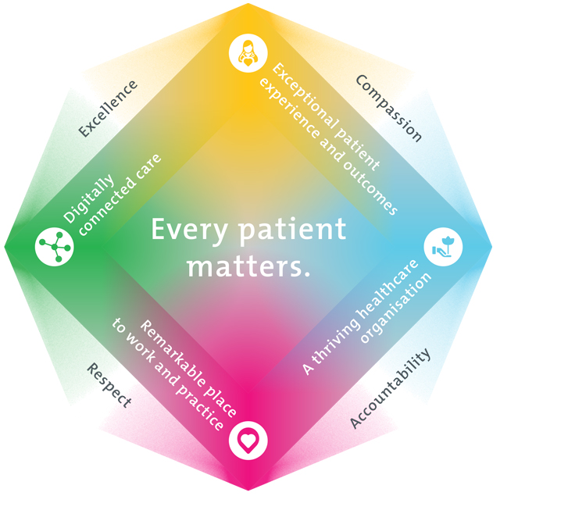
All roles are linked to the Epworth strategy and are fundamental in achieving its vision and purpose.
Exceptional patient experience and outcomes - To empower our patients and deliver compassionate, expert and coordinated care.
A thriving healthcare organisation - To adapt and grow in a changing healthcare landscape by delivering a unique private not-for-profit healthcare organisation.
Remarkable place to work and practice - To ensure Epworth is an outstanding place to work and practice through a culture of care
and investment in our people.
Digitally connected care - To innovate and improve the digital experience, interactions and outcomes for our patients, staff and doctors.
4. Purpose of the Position
The Director of Epworth Eastern Growth Strategy will lead on the development and execution of strategic plans and initiatives designed to accelerate the growth and expansion of services at Epworth Eastern. The Director will oversee a multi-stream work program that will contain initiatives that will work towards achieving key performance metrics.

The Director will be responsible for:
- Sequencing work to ensure that it is achievable by impacted parties and delivers the best value outcomes
- Working with stream leads to develop a work program with key milestones for delivery
- Govern the delivery of the work program through approved Epworth tools
- Building relationships to help enhance the delivery of the work program both with staff and VMOs
- Identifying the quantum and type of resources required to successfully deliver the work program
- Escalating any risks to delivery of the work program
- Design business models and proposals for approval by the Executive General Manager
- Provide reporting documents, business cases and briefing papers for Eastern Growth Strategy initiatives
5. Clinical Governance Framework
This role is required to put into practice the Clinical Governance Framework at Epworth as every employee is accountable for ensuring that our patients and community receive safe, high quality and person-centred care in every interaction with Epworth. This is achieved through active participation in the five domains of clinical governance at Epworth:

Clinical Governance Domain | Role
Leadership and culture | Promote and participate in a supportive, fair and transparent culture where lessons from previous outcomes are learned and patient safety and quality is a priority at all levels of the organisation.
Consumer Partnerships | Understand and where relevant, ensure that each patient is actively involved in their own care and treatment including families/carers wherever possible.
Effective Workforce | Develop and maintain one’s own competency, skills and knowledge to ensure high quality service provision and care.
Clinical Safety and Effectiveness | Understand and where relevant, ensure, that the right care is provided to the right person at the right time, in the right place and patient outcomes are monitored and improved.
Risk Management | Be responsible for identifying and reporting risks, hazards and near misses for people in our care and participating in risk mitigation strategies.
6. Key Accountabilities
KEY RESPONSIBILITIES | MEASURES/KPIs TO BE ACHIEVED
Strategic Leadership | Support the continued development and implementation of the Epworth Eastern Growth Strategy  Development of a comprehensive workplan that aligns to the Eastern Growth Strategy  Maintaining project plan and status reports.  Build dashboards and required reporting and business case development  Lead the creation, management and continuous improvement of projects and growth strategy initiatives
Operational Excellence | Develop and implement operational strategies and business plans to enhance service delivery, streamline processes, and improve service outcomes.  Lead the creation, management and continuous improvement of projects which will deliver sustainable change, transformational service redesign and significant cost improvement.
Performance Delivery Framework | Delivery of key performance milestones, outcomes and metrics  Agreed metrics are monitored on a regular basis  Agreed metrics are achieved  Formal reports and project status reports completed and submitted within expected timeframes  Projecting reporting and status updates reflected in Monday.com templates prior to relevant meetings.
Governance | Ensure that appropriate reporting, escalation and guidance is delivered to:  - Epworth Eastern Growth Strategy  - Project Review Committee  - Internal Epworth Eastern updates and communication  - Other reporting as required
Stakeholder Engagement | Build strong relationships with key clients, internal and external parties (including current and prospective VMOs) to ensure the successfully delivery of the program of work  Lead multidisciplinary working groups and work collaboratively with stakeholders  Effective communication and problem solving
Customer Service  Epworth is committed to the provision of excellent customer service to all of our people, customers and stakeholders including patients and external suppliers.  Superior patient service leads to improved healing in a trusting, caring environment and creates a safe environment for patients and employees.  - Role model and actively promote a culture of high quality patient care  - Provide excellent, helpful service to patients, visitors and staff  - Communicate with clear and unambiguous language in all interactions, tailored to the audience  - Build customer relationships and greet customers and patients promptly and courteously  - Actively seek to understand patients' and their family's expectations and issues, using multiple strategies  - Uses data (such as patient experience feedback) to identify opportunities for improvement in internal processes and systems that directly impact patient care and customer service  - Responds quickly and proactively escalate concerns when necessary  - Role model and actively promote a culture of high-quality patient care and experience by ensuring that solutions, practices and procedures (such as hourly rounding, leader rounding and bedside handover) are carried out with empathy and compassion | - Patient and customer service satisfaction surveys within agreed targets  - Use AIDET principles in all interactions  - Compliments to complaints ratios  - Completes leader rounding at agreed frequency  - Issues are escalated to the manager and resolved in a timely manner
Safety and Wellbeing  To ensure a safe workplace is provided for all employees and other personnel including contractors, agency staff, volunteers and students.  - All employees and other personnel under the authority of the manager are fully informed of the hazards associated with their work activities, adequately trained and instructed in safe work procedures and appropriately supervised. Participate actively and positively in the area of health and safety to reduce all hazards and incidents within the workplace  - Integrate and review OHS performance  - Ensure all direct reports are held accountable for safety performance and actions | - Adhere to infection control/personal hygiene precautions  - Implement and adhere to Epworth OHS policies, protocols and safe work procedures  - Ensure all hazards, incidents and injuries are reported in Riskman within 24 hours  - Ensure all hazards, incidents and injuries are investigated and corrective actions implemented within agreed timeframes  - Mandatory training completed at agreed frequency
7. Position Requirements/Key Selection Criteria
COMPONENT
Qualifications | Essential  - Tertiary qualification in health, business, project management or a related field  Desirable  - Health care qualification
Previous Experience | Essential  - Senior management leadership position in an Australian Hospital  - Proven senior experience with the delivery of major performance improvement initiatives and growth strategies  Desirable  - Project management experience in a non-hospital environment eg. commercial or other business environment  - Senior experience in a Private Hospital  - Hospital operational experience
Required Knowledge & Skills | Essential  - An in-depth understanding of the ways that hospitals work, their funding environment, their relationship with VMOs  - Excellent written and verbal communication skills  - Project management expertise  Desirable  - Business development insights and understanding
Personal Attributes & Values  All employees are expected to consistently work in accordance with Epworth’s values and behaviours  - Compassion  - Accountability  - Respect  - Excellence | Essential  - Strategic thinker, highly organised, influential  - Proven, well developed stakeholder engagement skills  - Self starter and strategic problem solver  - An ability to build excellent relations with a wide range of internal and external stakeholders.  - Strong verbal and numerical skills  - Behaviours align to Epworth values  Desirable  - Ability to tolerate ambiguity

Document Control
Date Developed: | Date Last Reviewed: | Developed and Reviewed By (Position Title):
27 November 2025 | 27 November 2025 | Group Director, Projects and Change (developed)  Executive General Manager Epworth Eastern (reviewed and updated)

8. Employee Position Declaration
I have read and understand the requirements and expectations of the above Position Description. I agree that I have the physical ability to fulfil the inherent physical requirements of the position, and accept my role in fulfilling the Key Accountabilities. I understand that the information and statements in this position description are intended to reflect a general overview of the responsibilities and are not to be interpreted as being all-inclusive.
Employee Signature:
Print Name: | Date:

