- General Information
Position Title: | Menu Monitor
Division/Department: | Support Services Department
Position Reports to: | Hospitality Services Operations Manager
Enterprise/Individual Agreement: | Epworth HealthCare Health and Allied Services Enterprise Agreement 2022
Classification/Grade: | FMO01 - FMO05
Location: | All Epworth Sites (As advertised in advert)
Employment Status: | Full time / Part time / Casual
Resource Management  (for Management positions only)  Number of Direct Reports:  Budget under management: | Nil  Nil
Key Relationships - internal and external | - Hospitality Services Operations Manager  - Food Services Supervisor  - Head Chef, Host, Food Services team  - Patients, inclusive of family member/s and visitors  - NUM, ANUM and Patient Care team, internal service providers i.e. Nursing and Ward Administration staff, Patient Transport  - Dieticians and Speech Pathologists
2. Overview of Epworth HealthCare
Epworth HealthCare is Victoria’s largest not-for-profit private health care group, renowned for excellence in diagnosis, treatment, care and rehabilitation. Epworth is an innovator in Australia’s health system, embracing the latest in evidence-based medicine to pioneer treatments and services for our patients.
Epworth’s values define our approach and our delivery. We pride ourselves on communicating our values and delivering on them in a real and meaningful way. Our Values are Compassion, Accountability, Respect and Excellence. More information can be found on the Epworth website.

Epworth’s purpose is Every Patient Matters.
Our Vision is Delivering another 100 years of exceptional healthcare and innovation to the Victorian community.

3. Epworth HealthCare Strategy
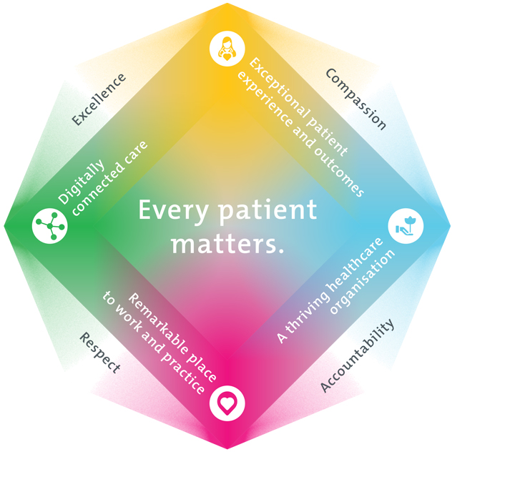
All roles are linked to the Epworth strategy and are fundamental in achieving its vision and purpose.
Exceptional patient experience and outcomes - To empower our patients and deliver compassionate, expert and coordinated care.
A thriving healthcare organisation - To adapt and grow in a changing healthcare landscape by delivering a unique private not-for-profit healthcare organisation.
Remarkable place to work and practice - To ensure Epworth is an outstanding place to work and practice through a culture of care
and investment in our people.
Digitally connected care - To innovate and improve the digital experience, interactions and outcomes for our patients, staff and doctors.
4. Purpose of the Position
The Menu Monitor is a front of house (FOH) role and compliments clinical care. Primarily this role will be responsible for ensuring that patient meal selection consists of adequate and appropriate food choices in accordance with patient dietary requirements. The Menu Monitor will work closely with the Dietetics and Speech Pathology teams to provide optimal nutrition status for patients. The menu monitor will utilise knowledge of nutrition and dietary requirements to assist Hosts with complex patient dietary needs. As an active member of the Food Services Team the Menu Monitor will build a community-based culture that fosters a spirit of achievement and capability development, which will ensure Epworth delivers excellence everywhere, every day. In particular this position will utilise available resources, assist hosts with promoting Point of Care to patients and families, and ensure a positive dining experience and hospital stay. This position will deliver best practice in high quality patient care and customer service in accordance with the physical, psychological, emotional, social and spiritual wellbeing of our patients to ensure they have an exceptional experience.
5. Clinical Governance Framework
This role is required to put into practice the Clinical Governance Framework at Epworth as every employee is accountable for ensuring that our patients and community receive safe, high quality and person-centred care in every interaction with Epworth. This is achieved through active participation in the five domains of clinical governance at Epworth:

Clinical Governance Domain | Role
Leadership and culture | Promote and participate in a supportive, fair and transparent culture where lessons from previous outcomes are learned and patient safety and quality is a priority at all levels of the organisation.
Consumer Partnerships | Understand and where relevant, ensure that each patient is actively involved in their own care and treatment including families/carers wherever possible.
Effective Workforce | Develop and maintain one’s own competency, skills and knowledge to ensure high quality service provision and care.
Clinical Safety and Effectiveness | Understand and where relevant, ensure, that the right care is provided to the right person at the right time, in the right place and patient outcomes are monitored and improved.
Risk Management | Be responsible for identifying and reporting risks, hazards and near misses for people in our care and participating in risk mitigation strategies.
6. Key Accountabilities
KEY RESPONSIBILITIES | MEASURES/KPIs TO BE ACHIEVED
Patient Care  - Encourage patients to select menu items from available options  - Assist with guiding patients through Point of Care for menu selections  - Report back to Head Chef and/or Chef in Charge all menu selections outside current menu for approval, prior to placing order  - Practice in accordance with food safety handling requirements, infection control standards, legislative and common law requirements  - Actively participate in patient care through superior patient focussed service  - Utilises a reflective, critical thinking approach to the provision of care to patients  - Timely reporting of patient concerns relating to food quality and services, to Head Chef and Supervisor  - Demonstrate a high-level understanding of therapeutic dietary requirements, food allergy management and prescribed diet codes  - Demonstrate empathy and compassion to patients and their family, colleagues and VMOs.  - Respect and uphold the dignity and rights of consumers, relatives, carers, colleagues and members of the community  - Maintain patient confidentiality as prescribed by the relevant Acts and organisational policies and protocols  - Transportation of patient food and beverages via equipment provided from Kitchen to Wards, departments and internal functions  - Demonstrate personal hygiene standards and work practices to deliver an exceptional customer experience  - Report all Food Safety non-compliances to Head Chef, and assist in taking corrective actions to mitigate risks to food safety  - Temperature checks as per Food Safety requirements  - Prepare Barista quality coffee in wards as required  - Work collaboratively with clinical staff to ensure patient safety  - Ensure clinical staff are given timely notification of meal orders if required  - Retrieve menu from complex patients requiring specialised assistance and in areas without POC.  - Track tray collection both manually and electronically  - Ensure areas without Point of Care are seen and that patients receive meals  - Use meal Ordering software to check for missing meals or patients who have not ordered  - Compliance with HACCP principles and Epworth’s Food Safety ISO 22000 – 2018 Plan at all times | - As required, Liaise and assist patients with Diet Selection, ensuring adequate and appropriate nutrition is achieved  - Assist Host to orientate the patient to meal selection through Point of Care  - Retrieve menus from patients in wards/units that do not have Point of Care.  - Compliance with mandatory and unit specific competencies every 12 months or as prescribed  - Compliance with food and/or beverage delivery and tray retrieval within organisation KPIs inclusive of main and mid-meal services  - Compliance with HACCP principles and Epworth’s Food Safety Plan (FSP) at all times  - Compliance with legislative and common law requirements  - Patient and customer service satisfaction surveys to be within organisational Compliance with Information Privacy Act (2000) and the Health Records Act (2000)  - Compliance with all Policies and Protocols of Epworth HealthCare  - Develop and maintain sound relationships with patients, family members, visitors, customers and other staff
Customer Service  Epworth is committed to the provision of excellent customer service to all of our people, customers and stakeholders including patients and external suppliers.  Superior patient service leads to improved healing in a trusting, caring environment and creates a safe environment for patients and employees.  - Provide excellent, helpful service to patients, visitors and staff  - Communicate with clear and unambiguous language in all interactions, tailored to the audience  - Build customer relationships and greet customers and patients promptly and courteously  - Actively seek to understand patients' and their family's (customers) expectations and issues | - Patient and customer service satisfaction surveys within agreed targets  - Use AIDET principles in all interactions  - Issues are escalated to the manager and resolved in a timely manner  - Deliver best practise in high quality patient care and customer service  - Build customer relationships and greet customers and patients promptly and courteously  - Actively seek to understand patients' and their family's circumstances, expectations and issues  - Proactively escalates concerns when necessary to ensure resolution of any current or potential breakdown in processes and systems that impact patient care and customer service  - Consistently meet or exceed the expectations of our patients and customers at all times  - Utilise exemplary communication skills to assist Patients, family members and visitors in the use of Point of Care as required  - Track tray collection both manually and electronically and within KPI targets
Team Work  - Works cooperatively and collaboratively with all members of the patient care team including Dieticians and Speech Pathologists  - Provides positive and constructive feedback to other team members  - When requested, actively participates as a member of the departmental team  - Assists all other Front of House staff as required  - Assist in the deployment of Menu Monitors to customers requiring assistance | - Attends and actively participates in department and team meetings  - Feedback from team members  - Prioritises tasks to achieve customer focused results  - When requested, attends daily ward huddles
Quality Improvement  - Strives to consistently improve service delivery and clinical practice  - Provides suggestions, and feedback to Supervisor and Head Chef on quality activities  - Actively participates in quality improvement activities within the unit or department in accordance with the National Standards for Clinical Excellence and ACHS Accreditation Standards | - Evidence of participation in quality activities  - Improved patient care  - Improvement in performance of department and Epworth HealthCare  - Show a proactive attitude in reviewing, supporting and implementing relevant initiatives into service improvements  - Shares knowledge openly
Personal and Professional Development  - Participates in prescribed performance development system annually  - Evaluates personal performance and plans self-development  - Participates in supervision and training of junior staff (where requested by Chef or Food Services Supervisor)  - Participates in the orientation of new and casual staff (where requested by Chef or Food Services Supervisor) | - Completion of annual performance appraisal  - Participation in in-services, department education and meetings  - Completion of objectives outlined in self-development plan (provide evidence of)  - Training of staff in relevant department specific activities (when requested by Head Chef or delegate)
Safety and Wellbeing  Participate actively and positively in the area of health and safety to reduce all hazards and incidents within the workplace  - Report all hazards, incidents, injuries and near misses immediately to your manager and log them in RiskMan | - Adhere to infection control/personal hygiene precautions  - Implement and adhere to Epworth OHS policies, protocols and safe work procedures  - Mandatory training completed at agreed frequency
7. Position Requirements/Key Selection Criteria
COMPONENT
Qualifications | Essential  - Food Handling Certificate or equivalent  Desirable  - Customer Service Qualification / Certificate  - Responsible Service of Alcohol  - Barista Coffee Certificate  - Certificate IV in Allied Health Assistance (Nutrition and Dietetics Specialisation)
Previous Experience | Essential  - Food service experience in a customer focused organisation  - Knowledge of Diet codes and nutritional therapeutic and dietary requirements  - Food Allergens  Desirable  - Private Hospital or Hotel sector-based experience
Required Knowledge & Skills | Essential  - Demonstrate understanding of principles of customer care  - Knowledge and commitment to Acts, Agreements and Epworth Healthcare directions, policies, procedures and staff code of conduct  - Commitment to the ACHS Accreditation Standards  - Time management and organisational skills  - Solid computer skills, including the use of WOW, Delegate Meal Ordering and Point of Care (POC) and Tray Tracking Application  - Sound & effective written, oral and verbal communication  - Full knowledge in all diets and able to assist, guide and recommend patients in decision making within their diet code and food menu choice  - Knowledge of Allergies  Desirable  - Demonstrate role model behaviour  - Complaint resolution skills
Personal Attributes & Values  All employees are expected to consistently work in accordance with Epworth’s values and behaviours  - Compassion  - Accountability  - Respect  - Excellence | Essential  - High standard of personal presentation  - Belief in patient centred care  - Committed to providing a safe environment for patients & colleagues  - Professional work ethic  - Practices within the ethos of the Epworth HealthCare Values & Behaviours  - Self-motivated and self-directed; able to anticipate customer needs and respond accordingly  - Ability to work autonomously and as part of a team  Desirable

Document Control
Date Developed: | Date Last Reviewed: | Developed and Reviewed By (Position Title):
February 2017 |  | Group Director of Hospitality Services & Hospitality Services Operations Manager/s

8. Employee Position Declaration
I have read and understand the requirements and expectations of the above Position Description. I agree that I have the physical ability to fulfil the inherent physical requirements of the position, and accept my role in fulfilling the Key Accountabilities. I understand that the information and statements in this position description are intended to reflect a general overview of the responsibilities and are not to be interpreted as being all-inclusive.
Employee Signature:
Print Name: | Date:

