- General Information
Position Title: | Group Director, Patient Services
Division/Department: | Freemasons
Position Reports to: | Executive General Manager Freemasons
Enterprise/Individual Agreement: | Individual Agreement
Classification/Grade: | N/A
Location: | Melbourne
Employment Status: | Full Time
Resource Management  Number of Direct Reports:  Budget under management: | Four  TBC
Key Relationships - internal and external | Direct and Indirect Reports: Patient Services Site Management Teams - Acute Hospitals and their direct reports  Colleagues: Director of Clinical Services, Director of Clinical and Maternity Services, Director of Medical Services, Finance Managers, Perioperative Services Managers, Director Digitise Program • Info Systems-Plan & Design  Works predominantly with: Executive General Manager; Hospital Executive Teams; Epworth Corporate Department leads  Responsible to: Group Executive and Epworth Board of Management
2. Overview of Epworth HealthCare
Epworth HealthCare is Victoria’s largest not-for-profit private health care group, renowned for excellence in diagnosis, treatment, care and rehabilitation. Epworth is an innovator in Australia’s health system, embracing the latest in evidence-based medicine to pioneer treatments and services for our patients.

Epworth’s values define our approach and our delivery. We pride ourselves on communicating our values and delivering on them in a real and meaningful way. Our Values are Compassion, Accountability, Respect and Excellence. More information can be found on the Epworth website.

Epworth’s purpose is Every Patient Matters. Our Vision is Delivering another 100 years of exceptional healthcare and innovation to the Victorian community.

3. Epworth HealthCare Strategy
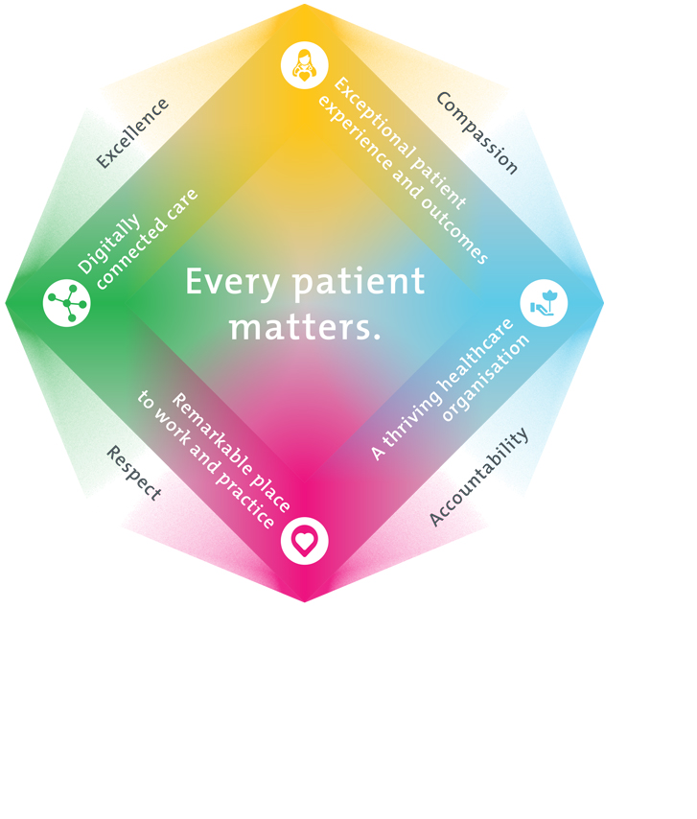
All roles are linked to the Epworth strategy and are fundamental in achieving its vision and purpose.
Exceptional patient experience and outcomes - To empower our patients and deliver compassionate, expert and coordinated care.
A thriving healthcare organisation - To adapt and grow in a changing healthcare landscape by delivering a unique private not-for-profit healthcare organisation.
Remarkable place to work and practice - To ensure Epworth is an outstanding place to work and practice through a culture of care
and investment in our people.
Digitally connected care - To innovate and improve the digital experience, interactions and outcomes for our patients, staff, and doctors.

4. Purpose of the Position
Reporting to the Executive General Manager Freemasons, the role provides leadership to the Patient Services Team throughout the organisation to ensure consistent, accurate, timely and valuable patient services across Epworth to support the strategic priority: Exceptional Patient Experience and Outcomes.
This critical position will work to achieve impactful business outcomes through:

- embedding a ‘One Epworth’ approach to Patient Services to enhance a collaborative, team oriented, integrated and future focused service delivering on our highest priorities in an efficient and effective way;

- working closely with Epworth’s Hospital Executive Teams to identify opportunities, plan for and provide initiatives and services across Epworth in a consistent and sustainable manner;

- building and strengthening productive relationships that promote collaboration across the broader Patient Services team and with other departments.

5. Clinical Governance Framework
This role is required to put into practice the Clinical Governance Framework at Epworth as every employee is accountable for ensuring that our patients and community receive safe, high quality and person-centred care in every interaction with Epworth. This is achieved through active participation in the five domains of clinical governance at Epworth:

Clinical Governance Domain | Role
Leadership and culture | Promote and participate in a supportive, fair, and transparent culture where lessons from previous outcomes are learned and patient safety and quality is a priority at all levels of the organisation.
Consumer Partnerships | Understand and where relevant, ensure that each patient is actively involved in their own care and treatment including families/carers wherever possible.
Effective Workforce | Develop and maintain one’s own competency, skills and knowledge to ensure high quality service provision and care.
Clinical Safety and Effectiveness | Understand and where relevant, ensure, that the right care is provided to the right person at the right time, in the right place and patient outcomes are monitored and improved.
Risk Management | Be responsible for identifying and reporting risks, hazards and near misses for people in our care and participating in risk mitigation strategies.

6. Key Accountabilities
KEY RESPONSIBILITIES | MEASURES/KPIs TO BE ACHIEVED
Patient Service Operations  - Ensure exceptional Patient Service teams delivering in line with operational and strategic priorities  - Implementation of efficient and innovative workforce models  - Work with digitised teams to develop and implement new service delivery models  - Drive and facilitate the delivery of initiatives to achieve agreed identified priorities  - Establish and implement KPIs and Targets for Patient Services  - Robust workforce plans are in place to ensure flexible and innovative service delivery | - Standardised customer service and governance model in place  - Patient Services operational and financial KPIs are within budget  - Patient Experience – Insync are above agreed benchmark for items relating to patient services  - Site and Group projects relating to Patient Services are completed to time and within agreed KPIs  - Workforce plans in place and achieving operational and strategic priorities  - Digitise Program KPIs - Customer Relationship Manager, Doctor App and Patient Interactions KPIs are met on time and to budget
Stakeholder engagement  - Provide clear and consistent communication to key stakeholder groups for specific initiatives ensuring awareness and transparency.  - Engage and consult with relevant parties across Epworth HealthCare to challenge the operational status quo.  - Identify and implement opportunities for system improvement across Epworth Patient Services  - Collaborating with Epworth senior leaders to appropriately manage initiatives and service delivery  - Establish and maintain strong working relationships with Hospital and Corporate Department leadership teams to identify and lead continuous improvement opportunities for the streamlining of the delivery of services. | - Updates provided to key stakeholders as per agreed schedule and format  - Papers written on time and to standard  - Change management is compliant with Epworth policies and legislative requirements
Customer Service  Epworth is committed to the provision of excellent customer service to all our people, customers and stakeholders including patients and external suppliers.  - Role model and actively promote a culture of high-quality customer service and patient care  - Ensure Patient Services team provides excellent, helpful service to patients, visitors, and staff  - Ensure policies and procedures for the Patient Services team are contemporary and are driving excellence in customer service reflecting strategic priorities  - Communicate with clear and unambiguous language in all interactions, tailored to the audience  - Build customer relationships internally and externally  - Uses data (such as patient experience feedback) to identify opportunities for improvement in Patient Services  - Responds quickly and proactively to escalated concerns | - Patient and customer service satisfaction surveys within agreed targets  - Compliments to complaints ratios  - Escalated Issues are resolved in a timely manner  - Policies and procedures are developed, reviewed and updated to agreed timelines  - Demonstrated reduction in patient complaints relating to Patient Services
Safety and Wellbeing  To ensure a safe workplace is provided for all employees and other personnel including contractors, agency staff, volunteers and students.  - All employees and other personnel under the authority of the manager are fully informed of the hazards associated with their work activities, adequately trained and instructed in safe work procedures and appropriately supervised. Participate actively and positively in the area of health and safety to reduce all hazards and incidents within the workplace  - Integrate and review OHS performance in staff PDPs  - Ensure all direct reports are held accountable for safety performance and actions  - Drive health and safety initiatives as part of the senior leadership group | - Adhere to infection control/personal hygiene precautions  - Implement and adhere to Epworth OHS policies, protocols and safe work procedures  - Ensure all hazards, incidents and injuries are reported in Riskman within 24 hours  - Ensure all hazards, incidents and injuries are investigated and corrective actions implemented within agreed timeframes  - Mandatory training completed at agreed frequency  - Regular communication and consultation with key Health and Wellbeing Group representatives  - LTIFR at or below agreed threshold  - Reduction in reported incidents and hazards across Patient Services team
Finance  - Ensure budget is managed effectively and meets/exceeds agreed outcomes  - Effective management of staff costs and reporting on all budget processes and outcomes. | - Patient Services budgetary and operational KPIs met/exceeded  - Key projects are delivered to budget  - Agreed savings identified and achieved
People  - Ensure site managers lead and facilitate effective team work across the Patient Services Team and through strong leadership and management of staffing, recruitment, retention and performance management.  - Model and lead a positive culture that builds a working environment in line with Epworth’s goal to be an employer of choice.  - Oversee the HR KPIs to ensure that target levels are achieved.  - Build workforce capability that ensures staff skills are maintained and developed to meet current and future service and clinical business needs.  - Management of industrial and employee relations matters in conjunction with People and Culture  - Ensure changes are managed in consultation with People and Culture and in accordance with change management obligations  - Ensure staff performance issues are managed and addressed in a timely manner and in accordance with internal policies and EA requirements.  - Adhering to Epworth industrial relations policies and procedures to reduce reputational risk and to comply with FairWork Act 2009. | - Workforce KPIs are achieved including recruitment, retention and performance management of staff, mandatory competencies are completed and Employee Engagement results show steady improvement  - Employee Engagement scores and feedback are improving  - Change management is compliant with Epworth policies and legislative requirements  - In consultation with People and Culture, all potential industrial relations issues and concerns are actioned in a timely manner in accordance with legislative requirements

7. Position Requirements/Key Selection Criteria
COMPONENT
Qualifications | Desirable  - A degree or diploma in healthcare management, business administration or related field.
Previous Experience | Essential  - Demonstrated ability to work in a matrix structure  - Extensive operational leadership of a large patient services team including budgetary management  - Leadership experience in a multisite hospital or healthcare setting.  - Relevant administration, financial, and people management experience  Desirable  - Understanding of health fund contracts  - Clinical data management and sound analytical skills  - Previous experience in a similar role
Required Knowledge & Skills | Essential  - Proven strength in influencing and negotiation skills  - Demonstrated knowledge of hospital operations, including patient care and support services.  - Exceptional leadership and people development experience and skills  - Achievement of identified deliverables in multiple major change initiatives  - Demonstrated positive and collaborative stakeholder engagement skills  - Excellent organisational, planning, coordination and analytical capability  - Strong communication skills- both written and verbal  - Demonstrated competency in all aspects of financial management  - Comfortable to challenge the status quo  - Collaborative leadership skills
Personal Attributes & Values  All employees are expected to consistently work in accordance with Epworth’s values and behaviours  - Compassion  - Accountability  - Respect  - Excellence | Essential  - Dynamic and strategic thinking leader, bringing a strong focus and alignment to outcomes and implementation.  - Excellent communication and stakeholder engagement skills, combined with exceptional leadership capability.  - Robust business acumen, a strong analytical mind and able to work collaboratively with a diverse group of stakeholders.  - Role model values driven leadership and commitment to people-centred care

Document Control
Date Developed: | Date Last Reviewed: | Developed and Reviewed By (Position Title):
June 2025 |  | Executive General Manager Freemasons

8. Employee Position Declaration
I have read and understand the requirements and expectations of the above Position Description. I agree that I have the physical ability to fulfil the inherent physical requirements of the position and accept my role in fulfilling the Key Accountabilities. I understand that the information and statements in this position description are intended to reflect a general overview of the responsibilities and are not to be interpreted as being all-inclusive.
Employee Signature:
Print Name: | Date:

