- General Information
Position Title: | Allied Health Assistant
Position Reports to: | Deputy Manager Physiotherapy; Senior Occupational Therapist
Enterprise/Individual Agreement: | Epworth Healthcare Health & Allied Services Enterprise Agreement
Classification/Grade: | Allied Health Assistant (AHA Grade 1 year 1 – AHA Grade 2 year 5)
Location: | Geelong
Employment Status: | Part time
Key Relationships - internal and external | • Patients and family members & visitors  • Multi-disciplinary team members  • External service providers and referrers
2. Overview of Epworth HealthCare
Epworth HealthCare is Victoria’s largest not-for-profit private health care group, renowned for excellence in diagnosis, treatment, care and rehabilitation. Epworth is an innovator in Australia’s health system, embracing the latest in evidence-based medicine to pioneer treatments and services for our patients.

Epworth’s values define our approach and our delivery. We pride ourselves on communicating our values and delivering on them in a real and meaningful way. Our Values are Compassion, Accountability, Respect and Excellence. More information can be found on the Epworth website.

Epworth’s purpose is Every Patient Matters.

Our Vision is Delivering another 100 years of exceptional healthcare and innovation to the Victorian community.

3. Epworth HealthCare Strategy
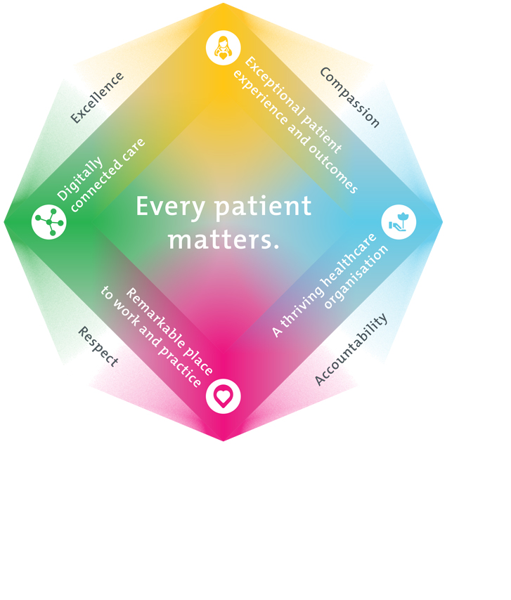
All roles are linked to the Epworth strategy and are fundamental in achieving its vision and purpose.
Exceptional patient experience and outcomes - To empower our patients and deliver compassionate, expert and coordinated care.
A thriving healthcare organisation - To adapt and grow in a changing healthcare landscape by delivering a unique private not-for-profit healthcare organisation.
Remarkable place to work and practice - To ensure Epworth is an outstanding place to work and practice through a culture of care
and investment in our people.
Digitally connected care - To innovate and improve the digital experience, interactions and outcomes for our patients, staff and doctors.
4. Purpose of the Position
To assist the Rehabilitation Department to provide optimal services and positive clinical outcomes to patients ensuring long-term health and wellbeing that is consistent with Epworth HealthCare's Vision and Values. Working within a multidisciplinary team, provide effective clinical, educational, emotional support and holistic best practice care to the patient and the family. Promote excellence to our customers and the marketplace and support colleagues by sharing knowledge and expertise.
5. Clinical Governance Framework
This role is required to put into practice the Clinical Governance Framework at Epworth as every employee is accountable for ensuring that our patients and community receive safe, high quality and person-centred care in every interaction with Epworth. This is achieved through active participation in the five domains of clinical governance at Epworth:

Clinical Governance Domain | Role
Leadership and culture | Promote and participate in a supportive, fair and transparent culture where lessons from previous outcomes are learned and patient safety and quality is a priority at all levels of the organisation.
Consumer Partnerships | Understand and where relevant, ensure that each patient is actively involved in their own care and treatment including families/carers wherever possible.
Effective Workforce | Develop and maintain one’s own competency, skills and knowledge to ensure high quality service provision and care.
Clinical Safety and Effectiveness | Understand and where relevant, ensure, that the right care is provided to the right person at the right time, in the right place and patient outcomes are monitored and improved.
Risk Management | Be responsible for identifying and reporting risks, hazards and near misses for people in our care and participating in risk mitigation strategies.
6. Key Accountabilities
KEY RESPONSIBILITIES | MEASURES/KPIs TO BE ACHIEVED
Clinical Care/Professional Practice  • Assist in the provision of allied health therapies to inpatients and outpatients in a group or individual setting  • Ensure optimal level of function and independence for all patients under direction from the Allied Health Professional  • Carry out referred treatment in relation to physical, cognitive, psychological needs to enable participation in the activities of everyday life  • Establish and maintain appropriate standards of practice relating to patient treatment, family liaison and associated administration  • Carry out treatment programs within the clinical area as directed by the Allied Health Professional, considering a patient centred model of care  • Demonstrate empathy and compassion and encourage patient and family members participation in all stages of care  • Practise within the scope of an Allied Health Assistant.  • Practise in accordance with the National Safety and Quality Health Services (NSQHS) Standards  • Implement reflective, critical thinking and evidence-based approach to the provision of patient care  • Maintain patient confidentiality as prescribed by the relevant acts and organizational policies and procedures  • Understand and implement Epworth HealthCare Policies and Procedures and departmental work place instructions  • Contribute to the development and maintenance of new and established clinical services  • Work in partnership with the manager and senior staff to review and update departmental guidelines, policies and procedures.  • Assist with program development and evaluation based on evidence. | - Appropriate standards of practice relating to treatments that are implemented in a timely manner by all staff in designated areas  - Compliance with mandatory and team-based documentation in patient’s medical record within agreed timeframes  - Direct patient care provided within allocated time frames from referral to treatment  - Timely intervention is provided to support the team in achieving patient’s length of stay goals  - Sound relationships are developed and maintained with patients, families and colleagues  - Patient satisfaction results meet organisational targets  - Compliance with NSQHS and clinical competencies  - Compliance with accepted professional standards and Code of Ethics  - Compliance with legislative and common law requirements including Privacy Act and Health Records Act  - Adherence to all Epworth Policies and Procedures
Customer Service  Epworth is committed to the provision of excellent customer service to all of our people, customers and stakeholders including patients and external suppliers.  Superior patient service leads to improved recovery in a trusting, caring environment and also creates a safe environment for patients and employees.  • Provide excellent, helpful service to patients, visitors and staff  • Communicate with clear and unambiguous language in all interactions, tailored to the audience  • Build customer relationships and greet customers and patients promptly and courteously  • Actively seek to understand patient’s and their family's expectations and issues | - Patient and customer service satisfaction surveys within agreed targets  - Patients are given the opportunity to actively participate in their  - treatment planning and implementation  - Use AIDET principles in all interactions  - Issues or concerns are proactively escalated to the Allied Health Professional when required, and resolved in a timely manner  - Patient compliments and complaints are recorded in Riskman  - Consistently meet or exceed the expectations of our patients and customers at all times  - Awareness of Epworth HealthCare's complaints process and assistance provided to patients if required  - Effectively handle and resolve patient complaints in accordance with Patient Complaint Protocol
Team Work /Communication  • Actively participate as a member of the department and multidisciplinary team and relevant committees  • Provide positive and constructive feedback to other team members  • Engage in an open, friendly and professionally supportive department  • Demonstrates ability to initiate discussions with supervisor regarding issues of concern  • Capacity to effectively manage issues through the line of accountability  • Capacity for effective negotiation and wide consultation at all levels, to maintain and foster key interpersonal relationships  • Identifies issues, considers solutions and presents these to the treating Allied Health Professional  • Understands and follows Epworth HealthCare and departmental channels of authority | - Collaborate effectively with all team members and external agencies for efficient, effective and caring patient management  - Attendance and active participation in departmental and multidisciplinary team meetings  - Positive feedback from team members indicating early resolution of issues  - Allied Helath Professional notified of issues in a timely manner
Continuous Quality Improvement  • Actively participate in quality activities ensuring opportunities for improvement are actively explored and best practice is achieved  • Regularly review administrative procedures, systems, and tasks, and take action to improve these in conjunction with the Physiotherapy department  • Assist in identifying, obtaining and updating department resources & equipment  • Assist development and implementation of departmental audits | - Evidence of participation in quality enhancement activities  - Quality projects are registered and completed within agreed time frame  - Evidence of improvement in patient satisfaction  - Demonstrated commitment to Australian Commission on Safety and Quality in Health Care, National Safety and Quality HealthCare Services (NSQHS) Standards.  - Departmental resources, equipment and educational information are cleaned, maintained, and updated completion of annual audits
Personal and Professional Development  • Participate in the ongoing professional development of self and colleagues by participating in both internal and external educational opportunities and supervision.  • Impart clinical or departmental knowledge through structured in-service programs, lectures and tutorials  • Actively participate in a Performance Development Plan annually  • Evaluate personal performance and plan self-development | - Participate in department meetings  - Participation in in-service and educational activities and events  - Completion of performance review and development plan
Safety and Wellbeing  To ensure a safe workplace is provided for all employees and other personnel including contractors, agency staff, volunteers and students.  - All employees and other personnel under the authority of the manager are fully informed of the hazards associated with their work activities, adequately trained and instructed in safe work procedures and appropriately supervised. Participate actively and positively in the area of health and safety to reduce all hazards and incidents within the workplace  - Integrate and review OHS performance in staff PDPs  - Ensure all direct reports are held accountable for safety performance and actions | - Adhere to infection control/personal hygiene precautions  - Implement and adhere to Epworth OHS policies, protocols and safe work procedures  - Ensure all hazards, incidents and injuries are reported in Riskman within 24 hours  - Ensure all hazards, incidents and injuries are investigated and corrective actions implemented within agreed timeframes  - Mandatory training completed at agreed frequency

7. Position Requirements/Key Selection Criteria
COMPONENT
Qualifications | Essential  - Certificate IV Allied Health Assistance qualification or equivalent is essential  Desirable  - N/A
Previous Experience | Essential  - N/A  Desirable  - Previous experience as an Allied Health Assistant, within rehabilitation or a hospital setting
Required Knowledge & Skills | Essential  - Demonstrate excellent verbal and written communication and presentation skills  - Demonstrated skill in working as a member of a team and liaising, collaborating and negotiating with other service providers and agencies, patient’s, their families and carers  - Innovative, proactive and creative attitude to problem solving  - Well-developed organisational skills  - Proven ability to interact and collaborate with all members of a multidisciplinary team  - Excellent computer literacy  - Knowledge and understanding of the National Standards and ACHS Accreditation Standards  - Appropriate knowledge of community resources and services  - Demonstrate customer service focus in service provision  - Demonstrates well developed skills in conflict resolution  - Ability to drive a motor vehicle and holds a full current driver’s licence  Desirable  - N/A
Personal Attributes & Values  All employees are expected to consistently work in accordance with Epworth’s values and behaviours  - Compassion  - Accountability  - Respect  - Excellence | Essential  • Belief in patient centred care  • Ability to work autonomously  • Sensitive to the psychosocial implications of illness  • Sensitive to cultural, racial and gender differences  • Helpful and professional manner  • Professional work ethic  • Practice within the ethos of the Epworth HealthCare Values and Behaviours  • Role model expected professional behaviours  • Flexibility to assist others within the department and across sites as required  • Self-motivated and self-directed  Desirable  • Flexible and available to be contacted for casual shifts for weekdays and/or weekends as required

Document Control
Date Developed: | Date Last Reviewed: | Developed and Reviewed By (Position Title): Katie Ward  Acting Deputy Physiotherapy Manager
October 2020 | September 2025 | Deputy Manager Physiotherapy and Allied Health Manager

8. Employee Position Declaration
I have read and understand the requirements and expectations of the above Position Description. I agree that I have the physical ability to fulfil the inherent physical requirements of the position, and accept my role in fulfilling the Key Accountabilities. I understand that the information and statements in this position description are intended to reflect a general overview of the responsibilities and are not to be interpreted as being all-inclusive.
Employee Signature:
Print Name: | Date:

