- General Information
Position Title: | Theatre Receptionist
Division/Department: | Epworth Freemasons Perioperative Services
Position Reports to: | Associate Director Perioperative Services & Health Clinics
Enterprise/Individual Agreement: | Epworth HealthCare Health and Allied Services Enterprise Agreement
Classification/Grade: | Receptionist (Business Office) (REC09)
Location: | Epworth Freemasons (Albert Street)
Employment Status: | Fixed Term Full Time
Resource Management  (For Management positions only)  Number of Direct Reports:  Budget under management: | N/A
Key Relationships - internal and external | - Business Manager, Perioperative Services and Critical Care  - Director of Perioperative Services & Perioperative Services Senior Leadership Team  - Perioperative Services Administration Team  - Epworth Richmond Perioperative Services Floor Coordinators and wider departmental team
2. Overview of Epworth HealthCare
Epworth HealthCare is Victoria’s largest not-for-profit private health care group, renowned for excellence in diagnosis, treatment, care, and rehabilitation. Epworth is an innovator in Australia’s health system, embracing the latest in evidence-based medicine to pioneer treatments and services for our patients.

Epworth’s values define our approach and our delivery. We pride ourselves on communicating our values and delivering on them in a real and meaningful way. Our Values are Compassion, Accountability, Respect and Excellence. More information can be found on the Epworth website.

Epworth’s purpose is Every Patient Matters.

Our Vision is Delivering another 100 years of exceptional healthcare and innovation to the Victorian community.

3. Epworth HealthCare Strategy
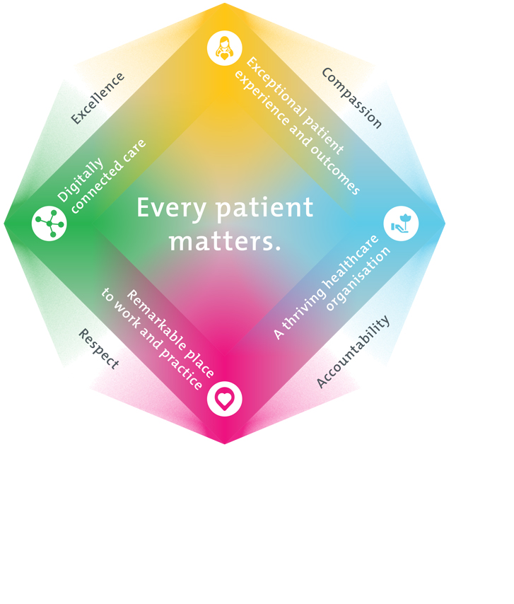
All roles are linked to the Epworth strategy and are fundamental in achieving its vision and purpose.
Exceptional patient experience and outcomes - To empower our patients and deliver compassionate, expert and coordinated care.
A thriving healthcare organisation - To adapt and grow in a changing healthcare landscape by delivering a unique private not-for-profit healthcare organisation.
Remarkable place to work and practice - To ensure Epworth is an outstanding place to work and practice through a culture of care
and investment in our people.
Digitally connected care - To innovate and improve the digital experience, interactions and outcomes for our patients, staff, and doctors.
4. Purpose of the Position
[Provide a brief overview and the main objective of the position]
5. Clinical Governance Framework
This role is required to put into practice the Clinical Governance Framework at Epworth as every employee is accountable for ensuring that our patients and community receive safe, high quality and person-centred care in every interaction with Epworth. This is achieved through active participation in the five domains of clinical governance at Epworth:

Clinical Governance Domain | Role
Leadership and culture | Promote and participate in a supportive, fair, and transparent culture where lessons from previous outcomes are learned and patient safety and quality is a priority at all levels of the organisation.
Consumer Partnerships | Understand and where relevant, ensure that each patient is actively involved in their own care and treatment including families/carers wherever possible.
Effective Workforce | Develop and maintain one’s own competency, skills, and knowledge to ensure high quality service provision and care.
Clinical Safety and Effectiveness | Understand and where relevant, ensure, that the right care is provided to the right person at the right time, in the right place and patient outcomes are monitored and improved.
Risk Management | Be responsible for identifying and reporting risks, hazards, and near misses for people in our care and participating in risk mitigation strategies.
6. Key Accountabilities
KEY RESPONSIBILITIES | MEASURES/KPIs TO BE ACHIEVED
Operational Requirements  - Meet and greet patients, third-party providers, answer phone calls and  - enquiries  - Demonstrates empathy and compassion to patients and their family,  - colleagues and VMOs - Respect and uphold the dignity and rights of  - consumers, relatives, carers, colleagues, and members of the community  - Support department with daily clerical/administrative tasks  - Carry out set administrative and basic financial tasks as directed.  - Maintain accurate departmental records.  - Managing correspondence internal / external (including mail)  - Maintain a neat and professional reception area.  - Assist the Business Manager to establish and maintain a departmental  - procedure manual  - Well-developed organisational skills with focus on customer care  - Establish and deliver on priorities and without direct supervision.  - Ordering of supplies from both internal stores & external parties  - Consistently facilitates the delivery of quality care and service.  - Maintain patient confidentiality as prescribed by the relevant policies.  - Awareness of maintenance requirements of office equipment  - Demonstrates behaviours in accordance with legislative and common law.  - requirements | - Patient and customer service satisfaction surveys to be within  - organisational targets  - Sound relationships developed and maintained with customers.  - Stock and supplies are maintained at agreed par levels.  - Accurate processing of patient bookings, details and maintaining  - other data in the Patient Management System (iPM) at all times  - Data entry of Count Sheet information into iPM and timely update of  - the Data Quality Tracker ready for handover in an efficient manner  - High quality administrative support to department by providing the  - Handover, Daily Add Ons, Allocations Forms and other documentation.  - as required.  - Clerical processing of invoices as well as data entry into CASCOM,  - Tech1, spreadsheet registers, Work Order Request system, My Roster  - as and when required.  - Liaising efficiently with all departments within the perioperative  - services as well as the whole hospital  - Undertake other duties as required by the Business Manager  - Demonstrates flexibility in the face of changing priorities & situations.  - Compliance with legislative and common law requirements
Teamwork  - Actively participates as a member of the team. | - Supports the Personal Assistant and Data Coordinator roles when.  - directed by the Business Manager  - Establishes positive relationships with colleagues.  - Contributes to the departmental efficiency by effective utilisation of  - time and resources  - Attends and actively participates in department and team meetings.  - Positively provides/receives constructive feedback to/from team.  - members
Quality Improvement  - Strives to consistently improve service delivery.  - Provides suggestions, and feedback on quality activities.  - Actively participates in quality improvement activities within the department | - Continued focus on customer service.  - Improvement in performance of unit and Epworth healthcare site  - Show a proactive attitude in reviewing, supporting, and implementing.  - customer-focused initiatives
Personal and Professional Development  - Participates in prescribed performance development system annually.  - Evaluates personal performance and plans self-development.  - Participates in the orientation of staff. | - Compliance with mandatory and department specific competencies  - every 12 months or as prescribed  - Completion of annual performance appraisal  - Completion of objectives outlined in self-development plan (provide  - evidence of)  - Training of staff in department specific activities as requested by the  - Business Manager
Customer Service  Epworth is committed to the provision of excellent customer service to all our people, customers and stakeholders including patients and external suppliers.  Superior patient service leads to improved healing in a trusting, caring environment and creates a safe environment for patients and employees.  - Role model and actively promote a culture of high-quality patient care.  - Provide excellent, helpful service to patients, visitors, and staff.  - Communicate with clear and unambiguous language in all interactions, tailored to the audience.  - Build customer relationships and greet customers and patients promptly and courteously.  - Actively seek to understand patients' and their family's expectations and issues, using multiple strategies  - Uses data (such as compliments, complaints, and Press Ganey) to identify breakdowns in internal processes and systems that directly impact patient care and customer service.  - Responds quickly and proactively escalate concerns when necessary.  - Role model and actively promote a culture of high-quality patient care and experience by ensuring that solutions, practices, and procedures (such as hourly rounding, leader rounding and bedside handover) are carried out with empathy and compassion | - Patient and customer service satisfaction surveys within agreed targets  - Use AIDET principles in all interactions.  - Compliments to complaints ratios  - Completes leader rounding at agreed frequency.  - Issues are escalated to the manager and resolved in a timely manner.
Safety and Wellbeing  To ensure a safe workplace is provided for all employees and other personnel including contractors, agency staff, volunteers, and students.  - All employees and other personnel under the authority of the manager are fully informed of the hazards associated with their work activities, adequately trained, and instructed in safe work procedures and appropriately supervised. Participate actively and positively in health and safety to reduce all hazards and incidents within the workplace.  - Integrate and review OHS performance in staff PDPs.  - Ensure all direct reports are held accountable for safety performance and actions | - Adhere to infection control/personal hygiene precautions.  - Implement and adhere to Epworth OHS policies, protocols, and safe work procedures.  - Ensure all hazards, incidents and injuries are reported in Riskman within 24 hours.  - Ensure all hazards, incidents and injuries are investigated and corrective actions implemented within agreed timeframes.  - Mandatory training completed at agreed frequency.
Customer Service  Epworth is committed to the provision of excellent customer service to all our people, customers and stakeholders including patients and external suppliers.  Superior patient service leads to improved healing in a trusting, caring environment and creates a safe environment for patients and employees.  - Provide excellent, helpful service to patients, visitors, and staff.  - Communicate with clear and unambiguous language in all interactions, tailored to the audience.  - Build customer relationships and greet customers and patients promptly and courteously.  - Actively seek to understand patients' and their family's (customers) expectations and issues | - Patient and customer service satisfaction surveys within agreed targets  - Use AIDET principles in all interactions.  - Issues are escalated to the manager and resolved in a timely manner.
Safety and Wellbeing  Participate actively and positively in health and safety to reduce all hazards and incidents within the workplace.  - Report all hazards, incidents, injuries, and near misses immediately to your manager and log them in RiskMan | - Adhere to infection control/personal hygiene precautions.  - Implement and adhere to Epworth OHS policies, protocols, and safe work procedures.  - Mandatory training completed at agreed frequency.
7. Position Requirements/Key Selection Criteria
COMPONENT
Qualifications | N/A
Previous Experience | Essential  - Experience within a similar role in the health care sector is advantageous.
Required Knowledge & Skills | Essential  - Excellent computer skills including all MS Office products and the ability to efficiently learn specialist programs used within the  - Department  - Relationship and people management skills  - Highly developed written and verbal communication skills  - Excellent time management, interpersonal and organisational skills
Personal Attributes & Values  All employees are expected to consistently work in accordance with Epworth’s values and behaviours.  - Compassion  - Accountability  - Respect  - Excellence | - Demonstrates responsibility for own professional development.  - Belief in patient-centred care  - Committed to providing a safe environment for patients & staff.  - Professional work ethic and presentation  - Strong customer focus  - Practices within the ethos of the Epworth HealthCare Values & Behaviours  - Self-motivated and self-directed  - High level of respect of all with a community focus

Document Control
Date Developed: | Date Last Reviewed: | Developed and Reviewed By (Position Title):
November 2016 | August 2023 | Business Manager, Perioperative Services & Critical Care

8. Employee Position Declaration
I have read and understand the requirements and expectations of the above Position Description. I agree that I have the physical ability to fulfil the inherent physical requirements of the position and accept my role in fulfilling the Key Accountabilities. I understand that the information and statements in this position description are intended to reflect a general overview of the responsibilities and are not to be interpreted as being all-inclusive.
Employee Signature:
Print Name: | Date:

