- General Information
Position Title: | Associate Nurse Unit Manager
Division/Department: | General Surgical
Position Reports to: | Nurse Unit Manager 5 East
Enterprise/Individual Agreement: | Epworth HealthCare Nurses and Midwives Enterprise Agreement
Classification/Grade: | ANUMY1
Location: | Epworth Geelong
Employment Status: | Part Time
Resource Management
(for Management positions only)
Number of Direct Reports:
Budget under management:
Key Relationships - internal and external | - Nurse Unit Manager  - Associate Director of Clinical Services  - Director of Clinical Services  - Nursing Staff and other ward unit staff (e.g. ward clerk, allied health, support services)  - Visiting Medical Officers (VMOs)  - Patients and families
2. Overview of Epworth HealthCare
Epworth HealthCare is Victoria’s largest not-for-profit private health care group, renowned for excellence in diagnosis, treatment, care and rehabilitation. Epworth is an innovator in Australia’s health system, embracing the latest in evidence-based medicine to pioneer treatments and services for our patients.

Epworth’s values define our approach and our delivery. We pride ourselves on communicating our values and delivering on them in a real and meaningful way. Our Values are Compassion, Accountability, Respect and Excellence. More information can be found on the Epworth website.

Epworth’s purpose is Every Patient Matters.
Our Vision is Delivering another 100 years of exceptional healthcare and innovation to the Victorian community.
3. Epworth HealthCare Strategy
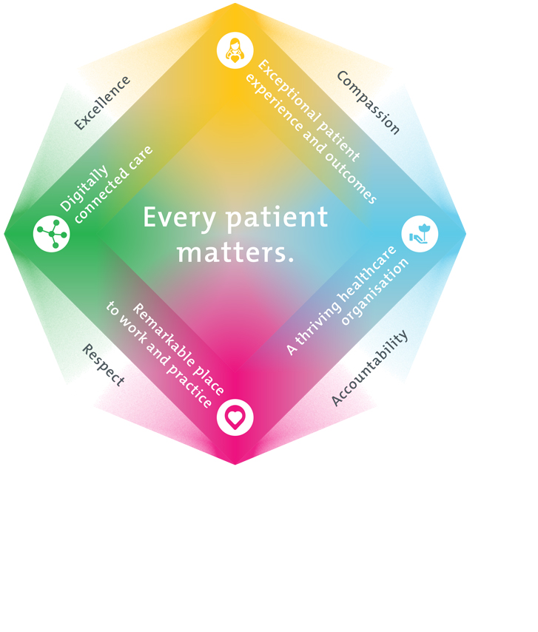
All roles are linked to the Epworth strategy and are fundamental in achieving its vision and purpose.
Exceptional patient experience and outcomes - To empower our patients and deliver compassionate, expert and coordinated care.
A thriving healthcare organisation - To adapt and grow in a changing healthcare landscape by delivering a unique private not-for-profit healthcare organisation.
Remarkable place to work and practice - To ensure Epworth is an outstanding place to work and practice through a culture of care
and investment in our people.
Digitally connected care - To innovate and improve the digital experience, interactions and outcomes for our patients, staff and doctors.
4. Purpose of the Position
The Associate Nurse Unit Manager (ANUM) is an integral member of the management team, assisting the Nurse Unit Manager in the course of their duties to ensure effective management and the ongoing development of the Unit from an operational perspective. This is achieved through effectively balancing and prioritising the core business activities of:

- Being a role model in setting the clinical standards to achieve a high quality of nursing care.
- Leading the team to deliver timely, safe, evidence-based patient-centred clinical care to patients at Epworth HealthCare achieving optimal clinical outcomes and an exceptional patient experience
- Supporting the NUM to build and maintain high performing teams that operate within a performance framework; to drive a culture of accountability, best practice and innovation
- Effective management of resources to optimise the quality, activity, and financial performance of the Unit
- Supporting the NUM with the maintenance of a safe clinical and operating environments to optimise safety and wellbeing of patients, visitors and staff
- Contributing to the ongoing development of Epworth HealthCare’s internal culture and external reputation through - Demonstrating behaviours and attitudes that are consistent with Epworth’s Vision and Values, and professional nursing philosophy - Building strong and trusting relationships with the multidisciplinary team, including highly effective doctor relationship management.
- The ANUM assumes the responsibilities and authority of the Nurse Unit Manager in their absence and as such must have a working knowledge of the administrative operation of the department.
5. Clinical Governance Framework
This role is required to put into practice the Clinical Governance Framework at Epworth as every employee is accountable for ensuring that our patients and community receive safe, high quality and person-centred care in every interaction with Epworth. This is achieved through active participation in the five domains of clinical governance at Epworth:

Clinical Governance Domain | Role
Leadership and culture | Promote and participate in a supportive, fair and transparent culture where lessons from previous outcomes are learned and patient safety and quality is a priority at all levels of the organisation.
Consumer Partnerships | Understand and where relevant, ensure that each patient is actively involved in their own care and treatment including families/carers wherever possible.
Effective Workforce | Develop and maintain one’s own competency, skills and knowledge to ensure high quality service provision and care.
Clinical Safety and Effectiveness | Understand and where relevant, ensure, that the right care is provided to the right person at the right time, in the right place and patient outcomes are monitored and improved.
Risk Management | Be responsible for identifying and reporting risks, hazards and near misses for people in our care and participating in risk mitigation strategies.
6. Key Accountabilities
KEY RESPONSIBILITIES | MEASURES/KPIs TO BE ACHIEVED
Streamlined and safe patient services within an optimal clinical environment  - Oversees the delivery of patient-centred care and implements strategies to enhance the patient experience and journey and their overall satisfaction with Epworth; ensuring this is coordinated through NUMs & other Senior Staff.  - Leads and coordinates the patient care team (includes the activities of medical, nursing, education, allied health and non-clinical support staff) to deliver high quality holistic patient centred care in a cost effective manner  - Undertakes leadership rounding  - Oversees the implementation and delivery of care within the National Safety and Quality Health Service (NSQHS) Standards.  Drives and actively improves on relevant models of care that fosters a collaborative approach to evidence-based practises.  - Uses information resulting from patient incidents/adverse events to identify areas for improvement to influence changes to clinical practice.  - Recognises the value of research in contributing to developments in nursing and improved standards of care, by participating in unit/hospital Quality Improvement/Research Activities | - Clinical Incident rate: % achievement of selected KPI that is relevant to unit (as measured on quality dashboard) at least to target
Leadership  Undertakes appropriate workforce planning to build and maintain a strong clinical team.  The ANUM supports the NUM to:  - Ensures the right level of seniority and skill mix in the ward/unit team  - Ensures that staff have access to appropriate resources and training required to maintain strong clinical skills and adhere to the safety/quality standards within the set budget  - Ensuring each staff member allocated to the ANUM has performance and personal development/management plans that set out work related goals, standards and behaviours (includes maintaining 100% compliance with mandatory and unit specific competencies every 12 months or as prescribed)  - Assists the NUM in actively managing the Performance Appraisal of staff and completes delegated PDP for unit staff.  - Creating a positive environment that enables good learning experiences for students on the unit  - Appropriate orientation is provided to new staff members as per Epworth Healthcare policies  - Participates in relevant committees, meetings and projects  Foster a culture of ongoing development and improvement  - Acts as a resource person/mentor to all nursing staff rotating within the unit  - Assists with informal and formal education sessions on the unit. • Supports enquiry and questioning in the delivery of clinical care  - Holds staff accountable for areas of responsibility and actions taken  - Completes patient and leader rounding as NUM delegate on weekends as per group policy  Active succession planning, identification and retention of talented staff  - In liaison with the Nurse Unit Manager develops and implements succession planning for nursing staff to ensure appropriate career pathways.  - Identifies talented junior staff, coaching and nurturing of staff to prepare them for advancement or promotion into ever more challenging roles  Portfolio Management  - Builds strong and trusting relationships with internal and external stakeholder to promote and maintain the reputation of the unit | - Staff development % of delegated staff have PDPs completed within scheduled timeframe
Access to Services  Monitors and co-ordinates patient flow in and out of the unit/ ward  - The facilitation of unit-based patient flow processes that maximise patients’ timely access to care  - develops and implements patient flow initiatives within the Unit • Effective allocation of patients to staff with appropriate skills  - Ensuring processes are in place to enable patients’ timely and effective discharge management LOS Management and review  - Facilitates processes for frequent review of LOS and Estimated Discharge Date Activity Management  - Understanding of daily requirements and forecasting activity to facilitate appropriate resource management  - In collaboration with the NUM team, identifies opportunity to achieve occupancy target | - Access 10am discharge rate at least target percentage OR Activity/LOS Management ALOS/minutes per procedure within agreed target
Operational Management
Develops strategies and actions to meet budget
- In the absence of the Nurse Unit Manager, provides management and clinical direction to all nursing staff
- In consultation with the NUM, reviews work practices to ensure cost effective management of both human and material resources
- In collaboration with the NUM, monitors and reviews the unit budget to meet agreed targets
Unit Business Planning
- Manages and monitors risks within area/s of responsibility and reports key/emerging risks and opportunities to NUM
Variance Analysis & Reporting
- Provides information in relation to variances against budget to the NUM

Customer Service  Epworth is committed to the provision of excellent customer service to all of our people, customers and stakeholders including patients and external suppliers.  Superior patient service leads to improved healing in a trusting, caring environment and creates a safe environment for patients and employees.  - Role model and actively promote a culture of high quality patient care  - Provide excellent, helpful service to patients, visitors and staff  - Communicate with clear and unambiguous language in all interactions, tailored to the audience  - Build customer relationships and greet customers and patients promptly and courteously  - Actively seek to understand patients' and their family's expectations and issues, using multiple strategies  - Uses data (such as patient experience feedback) to identify opportunities for improvement in internal processes and systems that directly impact patient care and customer service  - Responds quickly and proactively escalate concerns when necessary  - Role model and actively promote a culture of high-quality patient care and experience by ensuring that solutions, practices and procedures (such as hourly rounding, leader rounding and bedside handover) are carried out with empathy and compassion | - Patient and customer service satisfaction surveys within agreed targets  - Use AIDET principles in all interactions  - Compliments to complaints ratios  - Completes leader rounding at agreed frequency  - Issues are escalated to the manager and resolved in a timely manner
Safety and Wellbeing  To ensure a safe workplace is provided for all employees and other personnel including contractors, agency staff, volunteers and students.  - All employees and other personnel under the authority of the manager are fully informed of the hazards associated with their work activities, adequately trained and instructed in safe work procedures and appropriately supervised. Participate actively and positively in the area of health and safety to reduce all hazards and incidents within the workplace  - Integrate and review OHS performance in staff PDPs  - Ensure all direct reports are held accountable for safety performance and actions | - Adhere to infection control/personal hygiene precautions  - Implement and adhere to Epworth OHS policies, protocols and safe work procedures  - Ensure all hazards, incidents and injuries are reported in Riskman within 24 hours  - Ensure all hazards, incidents and injuries are investigated and corrective actions implemented within agreed timeframes  - Mandatory training completed at agreed frequency
7. Position Requirements/Key Selection Criteria
COMPONENT
Qualifications | Essential  - Registered Nurse or Midwife with Nursing and Midwifery Board of Australia Health Practitioner Regulation Agency (AHPRA  - Post graduate qualification in the area of specialisation
Previous Experience | Essential  - Relevant post registration clinical experience
Required Knowledge & Skills | Essential  Leadership and Interpersonal Skills  - Well developed interpersonal and leadership skills that inspire the trust and confidence required to lead and manage high performing teams and build strong relationships with patients, their families and key internal & external stakeholders  - Ability to build strong relationships to work collaboratively with NUM & peers  - Demonstrated capability for and focus on innovation through initiating and implementing improvements to service delivery, models of care, evidence based practice, and practice development  - Provide opportunities and support for the professional development the team  Clinical Expertise and commitment to high quality patient care and continuous improvement  - Evidence of a commitment to patient/customer service, clinical governance and quality improvement.  - Positive role model to all levels of staff in terms of commitment to the delivery of high quality patient care.  - Knowledge and understanding of the National Standards for Clinical Excellence and ACHS Accreditation Standards.  - Demonstrated clinical expertise in clinical advancements particularly in the speciality of the unit.  Leadership, HR and Business Acumen  - Demonstrated ability to lead, assist and support organisational change.  - Knowledge and understanding of Legislation, OH&S principles and relevant awards.  - Knowledge and commitment to Acts, Agreements and Epworth HealthCare directions, policies, procedures and staff code of conduct.  Marketing and Growth  - Committed to achieving a culture of success, assisting NUM to initiate any change management associated with success and growth of the department.  - Committed to building relationships with external and internal stakeholders to promote the Epworth HealthCare brand  Teaching and Research  - Demonstrated willingness to teach undergraduate & postgraduate nurses, other health professionals, patients, families and groups.  - Show a proactive attitude in reviewing, supporting and implementing relevant research into the clinical environment.  Broader Knowledge Base and Skills  - Computer literacy in Microsoft Applications.
Personal Attributes & Values  All employees are expected to consistently work in accordance with Epworth’s values and behaviours  - Compassion  - Accountability  - Respect  - Excellence | Essential  Customer Focus  - Strong customer focus to drive holistic person-centred care to patients and provide support to carers and families.  - Able to build strong and trusted relationships with medical consultants.  Professional Development  - Strong advocate of self-development and personal and professional learning for self and others in the Unit, facilitating a culture of continuous learning  - Committed to the professional development of nursing staff  - Creating a culture that values the contributions of nurses with regular leadership rounding of staff to ensure staff are fully engaged  - Committed to the coaching and developing of others
Document Control
Date Developed: | Date Last Reviewed: | Developed and Reviewed By (Position Title):
October 2015 | October 2025 | Executive Director Clinical Services & Nurse Unit Manager

8. Employee Position Declaration
I have read and understand the requirements and expectations of the above Position Description. I agree that I have the physical ability to fulfil the inherent physical requirements of the position, and accept my role in fulfilling the Key Accountabilities. I understand that the information and statements in this position description are intended to reflect a general overview of the responsibilities and are not to be interpreted as being all-inclusive.
Employee Signature:
Print Name: | Date:

