- General Information
Position Title: | Director of Emergency Services, Epworth Richmond
Division/Department: | Epworth Richmond / Emergency Department
Position Reports to: | Director Medical Services
Enterprise/Individual Agreement: | Individual Agreement
Classification/Grade: | NA
Location: | Epworth Richmond
Employment Status: | Full Time
Resource Management  (for Management positions only)  Number of Direct Reports: | 70-85 including Emergency Physicians, Doctors in Training, Career Medical Officers, Personal Assistant, Data Coordinator and others
Key Relationships - internal and external | Director of Medical Services, Epworth Richmond  Executive General Manager, Epworth Richmond  Chief Medical Officer, Epworth HealthCare  Deputy Chief Medical Officer / Medical Workforce & Deputy Chief Medical Officer / Academia  Director, Critical Care Clinical Institute  Critical Care Services Manager  Nurse Unit Manager, Emergency Department  Medical Director, Emergency Services, Epworth Geelong  ED medical, nursing and administrative staff  Senior Management Team, Epworth Richmond  Education & Research staff  Clinical Governance Manager

2. Overview of Epworth HealthCare
Epworth HealthCare is Victoria’s largest not-for-profit private health care group, renowned for excellence in diagnosis, treatment, care and rehabilitation. Epworth is an innovator in Australia’s health system, embracing the latest in evidence-based medicine to pioneer treatments and services for our patients.

Epworth’s values define our approach and our delivery. We pride ourselves on communicating our values and delivering on them in a real and meaningful way. Our Values are Compassion, Accountability, Respect and Excellence. More information can be found on the Epworth website.

Epworth’s purpose is Every Patient Matters. Our Vision is Delivering another 100 years of exceptional healthcare and innovation to the Victorian community.

3. Epworth HealthCare Strategy
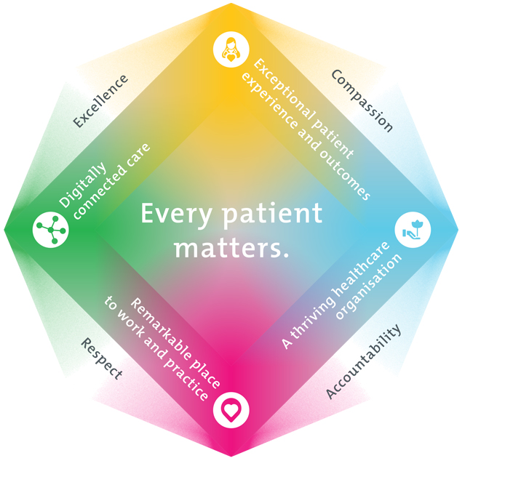
All roles are linked to the Epworth strategy and are fundamental in achieving its vision and purpose.
Exceptional patient experience and outcomes - To empower our patients and deliver compassionate, expert and coordinated care.
A thriving healthcare organisation - To adapt and grow in a changing healthcare landscape by delivering a unique private not-for-profit healthcare organisation.
Remarkable place to work and practice - To ensure Epworth is an outstanding place to work and practice through a culture of care
and investment in our people.
Digitally connected care - To innovate and improve the digital experience, interactions and outcomes for our patients, staff and doctors.

4. Purpose of the Position
The Director of Emergency, Epworth Richmond, will provide strong clinical and medical leadership, expertise and advice so that the highest quality care is delivered in Epworth Richmond ED. They will ensure effective clinical governance and compliance with legal and regulatory obligations. They will lead effective business planning and resource management within agreed budget and growth plans, including best customer service. They will support medical workforce planning and recruitment, credentialing, quality, safety and information systems, professional development, education and research within the Epworth Richmond Emergency Department.

Key Responsibilities
- Provide outstanding clinical leadership to ED medical and nursing teams
- Champion the highest quality of healthcare and patient safety, and work collaboratively to ensure integrated care is delivered across the hospital
- Provide accessible, responsive and innovative Emergency Services within Epworth Richmond
- Manage the resources of the ED to ensure optimal effectiveness, efficiency and continuing service improvement
- Develop and support the academic, research and education roles of the ED at undergraduate, postgraduate and advanced levels
- Build and maintain productive relationships with internal and external stakeholders and partners, locally, nationally and internationally
5. Clinical Governance Framework
This role is required to put into practice the Clinical Governance Framework at Epworth as every employee is accountable for ensuring that our patients and community receive safe, high quality and person-centred care in every interaction with Epworth. This is achieved through active participation in the five domains of clinical governance at Epworth:

Clinical Governance Domain | Role
Leadership and culture | Promote and participate in a supportive, fair and transparent culture where lessons from previous outcomes are learned and patient safety and quality is a priority at all levels of the organisation.
Consumer Partnerships | Understand and where relevant, ensure that each patient is actively involved in their own care and treatment including families/carers wherever possible.
Effective Workforce | Develop and maintain one’s own competency, skills and knowledge to ensure high quality service provision and care.
Clinical Safety and Effectiveness | Understand and where relevant, ensure, that the right care is provided to the right person at the right time, in the right place and patient outcomes are monitored and improved.
Risk Management | Be responsible for identifying and reporting risks, hazards and near misses for people in our care and participating in risk mitigation strategies.
6. Key Accountabilities
KEY RESPONSIBILITIES | MEASURES/KPIs TO BE ACHIEVED
Leadership  - Accountability for upholding, supporting and maintaining Epworth Healthcare’s Values and Behaviours  - Liaison with sub-speciality units and VMOs regarding their on-call support for the ED / service delivery to their patients  - Liaison with third parties to ensure appropriate level of service provided to the ED (diagnostic imaging, pathology, Ambulance Victoria)  - Collaborate with leaders of other health services (trauma, paediatrics, public Emergency Departments) to facilitate best care for all patients presenting to Epworth ED  - Support and inform the Director of Medical Services (DMS) and Richmond executive team, provide medical leadership and advice in key organisational meetings and forums  - Represent ED on Epworth Richmond Medical Advisory Committee (MAC), Epworth Critical Care Clinical Institute (CCCI), Richmond Clinical Governance Committee,  - Support specialist medical staff in undertaking continuing medical education (CME) and research programs  - Support the education and development of Doctors in Training, and ensure Epworth Richmond is undertaking best practice  - Support medical, nursing and allied health education and teaching roles within the ED  - Enforcement and support of ACEM accreditation (operational & training requirements)  - Enforcement and support of hospital accreditation process (ACHS, DOH) | - Regular meetings with senior ED staff regarding operational activity personnel, budget, education, complaints, quality etc  - Maintenance of departmental accreditation with ACEM on regular cycle  - Implementation and maintenance of Department of Health and ACHS recommendations and standards  - Representation of ED at Epworth Richmond at local and group leadership forums and events
Clinical Quality & Risk  - Clinical supervision of staff (junior and senior) within ED.  - Implement processes that minimise the rate of adverse events  - Investigate adverse events / clinical incidents and generate actions to prevent recurrence  - Ensure high quality clinical care is provided by Emergency Physicians, Advanced Trainees, CMOs, HMOs and NPs within the ED  - Provide advice on clinical issues relating to patients, staff, VMOs and risk management matters  - Oversee any departmental clinical audits as required  - Provide guidance and direction with policies and procedures pertinent to the ED | - Clinical incidents within the ED remain within appropriate benchmark levels  - All clinical incidents are appropriately reported in RiskMan within 24 hours;  - Attends “huddles” relating to ED clinical incidents  - Timely and collaborative response to patient and staff complaints with CCSM, NUM, PLO and ED clerical lead.  - Compliance with legislative and common law requirements  - Actively engages with Clinical Governance Manager and Quality Unit in quality improvement activities and to address matters relating to adverse events in ED  - Attends and participates in Richmond Clinical Governance Committee
Business Development  - Develop and oversee strategic initiatives to promote the ED outside the hospital  - Actively promote ED activities and availability for EHC staff and other hospital and VMOs  - Proactively work with hospital executives to explore options to continuously improve and enhance the operational success of the ED | - Achievement of annual ED activity targets  - Introduction of new processes or procedures that improve patient flow and enhance patient experience
Finance  - Provide advice regarding purchase or upgrade of equipment requirements and disposables  - Oversee and provide input into the ED budget including expenditure and income | - Achievement of budget targets  - Adherence to labour matrix and cost management strategies
Human Resources  - Provide a continuous roster to cover the ED with skilled and experienced senior medical staff  - Recruit skilled and experienced advanced ACEM trainees (registrars) to support the roster and continue fellowship training program as per accreditation requirements  - Participate in recruitment and appointment processes for senior positions within the ED staff  - Create a harmonious and positive working environment for ED staff  - Address and manage any doctor related performance issues in conjunction with People & Culture | - Medical recruitment and rostering needs of the department are met within budget / labour matrix  - Performance Development plans completed annually for each employee; monitoring of performance and feedback to be  - Staff engagement surveys indicate a high level of staff satisfaction
Customer Service  Epworth is committed to the provision of excellent customer service to all of our people, customers and stakeholders including patients and external suppliers.  Superior patient service leads to improved healing in a trusting, caring environment and creates a safe environment for patients and employees.  - Role model and actively promote a culture of high-quality patient care  - Provide excellent, helpful service to patients, visitors and staff  - Communicate with clear and unambiguous language in all interactions, tailored to the audience  - Build customer relationships and greet customers and patients promptly and courteously  - Actively seek to understand patients' and their family's expectations and issues, using multiple strategies  - Uses data (such as patient experience feedback) to identify opportunities for improvement in internal processes and systems that directly impact patient care and customer service  - Responds quickly and proactively escalate concerns when necessary  - Role model and actively promote a culture of high-quality patient care and experience by ensuring that solutions, practices and procedures (such as hourly rounding, leader rounding and bedside handover) are carried out with empathy and compassion | - Patient and customer service satisfaction surveys within agreed targets  - Use AIDET principles in all interactions  - Compliments to complaints ratios  - Completes leader rounding at agreed frequency  - Issues are escalated to the manager and resolved in a timely manner
Safety and Wellbeing  To ensure a safe workplace is provided for all employees and other personnel including contractors, agency staff, volunteers and students.  - All employees and other personnel under the authority of the manager are fully informed of the hazards associated with their work activities, adequately trained and instructed in safe work procedures and appropriately supervised. Participate actively and positively in the area of health and safety to reduce all hazards and incidents within the workplace  - Integrate and review OHS performance in staff PDPs  - Ensure all direct reports are held accountable for safety performance and actions | - Adhere to infection control/personal hygiene precautions  - Implement and adhere to Epworth OHS policies, protocols and safe work procedures  - Ensure all hazards, incidents and injuries are reported in RiskMan within 24 hours  - Ensure all hazards, incidents and injuries are investigated and corrective actions implemented within agreed timeframes  - Mandatory training completed at agreed frequency
7. Position Requirements/Key Selection Criteria
COMPONENT
Qualifications | Essential  - MBBS or equivalent  - Current specialist registration with Australian Health Practitioner Regulation Agency  - Fellowship of the Australasian College of Emergency Medicine (FACEM)  - Eligibility for unrestricted provider number  Desirable  - Post-graduate qualification in health administration / business management  - Post-graduate qualification in public health
Previous Experience | Essential  - Minimum 3 years post-specialist qualification  Desirable  - Experience within private Emergency Department
Required Knowledge & Skills | - Strong clinical knowledge in Emergency Medicine  - Capacity to represent Epworth Richmond in a constructive manner to all stakeholders  - Strong understanding of the service delivery models within the private sector  - Committed to the professional development of ED doctors and nursing staff  - Supports an environment of continuous learning and quality improvement  - Understands and capable of managing the budgets
Personal Attributes & Values  All employees are expected to consistently work in accordance with Epworth’s values and behaviours  - Compassion  - Accountability  - Respect  - Excellence | - Communicates effectively with all internal and external stakeholders  - Demonstrates effective and appropriate interpersonal skills  - Demonstrates a commitment to delivery of high-quality services  - Ability to work with a high degree of autonomy  - Open to new ideas and innovation  - Able to give and receive feedback in a supportive manner  - Ability to build and sustain effective and efficient teams  - A logical and practical thinker, capable of problem solving  - Highly motivated and comfortable working in a team environment  - Proactive and collaborative approach

Document Control
Date Developed: | Date Last Reviewed: 11.09.2025 | Developed and Reviewed By (Position Title):

8. Employee Position Declaration
I have read and understand the requirements and expectations of the above Position Description. I agree that I have the physical ability to fulfil the inherent physical requirements of the position, and accept my role in fulfilling the Key Accountabilities. I understand that the information and statements in this position description are intended to reflect a general overview of the responsibilities and are not to be interpreted as being all-inclusive.
Employee Signature:
Print Name: | Date:

