- General Information
Position Title: | Social Worker
Division/Department: | Epworth Geelong
Position Reports to: | Allied Health Manager
Enterprise/Individual Agreement: | Epworth Healthcare Health Professionals Enterprise Agreement
Classification/Grade: | Grade 1: HP12 – HP17
Location: | Geelong
Employment Status: | Casual
Resource Management  (for Management positions only)  Number of Direct Reports:  Budget under management: | N/A
Key Relationships - internal and external | Patients and family members & visitors  Multi-disciplinary team members and Nursing staff  Rehabilitation Consultants, Medical Staff & VMO’s  External service providers and referrers
2. Overview of Epworth HealthCare
Epworth HealthCare is Victoria’s largest not-for-profit private health care group, renowned for excellence in diagnosis, treatment, care and rehabilitation. Epworth is an innovator in Australia’s health system, embracing the latest in evidence-based medicine to pioneer treatments and services for our patients.

Epworth’s values define our approach and our delivery. We pride ourselves on communicating our values and delivering on them in a real and meaningful way. Our Values are Compassion, Accountability, Respect and Excellence. More information can be found on the Epworth website.

Epworth’s purpose is Every Patient Matters.

Our Vision is Delivering another 100 years of exceptional healthcare and innovation to the Victorian community.
3. Epworth HealthCare Strategy
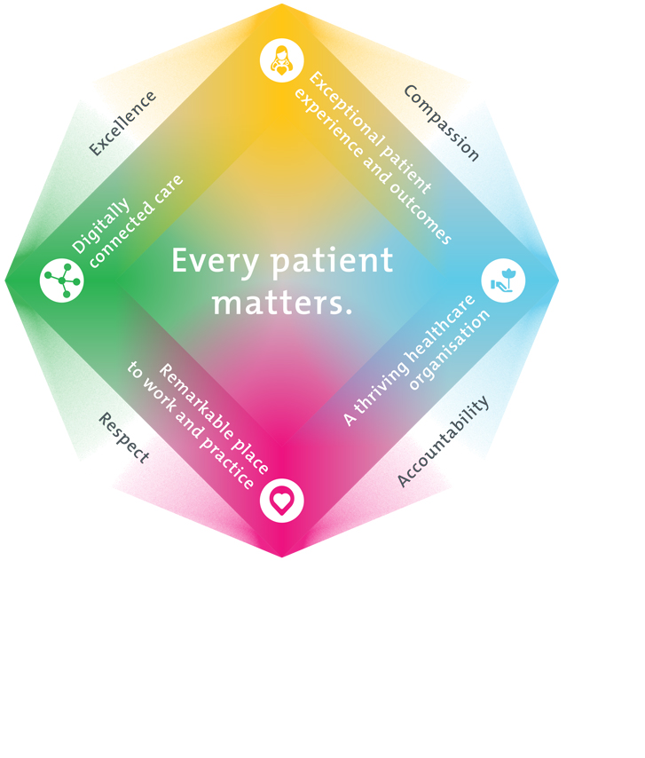
All roles are linked to the Epworth strategy and are fundamental in achieving its vision and purpose.
Exceptional patient experience and outcomes - To empower our patients and deliver compassionate, expert and coordinated care.
A thriving healthcare organisation - To adapt and grow in a changing healthcare landscape by delivering a unique private not-for-profit healthcare organisation.
Remarkable place to work and practice - To ensure Epworth is an outstanding place to work and practice through a culture of care
and investment in our people.
Digitally connected care - To innovate and improve the digital experience, interactions and outcomes for our patients, staff and doctors.
4. Purpose of the Position
To provide optimal social work services and positive clinical outcomes to patients ensuring long-term health and wellbeing that is consistent with Epworth HealthCare's Vision and Values. Working within a multidisciplinary team, provide effective clinical, educational, emotional support and holistic best practice care to the patient and the family. Promote excellence to our customers and the marketplace and support colleagues by sharing knowledge and expertise.
5. Clinical Governance Framework
This role is required to put into practice the Clinical Governance Framework at Epworth as every employee is accountable for ensuring that our patients and community receive safe, high quality and person-centred care in every interaction with Epworth. This is achieved through active participation in the five domains of clinical governance at Epworth:

Clinical Governance Domain | Role
Leadership and culture | Promote and participate in a supportive, fair and transparent culture where lessons from previous outcomes are learned and patient safety and quality is a priority at all levels of the organisation.
Consumer Partnerships | Understand and where relevant, ensure that each patient is actively involved in their own care and treatment including families/carers wherever possible.
Effective Workforce | Develop and maintain one’s own competency, skills and knowledge to ensure high quality service provision and care.
Clinical Safety and Effectiveness | Understand and where relevant, ensure, that the right care is provided to the right person at the right time, in the right place and patient outcomes are monitored and improved.
Risk Management | Be responsible for identifying and reporting risks, hazards and near misses for people in our care and participating in risk mitigation strategies.
6. Key Accountabilities
KEY RESPONSIBILITIES | MEASURES/KPIs TO BE ACHIEVED
Clinical Care/Professional Practice  - Ensure optimal level of function and independence for all patients in the clinical caseload by appropriate assessments and treatments, provided in both individual and group sessions  - Assess patient in relation to psychosocial aspects and their environment and determine appropriate interventions to address the life challenges and enhance their wellbeing  - Establish and maintain appropriate standards of practice relating to patient admission, assessment, treatment, family liaison and discharge planning  - Implement counselling services within the clinical area, using a patient centred evidence informed practice model of care  - Demonstrate empathy and compassion and encourage patient and family members participation in all stages of care  - Practise in accordance with the National Safety and Quality Health Services (NSQHS) Standards  - Maintain patient confidentiality as prescribed by the relevant acts and organizational policies and procedures  - Understand and implement Epworth HealthCare Policies and Procedures and departmental work place instructions  - Contribute to the development and maintenance of new and established clinical services within social work and the broader team | - Appropriate standards of practice relating to assessments and treatments are implemented in a timely manner  - Compliance with mandatory and team-based documentation in patients’ medical records within agreed timeframes  - Direct patient care is provided within 48 hours from referral/admission and within funding parameters  - Timely intervention is provided to support the team in achieving patients’ length of stay goals  - Sound relationships are developed and maintained with customers, family and colleagues  - Patient satisfaction results meet organisational targets  - Compliance with NSQHS and clinical competencies  - Compliance with accepted professional standards and Code of Ethics  - Compliance with legislative and common law requirements including Privacy Act and Health Records Act  - Adherence to all Epworth Policies and Procedures
Customer Service  Epworth is committed to the provision of excellent customer service to all of our people, customers and stakeholders including patients and external suppliers.  Superior patient service leads to improved healing in a trusting, caring environment and creates a safe environment for patients and employees.  - Provide excellent, helpful service to patients, visitors and staff  - Communicate with clear and unambiguous language in all interactions, tailored to the audience  - Build customer relationships and greet customers and patients promptly and courteously  - Actively seek to understand patients' and their family's (customers) expectations and issues | - Patient and customer service satisfaction surveys within agreed targets  - Use AIDET principles in all interactions  - Issues are escalated to the manager and resolved in a timely manner
Safety and Wellbeing  Participate actively and positively in the area of health and safety to reduce all hazards and incidents within the workplace  - Report all hazards, incidents, injuries and near misses immediately to your manager and log them in RiskMan | - Adhere to infection control/personal hygiene precautions  - Implement and adhere to Epworth OHS policies, protocols and safe work procedures  - Mandatory training completed at agreed frequency
Team Work /Communication  - Actively participate as a member of the department and multidisciplinary team  - Provide positive and constructive feedback to other team members | - Collaborate effectively with all other team members and external agencies for efficient patient management  - Attendance and active participation in departmental and multidisciplinary team meetings and relevant committees
Continuous Quality Improvement  - Actively participate in quality activities ensuring opportunities for improvement are actively explored and best practice is achieved  - Provide suggestions and feedback to consistently improve service delivery, clinical practice and patient satisfaction  - Promote and enhance Epworth HealthCare and the department’s positive image within the community | - Evidence of participation in quality enhancement activities  - Quality projects are completed within agreed time frame  - Demonstrated commitment to Australian Commission on Safety and Quality in Health Care, National Safety and Quality HealthCare Services (NSQHS) Standards  - Departmental resources, equipment and educational information are maintained and updated
Personal and Professional Development  - Participate in ongoing professional development by upgrading clinical competencies and knowledge and participating in both internal and external educational opportunities  - Actively participate in Performance Development Plan annually and evaluate personal performance and plan self-development  - Educate and support AHA staff and students as required  - Contribute to student development programs as directed | - Participation in Social Work Week  - Attendance in external professional development/educational forums  - Participation in in-service and education activities and events  - Completion of performance review and development plan
7. Position Requirements/Key Selection Criteria
COMPONENT
Qualifications | Essential  - Bachelor of Social Work or Masters of Social Work  - Eligibility for membership of the Australian Association of Social Worker (AASW)
Previous Experience | Desirable  - Relevant experience in a hospital, rehabilitation or community setting
Required Knowledge & Skills | Essential  - Sound theoretical knowledge of current social work practices, particularly in the areas of health and disability  - An understanding of relevant assessments and interventions  - Well-developed organisational and planning skills  - Ability to interact and collaborate with all members of a multidisciplinary team  - Good verbal and written communication and presentation skills  - Innovative, proactive and creative attitude to problem solving and formulate plans  - Excellent computer literacy including MS Office Word & Excel  - Knowledge and understanding of the National Standards and ACHS Accreditation Standards  - Customer service focus in service provision and evaluation  - Ability to drive a motor vehicle and holds a full current driver’s licence  Desirable  - Knowledge of the impact of injury and/or illness on psychosocial functioning and relationships  - Knowledge of relevant funding bodies  - Skills in conflict resolution and ability to manage challenging behaviour  - Knowledge of medico-legal and health and safety issues as they relate to health care  - Appropriate knowledge of community resources and services
Personal Attributes & Values  All employees are expected to consistently work in accordance with Epworth’s values and behaviours  - Respect  - Excellence  - Compassion  - Community  - Integrity  - Accountability | Essential  - Professional Development is regarded as a priority  - Ability to work autonomously  - Sensitive to the psychosocial implications of illness  - Sensitive to cultural, racial and gender differences  - Helpful and professional manner  - Flexibility to assist others within the department and across sites as required  Desirable  - Flexible and available to be on call and to work weekends as required

Document Control
Date Developed: | Date Last Reviewed: | Developed and Reviewed By (Position Title):
August 2016 | August 2025 | Human Resources & Allied Health Managers

8. Employee Position Declaration
I have read and understand the requirements and expectations of the above Position Description. I agree that I have the physical ability to fulfil the inherent physical requirements of the position, and accept my role in fulfilling the Key Accountabilities. I understand that the information and statements in this position description are intended to reflect a general overview of the responsibilities and are not to be interpreted as being all-inclusive.
Employee Signature:
Print Name: | Date:

