- General Information
Position Title: | Ward Clerk
Position Reports to: | Nurse Unit Manager
Enterprise/Individual Agreement: | Epworth HealthCare Health and Allied Services Enterprise Agreement
Classification/Grade: | Ward Clerk (WAS01 – WAS04)
Location: | Epworth Richmond
Employment Status: | Full Time Fixed Term
Resource Management
(for Management positions only)
Number of Direct Reports:
Budget under management:
Key Relationships - internal and external | - Nurse Unit Manager  - Central Resource Unit operational team  - Nursing Staff and all ward/unit staff (eg. allied health, support services, etc)  - Visiting Medical Officers (VMOs)  - Patients and families  - Any person who has cause or business to interact with the ward/unit
2. Overview of Epworth HealthCare
Epworth HealthCare is Victoria’s largest not-for-profit private health care group, renowned for excellence in diagnosis, treatment, care and rehabilitation. Epworth is an innovator in Australia’s health system, embracing the latest in evidence-based medicine to pioneer treatments and services for our patients.

Epworth’s values define our approach and our delivery. We pride ourselves on communicating our values and delivering on them in a real and meaningful way. Our Values are Compassion, Accountability, Respect and Excellence. More information can be found on the Epworth website.

Epworth’s purpose is Every Patient Matters.

Our Vision is Delivering another 100 years of exceptional healthcare and innovation to the Victorian community.
3. Epworth HealthCare Strategy
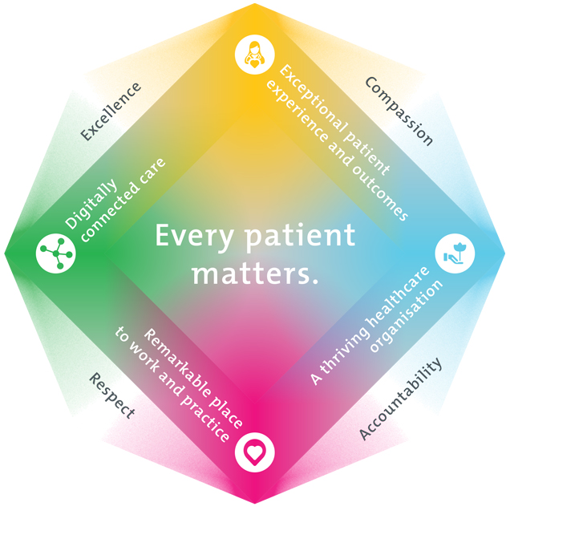
All roles are linked to the Epworth strategy and are fundamental in achieving its vision and purpose.
Exceptional patient experience and outcomes - To empower our patients and deliver compassionate, expert and coordinated care.
A thriving healthcare organisation - To adapt and grow in a changing healthcare landscape by delivering a unique private not-for-profit healthcare organisation.
Remarkable place to work and practice - To ensure Epworth is an outstanding place to work and practice through a culture of care
and investment in our people.
Digitally connected care - To innovate and improve the digital experience, interactions and outcomes for our patients, staff and doctors.
4. Purpose of the Position
Provide administrative support to ensure efficient ward operations and excellence in customer service to all patients, visitors, medical staff and unit staff. This position must maintain privacy and confidentiality at all times.
5. Clinical Governance Framework
This role is required to put into practice the Clinical Governance Framework at Epworth as every employee is accountable for ensuring that our patients and community receive safe, high quality and person-centred care in every interaction with Epworth. This is achieved through active participation in the five domains of clinical governance at Epworth:

Clinical Governance Domain | Role
Leadership and culture | Promote and participate in a supportive, fair and transparent culture where lessons from previous outcomes are learned and patient safety and quality is a priority at all levels of the organisation.
Consumer Partnerships | Understand and where relevant, ensure that each patient is actively involved in their own care and treatment including families/carers wherever possible.
Effective Workforce | Develop and maintain one’s own competency, skills and knowledge to ensure high quality service provision and care.
Clinical Safety and Effectiveness | Understand and where relevant, ensure, that the right care is provided to the right person at the right time, in the right place and patient outcomes are monitored and improved.
Risk Management | Be responsible for identifying and reporting risks, hazards and near misses for people in our care and participating in risk mitigation strategies.
6. Key Accountabilities
KEY RESPONSIBILITIES | MEASURES/KPIs TO BE ACHIEVED
Administrative and Operational Support Admission/Discharge Process  - Keep patient management system ‘live’ with timely and accurate management of admission, discharge and other patient details  - Patient Services Centre is notified of any patients directly admitted to Ward within 30 minutes  - Timely and effective communication with Patient Services Centre, Hospital Coordinators and Health Information Services  Record Administration  - Manage Medical Records in alignment with HIS requirements and policy  - Accurate and timely compilation of admission and discharge documentation, including ward care guides  - Filing of pathology in a timely manner  - Photocopy charts for patient transfer  Resource Management  - Effective monitoring of stock and supply, with a view to timely replenishment as required  - All Patient Transport Bookings to be made day before discharge, or as soon as discharge confirmed, and made at the most cost effective rate available  - Effective utilization of Epworth Healthcare IT programs relevant to the role (e.g. BOSSnet, Pathology, Imaging, Tech1 etc.)  - Coordinate the maintenance of biomedical and office equipment, with all broken equipment to be labeled and logged on Tech one within 2 hours  - Orientate patients to Point of Care (POC) and check details are all correct on arrival to the ward.  Leadership Support  - Timely and accurate preparation of relevant lists, phone and other reports for the area/department e.g. nursing handover reports  - Administrative Assistance to the Nurse Unit Manager  - Complete other duties as directed by the department manager | - 100% of all patient transport jobs completed using appropriate tools/technology available  - Medical Records compiled and returned to HIS within 24 hours of discharge  - Medical records for internal rehab transers to be compiled within 1 hour
Customer Service  Communication  - Carry out role in accordance with AIDET principles  - Provide timely response to enquiries and escalation of issues as appropriate  - Provide high-level customer service and communication to unit staff, medical staff, patients and visitors  - Acknowledge all visitors attending reception at time of arrival  - Timely communication to Allied health staff i.e. discharges  - Liaising with other departments for optimal bed flow management  Quality  - Enter all compliments into Riskman  - Actively work with the NUM and broader team to identify opportunities to improve and further enhance the experience of all customers to the unit | - 100% of telephone calls answered within fifteen seconds  - Patient Satisfaction results
Team Effectiveness Team development  - Establish positive relationships with colleagues  Role Model  - Respond to changing priorities and situations with flexibility and positivity  - Actively contribute to a positive work environment with colleagues  - Be a positive role model on the ward  - Mentor and orientate all new staff, students and doctors to the Ward, including new clerks | - Attendance at 90% of ward clerk forums, ward meetings and ‘huddles’.
Professional Development Mandatory Training  - Personal annual training maintained at all times  Continuous Improvement  - Identify and prioritise professional development, be responsible for own learning  - Management of designated work portfolios. | - Participation in at least 1 professional development program/annum
Safety and Wellbeing  Participate actively and positively in the area of health and safety to reduce all hazards and incidents within the workplace  - Report all hazards, incidents, injuries and near misses immediately to your manager and log them in RiskMan | - Adhere to infection control/personal hygiene precautions  - Implement and adhere to Epworth OHS policies, protocols and safe work procedures  - Mandatory training completed at agreed frequency

7. Position Requirements/Key Selection Criteria
COMPONENT
Qualifications | Not applicable
Previous Experience | Essential  - Relevant experience in an administrative role in healthcare setting.
Required Knowledge & Skills | Essential  - Medical terminology competence  - Well developed computer skills including knowledge of Microsoft Office suite and clinical patient management software  - Effective communication and interpersonal skills  - Competent administrative skills  - Effective problem solving skills  - Ability to work effectively without direct supervision
Personal Attributes & Values  All employees are expected to consistently work in accordance with Epworth’s values and behaviours  - Compassion  - Accountability  - Respect  - Excellence | Essential  - Customer Focus – strong customer focus to drive holistic person-centred care to patients and provide support to carers and families.  - Sets priorities and works effectively in a high pressure environment  - Participates in team based environment  - Committed to Epworth vision and values  - Committed to ongoing professional development and learning  - Committed to continuous quality improvement

Document Control
Date Developed: | Date Last Reviewed: | Developed and Reviewed By (Position Title):
December 2021

8. Employee Position Declaration
I have read and understand the requirements and expectations of the above Position Description. I agree that I have the physical ability to fulfil the inherent physical requirements of the position, and accept my role in fulfilling the Key Accountabilities. I understand that the information and statements in this position description are intended to reflect a general overview of the responsibilities and are not to be interpreted as being all-inclusive.
Employee Signature:
Print Name: | Date:

