General Information

Position Title: | Patient Revenue Officer – Support Services
Position Reports to: | Patient Revenue Team Leader Group Manager, HIS & Patient Revenue
Enterprise/Individual Agreement: | Health & Allied Services Enterprise Agreement
Classification/Grade: | Patient Revenue Officer (PROS1)
Key Relationships - internal and external | Internal stakeholders Third Party Providers External stakeholders
- Overview of Epworth HealthCare
Epworth HealthCare is Victoria’s largest not-for-profit private health care group, renowned for excellence in diagnosis, treatment, care and rehabilitation. Epworth
is an innovator in Australia’s health system, embracing the latest in evidence-based medicine to pioneer treatments and services for our patients.

Epworth’s values define our approach and our delivery. We pride ourselves on communicating our values and delivering on them in a real and meaningful way. Our Values are Compassion, Accountability, Respect and Excellence. More information can be found on the Epworth website.
Epworth’s purpose is Every Patient Matters.

Our Vision is Delivering another 100 years of exceptional healthcare and innovation to the Victorian community.

Epworth HealthCare Strategy
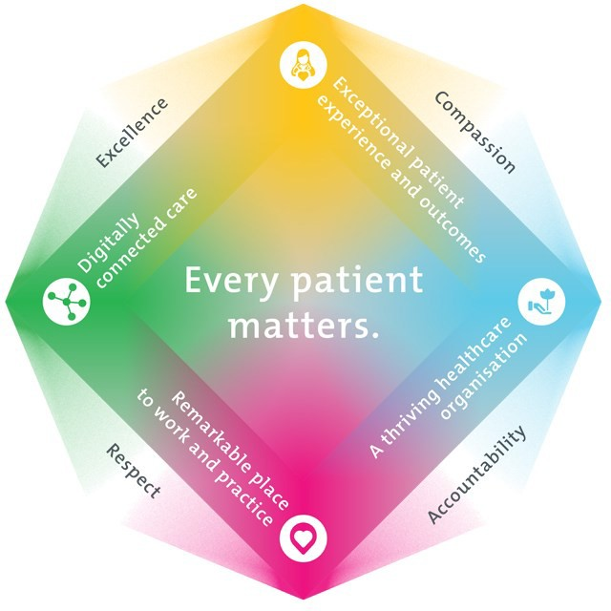

All roles are linked to the Epworth strategy and are fundamental in achieving its vision and purpose.
Exceptional patient experience and outcomes - To empower our patients and deliver compassionate, expert and coordinated care.
A thriving healthcare organisation - To adapt and grow in a changing healthcare landscape by delivering a unique private not-for-profit
healthcare organisation.
Remarkable place to work and practice - To ensure Epworth is an outstanding place to work and practice through a culture of care
and investment in our people.
Digitally connected care - To innovate and improve the digital experience, interactions and outcomes for our patients, staff and doctors.

- Purpose of the Position
The primary function of the Patient Revenue Officer (Support Services) is to support and assist the billing, credit and accounts receivable functions within the Patient Revenue Team. The Patient Revenue Officer (Support Services), under the direction and supervision of the Patient Revenue Team Leader & Group Manager HIS & Patient Revenue, will provide a high level of customer service to all patients, departments and insurers. Working within a team- based framework, the Patient Revenue Officer (Support Services) will contribute to the overall performance of the department / team and display Epworth’s Values & Behaviours on a daily basis.

Clinical Governance Framework
This role is required to put into practice the Clinical Governance Framework at Epworth as every employee is accountable for ensuring that our patients and community receive safe, high quality and person-centred care in every interaction with Epworth. This is achieved through active participation in the five domains of clinical governance at Epworth:

Clinical Governance Domain | Role
Leadership and culture | Promote and participate in a supportive, fair and transparent culture where lessons from previous outcomes are learned  and patient safety and quality is a priority at all levels of the organisation.
Consumer Partnerships | Understand and where relevant, ensure that each patient is actively involved in their own care and treatment including  families/carers wherever possible.
Effective Workforce | Develop and maintain one’s own competency, skills and knowledge to ensure high quality service provision and care.
Clinical Safety and Effectiveness | Understand and where relevant, ensure, that the right care is provided to the right person at the right time, in the right  place and patient outcomes are monitored and improved.
Risk Management | Be responsible for identifying and reporting risks, hazards and near misses for people in our care and participating in risk  mitigation strategies.

Key Accountabilities

KEY RESPONSIBILITIES | MEASURES/KPIs TO BE ACHIEVED
- Answer all telephone calls to the Patient Revenue department in a prompt and courteous manner.  - Respond and action all emails directed to the Group mailbox.  - Ensure all patient refunds are processed promptly and accurately.  - All manual accounts are collated, matched with correct documentation and mailed within 24 hrs.  - Accounts with missing signed claim forms are actioned with letter and claim form sent to patient.  - Completed certificates are marked “Received” in iPM and scanned  correctly into BOSSnet on the day they are received.  - Scanning of remittances into Sharepoint.  - Cheque refunds are allocated in iPM correctly and mailed to the patient in a timely manner.  - Requests for further clinical documentation from insurers is provided to Credit staff promptly as requested.  - All mail entering department is opened, sorted and distributed accordingly.  - Account adjustments are entered in iPM correctly.  - Patient debt is followed up via mail, phone call, and sms according to set timelines.  - Regular Liaison with Debt Collection Agency for aged debt where Page 4 of 7 all other avenues have been exhausted.  - Print patient invoices on a daily basis.  - Order department stationary as required | - Complete patient refunds within agreed KPI  - Accounts are collated and sent to patients / insurers within agreed KPI  - Certificates / Remittances are scanned into BOSSnet / Sharepoint within agreed KPI  - Patient debt is followed up and actioned within agreed KPIs
Customer Service  Epworth is committed to the provision of excellent customer service to all of our people, customers and stakeholders including patients and external suppliers. | - Patient and customer service satisfaction surveys within agreed targets  - Use AIDET principles in all interactions  - Issues are escalated to the manager and resolved in a timely manner

Superior patient service leads to improved healing in a trusting, caring environment and creates a safe environment for patients and employees.

- Provide excellent, helpful service to patients, visitors and staff
- Communicate with clear and unambiguous language in all interactions, tailored to the audience
- Build customer relationships and greet customers and patients promptly and courteously
- Actively seek to understand patients' and their family's (customers) expectations and issues
Safety and Wellbeing  Participate actively and positively in the area of health and safety to reduce all hazards and incidents within the workplace  - Report all hazards, incidents, injuries and near misses immediately to your manager and log them in RiskMan | - Adhere to infection control/personal hygiene precautions  - Implement and adhere to Epworth OHS policies, protocols and safe work procedures  - Mandatory training completed at agreed frequency
- Position Requirements/Key Selection Criteria

COMPONENT
Qualifications | - No formal qualification required
Previous Experience | Essential  - Customer service  - Administration  - Switchboard  Desirable  - HealthCare Sector

Required Knowledge & Skills | Essential  - Strong Computer skills  Desirable  - Knowledge of iPM
Personal Attributes & Values  All employees are expected to consistently work in accordance with Epworth’s values and behaviours  - Compassion  - Accountability  - Respect  - Excellence | Essential  - Belief in patient centred care  - Committed to providing a safe environment for patients & colleagues  - Professional work ethic  - Practices within the ethos of the Epworth HealthCare Values & Behaviours  Desirable  - Self-motivated and self-directed
Document Control
Date Developed: | Date Last Reviewed: | Developed and Reviewed By (Position Title):
February 2024 | May 2026

Employee Position Declaration
I have read and understand the requirements and expectations of the above Position Description. I agree that I have the physical ability to fulfil the inherent physical requirements of the position, and accept my role in fulfilling the Key Accountabilities. I understand that the information and statements in this position description are intended to reflect a general overview of the responsibilities and are not to be interpreted as being all-inclusive.

Employee Signature:
Print Name: | Date:

