- General Information
Position Title: | HIS Clerical Operations Manager – Richmond and Freemasons
Division/Department: | Epworth Corporate / Health Information Services
Position Reports to: | Group Manager Health Information Services and Patient Revenue
Enterprise/Individual Agreement: | Epworth Healthcare Allied Health Professionals Enterprise Agreement 2022
Classification/Grade: | In accordance with experience
Location: | Epworth Richmond
Employment Status: | Full Time
Resource Management  Number of Direct Reports:  Budget under management: | 31 staff (22.6 FTE)  $3m+
Key Relationships - internal and external | Working across Epworth sites (Richmond and Freemasons)  Group Manager, HIS and Patient Revenue, DMR Quality and Development Manager, HIS Site Managers, Coding Manager – Richmond and Group Operations  HIS Clerical staff, Health Information Managers/Clinical Coders, Medical Record Access Officers, Scanning Quality Officers, HIS Administration Officer, IT Clinical Informatics Team.
2. Overview of Epworth HealthCare
Epworth HealthCare is Victoria’s largest not-for-profit private health care group, renowned for excellence in diagnosis, treatment, care and rehabilitation. Epworth is an innovator in Australia’s health system, embracing the latest in evidence-based medicine to pioneer treatments and services for our patients.

Epworth’s values define our approach and our delivery. We pride ourselves on communicating our values and delivering on them in a real and meaningful way. Our Values are Respect, Excellence, Community, Compassion, Integrity and Accountability. More information can be found on the Epworth website.

Epworth’s purpose is Every Patient Matters. We strive to improve health outcomes and experience through compassion, collaboration, learning and Innovation. Our Vision is Caring for People. Innovating for a healthy community.

3. Epworth HealthCare Strategy
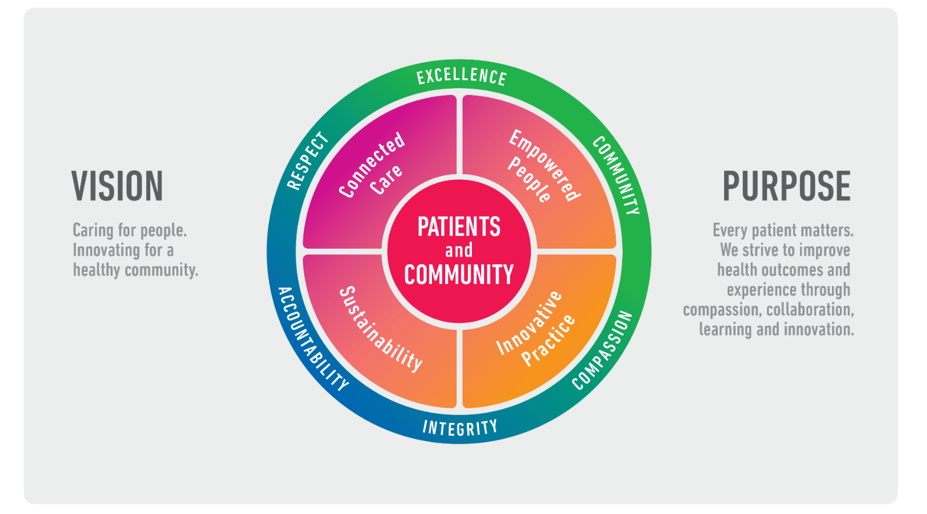
All roles are linked to the Epworth strategy and are fundamental in achieving its vision and purpose.
Connected Care – Partner with our patients through an integrated, holistic experience tailored to their needs and choices, enabling them to achieve their wellness potential
Empowered People – Enable and empower our people and teams to be their best and make a difference to the patient experience
Innovative Practice – Make a difference to our community through encouraging the ideas of our people and finding new and better ways to care and support care delivery
Sustainability – Be accountable to use resources wisely; to ensure organisational sustainability, enhance access, support the patient journey and create greater capacity for care.
4. Purpose of the Position
To coordinate, oversee and manage a number of functions within the Health Information Service department including managing the scanned medical record service across 2 sites (Richmond and Freemasons), oversight and management of the Medical Record Access (MRA) function, and management of the HIS Administration Officer, appropriate management of duplicate URs, privacy breaches, and coordination of public in private contract work relevant to medical records. The purpose of the role is to ensure that the various functions operate efficiently and effectively, and in accordance with legislative requirements, ensuring that medical are available digitally in a timely manner for continuity of care and are of high quality to support optimised clinical coding.
- Staff management and leadership of HIS scanning, clerical and administrative staff at Richmond and Freemasons, including effective rostering, leave management and leave coverage
- Manage the day to day scanning operations / clerical processes across Epworth Richmond and Freemasons to ensure a complete patient record
- Ensure individual monthly/daily scanning KPIs are achieved and maintained by all staff
- Effective recruitment, coordination and training of HIS scanning and clerical staff, Medical Record Access Officers, and HIS Admin Officer
- Liaise with the Epworth HIS Site Managers to ensure HIS department priorities are met
- Follow up missing documentation or incomplete documentation in a timely manner to support continuity of care and coding optimisation, and follow appropriate process in relation to documentation where admissions are identified to be missing.
- Manage and oversee the Medical Record Access (MRA) service including the MedicoLegal database, review and updating of the information, medical record access request form, reviewing, determining and updating the applicable fees associated with access in accordance with the Health Records Act.
- Review and management of more complex requests received for patient health records, including assessing the validity of authority provided with requests, and liaising with Legal Counsel where required for advice
- Facilitate and coordinate correction of records where appropriate where such requests are made in accordance with the Health Records Act
- Manage and coordinate medical record compliance requirements for all public in private contracts including but not limited to Alfred Health, Eastern Health, Northern Health, Austin Health, Western Health, Melbourne Health and Peter MacCallum, ensuring medical records are scanned as a priority and returned to the contracted health service within a timely manner
- Manage duplicate UR merges appropriately and in a timely manner
- Run report to review potential breaches of patient medical records and appropriately escalate to People and Culture where breach suspected
- Highlight opportunities for automation and digitation to streamline clerical processes in Health Information Services. Work with Epworth IT and external product vendors to implement such initiatives
- Working with the HIS management team to develop and streamline clerical processes group-wide
- Communication / provision of training to Nurse Unit Managers and Ward Clerks to ensure complete documents are returned to HIS in a timely fashion.
- Liaison / Training of Unit Receptionists, Business Office Staff, Allied Health Staff, and Clinical Staff on HIS/organisation expectations, practices, and processes
- Management of departmental budget to ensure efficiency and achieve an annual surplus
- Planning and participation in Quality activities to facilitate Accreditation requirements at both departmental and organisational level
- Revising and drafting of organisational policies and protocols relating to Privacy and Confidentiality and Medical Records Management on a cyclic basis
- Oversee the maintenance of historic Medical Record/Admissions storage in primary and secondary storage and destruction.
- Oversee the destruction of scanned medical records on a cyclic basis.
- Attendance to meetings where a representative from the HIS department is required
- Participating in Epworth’s move towards digital health solutions for both our patients and doctors.
- Other responsibilities as directed

5. Key Accountabilities
KEY RESPONSIBILITIES | MEASURES/KPIs TO BE ACHIEVED
Leadership and Management  Build and maintain relationships with internal and external stakeholders including Epworth staff, other hospitals/organisations, universities, government departments, international organisations and the wider community.  Monthly monitoring of expenditure and efficient rostering of staff on a day-to-day basis to meet the needs of the department/organisation.  Regular feedback to staff regarding individual and departmental performance through annual PDPs, quarterly catch ups, monthly feedback (i.e EOM results, Scanning Quality Feedback and throughput statistics).  Solution oriented approach to wide range of queries and activities. | - A budget surplus is achieved each financial year  - Clerical KPIs are achieved on an ongoing basis  - Maintain positive staff engagement survey results
Scanning  Daily monitoring of WIP to ensure even throughput of scanning to maintain revenue throughout the month.  Balancing scanning requirements across multiple campuses to ensure business needs are met. | - Scanning throughput & accuracy KPIs are achieved.
Process Review, Automation and Digitisation  Ongoing review of HIS Clerical processes to determine opportunities for automation to assist current workflow.  Ensure HIS Clerical process support the core function of HIS and update, amend or create as required. | - Delivery of projects deemed beneficial by Epworth HIS  - Streamlined processes and removal of manual tasks
Medical Record Access (MRA) Service  Ensure all requests received by Epworth are managed in a timely manner in accordance within legislated timeframes (as per Health Records Act).  Manage and coordinate any requests for correction of Health Records in accordance with legislation.  Maintain and update as required, the MedicoLegal database, template letters and spreadsheets to manage all requests effectively.  Review and update the Medical Record Access information and application form annually and amend fees applicable in accordance with fee units.  Liaise and respond to complaints made in relation to Medical Record Access, to the Health Complaints Commissioner where required.  Appropriately manage more complex requests escalated to assess authority, legislation or other relevant information, and liaise with Legal Counsel where required.  Ensure duplicate URs are assessed and actioned in a timely manner.  Review potential breaches of access to medical records and report as required.  Seek to locate and upload Medical Cause of Death certificates as requested.  Meet weekly with the MRA team to discuss items to be actioned, or escalated. | - Medical Record Access requests received are responded to within the legislated timeframes in accordance with the Health Records Act.  - Ensure any requests for correction of medical records are reviewed and responded to in accordance with the Health Records Act.  - Ensure all subpoenas, court orders, coroner’s requests, warrants etc, are provided for by the specified production date.
Public in Private (PIP) Contractual Agreements  Manage and coordinate PIP contractual arrangements relating to medical records including ensuring the report is run on a daily basis to ascertain any patients admitted under contractual arrangements for scanning prioritisation.  Ensure records are sent to the public health service within the timeframe documented within each of the contracts.  Attend meetings with relevant public health services regularly to discuss any matters or issues relating to sharing of patient notes.  Implement and review processes as necessary to ensure ongoing compliance in relation to contractual work and the sending of medical records. | - Ensure contractual obligations are met in relation to all public in private patients and medical records sent to the respective public hospital in accordance with relevant contract timeframe.
Manage HIS Administration Officer  Manage and oversee tasks and activities of the HIS Administration Officer including;  - Follow up of admissions unreturned from ward, deficient admissions missing documentation, or similar.  - Coordinate issues with the registering of visits, attendances and admissions on the Patient Administration System with relevant staff.  - Meet with HIS Administration Officer weekly to review outstanding work and escalate where required. | - Deficiencies identified with patient medical records, or with Patient Administration System in relation to missing episodes of care are raised with relevant parties in a timely manner for rectification.
Quality Improvement  Active participation in the Australian Council of Healthcare Standards (ACHS) accreditation process.  Maintain confidentiality of information in compliance with the Privacy Act/s.  Participation/organisation of key quality initiatives. | - ACHS accreditation maintained
Customer Service – Manager  Epworth is committed to the provision of excellent customer service to all of our people, customers and stakeholders including patients and external suppliers.  Superior patient service leads to improved healing in a trusting, caring environment and creates a safe environment for patients and employees.  - Role model and actively promote a culture of high quality patient care  - Provide excellent, helpful service to patients, visitors and staff  - Communicate with clear and unambiguous language in all interactions, tailored to the audience  - Build customer relationships and greet customers and patients promptly and courteously  - Actively seek to understand patients' and their family's expectations and issues, using multiple strategies  - Uses data (such as compliments, complaints and patient feedback surveys) to identify breakdowns in internal processes and systems that directly impact patient care and customer service  - Responds quickly and proactively escalate concerns when necessary  - Role model and actively promote a culture of high quality patient care and experience by ensuring that solutions, practices and procedures (such as hourly rounding, leader rounding and bedside handover) are carried out with empathy and compassion. | - Patient and customer service satisfaction surveys within agreed targets  - Use AIDET principles in all interactions  - Compliments to complaints ratios  - Completes leader rounding at agreed frequency  - Issues are escalated to the manager and resolved in a timely manner
Safety and Wellbeing - Manager  To ensure a safe workplace is provided for all employees and other personnel including contractors, agency staff, volunteers and students.  - All employees and other personnel under the authority of the manager are fully informed of the hazards associated with their work activities, adequately trained and instructed in safe work procedures and appropriately supervised. Participate actively and positively in the area of health and safety to reduce all hazards and incidents within the workplace  - Integrate and review OHS performance in staff PDPs  - Ensure all direct reports are held accountable for safety performance and actions | - Adhere to infection control/personal hygiene precautions  - Implement and adhere to Epworth OHS policies, protocols and safe work procedures  - Ensure all hazards, incidents and injuries are reported in RiskMan within 24 hours  - Ensure all hazards, incidents and injuries are investigated and corrective actions implemented within agreed timeframes  - Mandatory training completed at agreed frequency
6. Position Requirements/Key Selection Criteria
COMPONENT
Qualifications | Desirable  - Bachelor Health Information Management (equivalent/higher)  - Eligible for membership to the HIMAA
Previous Experience | Essential  - Previous staff management experience in Health Information Services or within a healthcare environment.  Desirable  - Experience working with a digital medical record  - Experience in process automation through the use of robotic technology
Required Knowledge & Skills | Essential  - Strong verbal and written communication skills  - Excellent computer skills including a comprehensive knowledge of Microsoft Office and Adobe.  Desirable  - Experience working with Patient Administration Systems such as iPM  - Experience working electronic or scanned health record platforms (BOSSnet)
Personal Attributes & Values  All employees are expected to consistently work in accordance with Epworth’s values and behaviours  - Respect  - Excellence  - Compassion  - Community  - Integrity  - Accountability | Essential  - Team player with a collaborative empathetic approach  - Committed to continuous quality improvement  - Committed to self-development / learning  - Self-directed with a team focus  - Exceptional verbal and written communication skills  - Ability to plan, prioritise, work well under pressure and meet deadlines  - Highly effective administrative and organisational skills  - Proven problem-solving skills  - High level of confidentiality, integrity and discretion  - A professional and friendly approach with the ability to build relationships and maintain rapport with key stakeholders  - Attention to detail

Document Control
Date Developed: | Date Last Reviewed: | Developed and Reviewed By  (Position Title):
August 2018 | February 2026 | Group Manager, HIS and Patient Revenue

Employee Position Declaration
I have read and understand the requirements and expectations of the above Position Description. I agree that I have the physical ability to fulfil the inherent physical requirements of the position, and accept my role in fulfilling the Key Accountabilities. I understand that the information and statements in this position description are intended to reflect a general overview of the responsibilities and are not to be interpreted as being all-inclusive.

Employee Signature:
Print Name: | Date:

