General Information

Position Title: | Allocations Officer
Division/Department: | Central Resource Unit
Position Reports to: | Central Resource Unit Manager
Enterprise/Individual Agreement: | Health and Allied Services
Classification/Grade: | Allocations Officer
Location: | Location may vary between Epworth Eastern, Richmond, Hawthorn or Camberwell.
Employment Status: | Part Time
Resource Management  (for Management positions only)  Number of Direct Reports:  Budget under management: | NA
Key Relationships - internal and external | Hospital Coordinators, Agency Contractors, Department Leaders, CRU Site Partners, CRU Workforce, Director of Clinical Workforce and Chief Nurse
- Overview of Epworth HealthCare
Epworth HealthCare is Victoria’s largest not-for-profit private health care group, renowned for excellence in diagnosis, treatment, care and rehabilitation. Epworth is an innovator in Australia’s health system, embracing the latest in evidence-based medicine to pioneer treatments and services for our patients.

Epworth’s values define our approach and our delivery. We pride ourselves on communicating our values and delivering on them in a real and meaningful way. Our Values are Respect, Excellence, Community, Compassion, Integrity and Accountability. More information can be found on the Epworth website.

Epworth’s purpose is Every Patient Matters. We strive to improve health outcomes and experience through compassion, collaboration, learning and Innovation. Our Vision is Caring for People. Innovating for a healthy community.

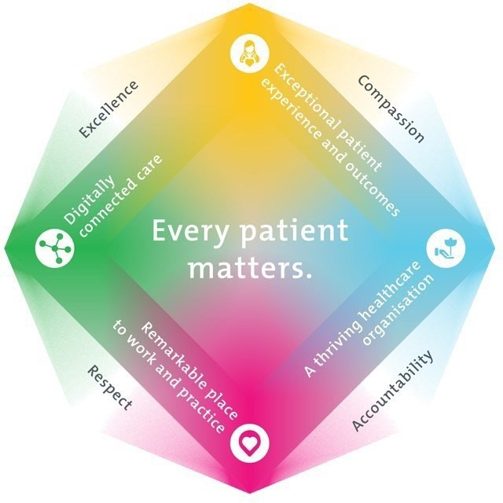
Epworth HealthCare Strategy

All roles are linked to the Epworth strategy and are fundamental in achieving its vision and purpose.
Exceptional patient experience and outcomes - To empower our patients and deliver compassionate, expert and coordinated care.
A thriving healthcare organisation - To adapt and grow in a changing healthcare landscape by delivering a unique private not-for-profit healthcare organisation.
Remarkable place to work and practice - To ensure Epworth is an outstanding place to work and practice through a culture of care and investment in our people.

Digitally connected care - To innovate and improve the digital experience, interactions and outcomes for our patients, staff and doctors.

- Purpose of the Position
The primary function of the Allocations Officer role is to allocate casual, permanent pool and agency staff to appropriate units, utilising Shiftmatch within the required timeframes. The role will incorporate liaising with key stakeholders such as department managers, nursing staff and nursing agencies. The role requires effective customer service skills and provides administrative support to the Nurse Manager - Nurse Resource Team.

Key Accountabilities

KEY RESPONSIBILITIES | MEASURES/KPIs TO BE ACHIEVED
Overview of Administrative Support Responsibilities | • | Demonstration of high-level communication skills with all
- Accurately manage shortfalls in Shift match within required timeframe. |  | members of the health care team.
- Allocate within the framework as provided by the Epworth Agency tender. | - ​ | Timely and professional escalation of problematic situations
- Ensure MyRoster is updated as necessary |  | pertaining to allocations, admissions and clerical tasks as
- Participation in education and training. |  | they arise to the Nurse Unit Manager, Associate Nurse Unit  Manager or Hospital Coordinator.

Customer Service  - Ensure high standards of customer service delivery.  - Identify and attend to customer needs and expectations as appropriate.  - Act as a role model in the provision of customer service. |  | Provision of high-level customer service to all key stakeholders including
 |  | external agencies.
 |  | Efficient processing of all telephone calls with a clear focus on customer
 |  | service delivery.
 |  | Provision of accurate information and managing roster shortfalls as
 |  | requested by departments.
Team Effectiveness | - ​  - ​
- Actively participate as a member of the department. |  | Establish positive relationship with colleagues.  Prioritise daily tasks within the role to ensure the effectiveness ofthe
 |  | position.
 | - ​ | Contribution to department efficiency by effective | utilisation of
 |  | time and resources.
 |  | Demonstrates flexibility in the face of changing priorities and
 |  | situations.

Risk and Safety Management  - Escalation & reporting of identified risks or incidents.  - Complete of Emergency CodeTraining.  - Completion of No Bullying And Harassment training.  - Familiarisation of relevant Epworth HealthCare policies and procedures relevant to OH&S.  - Participate actively and positively in the area of health and safety to reduce all hazards and incidents within the workplace. Report all hazards, incidents, injuries and near misses immediately to manager and log them in RiskMan. | - ​  - ​ | Observe safety procedures and instructions provided, and work in manner which minimises the risk of injury to themselves, fellow employees, patients and visitors according to Epworth Hospital policies and procedures relating to Occupational Health and Safety.  Recognise and report to team leader/supervisor or manager any OH&S hazards identified in order to initiate the risk management process and ensure a safe work environment.

Personal and Professional Development  - Completion of annual mandatory competencies.  - Completion of objectives as outlined in Professional Development Plan. | - Complete all mandatory competencies annually.

Required Knowledge& Skills

Essential
- Professional, respectful consultative and responsive style; high level of confidentiality, integrity and discretion
- Demonstrable excellent customer service and continuous improvement
- A professional and friendly manner with the ability to build and maintain rapport and key relationships/networks
- Proactive, co-operative and enthusiastic approach to responsibilities with an ability to make decisions and identify solutions
- High organisational skills; an ability to plan, prioritise, work under pressure and meet tight deadlines
- Committed to modelling Epworth HealthCare’s Values & Behaviours
- Highly motivated and self-directed with an ability to work autonomously as well as an effective member of a team in a dynamicand fast paced environment
- Highly developed computer skills including a comprehensive knowledge of the Microsoft suite.
- Ability to thrive in a busy environment and effectively manage competing priorities.
- Excellent forward-thinking administrative skills including ability to think outside the box.
- Exceptional verbal communication and people skills.
- Strong, plain English writing skills (editing of papers and minute taking)
- Attention to detail.
Desirable
Previous experience in HealthCare/workforce planning and knowledge of medical/clinical terminology would be an advantage

Document Control
Date Developed: | Date Last Reviewed: | Developed and Reviewed By (Position Title):
December 2016 | July 2025 | David Sam - Central Resource Unit Manager

Employee Position Declaration
I have read and understand the requirements and expectations of the above Position Description. I agree that I have the physical ability to fulfil the inherent physical requirements of the position, and accept my role in fulfilling the Key Accountabilities. I understand that the information and statements in this position description are intended to reflect a general overview of the responsibilities and are not to be interpreted as being all-inclusive.

Employee Signature:

Print Name: Date:

