- General Information
Position Title: | Speech Pathologist
Division/Department: | Epworth Rehabilitation and Mental Health or Acute Divisions
Position Reports to: | Manager, Speech Pathology & Dietetics and Grade 3 Senior Clinician or other as delegated by Manager
Enterprise/Individual Agreement: | Epworth Healthcare Health Professionals Enterprise Agreement (HSUA No. 3)
Classification/Grade: | Grade 2: HP21 – HP25
Location:
Employment Status:
Resource Management  (for Management positions only)  Number of Direct Reports:  Budget under management: | N/A
Key Relationships - internal and external | - Patients and family members & visitors  - Multi-disciplinary team members and Nursing staff  - Rehabilitation Consultants, Medical Staff & VMO’s  - External service providers and referrers
2. Overview of Epworth HealthCare
Epworth HealthCare is Victoria’s largest not-for-profit private health care group, renowned for excellence in diagnosis, treatment, care and rehabilitation. Epworth is an innovator in Australia’s health system, embracing the latest in evidence-based medicine to pioneer treatments and services for our patients.

Epworth’s values define our approach and our delivery. We pride ourselves on communicating our values and delivering on them in a real and meaningful way. Our Values are Compassion, Accountability, Respect & Excellence. More information can be found on the Epworth website.

Epworth’s purpose is Every Patient Matters. We strive to improve health outcomes and experience through compassion, collaboration, learning and Innovation. Our Vision is Caring for People. Innovating for a healthy community.

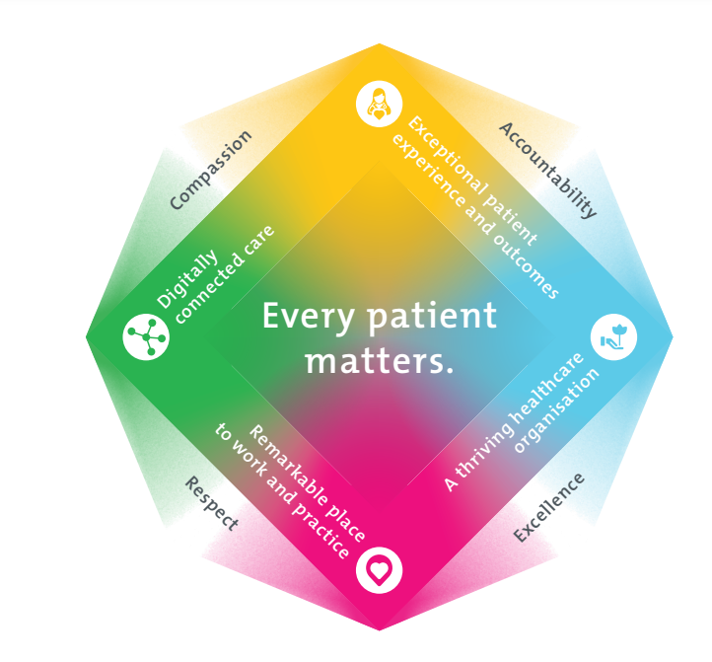
3. Epworth HealthCare Strategy

All roles are linked to the Epworth strategy and are fundamental in achieving its vision and purpose.
Exceptional patient experience and outcomes -To empower our patients and deliver compassionate, expert and coordinated care
A thriving healthcare organisation - To adapt and grow in a changing healthcare landscape by delivering a unique private not-for-profit healthcare organisation
Remarkable place to work and practice - To ensure Epworth is an outstanding place to work and practice through a culture of care and investment in our people.
Digitally connected care - To innovate and improve the digital experience, interactions and outcomes for our patients, staff and doctors.
4. Purpose of the Position
To provide optimal Speech Pathology services and positive clinical outcomes to the patient ensuring long-term health and wellbeing that is consistent with Epworth HealthCare's Vision and Values. Working within a multidisciplinary team, provide effective clinical, educational, emotional support and holistic best practice care to the patient and the family. Promote excellence to our customers and the marketplace and support colleagues by sharing knowledge and expertise.
5. Clinical Governance Framework
This role is required to put into practice the Clinical Governance Framework at Epworth as every employee is accountable for ensuring that our patients and community receive safe, high quality and person-centred care in every interaction with Epworth. This is achieved through active participation in the five domains of clinical governance at Epworth:

Clinical Governance Domain | Role
Leadership and culture | Promote and participate in a supportive, fair and transparent culture where lessons from previous outcomes are learned and patient safety and quality is a priority at all levels of the organisation.
Consumer Partnerships | Understand and where relevant, ensure that each patient is actively involved in their own care and treatment including families/carers wherever possible.
Effective Workforce | Develop and maintain one’s own competency, skills and knowledge to ensure high quality service provision and care.
Clinical Safety and Effectiveness | Understand and where relevant, ensure, that the right care is provided to the right person at the right time, in the right place and patient outcomes are monitored and improved.
Risk Management | Be responsible for identifying and reporting risks, hazards and near misses for people in our care and participating in risk mitigation strategies.
6. Key Accountabilities
KEY RESPONSIBILITIES | MEASURES/KPIs TO BE ACHIEVED
Clinical Care/Professional Practice  - Ensure optimal level of function and independence for all patients in the clinical caseload by appropriate assessments and treatments, provided in both individual and group sessions  - Assess and evaluate patient in relation to communication, cognitive, and swallowing abilities and upon diagnosis determine appropriate treatment  - Establish and maintain appropriate standards of practice relating to patient admission, assessment, treatment, family liaison and discharge planning  - Implement, monitor and modify treatment programs within the clinical area as appropriate using a patient centred evidence informed practice model of care  - Demonstrate empathy and compassion and encourage patient and family members participation in all stages of care  - Provide clinical leadership in a specialty area, demonstrating well consolidated skills and the application of theory to practice  - Practise in accordance with the National Safety and Quality Health Services (NSQHS) Standards  - Demonstrate reflective, critical thinking and evidence-based approach to the provision of patient care  - Maintain patient confidentiality as prescribed by the relevant acts and organizational policies and procedures  - Contribute to the development and maintenance of new and established clinical services within Speech Pathology and the broader team  - Understand and implement Epworth HealthCare Policies and Procedures and departmental work place instructions | - Appropriate standards of practice relating to assessments and treatments are implemented in a timely manner  - Compliance with mandatory and team-based documentation in patients’ medical record within agreed timeframes  - Direct patient care provided within allocated time frames from referral to treatment and within funding parameters  - Timely intervention is provided to support the team in achieving patient’s length of stay goals  - Sound relationships are developed and maintained with customers, family and colleagues  - Patient satisfaction results meet organisational targets  - Compliance with NSQHS and clinical competencies  - Compliance with accepted professional standards and Code of Ethics  - Compliance with legislative and common law requirements including Privacy Act and Health Records Act  - Adherence to all Epworth Policies and Procedures
Customer Service  Epworth is committed to the provision of excellent customer service to all of our people, customers and stakeholders including patients and external suppliers.  Superior patient service leads to improved recovery in a trusting, caring environment and also creates a safe environment for patients and employees.  - Role model and actively promote a culture of high-quality patient care  - Provide excellent, helpful service to patients, visitors and staff  - Communicate with clear and unambiguous language in all interactions, tailored to the audience  - Build customer relationships and greet customers and patients promptly and courteously  - Actively seek to understand patients' and their family's expectations and issues, using multiple strategies  - Uses data (such as compliments, complaints and Press Ganey) to identify breakdowns in internal processes and systems that directly impact patient care and customer service  - Responds quickly and proactively escalate concerns when necessary | - Patient and customer service satisfaction surveys within agreed targets  - Patients are given the opportunity to actively participate in their treatment planning and implementation  - Use AIDET principles in all interactions  - Issues or concerns are proactively escalated to the manager and resolved in a timely manner  - Compliments recorded on Riskman  - Consistently meet or exceeds the expectations of our patients and customers at all times  - Awareness of Epworth HealthCare's complaints process and assistance provided to patients if required
Leadership  - Lead and participate in the supervision of Grade 1’s, AHA’s and students  - Provide education and support to junior staff and students as requested  - Participate in the orientation of new and casual staff | - Effective supervision and support provided to staff and students  - Supervision sessions completed and documented  - Contribution to supervisees PDP process as supported by the Manager
Team Work /Communication  - Actively participate as a member of the department and multidisciplinary team  - Provide positive and constructive feedback to other team members | - Collaborate effectively with all other team members and external agencies, for efficient patient management  - Supportive environment for both patients and staff is provided  - Attendance and active participation in departmental and multidisciplinary team meetings  - Representation of discipline at relevant committees/meetings
Continuous Quality Improvement  - Initiate, lead and actively participate in quality activities ensuring opportunities for improvement are actively explored and best practice is achieved  - Provide suggestions and feedback to consistently improve service delivery, clinical practice and patient satisfaction  - Strive to enhance the Speech Pathology Department and Epworth’s positive image within the community | - Evidence of participation in quality enhancement activities  - Quality projects are completed within agreed time frame  - Demonstrated commitment to Australian Commission on Safety and Quality in Health Care, National Safety and Quality HealthCare Services (NSQHS) Standards  - Departmental resources, equipment and educational information are maintained and updated
Personal and Professional Development  - Participate in the ongoing professional development of self, colleagues and the wider Epworth HealthCare community by upgrading clinical competencies and knowledge and participating in both internal and external educational opportunities  - Impart clinical knowledge through structured in-service programs, lectures and tutorials  - Actively participate in Performance Development Plan annually and evaluate personal performance and plan self-development | - Training of staff in department meetings and other staff through in-service programs, tutorials, etc  - Active participation in relevant professional organisations  - Participation in internal in-service and education activities and events  - Completion of performance review and development plan
Safety and Wellbeing  - Participate actively and positively in the area of health and safety to reduce all hazards and incidents within the workplace  - Report all hazards, incidents, injuries and near misses immediately to the manager and log them in RiskMan | - Adhere to infection control/personal hygiene precautions  - Implement and adhere to Epworth OHS policies, protocols and safe work procedures  - Ensure all hazards, incidents and injuries are reported in Riskman within 24 hours  - Ensure all hazards, incidents and injuries are investigated and corrective actions implemented within agreed timeframes  - Mandatory training completed at agreed frequency
6. Position Requirements/Key Selection Criteria
COMPONENT
Qualifications | Essential  - Bachelor of Speech Pathology or equivalent degree  - Eligible for membership with Speech Pathology Australia (SPA)  Desirable  - Relevant Post Graduate qualification
Previous Experience | Essential  - Demonstrated previous experience as a Speech Pathologist  Desirable  - Relevant experience in an acute hospital, rehabilitation hospital or community setting  - Experience in tracheostomy management  - Experience in administering and interpreting Swallowing Videofluoroscopy Assessments and Fibreoptic Endoscopic Evaluation of Swallowing (FEES)  - Credentialed in Lee Silverman Voice Technique (LSVT)®
Required Knowledge & Skills | Essential  - Well-developed expertise in relevant assessment tools and interventions  - Demonstrated skill in working as a member of a team and liaising, collaborating and negotiating with other service providers and agencies, patient’s families and carers  - Excellent verbal and written communication and presentation skills  - Innovative, proactive and creative attitude to problem solving  - Ability to constructively supervise and educate junior staff and students  - Well-developed organisational skills  - Ability to interact and collaborate with all members of a multidisciplinary team  - Excellent computer literacy including MS Office Word & Excel  - Knowledge and understanding of the The National Safety and Quality Health Service (NSQHS)  - Appropriate knowledge of community resources and services  - Demonstrated customer service focus in service provision and evaluation  - Ability to drive a motor vehicle and holds a full current driver’s licence  Desirable  - Skills in conflict resolution and ability to manage challenging behaviour  - Knowledge of medico-legal and health and safety issues as they relate to health care
Personal Attributes & Values  All employees are expected to consistently work in accordance with Epworth’s values and behaviours  - Respect  - Excellence  - Compassion  - Community  - Integrity  - Accountability | Essential  - Belief in patient centred care  - Ability to work autonomously  - Sensitive to the psychosocial implications of illness  - Sensitive to cultural, racial and gender differences  - Helpful and professional manner  - Professional work ethic  - Practice within the ethos of the Epworth HealthCare Values and Behaviours  - Act as a role model for junior staff  - Flexibility to assist others within the department and across sites as required  Desirable  - Flexible and available to be on call and to work weekends as require

Document Control
Date Developed: | Date Last Reviewed: | Developed and Reviewed By (Position Title):
August 2016 | October 2023 | Human Resources & Allied Health Managers

Employee Position Declaration
I have read and understand the requirements and expectations of the above Position Description. I agree that I have the physical ability to fulfil the inherent physical requirements of the position, and accept my role in fulfilling the Key Accountabilities. I understand that the information and statements in this position description are intended to reflect a general overview of the responsibilities and are not to be interpreted as being all-inclusive.
Employee Signature:
Print Name: | Date:

