- General Information
Position Title: | Patient Care Associate
Division/Department: | Central Resource Unit
Position Reports to: | Central Resource Unit Manager
Enterprise/Individual Agreement: | Health and Allied Services Enterprise Agreement
Classification/Grade: | Personal Care Associate Year 1-5
Location: | Epworth Geelong, Richmond, Freemasons, Eastern, Hawthorn and or Camberwell
Employment Status: | Casual
Resource Management  (for Management positions only)  Number of Direct Reports:  Budget under management: | NA
Key Relationships - internal and external | - Patients, inclusive of family member(s) and visitors  - NUM, ANUM and patient care team  - CRU Manager, CRU Site Partner and Allocators  - Internal service providers i.e. Nursing and ward administration staff, food services team and patient transport.
2. Overview of Epworth HealthCare
Epworth HealthCare is Victoria’s largest not-for-profit private health care group, renowned for excellence in diagnosis, treatment, care and rehabilitation. Epworth is an innovator in Australia’s health system, embracing the latest in evidence-based medicine to pioneer treatments and services for our patients.

Epworth’s values define our approach and our delivery. We pride ourselves on communicating our values and delivering them on in a real and meaningful way. Our Values are Compassion, Accountability, Respect, Excellence. More information can be found on the Epworth website.

Epworth’s purpose is Every Patient Matters. We strive to improve health outcomes and experience through compassion, collaboration, learning and Innovation. Our Vision is Caring for People. Innovating for a healthy community.

- Epworth HealthCare Strategy

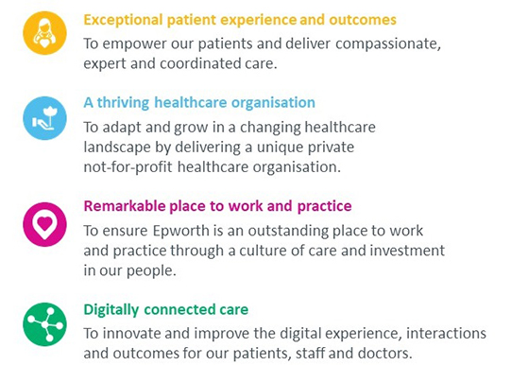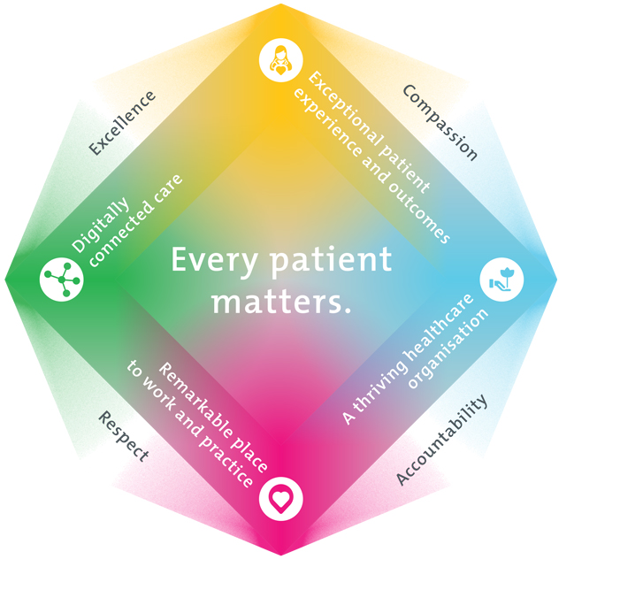

Purpose of the Position
The primary function of the Patient Care Associate (PCA) is to aid clinical staff in delivering patient care.

You will work as member of the patient care support team under the direction of nursing staff to provide a high quality, clean and safe environment for patient’s that is consistent with the infection control standards. In particular to utilise available resources, promote and participate in all required standards and quality activities and provide outstanding customer service to ensure a positive patient experience.

You will play an active role within the Epworth team, participating in building a community-based culture that fosters a spirit of achievement, capability and development by ensuring consistency with Epworth’s Mission and Values.
5. Key Accountabilities
KEY RESPONSIBILITIES | MEASURES/KPIs TO BE ACHIEVED
Patient Care  - Escort new patients to the room and orientate them to their surroundings and advise assigned nurse they have arrived  - Assists with patient hygiene and activities of daily living, promoting independence where possible  - Continence care inclusive of application of continence aids and personal hygiene  - Assist with oral care and hygiene  - Escorting patients to the bathroom as appropriate  - Provides constant observation as directed by the Registered Nurse (excluding patients with an IV therapy or oxygen therapy in progress where a nurse escort is also required)  - Assists with meal set up and feeding where approved by the registered Nurse where safe to do so – no swallowing issues identified.  - Timely reporting of patient issues and concerns such as care, environmental, food etc to the registered nurse  - Assists with patient mobility including in and out of bed whist being aware of their falls risk under the direction of the registered nurse or midwife/allied health practitioner  - Assistance with pressure area care under the direction of the registered nurse  - Escorts patients to reception on discharge.  - Encourage patients and family members participation in Point of Care usage  - Transports patients to therapy areas as required at the direction of the registered nurse  - Transport of other items including (but not limited to) pharmacy, samples and test materials, and newspaper delivery  - Restocking of supplies as directed  - Setting up equipment required by clinical staff | - Compliance with mandatory annual Manual Handling and Safe Moves training  - Compliance with mandatory and unit specific competencies every 12 months or as prescribed  - Safe movement and positioning of patients (in conjunction with clinical staff)  - Patients are ready for scheduled therapy sessions  - Patient’s physical care requirements are met  - Patients and their families engage with using Point of Care as required  - Patient feedback indicates patients feel welcome and informed about their stay.  - Compliance with confidentiality requirements
Cleaning Care  Efficient and effective delivery of waste management including general and periodic cleaning of patient rooms / bathrooms, wards, departments, public areas, internal or external areas as directed.  - Safely remove waste and linen from allocated area  - Stripping of and making beds as required  - Maintain nominated areas in a clean state in accordance with specified work schedules and cleaning system  - Undertake room preparation tasks as directed | - Compliance with Infection Control Standards  - Safe and correct operation of cleaning equipment  - Practice in accordance with chemical handling requirements  - Patient rooms and other areas of responsibility are tidy and any issues relating to cleanliness are reported to the nurse in charge or environmental staff
Team Work  - Works cooperatively and collaboratively with all members of the patient care team  - Provides positive and constructive feedback and communicates well with other team members  - Actively participates as a member of the team and department | - Attends and actively participates in department and team meetings  - Provides and receives feedback in a positive and professional manner  - Adheres to Epworth HealthCare’s Values and Behaviours
Quality Improvement  - Strives to consistently improve service delivery and practice  - Provides suggestions, and feedback to Supervisor and Manager on quality activities  - Actively participates in quality improvement activities within the unit or department in accordance with the National Safety and Quality Health Service (NSQHS) Standards | - Evidence of participation in quality activities  - Contributes to improved patient care  - Shows a proactive attitude in reviewing, supporting and implementing relevant initiatives into service improvements
Personal and Professional Development  - Participates in the orientation of new and casual staff, act as a buddy as required | - Knowledge and commitment to Epworth HealthCare policies, procedures and staff code of conduct  - Participation in in-services, department education and meetings as relevant
Customer Service  Epworth is committed to the provision of excellent customer service to all of our people, customers and stakeholders including patients and external suppliers.  Superior patient service leads to improved healing in a trusting, caring environment and creates a safe environment for patients and employees.  - Provide excellent, helpful service to patients, visitors and staff  - Communicate with clear and unambiguous language in all interactions, tailored to the audience  - Build customer relationships and greet customers and patients promptly and courteously  - Actively seek to understand patients' and their family's (customers) expectations and issues | - Issues are escalated to the manager or Registered Nurse and resolved in a timely manner
Safety and Wellbeing  Participate actively and positively in the area of health and safety to reduce all hazards and incidents within the workplace  - Report all hazards, incidents, injuries and near misses immediately to your manager and log them in RiskMan | - Adhere to infection control/personal hygiene precautions  - Implement and adhere to Epworth OHS policies, protocols and safe work procedures  - Mandatory training completed at agreed frequency
6. Position Requirements/Key Selection Criteria
COMPONENT
Qualifications | Essential  - Certificate III Health Services Assistance or equivalent (to progress to Grade 2)
Previous Experience | Essential  - A minimum of twelve (12) months experience as a Patient Care Associate Grade 1 or equivalent  - Previous experience within the Health Services industry  Desirable  - Experience with patient transport, patient lifting or manual handling
Required Knowledge & Skills | Essential  - Understanding of infection control processes within a healthcare environment  - Responsible for work performed with a medium to high level of accountability or discretion  - Effective communication and interpersonal skills  - Ability to organise and prioritise tasks  - Ability to work unsupervised but take direction from the Registered Nurse/Nurse Unit Manager as required
Personal Attributes & Values  All employees are expected to consistently work in accordance with Epworth’s values and behaviours | Essential  - Belief in patient centred care  - Committed to providing a safe environment for patients and colleagues  - Professional work ethic  - Practices within the ethos of the Epworth HealthCare Values and Behaviours  - Ability to learn new skills  - Willingness and ability to work collaboratively within a team environment  - Maintain patient confidentiality

Document Control
Date Developed: | Date Last Reviewed: | Developed and Reviewed By (Position Title):
May 2023 | August 2025 | David Sam Central Resource Unit Manager

Employee Position Declaration
I have read and understand the requirements and expectations of the above Position Description. I agree that I have the physical ability to fulfil the inherent physical requirements of the position, and accept my role in fulfilling the Key Accountabilities. I understand that the information and statements in this position description are intended to reflect a general overview of the responsibilities and are not to be interpreted as being all-inclusive.

Employee Signature:
Print Name: | Date:

