Page 1 of 8



1. **General Information**



|  |  |
| --- | --- |
| **Position Title:** | Executive Assistant |
| **Division/Department:** | Epworth Medical Foundation |
| **Position Reports to:** | Executive Director, Epworth Medical Foundation |
| **Enterprise/Individual Agreement:** | Individual Employment Agreement |
| **Classification/Grade:** | N/A |
| **Location:** | Epworth Richmond |
| **Employment Status:** | Full Time |
| **Resource Management**  (for Management positions only)  **Number of Direct Reports:**  **Budget under management:** | N/A |
| **Key Relationships - internal and external** | * Epworth Medical Foundation Team * Executive and Leadership Teams across Epworth * Executive and Personal Assistants across Epworth * Board and Committee Members * Staff and external stakeholders * EMF Donors |

1. **Overview of Epworth HealthCare**

Epworth HealthCare is Victoria’s largest not-for-profit private health care group, renowned for excellence in diagnosis, treatment, care, and rehabilitation. Epworth is

an innovator in Australia’s health system, embracing the latest in evidence-based medicine to pioneer treatments and services for our patients.

Epworth’s values define our approach and our delivery. We pride ourselves on communicating our values and delivering on them in a real and meaningful way. Our Values are Compassion, Accountability, Respect and Excellence. More information can be found on the [Epworth website](https://www.epworth.org.au/who-we-are/our-values).

Epworth’s purpose is Every Patient Matters.

Our Vision is Delivering another 100 years of exceptional healthcare and innovation to the Victorian community.

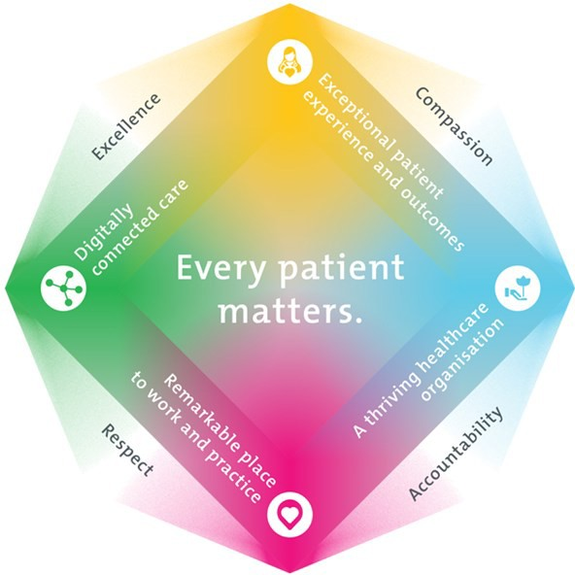

1. **Epworth HealthCare Strategy**

|  |
| --- |
| All roles are linked to the Epworth strategy and are fundamental in achieving its vision and purpose. |
| **Exceptional patient experience and outcomes -** To empower our patients and deliver compassionate, expert and coordinated care. |
| **A thriving healthcare organisation -** To adapt and grow in a changing healthcare landscape by delivering a unique private not-for-profit  healthcare organisation. |
| **Remarkable place to work and practice -** To ensure Epworth is an outstanding place to work and practice through a culture of care and investment in our people. |
| **Digitally connected care -** To innovate and improve the digital experience, interactions and outcomes for our patients, staff, and doctors. |

1. **Purpose of the Position**

To provide administrative and project support to the Executive Director, Epworth Medical Foundation and their leadership teams including preparation and management of EMF Board papers, Board manual, meeting and committee Secretariat, email and calendar management, travel and catering arrangements, preparation of presentations, reports and general administrative tasks in relation to employee benefits, awards and with cyclical P&C processes eg. annual salary reviews, performance reviews, etc.

1. **Key Accountabilities**

| **KEY RESPONSIBILITIES** | **MEASURES/KPIs TO BE ACHIEVED** |
| --- | --- |
| **Executive and Administrative Support**  Executive administrative support to the Executive Director, Epworth Medical Foundation including:   * Effective diary management and monitoring to ensure Executive time is structured effectively. * Efficient review of incoming electronic and paper-based correspondence to executive, bringing urgent matters to attention to ensure action and response is timely. * Responding to queries or issues on behalf of Executive where appropriate and in a timely manner. | * Diary schedules are appropriately and accurately managed and maintained. * Documents are professional and accurate in their production. * Efficient office procedures are appropriately managed, maintained or implemented. * Effectively compile and manage communications to staff. * Reliable and timely delivery of services. * Compliance with Policies and Procedures. * Provide accurate and timely advice and responses. * Responsiveness in the management of correspondence. * Executives notified of decision made on their behalf and any critical issues in a timely manner. |

|  |  |
| --- | --- |
| **EMF Board, Committee and Meeting Secretariat**  Drafting and collation of reporting papers for Board meetings, presentations to the Leadership Team meetings, Steering Committees and other forums as required.   * Document and follow-up of Leadership Team meetings and forums:   + Preparation of agendas, minutes and papers as required.   + Tracking and follow up of agreed action items.   + Prepare and disseminate EMF’s Board papers and related materials. | EMF Board papers and related materials are produced to the highest standard.  Quality and timeliness of the preparation and distribution of reports and documentation supporting Committees is satisfactory including:   * Minutes prepared in a timely manner. * Agendas are compiled and distributed in a timely manner. * Draft papers are available for review in a timely manner. * Follow-up with key stakeholders. * Projects, papers, briefings, letters, and presentations. |
| **Information Management**   * Ensure the effective and efficient management of information within the office/department. * Act as a first line resource for internal and external customers requiring information. * Manage and maintain the storage and filing of information as required. | * All electronic filing and storage of information is accurate, accessible and meets accepted organisational standards/ practice. * Executive Director notified of decision made on their behalf and any critical issues in a timely manner. |
| **Project Management and Event Management**   * Co-ordinate or assist in the management and delivery of small to medium projects, supporting the planning and organisation of activities as required to ensure the successful implementation of projects. * Assist the Executive Director of Epworth Medical Foundation with the collation and presentation of monthly & quarterly project updates and status reports as required. * Assist the Executive Director of Epworth Medical Foundation and other stakeholders to develop documentation for project scoping and approvals. * Contribute and participate in larger project initiatives as directed to ensure project objectives are achieved. * Ensure all events are run efficiently and effectively. | * Project work is delivered on time and to the agreed standard. * Internal and external events are coordinated from inception to conclusion in a timely manner with all key stakeholders involved. |
| **Stakeholder Management**  Establish and maintain effective relationships:   * Actively engage and contribute to the building of positive relationships with donors. * Build relationships with leadership, corporate departments, all other key staff. * A trusted central contact point for all major stakeholders. * Build relationships with staff, doctors, vendors, providers, and industry partners. | * Feedback from stakeholders. * Positive ability to influence change. |

|  |  |
| --- | --- |
| **Customer Service**   * Provide professional, friendly and helpful service to all internal and external stakeholders. * Epworth is committed to the provision of excellent customer service to all our people, customers and stakeholders including patients, donors, sponsors and doctors. | * Epworth values and behaviours demonstrated. * Negotiate meeting times with other Executive and Personal Assistants. * Build customer relationships and greet donors/stakeholders promptly and courteously. * Actively seek to understand stakeholder’s circumstances, expectations and issues. * Proactively escalates concerns when necessary to ensure resolution of any current or potential breakdown in processes and systems that impact patient care and customer service. * Consistently meet or exceed patients and customers’   Expectations. |
| **Safety and Wellbeing**  Participate actively and positively in the area of OHS to reduce all hazards and incidents within the workplace. | * Comply with all Epworth’s OHS policies, protocols and safe work procedures at all times. * Ensure your actions do not put yourself or others at risk. * Report all hazards, incidents, injuries and near misses immediately to your manager and log them in RiskMan. * Participate in and complete mandatory safety training on an annual basis and as required. |

1. **Position Requirements/Key Selection Criteria**

|  |  |
| --- | --- |
| **COMPONENT** |  |
| Qualifications | **Desirable**   * A degree in a business information related field. |
| Previous Experience | **Essential**   * Demonstrated experience as an outstanding executive assistant to a senior executive. * Experienced in co-ordination and support of small projects or project related activities. * Experience in a large, complex organisation.   **Desirable**   * Experience within a similar role in the health care sector is advantageous. |
| Required Knowledge & Skills | **Essential**   * Ability to prioritise and be proactive. * Outstanding administration and organisational skills. * Demonstrated analytical skills and attention to detail. * Exceptional verbal communication skills. * Strong, plain English writing skills (editing of Board papers and minute writing). * Time management skills that enable a range of activities to be organised concurrently. * Ability to work in a demanding and challenging work environment. * Committed to excellent customer service and continuous improvement. |

|  |  |
| --- | --- |
| Personal Attributes & Behaviours  All employees are expected to consistently work in accordance with Epworth’s values and behaviours | **Essential**   * Enjoys working with diverse groups of people. * Self-starter - Demonstrate a high level of self-direction and initiative with an ability. * Proactive, co-operative and enthusiastic approach to responsibilities with an ability to make decisions. * Honesty and integrity. * Strong interpersonal and communication skills. * Logical and analytical. * Ability to promote and support change. * Demonstrated ability to build rapport, negotiate and form relationships with people at all levels. * Ability to work independently & also in teams. * High level of confidentiality and discretion. |

**Document Control**

|  |  |  |
| --- | --- | --- |
| Date Developed: | Date Last Reviewed: | Developed and Reviewed By (Position Title): |
| August 2023 | August 2025 | Executive Director, Epworth Medical Foundation |

**Employee Position Declaration**

I have read and understand the requirements and expectations of the above Position Description. I agree that I have the physical ability to fulfil the inherent physical requirements of the position and accept my role in fulfilling the Key Accountabilities. I understand that the information and statements in this position description are intended to reflect a general overview of the responsibilities and are not to be interpreted as being all-inclusive.

|  |  |
| --- | --- |
| Employee Signature: | |
| Print Name: | Date: |