- General Information
Position Title: | Senior Technical Engineer
Division/Department: | Information Technology
Position Reports to: | Technology Operations Manager and Business Partner
Enterprise/Individual Agreement:
Classification/Grade:
Location: | Allocated sites across Epworth
Employment Status: | Full time
Resource Management  (for Management positions only)  Number of Direct Reports:  Budget under management: | None
Key Relationships - internal and external | Site coordinators and hospital site teams, including Management and VMOs/JMOs/Medical students, Corporate Teams including HODs, Information Technology Teams, Vendors, Hospital Executive Team (HET)
2. Overview of Epworth HealthCare
Epworth HealthCare is Victoria’s largest not-for-profit private health care group, renowned for excellence in diagnosis, treatment, care and rehabilitation. Epworth is an innovator in Australia’s health system, embracing the latest in evidence-based medicine to pioneer treatments and services for our patients.

Epworth’s values define our approach and our delivery. We pride ourselves on communicating our values and delivering on them in a real and meaningful way. Our Values are Compassion, Accountability, Respect and Excellence. More information can be found on the Epworth website.

Epworth’s purpose is Every Patient Matters.

Our Vision is Delivering another 100 years of exceptional healthcare and innovation to the Victorian community.

3. Epworth HealthCare Strategy
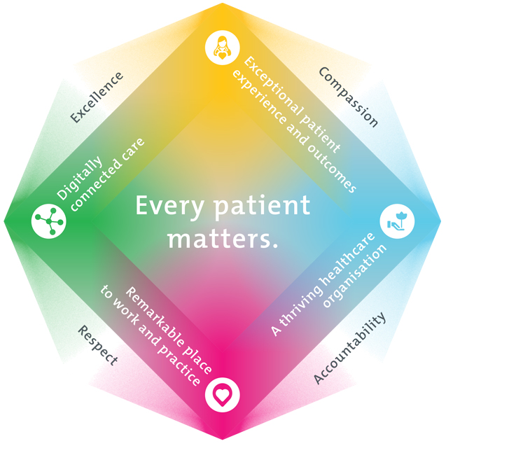
All roles are linked to the Epworth strategy and are fundamental in achieving its vision and purpose.
Exceptional patient experience and outcomes - To empower our patients and deliver compassionate, expert and coordinated care.
A thriving healthcare organisation - To adapt and grow in a changing healthcare landscape by delivering a unique private not-for-profit healthcare organisation.
Remarkable place to work and practice - To ensure Epworth is an outstanding place to work and practice through a culture of care
and investment in our people.
Digitally connected care - To innovate and improve the digital experience, interactions and outcomes for our patients, staff and doctors.

4. Purpose of the Position
The purpose of this role is to provide senior technical leadership and act as the the escalation point for complex, high‑impact technology issues, ensuring the stability, reliability, and security of critical systems that support clinical and operational functions at Epworth sites. The position exists to resolve the most challenging technical problems, drive permanent fixes, and reduce technical debt across the environment through expert troubleshooting, root‑cause analysis, and collaboration with infrastructure, application, and vendor teams.
The role is responsible for uplifting the capability of Technology Coordinators and site‑based support teams, offering mentoring, technical guidance, and solution validation to ensure consistent, high‑quality service delivery. By maintaining expertise across infrastructure, applications, networks, and integrated clinical systems, the position ensures that escalations are handled efficiently, accurately, and in alignment with organisational standards and ITIL practices.
A key purpose of the role is to strengthen system reliability, performance, and security, conducting proactive health checks, ensuring compliance with patching and configuration baselines, and identifying opportunities for automation and continuous improvement. Through high‑quality documentation, knowledge sharing, and collaboration with cross‑functional teams, the role contributes to a more mature, resilient, and efficient technology environment.
Ultimately, this position ensures that critical technology services remain stable, secure, and optimised, enabling staff and doctors to deliver safe, uninterrupted patient care and ensuring the organisation can operate with confidence in its technology foundations.
5. Clinical Governance Framework
This role is required to put into practice the Clinical Governance Framework at Epworth as every employee is accountable for ensuring that our patients and community receive safe, high quality and person-centred care in every interaction with Epworth. This is achieved through active participation in the five domains of clinical governance at Epworth:

Clinical Governance Domain | Role
Leadership and culture | Promote and participate in a supportive, fair and transparent culture where lessons from previous outcomes are learned and patient safety and quality is a priority at all levels of the organisation.
Consumer Partnerships | Understand and where relevant, ensure that each patient is actively involved in their own care and treatment including families/carers wherever possible.
Effective Workforce | Develop and maintain one’s own competency, skills and knowledge to ensure high quality service provision and care.
Clinical Safety and Effectiveness | Understand and where relevant, ensure, that the right care is provided to the right person at the right time, in the right place and patient outcomes are monitored and improved.
Risk Management | Be responsible for identifying and reporting risks, hazards and near misses for people in our care and participating in risk mitigation strategies.
6. Key Accountabilities
KEY RESPONSIBILITIES | MEASURES/KPIs TO BE ACHIEVED
Technical Expertise and Escalation  Act as the Tier 3 escalation point for complex incidents, major problems, and high‑impact technical issues.  Lead root‑cause analysis for recurring or critical issues and implement permanent corrective actions.  Provide expert troubleshooting across infrastructure, applications, networks, and integrated clinical systems.  Ensure escalations to infrastructure and application 3rd‑level teams are thorough, complete, well‑documented, and technically accurate.  Lead root‑cause analysis and drive permanent fixes to eliminate recurring issues.  Maintain deep expertise in assigned technologies and stay current with emerging tools, standards, and best practices.  Provide technical expertise to Technology Operations Manager and Business Partner and Director of IT Service Delivery  Demostrate strong customer focus with a genuine commitment to creating positive experiences for all staff and doctors.  Manage incidents and service requests within agreed SLAs using the ITSM tool, ensuring timely updates, accurate categorisation, and clear communication throughout the lifecycle. | Technical Debt Reduction: Measurable reduction in recurring issues or legacy risks each quarter (Target TBD).  Solution Validation: ≥95% of recommended implemented solutions resolve root cause issue, and do not require correction  SLA Performance: ≥95% of incidents and service requests managed and resolved within agreed SLAs, with accurate ITSM updates and lifecycle management.
Guidance & Support for Technology Coordinators  Provide technical guidance, mentoring, and knowledge support to the Technology Coordinator - Clinical & Site Support team, staff and Drs  Assist Coordinators with complex site issues, clinical system dependencies, and advanced troubleshooting.  Review and validate technical solutions proposed by Coordinators to ensure alignment with standards and best practice.  Support capability uplift by contributing to training and knowledge‑sharing sessions.  Provide technical expertise and support for the delivery of project initiatives. | Mentoring Feedback: Positive feedback from Technology Coordinators and Staff Site co-ordinators on guidance, clarity, and responsiveness.  Knowledge Uplift: Minimum one training session, walkthrough, or knowledge‑share contribution per month.
Collaboration with Infrastructure, Application Teams & Vendors  Work closely with Infrastructure teams to support system administration, patching, upgrades, and maintenance/ad-hoc activities.  Partner with Application 3rd‑level teams to resolve application‑related issues, integrations, and performance concerns.  Coordinate with external vendors for escalated issues, warranty repairs, system updates, and specialised troubleshooting.  Ensure vendor actions meet contractual expectations and are completed within agreed timeframes. | Vendor SLA Compliance: ≥95% of vendor tasks completed within agreed timeframes.  Cross‑Team Satisfaction: ≥90% satisfaction from Infrastructure and Application teams regarding collaboration quality (qualitative comments captured in surveys, ITSM feedback, performance reviews or post‑incident reviews).
Systems Reliability, Performance & Security  Monitor and optimise performance, capacity, and stability.  Ensure systems meet patching, security, and compliance requirements.  Conduct proactive health checks, audits, and performance tuning. | All scheduled system health checks completed on time with documented outcomes.
Documentation, Standards & Continuous Improvement  Develop and maintain high‑quality technical documentation, runbooks, diagrams, and knowledge articles.  Ensure all technical work aligns with security policies, and ITIL processes.  Identify opportunities for automation, simplification, and service improvement.  Lead or contribute to CSI initiatives that reduce incidents, improve reliability, or uplift user experience. | Documentation Accuracy: All technical documentation, runbooks, and knowledge articles updated within 5 business days of any system change, incident resolution, or new procedure.  100% adherence to mandatory security controls, patching requirements, and configuration baselines for all systems and end user devices under ownership.
Customer Service  Epworth is committed to the provision of excellent customer service to all of our people, customers and stakeholders including patients and external suppliers.  Superior patient service leads to improved healing in a trusting, caring environment and creates a safe environment for patients and employees.  - Provide excellent, helpful service to patients, visitors and staff  - Communicate with clear and unambiguous language in all interactions, tailored to the audience  - Build customer relationships and greet customers and patients promptly and courteously  - Actively seek to understand patients' and their family's (customers) expectations and issues | Patient and customer service satisfaction surveys within agreed targets  Use AIDET principles in all interactions  Issues are escalated to the manager and resolved in a timely manner
Safety and Wellbeing  Participate actively and positively in the area of health and safety to reduce all hazards and incidents within the workplace  - Report all hazards, incidents, injuries and near misses immediately to your manager and log them in RiskMan | Adhere to infection control/personal hygiene precautions  Implement and adhere to Epworth OHS policies, protocols and safe work procedures  Mandatory training completed at agreed frequency
7. Position Requirements/Key Selection Criteria
COMPONENT
Qualifications | Essential  Tertiary qualification in Information Technology, Computer Science, or a related discipline; or equivalent industry experience.  Relevant industry certifications (e.g., Microsoft, VMware, Cisco, ITIL Foundation).  ITIL Intermediate or Practitioner‑level certification  Desirable  Advanced or specialist certifications in infrastructure, cloud, networking, or security (e.g., Azure, AWS, VCP, CCNP, CISSP).  ITIL Intermediate or Practitioner‑level certification.  Training or certification in clinical or healthcare technology environments (if applicable).
Previous Experience | Essential  Demonstrated experience in a senior or 3rd‑level technical support role within a complex enterprise environment.  Experience supporting multi‑site operations with diverse user groups.  Proven ability to troubleshoot and resolve complex infrastructure, application, and integration issues.  Experience providing technical guidance or escalation support to Level 1/2 teams.  Experience working with vendors and 3rd‑level teams to resolve advanced technical issues.  Experience contributing to system maintenance, patching, upgrades, and change implementation.  Experience with InTune, SCCM, AutoPilot knowledge  Experience developing technical documentation, runbooks, or knowledge bases.  Desirable  Experience in healthcare, clinical systems, or other high‑availability, time‑critical environments.  Experience leading or contributing to continuous service improvement initiatives.
Required Knowledge & Skills | Essential  Strong technical expertise across infrastructure, systems, networks, or enterprise applications.  Advanced troubleshooting and diagnostic skills for complex incidents and major problems.  Ability to interpret and apply security policies, and ITIL processes.  Strong understanding of system performance, capacity, patching, and security requirements.  Ability to collaborate effectively with Infrastructure, Applications, and vendor teams.  Excellent written and verbal communication skills, including the ability to explain technical concepts to non‑technical users.  Ability to mentor and guide Technology Coordinators and uplift team capability.  Desirable  Knowledge of clinical workflows, clinical systems, or medical device integrations.  Experience with automation, scripting, or tools that improve operational efficiency.  Familiarity with cloud platforms (Azure, AWS) and hybrid environments.  Knowledge of enterprise monitoring, alerting, and performance‑management tools.
Personal Attributes & Values  All employees are expected to consistently work in accordance with Epworth’s values and behaviours  - Compassion  - Accountability  - Respect  - Excellence | Essential  Strong customer‑service mindset and culture, with a focus on minimising disruption to clinical and operational teams.  Proactive, solutions‑focused approach to problem‑solving.  Ability to remain calm and effective under pressure, especially during high‑impact incidents.  Collaborative and team‑oriented, with a willingness to support and uplift others.  Adaptable and comfortable working in a dynamic, fast‑paced environment.  Desirable  Demonstrated leadership influence without formal authority.  Continuous improvement mindset with a drive to enhance systems, processes, and user experience.  Strong stakeholder engagement skills, particularly with senior clinicians and operational leaders.

Document Control
Date Developed: | Date Last Reviewed: | Developed and Reviewed By (Position Title):
 | April 2026 | IT Service Delivery Manager

8. Employee Position Declaration
I have read and understand the requirements and expectations of the above Position Description. I agree that I have the physical ability to fulfil the inherent physical requirements of the position, and accept my role in fulfilling the Key Accountabilities. I understand that the information and statements in this position description are intended to reflect a general overview of the responsibilities and are not to be interpreted as being all-inclusive.
Employee Signature:
Print Name: | Date:

