General Information

Position Title: | Marketing and Digital Coordinator
Division/Department: | Communications and Engagement, Channels
Position Reports to: | Marketing Campaigns and Digital Manager
Enterprise/Individual Agreement: | Individual Employment Contract
Classification/Grade: | N/A
Location: | Pelaco
Employment Status: | 12 month Fixed term, 0.8FTE
Direct reports | N/A
Key Relationships - internal and external | Organisation-wide, external agencies and vendors.

- Overview of Epworth HealthCare
Epworth HealthCare is Victoria’s largest not-for-profit private hospital group, renowned for excellence in diagnosis, treatment, care and rehabilitation. Epworth is an innovator in Australia’s health system, embracing the latest in evidence-based medicine to pioneer treatments and services for our patients.
The values of Epworth define our approach and delivery. We pride ourselves on demonstrating our values in a real and meaningful way. Our Values are Compassion, Accountability, Respect and Excellence. More information can be found on the Epworth website.

Our purpose is to improve the health, wellbeing and experience of every patient by integrating clinical practice with education and research and our vision is to consistently deliver excellent patient-centred care with compassion and dignity.

3. Epworth HealthCare Strategy
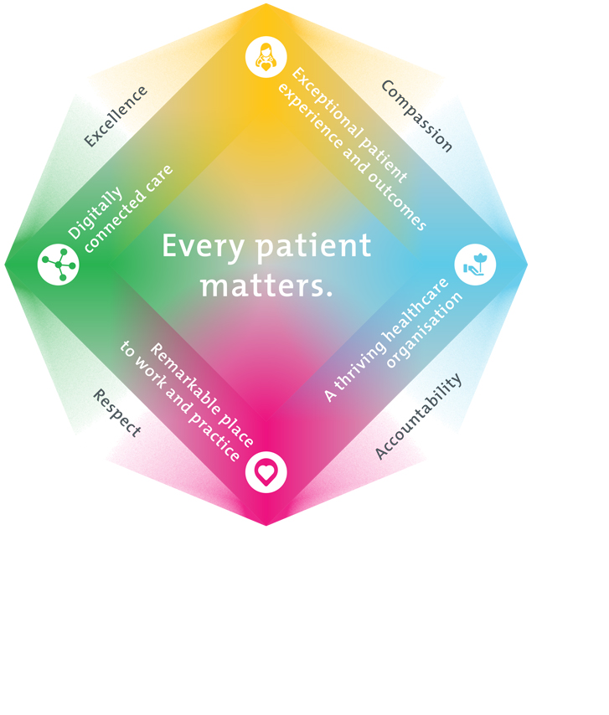
All roles are linked to the Epworth strategy and are fundamental in achieving its vision and purpose.
Connected Care – Partner with our patients and doctors to provide high-quality care through an integrated, holistic experience tailored to their needs and choices
Empowered People – Enable and empower our people and teams to be their best and make a difference to the patient experience
Innovative Practice – Informing and enabling health within our community through encouraging the ideas of our people and finding new and better ways to care and support care delivery
Sustainability – Be accountable to use resources wisely; to ensure organisational and environmental sustainability, enhance access, support the patient journey and create greater capacity for care.

Purpose of the Position

The Marketing and Digital Coordinator, reporting to the Marketing Campaigns and Digital Manager, supports the delivery of Epworth’s Strategic Workplan by contributing to the development and execution of integrated marketing and digital strategies. It involves monitoring and measuring marketing programs, enabling successful campaign delivery through collaborations with key stakeholders.

The role also manages and grows online communities, enhances brand reputation through engagement, and ensures consistent content publishing across social media platforms (Facebook, Instagram, LinkedIn, X, TikTok). Additionally, it supports platform optimisation and evaluates new channel opportunities, while maintaining a strong focus on reporting, performance tracking, and alignment with commercial objectives.
The Marketing and Digital Coordinator supports and maintains a strong brand presence to drive customer engagement through dynamic content creation for both traditional and digital marketing channels. This may include but not limited to social media posts, website pages, print and digital ads.

Key Accountabilities

KEY RESPONSIBILITIES | MEASURES/KPIs TO BE ACHIEVED
Campaign Implementation and Coordination  - Contribute to the creation of a comprehensive marketing and digital strategy that supports and enables the Epworth Strategic Workplan.  - Monitor and measure marketing programs, and through collaboration with members of the Communications & Engagement team, enabling successful campaign implementation and delivery.  - Build, grow and nurture our online communities on key social media channels and enhance our brand and reputation through increased engagement.  - Ensure regular posting of approved content and optimise existing platforms, while reviewing suitability of new platforms and channels.  - Collaborate with the Communications & Engagement team and stakeholders across the organisation to enable and support the Epworth Strategic Workplan, in combination with supporting the commercial objectives of our organisation. | - Campaigns delivered within agreed timeframes according to applicable budget.  - Regular campaign and content reviews with management team.  - 100% adherence to Epworth Social Media policy and brand guidelines.

Content Creation  - Develop content that contributes and supports the Epworth Strategic Workplan.  - Create engaging content that influences target audiences to choose Epworth through the development of written and visual material to highlight the Epworth proposition.  - Coordinate the ongoing streams of organic and paid content across all channels and ensure optimum presence and engagement.  - Collaborate with stakeholders and external agencies to ensure all marketing design and development follow approved standards and best practice. | - Strategy developed and approved that supports and enables the Epworth Strategic Workplan and all marketing projects are aligned.  - Strategy implementation according to plan and all work aligns with best practice, governance and relevant policies.
Performance and Analytics  - Support campaign execution and optimisation by providing regular marketing performance reports, suggesting tactical adjustments, and ensuring alignment with broader marketing objectives.  - Use performance and analytics tools such as Google Analytics or similar to track and improve all digital channels.  - Ensure accurate documentation and administration of campaign data, performance metrics, and optimisation activities to support transparency, accountability, and continuous improvement.  - Provide ongoing support and monitoring, inclusive of real-time optimisation/changes, of campaigns as needed. | - Contribute to accurate, timely and comprehensive monthly and quarterly marketing reports that contain statistical analysis and insights.  - Deliver programs and campaigns to objectives, specifications, on time and on budget.  - Comprehensive campaign tracking is established including:  - A/B testing  - Feedback loop with internal and external stakeholders
Communication and Collaboration  - Communicate and collaborate with various internal and external stakeholders involved in marketing campaigns and programs.  - Communicate marketing objectives, requirements, progress, and feedback clearly and effectively across the organisation.  - Collaborate with the Communications & Engagement team to manage program of work. | - 100% compliance to ensure cohesive branding across all marketing platforms.  - Positive user experience across all digital channels as measured by best practice benchmarking.
Teamwork  - Develop and grow the skillset and expertise within the team through staff development, on-the-job training and regular feedback sessions.  - Ensure efficient operations within the team, including completion of performance reviews and regular team meetings.  - Maintain appropriate adherence to Epworth values and behaviours.  - Build trust and influence at all levels of Epworth.  - Create and contribute to a positive, creative and inclusive work environment within the Communications & Engagement team and across Epworth. | - Employee Engagement Survey results.  - Model the correct Epworth values and behaviours.
Safety and Wellbeing  - Participate and co-operate in consultative processes to improve health and safety.  - Observe safe working practices and as far as you are able, protect your own and others’ health and safety.  - Complete all necessary personal training and professional development requirements. | - 100% compliance with all mandatory training and policy requirements.

- Position Requirements/Key Selection Criteria

COMPONENT
Qualifications | Essential  - Degree in Marketing, Communications, Digital Marketing, Social Media or a related discipline, or equivalent industry experience  - Working with Children Check
Previous Experience | Essential  - 2+ years of experience coordinating marketing, communications or digital programs for medium to large organisation/s  - Experience in social media and/or marketing campaigns  - Experience managing content for multi-channel outputs  - Project management and/or business analysis experience  - Experience in writing and editing for the web/social/blogs  - Experience managing internal stakeholders  Preferred  - Proficient in managing enterprise social media tools and technologies, including social media management, monitoring and analytics tools  - Experience filming and editing video content using Adobe Premiere Pro or similar  - Relevant expertise in related software such as Adobe Creative Suite, Content Management Systems  - Previous experience in a healthcare or not for profit sector

Personal Attributes & Values  All employees are expected to consistently work in accordance with the Four values of Epworth  - Compassion  - Accountability  - Respect  - Excellence | Essential  - Ability to build and maintain rapport and effective relationships with key internal and external stakeholders  - Collaborative attitude with demonstrated positive and practical approach to working in a team  - Ability to consider and effectively manage competing priorities and strategic directions, when achieving team planning and project outcomes  - Advanced interpersonal, organisational and critical thinking skills  - High attention to detail to deliver quality output  - Flexible approach to changing priorities and unplanned activity  - Displays initiative, motivation and self confidence  - Honest, competent and forward looking  - Committed to continuous quality improvement  - Aligned with the Vision, Values and Behaviours at Epworth
Demonstrated Job Competencies  Required | - Experienced in collaborating with internal and external stakeholders  - Skills in the creation, production and editing of marketing and/or digital content for various channels  - Understanding of traditional and digital marketing mix

Document Control
Date Developed: | Date Last Reviewed: | Developed and Reviewed By (Position  Title):
9 September 2025 | 9 September 2025 | Developed Colette Hynes, Deputy Communications & Engagement Officer  Approved Lousie Kanis, Chief Communications & Engagement Officer

Employee Position Declaration
I have read and understand the requirements and expectations of the above Position Description. I agree that I have the physical ability to fulfil the inherent physical requirements of the position and accept my role in fulfilling the Key Accountabilities. I understand that the information and statements in this position description are intended to reflect a general overview of the responsibilities and are not to be interpreted as being all-inclusive.

Employee Signature:
Print Name: | Date:

