General Information

Position Title: | Facilities Supervisor
Division/Department: | Infrastructure/Facilities/Eastern
Position Reports to: | Facilities Manager - Eastern
Enterprise/Individual Agreement: | Epworth Healthcare Health and Allied Services Enterprise Agreement 2022
Classification/Grade: | General Services Supervisor - GSS01
Location: | Facilities Department – Eastern and where required other Epworth Facilities
Employment Status: | Full Time
Resource Management  (for Management positions only)  Number of Direct Reports:  Budget under management: | 2 Trades Personnel
Key Relationships - Internal and External | Internal: Facilities Manager, maintenance personnel, facilities administrative staff, Department Heads  External: Construction and Maintenance 3rd party contractors (Building, Electrical, Plumbing, etc)
- Overview of Epworth HealthCare
Epworth HealthCare is Victoria’s largest not-for-profit private health care group, renowned for excellence in diagnosis, treatment, care and rehabilitation. Epworth
is an innovator in Australia’s health system, embracing the latest in evidence-based medicine to pioneer treatments and services for our patients.

Epworth’s values define our approach and our delivery. We pride ourselves on communicating our values and delivering on them in a real and meaningful way. Our Values are Compassion, Accountability, Respect and Excellence. More information can be found on the Epworth website.

Epworth’s purpose is Every Patient Matters.

Our Vision is Delivering another 100 years of exceptional healthcare and innovation to the Victorian community.

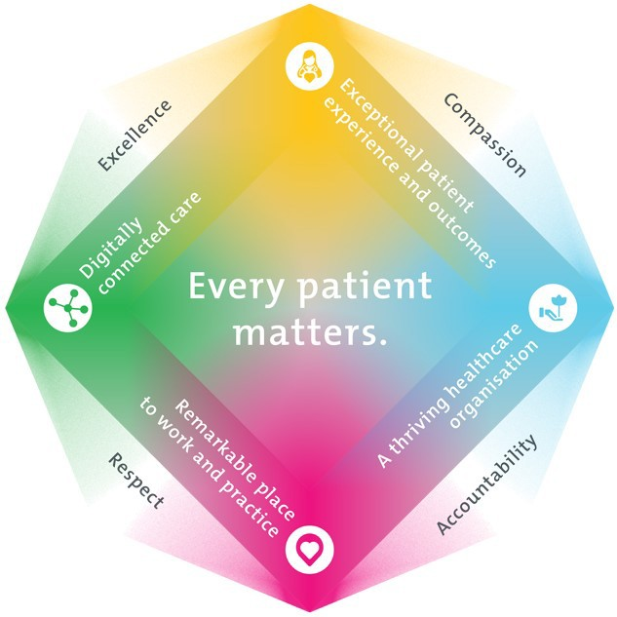
Epworth HealthCare Strategy

All roles are linked to the Epworth strategy and are fundamental in achieving its vision and purpose.
Exceptional patient experience and outcomes - To empower our patients and deliver compassionate, expert and coordinated care.
A thriving healthcare organisation - To adapt and grow in a changing healthcare landscape by delivering a unique private not-for-profit healthcare
organisation.
Remarkable place to work and practice - To ensure Epworth is an outstanding place to work and practice through a culture of care
and investment in our people.
Digitally connected care - To innovate and improve the digital experience, interactions and outcomes for our patients, staff and doctors.

- Purpose of the Position

The Facilities Supervisor;

  - Is to plan, co-ordinate, audit & review the activities and all elements of the corrective maintenance and in-house inspection processes via self-managed employees within the workshop team.
  - Is to coordinate all minor operational expenditure (Opex) and capital expenditure (Capex) projects assigned to the Eastern Facilities team.
  - As and when required work hands-on either individually or with team members to the technical capability of the incumbent.
  - Is to be available on call as per site roster

Clinical Governance Framework
This role is required to put into practice the Clinical Governance Framework at Epworth as every employee is accountable for ensuring that our patients and community receive safe, high quality and person-centred care in every interaction with Epworth. This is achieved through active participation in the five domains of clinical governance at Epworth:

Clinical Governance Domain | Role
Leadership and culture | Promote and participate in a supportive, fair and transparent culture where lessons from previous outcomes are learned and patient safety and quality is a priority at all levels of the organisation.
Consumer Partnerships | Understand and where relevant, ensure that each patient is actively involved in their own care and treatment including  families/carers wherever possible.
Effective Workforce | Develop and maintain one’s own competency, skills and knowledge to ensure high quality service provision and care.
Clinical Safety and Effectiveness | Understand and where relevant, ensure, that the right care is provided to the right person at the right time, in the right  place and patient outcomes are monitored and improved.
Risk Management | Be responsible for identifying and reporting risks, hazards and near misses for people in our care and participating in risk  mitigation strategies.

Key Accountabilities

KEY RESPONSIBILITIES | MEASURES/KPIs TO BE ACHIEVED
Team effectiveness  - Communicating, motivating and directing within the facilities team and direct/indirect reports  - Establish positive relationship with colleagues and stakeholders  - Contribution to department efficiency by effective utilisation of time and resources  - Participate in Facilities meetings both locally and across the group  - Participate in the on-call roster with other Eastern Facilities team members  - To assist in the provision of the overall facilities service to Epworth Eastern | - Supervise staff to ensure the corrective maintenance (CM) targets are achieved  - Supervise staff to ensure the in-house inspection and preventative maintenance (PM) targets are achieved in accordance with their required timeframes  - Actively participates and effective team member  - Ensure a consistent approach to work that is in-line with group expectations & requirements.
Communication skills  - Actively liaise and consult with relevant staff members and external contractors to ensure effective communication is maintained.  - Participate in effective communication and problem solving as part of the facilities team.  - Actively engage and provide recommendations to committees and prepare action statements/minutes as required  - Handling complaints, poor performance, or otherwise negotiating with others the ensure overall team targets are met. | - Maintain open communication - information loop between clinical, non-clinical, construction team members and Epworth HealthCare Department Heads and Executives  - Resolving conflicts and negotiating with others
Construction Management  - Create, monitor and maintain activities and actions against a project management plan  - Effective communication to all relevant parties to ensure effective and smooth establishment of departments and disciplines  - Work with various departments and disciplines to ensure they are aware of project requirements and interruptions.  - As required work hands on as a team member to ensure project or activity completion | - Completion on time, scope and budget  - Liaising with the consultant team and stakeholders to achieve  - Close out of the project defects  - Ensure all workmanship is within quality parameters and meets statutory and scope requirements
Operations Management  - Support the inhouse building trades team to perform CM and PM tasks;  - Create and maintain the inhouse building trades rosters;  - Identify operational service innovations;  - Conduct building audits/inspections to independently ensure operational compliance by the building trades team and 3rd party contractors in accordance with contractual deliverables and the Facility Management Strategy;  - Ensure CM and PM works are completed within pre-determined budget and response/completion times as specified within Tech1 assigned priorities;  - Assist to ensure the accuracy of hospital operational data (eg. Asset Registers, PM Schedules, EoL registers, various report recommendations etc);  - Ensure compliance with clinical, legislative and applicable standards relating to Epworth;  - Adhere with Epworth protocols and operational workflows;  - Be available for unforeseen after hours call-out in emergency/crisis situations with respect to building services & maintenance;  - Provide day to day functional management support, mentoring and training to direct reports;  - Tasks as assigned by the Facility Manager; | - Supervise in-house Teams and 3rd party contractors’ tasks/services to assigned KPI’s;  - Consumable inventory is maintained to agreed levels;  - Critical spares inventory is maintained to agreed levels;  - Inhouse rosters prepared in advance (minimum 1 month in advance);  - Delivery of PMs and CM works to assigned KPI’s  - PM and CM works not be extended more than one extension;  - Forwarding of accurate data for the preparation of operational and clinical reports by the Facility Manager;  - 3rd party contractor and inhouse building trades team works correctly receipted in Tech1 to not delay invoice payments;  - Minimise AP direct invoices;  - Mitigate clinical and legislative breaches;
Finance  - Record and track “out of scope” Opex and Capex works to substantiate monthly P&L expenditure;  - Manage within financial delegated authority limits;  - Supervise and validate that the inhouse building trades team and accurately ensure that all works (reactive and preventative) shall have Work Orders and/or Purchase Orders issued prior to contractors (suppliers) are appointed;  - Process/approve Work Orders and/or Purchase Orders within delegated authority limits;  - Supervise and validate receipt of Work Orders and/or Purchase Orders by the inhouse building trades team to ensure payment of invoices by AP Team; | - Meeting MTD and YTD financial targets;  - Formal tracking of “out of scope” Opex and Capex works;  - All external works to have purchase orders raised prior to receipt of invoices except for government organisations;  - 3rd party contractors (appointed by Facilities) to not place Epworth on stop credit;
Contract Management  - Accurately manage the service quality standards delivered by suppliers;  - Validate assigned suppliers, their performance against contract scope of services and KPIs.  - Assist in the review of Supplier contracts and provide recommendations for improvement; | - Conduct assigned supplier cyclic contract meetings;  - Maintain assigned contract variation matrix;
Customer Service  Epworth is committed to the provision of excellent customer service to all of our people, customers and stakeholders including patients and external suppliers.  Superior patient service leads to improved healing in a trusting, caring environment and creates a safe environment for patients and employees.  - Role model and actively promote a culture of high-quality patient care  - Provide excellent, helpful service to patients, visitors and staff  - Communicate with clear and unambiguous language in all interactions, tailored to the audience  - Build customer relationships and greet customers and patients promptly and courteously  - Actively seek to understand patients' and their family's expectations and issues, using multiple strategies  - Uses data (such as compliments, complaints and Press Ganey) to identify breakdowns in internal processes and systems that directly impact patient care and customer service  - Responds quickly and proactively escalate concerns when necessary  - Role model and actively promote a culture of high-quality patient care and experience by ensuring that solutions, practices and procedures (such as hourly rounding, leader rounding and bedside handover) are carried out with empathy and compassion | - Patient and customer service satisfaction surveys within agreed targets  - Use AIDET principles in all interactions  - Compliments to complaints ratios  - Completes leader rounding at agreed frequency  - Issues are escalated to the manager and resolved in a timely manner
Safety and Wellbeing  To ensure a safe workplace is provided for all employees and other personnel including contractors, agency staff, volunteers and students.  - All employees and other personnel under the authority of the manager are fully informed of the hazards associated with their work activities, adequately trained and instructed in safe work procedures and appropriately supervised.  - Integrate and review OHS performance in staff PDPs  - Ensure all direct reports are held accountable for safety performance and actions | - Adhere to infection control/personal hygiene precautions  - Implement and adhere to Epworth OHS policies, protocols and safe work procedures  - Ensure all hazards, incidents and injuries are reported in Riskman within 24 hours  - Ensure all hazards, incidents and injuries are investigated and corrective actions implemented within agreed timeframes  - Mandatory training completed at agreed frequency

- Position Requirements/Key Selection Criteria

COMPONENT
Qualifications | Essential  - A Trades qualification or equivalent experience in a facilities management role or similar  Desirable  - A Trades person with a mechanical or electrical certificate
Previous Experience | Essential  - 5 years working in a facilities environment  Desirable  - 5 years working experience in a facilities coordinating/supervising role or similar

COMPONENT
Required Knowledge & Skills | Essential  - Computer literacy e.g. MS Office,  - Organisational, prioritisation and time management skills,  - Work with managers to ensure high utilisation of available technology,  - Demonstrated organisational skills
Personal Attributes & Values  All employees are expected to consistently work in accordance with Epworth’s values and behaviours  - Compassion  - Accountability  - Respect  - Excellence | Essential  - Ability to work well as a member of different teams,  - Good communication, influencing, interpersonal and relationship management skills,  - Demonstrate initiative and management of human and material resources to meet the organisational requirement for cost efficient services whilst maintaining the safety of patients, visitors and staff.  - Contribute to the development of a cohesive, facilitative and inclusive team-based culture, embracing high levels of service orientation particularly towards key stakeholders.  - A ‘can-do’ attitude and solutions focussed approach with a proven track record in meeting KPIs and project management; Ability to manage differing and sometimes conflicting needs.  - Prepared to make a commitment to working towards Epworth’s mission and values and delivering on our strategic plan.
Document Control
Date Developed: | Date Last Reviewed: | Developed and Reviewed By (Position Title):
December 16th 2021 | 4 May 2026 | Group Manager Facilities and Asset Management

Employee Position Declaration
I have read and understand the requirements and expectations of the above Position Description. I agree that I have the physical ability to fulfil the inherent physical requirements of the position, and accept my role in fulfilling the Key Accountabilities. I understand that the information and statements in this position description are intended to reflect a general overview of the responsibilities and are not to be interpreted as being all-inclusive.

Employee Signature:
Print Name: | Date:

