General Information

Position Title: | Employment and Onboarding Coordinator
Division/Department: | People & Culture - Workforce
Position Reports to: | Contract and Onboarding Lead
Enterprise/Individual Agreement: | Individual Employment Agreement
Classification/Grade: | N/A
Location: | Epworth Pelaco (Richmond)
Employment Status: | Full-time/Part-time
Resource Management  (for Management positions only)  Number of Direct Reports:  Budget under management: | Nil
Key Relationships - internal and external | - People and Culture Team  - Hiring Managers  - Candidates  - Payroll Team
- Overview of Epworth HealthCare
Epworth HealthCare is Victoria’s largest not-for-profit private health care group, renowned for excellence in diagnosis, treatment, care and rehabilitation. Epworth
is an innovator in Australia’s health system, embracing the latest in evidence-based medicine to pioneer treatments and services for our patients.

Epworth’s values define our approach and our delivery. We pride ourselves on communicating our values and delivering on them in a real and meaningful way. Our Values are Compassion, Accountability, Respect and Excellence. More information can be found on the Epworth website.

Epworth’s purpose is Every Patient Matters.

Our Vision is Delivering another 100 years of exceptional healthcare and innovation to the Victorian community.

Epworth HealthCare Strategy
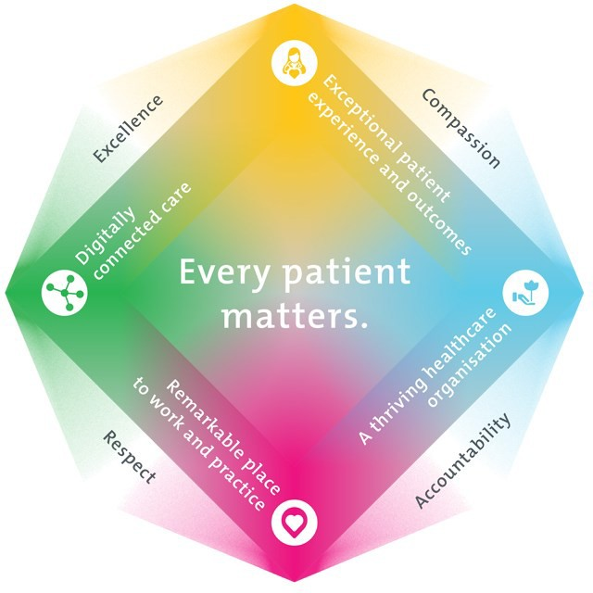

All roles are linked to the Epworth strategy and are fundamental in achieving its vision and purpose.
Exceptional patient experience and outcomes - To empower our patients and deliver compassionate, expert and coordinated care.
A thriving healthcare organisation - To adapt and grow in a changing healthcare landscape by delivering a unique private not-for-profit
healthcare organisation.
Remarkable place to work and practice - To ensure Epworth is an outstanding place to work and practice through a culture of care
and investment in our people.
Digitally connected care - To innovate and improve the digital experience, interactions and outcomes for our patients, staff and doctors.

Purpose of the Position
To coordinate and deliver end-to-end employment and onboarding activities, ensuring timely, accurate and compliant employment contracts, onboarding documentation and recruitment support.
The role supports hiring managers, candidates and internal stakeholders through proactive coordination, stakeholder communication and effective use of recruitment and onboarding systems.
Key focus areas:
  - Produce accurate employment contracts and quality advertisements within required timeframes.
  - Coordinate end-to-end onboarding activities, including proactive follow-ups with candidates and hiring managers
  - Act as a key point of contact for recruitment and onboarding enquiries from hiring managers and candidates
  - Ensure all payroll related information from new hires is accurately processed through to payroll.
  - Create employment files for all new employees.

Clinical Governance Framework
This role is required to put into practice the Clinical Governance Framework at Epworth as every employee is accountable for ensuring that our patients and community receive safe, high quality and person-centred care in every interaction with Epworth. This is achieved through active participation in the five domains of clinical governance at Epworth:

Clinical Governance Domain | Role
Leadership and culture | Promote and participate in a supportive, fair and transparent culture where lessons from previous outcomes are learned and patient safety and quality is a priority at all levels of the organisation.
Consumer Partnerships | Understand and where relevant, ensure that each patient is actively involved in their own care and treatment including  families/carers wherever possible.
Effective Workforce | Develop and maintain one’s own competency, skills and knowledge to ensure high quality service provision and care.
Clinical Safety and Effectiveness | Understand and where relevant, ensure, that the right care is provided to the right person at the right time, in the right  place and patient outcomes are monitored and improved.
Risk Management | Be responsible for identifying and reporting risks, hazards and near misses for people in our care and participating in risk  mitigation strategies.

Key Accountabilities

KEY RESPONSIBILITIES | MEASURES/KPIs TO BE ACHIEVED
Employment and Onboarding  Provision of employment establishment and onboarding functions utilising Epworth’s recruitment technologies in line with organisational policies and legislation.  - Administer and track all incoming recruitment advertising and employment contract requests and then ensure accurate and timely processing to completion, recording in relevant databases.  - Produce accurate and compliant employment contracts and quality advertisements within required timeframes and to required standards  - Initiate all new hire onboarding, including necessary follow-up with new hires and/or their managers as necessary  - Ensure all payroll related information from new hires is accurately processed through to payroll.  - Establish employee files for all new hires  - Respond to written and verbal enquiries from candidates and people leaders regarding system and onboarding queries.  - Respond to ‘phone, email, and face to face customer queries with a high  level of professionalism, tact and diplomacy.  - Process pre-employment screening checks in accordance with Epworth policies and protocols and any audit requirements  - Maintain high degree of confidentiality  - Support the administration of visa nominations/ sponsorship  - Demonstrate accuracy and strong organisational and time management skills with the ability to successfully complete several tasks concurrently  - Maintain high levels of attention to detail and timeframes to ensure all recruitment deadlines are met | - Meet Service Level Agreements (SLAs) – eg. Employment Contracts issued within agreed established timeframes and accurate information processed to Payroll well within deadlines  - High level accuracy  - Level of satisfaction experienced by new starters through feedback including onboarding surveys.  - Level of satisfaction experienced by People & Culture teams and hiring managers through feedback and customer surveys.  - Competency in recruitment management technology –eRecruit system (Smart Recruiter), Cognology, Fit2Work, eVISA and Chris 21  - Organised and easily accessed employee data and file information

KEY RESPONSIBILITIES | MEASURES/KPIs TO BE ACHIEVED
Service  - Meet or exceed deadlines and provide a high quality service to the organisation to foster excellent customer relationships  - Deal confidently and courteously with stakeholders at all levels  - Ensure consistent and regular communication with key internal stakeholders  - Identify system improvements, procedural requirements and personal training and development needs  - Be professional and courteous when faced with demands or unexpected tasks which may impact on deadlines  - Manage and respond to recruitment and onboarding enquiries via the Talent inbox and phone line in line with service expectations | - Monitor and evaluate the outcomes of tasks  - Stakeholder feedback  - Hiring manager satisfaction  - Candidate satisfaction  - Meeting timeframes to produce contracts after approval
Quality:  Adhere to internal systems and workflows for the delivery of a streamlined and robust recruitment process  - Demonstrate the drive and resilience to consistently achieve quality results  - Evaluate processes to improve efficiency  - Appropriately manage and maintain procedures  - Ensure documentation process is correctly managed | - Improve quality assurance by adhering thorough audit processes  - Reduction in the amount of late returned paperwork by tracking the amount received within the cut off period  - Feedback evaluations  - Audit tasks to ensure accuracy and quality work is being produced
People:  - Establish, build and maintain rapport with internal stakeholders  - Uphold a strong liaison with all stakeholder levels to ensure consistency in standards  - Address stakeholder queries promptly and professionally  - Work collaboratively and constructively in a team  - Handle situations sensitively and professionally  - Strictly maintains confidentiality | - Level of stakeholder satisfaction provided through feedback responses  - Team discussions and evaluations

KEY RESPONSIBILITIES | MEASURES/KPIs TO BE ACHIEVED
Customer Service -Staff  Epworth is committed to the provision of excellent customer service to all of our people, customers and stakeholders including patients and external suppliers.  Superior patient service leads to improved healing in a trusting, caring environment and creates a safe environment for patients and employees.  - Provide excellent, helpful service to patients, visitors and staff  - Communicate with clear and unambiguous language in all interactions, tailored to the audience  - Build customer relationships and greet customers and patients promptly and courteously  - Actively seek to understand patients' and their family's (customers) expectations and issues | - Patient and customer service satisfaction surveys within agreed targets  - Use AIDET principles in all interactions  - Issues are escalated to the manager and resolved in a timely manner
Safety and Wellbeing – Staff  Participate actively and positively in the area of health and safety to reduce all hazards and incidents within the workplace  - Report all hazards, incidents, injuries and near misses immediately to your manager and log them in RiskMan  - Patient and customer service satisfaction surveys within agreed targets  - Use AIDET principles in all interactions  - Issues are escalated to the manager and resolved in a timely manner  - ​ | - Adhere to infection control/personal hygiene precautions  - Implement and adhere to Epworth OHS policies, protocols and safe work procedures  - Mandatory training completed at agreed frequency

- Position Requirements/Key Selection Criteria

COMPONENT
Qualifications | Essential  - Nil  Desirable  - Human Resources qualifications
Previous Experience | Essential  - Experience in fast paced and high volume administrative recruitment related or similar role  Desirable  - Previous human resources experience in a healthcare or related environment  - Chris21 and Smart Recruiter / Cognology eRecruit technology experience
Required Knowledge & Skills | Essential  - High level of accuracy and attention to detail  - Highly organised with the ability to effectively manage competing priorities and meet deadlines  - Excellent written and verbal communication skills; able to communicate with tact and diplomacy.  - Ability to handle sensitive and highly personal information on a daily basis  - Ability to maintain confidentiality in a mature and non-judgmental manner  - Ability to work autonomously and as a constructive and participative team member  - Proficient in Microsoft Office applications – confident with learning new software  Desirable  - Exposure to e-recruitment software and Human Resource Information Systems
Personal Attributes & Values | Essential  - Passionate about providing exceptional candidate care  - Positive ‘can do’ attitude and proactive professional approach

All employees are expected to consistently work in accordance with Epworth’s values and behaviours  - Compassion  - Accountability  - Respect  - Excellence | - High level of initiative and self-directed  - Lives and role models Epworth’s values and associated behaviours  - Ability to provide and maintain a commitment to excellent customer service by supporting continuous improvement processes.  - Highly organised with excellent attention to detail and the ability to manage several projects at the same time  - Ability to work well under pressure, in a fast-paced, changing environment  - Motivated with a positive ‘can do’ attitude  - Resilient and able to adapt to changing circumstances and priorities  - Professional work ethic
Document Control
Date Developed: | Date Last Reviewed: | Developed and Reviewed By (Position Title):
January 2014 | April 2026 | Group Talent Acquisition Manager  Contract and Onboarding Lead

Employee Position Declaration
I have read and understand the requirements and expectations of the above Position Description. I agree that I have the physical ability to fulfil the inherent physical requirements of the position and accept my role in fulfilling the Key Accountabilities. I understand that the information and statements in this position description are intended to reflect a general overview of the responsibilities and are not to be interpreted as being all-inclusive.

Employee Signature:
Print Name: | Date:

