
Position Description

General Information

Position Title: | Patient Liaison Officer
Division/Department: | Clinical Services
Position Reports to: | Director of Clinical Services
Enterprise/Individual Agreement: | Individual Agreement
Classification/Grade:
Location: | Epworth Eastern
Employment Status: | Part time 0.4 FTE
Resource Management  (for Management positions only)  Number of Direct Reports:  Budget under management: | Nil
Key Relationships - internal and external | Internal - Executive Team, Managers, Doctors, Nursing, Allied Health & Support Services staff, IMed Radiology Melbourne Pathology, Slade Pharmacy, Finance, Legal Counsel  External - Patients, Carers, Health Complaints Commissioner, Safer Care Victoria

- Overview of Epworth HealthCare
Epworth HealthCare is Victoria’s largest not-for-profit private health care group, renowned for excellence in diagnosis, treatment, care and rehabilitation. Epworth is an innovator in Australia’s health system, embracing the latest in evidence-based medicine to pioneer treatments and services for our patients.

Epworth’s values define our approach and our delivery. We pride ourselves on communicating our values and delivering on them in a real and meaningful way. Our Values are Compassion, Accountability, Respect and Excellence. More information can be found on the Epworth website.

Epworth’s purpose is Every Patient Matters.

Our Vision is Delivering another 100 years of exceptional healthcare and innovation to the Victorian community.

Epworth HealthCare Strategy

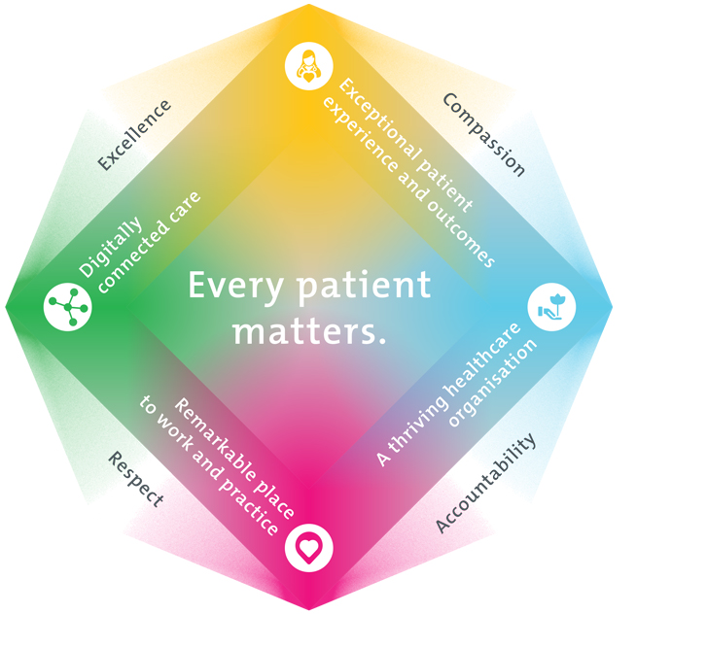
All roles are linked to the Epworth strategy and are fundamental in achieving its vision and purpose.
Exceptional patient experience and outcomes - To empower our patients and deliver compassionate, expert and coordinated care.
A thriving healthcare organisation - To adapt and grow in a changing healthcare landscape by delivering a unique private not-for-profit healthcare organisation.
Remarkable place to work and practice - To ensure Epworth is an outstanding place to work and practice through a culture of care
and investment in our people.
Digitally connected care - To innovate and improve the digital experience, interactions and outcomes for our patients, staff and doctors.

- Purpose of the Position
The purpose of the position is to be available to assist patients, carers, staff, doctors and managers in the resolution of patient care concerns. The role is responsible for receiving and initially addressing all patients' and carers' concerns and feedback, and then if required coordinating the investigation and review undertaken by the relevant clinical and management personnel. Instrumental in communicating and improving patient service delivery across the Division, the Patient Liaison Officer is a support and resource for all staff and doctors in their effective management of patients' concerns and feedback. The position is a key a point of contact for the Health Complaints Commission, Department of Health and any other external organisation in relation to patient feedback or complaints.

- Clinical Governance Framework
This role is required to put into practice the Clinical Governance Framework at Epworth as every employee is accountable for ensuring that our patients and community receive safe, high quality and person-centred care in every interaction with Epworth.
This is achieved through active participation in the five domains of clinical governance at Epworth:

Clinical Governance Domain | Role
Leadership and culture | Promote and participate in a supportive, fair and transparent culture where lessons from previous outcomes are learned and patient safety and quality is a priority at all levels of the organisation.
Consumer Partnerships | Understand and where relevant, ensure that each patient is actively involved in their own care and treatment including families/carers wherever possible.
Effective Workforce | Develop and maintain one’s own competency, skills and knowledge to ensure high quality service provision and care.
Clinical Safety and Effectiveness | Understand and where relevant, ensure, that the right care is provided to the right person at the right time, in the right place and patient outcomes are monitored and improved.
Risk Management | Be responsible for identifying and reporting risks, hazards and near misses for people in our care and participating in risk mitigation strategies.

- Key Accountabilities

KEY RESPONSIBILITIES | MEASURES/KPls TO BE ACHIEVED
Management of Patient and Carer Complaints through  - Early intervention with patients, carer and staff  - Thorough, timely and appropriate investigation of feedback  - Immediate corrective action if required  - Ensure appropriate co-ordination and escalation of patient complaints to relevant internal and/or external parties  - Oversee the timely, consistent, and empathetic handling of complaints across the site  - Contribution to prevention strategies  - Debriefing of staff and doctors  - Referral made to Health Complaints Commission (HCC) or other, appropriate external bodies as indicated  - Acting as a resource for Epworth's Complaints Management Policy | - Complaints / feedback managed within prescribed timeframes detailed in the Epworth Patient Complaint Procedure  - Significant or complex patient complaints are escalated promptly  - A customer service focus is demonstrated in every interaction and discussion with patients, carers, staff and doctors  - Written and verbal communication with patients and carers reflects organisational values, supports health literacy, and promotes person-centred care.  - Completion of Incident Management System for all complaints / feedback  Demonstrates:  - a consultative approach to complaints management  - an ability to work with a diverse range of people both internally and externally  - highly developed negotiation skills and experience in dispute resolution  - an understanding of complaints management and improving customer service within a risk management framework  - a sound knowledge of hospital systems and patient care processes
Review and Collation of Patient feedback data:  - Accurate and timely documentation undertaken  - Identify trends, recurring issues, and potential risks from complaint data  - Root cause analyses undertaken as required  - Written report undertaken monthly, or as requested  - Outcomes reported to assist continuous improvement activities  - Hospital-wide feedback and communication provided as required | - Analyses and trends data prepared on time and escalated as required  - Outcomes reported and recommendations made and shared to assist continuous improvement activities  Demonstrates:  - high level verbal and written communication skills  - highly developed analytical skills and attention to detail  - the timely provision of internal reports as required

Provision of education and support for staff and doctors in relation to service recovery, customer feedback and complaints management  - Be involved in or oversee customer service staff education programs to increase understanding of the Epworth approach to complaint handling and resolution processes  - Develop and deliver staff information and training programs in relation to improving patient experience  - Act as a trainer, mentor and adviser for staff tasked with the handling of complaints, ensuring staff have the skills required to manage complaints  effectively | - Appropriate education programs are developed  - Education Sessions are organised, led and evaluated  - Staff understand the importance of the appropriate, timely action taken in relation to feedback, and are able to de-escalate a challenging complaint situation with patients and carers  - Sought by staff and doctors for assistance  - Positive feedback about assistance provided is received from patients, carers, staff, doctors and managers
Customer Service  Epworth is committed to the provision of excellent customer service to all of our people, customers and stakeholders including patients and external suppliers.  Superior patient service leads to improved healing in a trusting, caring environment and creates a safe environment for patients and employees.  - Role model and actively promote a culture of high quality patient care  - Provide excellent, helpful service to patients, visitors and staff  - Communicate with clear and unambiguous language in all interactions, tailored to the audience  - Build customer relationships and greet customers and patients promptly and courteously  - Actively seek to understand patients' and their family's expectations and issues, using multiple strategies  - Uses data (such as compliments, complaints and patient experience feedback) to identify breakdowns in internal processes and systems that directly impact patient care and customer service  - Responds quickly and proactively escalate concerns when necessary | - Patient and customer service satisfaction surveys within agreed targets  - Use of AIDET principles evident in all interactions  - Compliments to complaints ratios  - Issues are escalated to the manager and resolved in a timely manner

- Role model and actively promote a culture of high quality patient care and experience by ensuring that solutions, practices and procedures are carried out with empathy and compassion
Safety and Wellbeing  To ensure a safe workplace is provided for all employees and other personnel including contractors, agency staff, volunteers and students.  - All employees and other personnel under the authority of the manager are fully informed of the hazards associated with their work activities, adequately trained and instructed in safe work procedures and appropriately supervised. Participate actively and positively in the area of health and safety to reduce all hazards and incidents within the workplace  - Integrate and review OHS performance in staff PDPs  - Ensure all direct reports are held accountable for safety performance and actions | - Adhere to infection control/personal hygiene precautions  - Implement and adhere to Epworth OHS policies, protocols and safe work procedures  - Ensure all hazards, incidents and injuries are reported in Riskman within 24 hours  - Ensure all hazards, incidents and injuries are investigated and corrective actions implemented within agreed timeframes  - Mandatory training completed at agreed frequency

Position Requirements/Key Selection Criteria

COMPONENT
Qualifications | Essential  - Degree in clinical or relevant health-related area of study  Desirable  - Relevant post-graduate qualification in health care related field
Previous Experience | Essential  - Demonstrated experience in complaint handling and resolution in a service industry  - Acute health care experience  Desirable  - Clinical practice experience in health care organisation  - Knowledge and experience of Riskman Feedback (software system)  - Experience in development and presentation of training/information sessions  - Knowledge of Complaint Handling Standards, privacy legislation and Statutory Duty of Candour
Required Knowledge & Skills | Essential  - Excellent writing skills  - Computer skills - Outlook, Word, Excel  - Highly developed negotiation skills and experience in dispute resolution  Desirable  - Advanced computer skills  - A consultative approach to complaints management and working closely with managers and other parties  - Ability to communicate compassionately, constructively and effectively

Personal Attributes & Values  All employees are expected to consistently work in accordance with Epworth's values and behaviours  - Compassion  - Accountability  - Respect  - Excellence | Essential  - Effective interpersonal and communication skills particularly in situations requiring de-escalation, resolution, and empathy  - Problem-solving skills  - Commitment to providing a customer focused service.  - Commitment to communicating with empathy and understanding.  - Strong emotional intelligence  - Resilience  - Calm  - Positive  - Kind, friendly demeanor  - Team focus  - Capacity to work under minimal supervision

Document Control
Date Developed: | Date Last Reviewed: | Developed and Reviewed By (Position Title):
November 2017 | January 2026 | Director of Clinical Services

Employee Position Declaration
I have read and understand the requirements and expectations of the above Position Description. I agree that I have the physical ability to fulfil the inherent physical requirements of the position, and accept my role in fulfilling the Key Accountabilities. I understand that the information and statements in this position description are intended to reflect a general overview of the responsibilities and are not to be interpreted as being all-inclusive.

Employee Signature:

Print Name: Date:

