- General Information
Position Title: | Senior Legal Counsel
Division/Department: | People and Culture – Legal Services
Position Reports to: | Chief Legal Officer & Executive Director Corporate Governance
Enterprise/Individual Agreement: | Individual Agreement
Location: | Corporate Office
Employment Status: | Permanent full time
Resource Management  (for Management positions only)  Number of Direct Reports:  Budget under management: | This position has no direct reports.  N/A
Key Relationships - internal and external | Group Executive  Executive General Managers  Corporate and Operational Managers  Health Information Services  Insurance Brokers and Insurers  External Law Firms  Coroners Court of Victoria  Victoria Police  Department of Health (Victoria)  Australian Charities and Not-for-Profits Commission  Australian Securities and Investments Commission  Australian Taxation Office/Australian Business Register  Office of the Australian Information Commissioner  Health Complaints Commissioner (Victoria)  Human Rights Commission  Australian Health Practitioner Regulation Agency

2. Overview of Epworth HealthCare
Epworth HealthCare is Victoria’s largest not-for-profit private health care group, renowned for excellence in diagnosis, treatment, care and rehabilitation. Epworth is an innovator in Australia’s health system, embracing the latest in evidence-based medicine to pioneer treatments and services for our patients.

Epworth’s values define our approach and our delivery. We pride ourselves on communicating our values and delivering on them in a real and meaningful way. Our Values are Compassion, Accountability, Respect and Excellence. More information can be found on the Epworth website.

Epworth’s purpose is Every Patient Matters.

Our Vision is Delivering another 100 years of exceptional healthcare and innovation to the Victorian community.

3. Epworth HealthCare Strategy
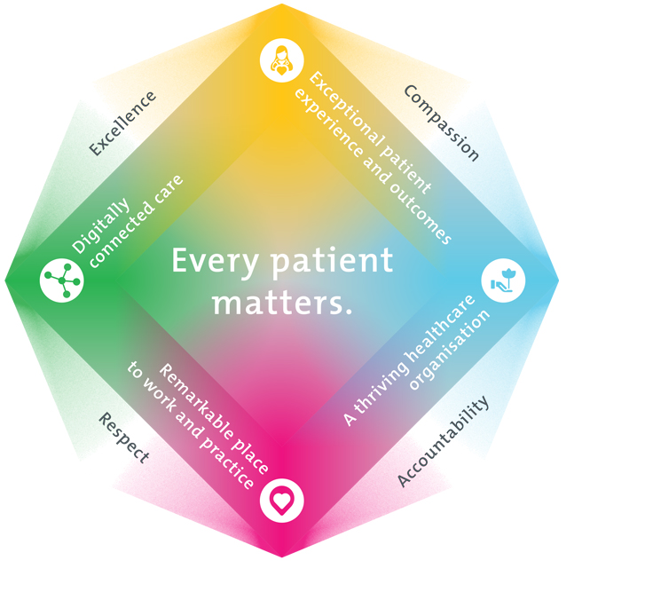
All roles are linked to the Epworth strategy and are fundamental in achieving its vision and purpose.
Exceptional patient experience and outcomes - To empower our patients and deliver compassionate, expert and coordinated care.
A thriving healthcare organisation - To adapt and grow in a changing healthcare landscape by delivering a unique private not-for-profit healthcare organisation.
Remarkable place to work and practice - To ensure Epworth is an outstanding place to work and practice through a culture of care
and investment in our people.
Digitally connected care - To innovate and improve the digital experience, interactions and outcomes for our patients, staff and doctors.
4. Purpose of the Position
The Senior Legal Counsel is responsible for providing legal services to the Epworth HealthCare in support of the organisation’s operational, compliance and risk management objectives.

This position is a member of the Legal Services Team, reporting to the General Counsel and responsible for the provision of legal services to Epworth HealthCare across a wide range of complex matters, with a specific focus on privacy, medico-legal, public liability and legislative compliance. The role primarily involves carriage of privacy advice, handling of claims and responding to legal queries from operational staff. The role is also responsible for supporting the Legal Services Manager in:
- developing and implementing of a robust privacy management framework and privacy management plan
- maintaining the privacy register; and
- managing of the organisation’s legislative compliance program and advising on legislative and policy compliance matters.

The broader responsibilities of the role reflect the diverse functions of the Legal Services Team and include contract review and drafting, corporate and commercial advice, general advisory work, advice on research activities and clinical trials and associated agreements, medical accreditation processes, general insurance claims, employment matters, advice on legislative and policy compliance and asset management.

The position is required to manage personally and commercially sensitive information with maturity and discretion, and to engage with staff at all levels of the organisation. Success in this role is characterised by a professional and responsive approach with sound legal acumen, leveraging relationships across a broad range of internal stakeholder groups to appropriately protect and position the business.

5. Clinical Governance Framework
This role is required to put into practice the Clinical Governance Framework at Epworth as every employee is accountable for ensuring that our patients and community receive safe, high quality and person-centred care in every interaction with Epworth. This is achieved through active participation in the five domains of clinical governance at Epworth:

Clinical Governance Domain | Role
Leadership and culture | Promote and participate in a supportive, fair and transparent culture where lessons from previous outcomes are learned and patient safety and quality is a priority at all levels of the organisation.
Consumer Partnerships | Understand and where relevant, ensure that each patient is actively involved in their own care and treatment including families/carers wherever possible.
Effective Workforce | Develop and maintain one’s own competency, skills and knowledge to ensure high quality service provision and care.
Clinical Safety and Effectiveness | Understand and where relevant, ensure, that the right care is provided to the right person at the right time, in the right place and patient outcomes are monitored and improved.
Risk Management | Be responsible for identifying and reporting risks, hazards and near misses for people in our care and participating in risk mitigation strategies.
6. Key Accountabilities
KEY RESPONSIBILITIES
Support the Chief Legal Officer & Executive Director Corporate Governance to ensure the provision of high quality, practical, timely and cost-effective legal work and advice on a wide range of matters to key Epworth HealthCare stakeholders, including –
LEGAL ADVICE
- Provide wide-ranging legal advice as required including in relation to privacy, health law, reporting obligations, consent to treatment and other issues relevant to Epworth HealthCare’s functions, corporate governance, commercial and regulatory issues, intellectual property and leases, insurance, contract interpretation, statutory interpretation, probity and procurement, policies and procedures.
PRIVACY
- Be the first point of contact for advice on privacy matters.
- Provide privacy advice in relation to projects that may have an impact on an individual’s personal information.
- Develop and implement a process for and conduct of privacy impact assessments.
- Conduct privacy training.
- Support the Legal Services Manager in the maintenance of the organisation’s privacy register.
LEGISLATIVE COMPLIANCE
- Keep up to date with changes in law affecting Epworth HealthCare and proactively engage management to develop and refine appropriate organisational changes meet evolving legal requirements.
- Monitor and assess changes that are made by the organisation to address legal and/or regulatory changes.
- Support the Legal Services Manager in the maintenance of the organisation’s legislative compliance register and legislative compliance subscription service (Comply Online).
CLAIMS AND LITIGATION
- Assist with dispute resolution by undertaking research and providing advice regarding claims and litigation as required.
- Manage medico-legal and general litigation matters, inquests and other inquiries, including by providing advice and reports to Epworth HealthCare management.
- Represent Epworth HealthCare in courts, including the Coroner’s Court, Tribunals and Commissions as required
- Advise and support clinical and other hospital staff in relating to medico-legal proceedings and the preparation of evidence to go before a court.
- Engage with the Epworth HealthCare’s insurance broker and insurers to ensure appropriate application of Epworth HealthCare’s insurance policies
CONTRACTUAL NEGOTIATION, DRAFTING AND REVIEW
- Negotiate and draft a broad range of contracts, including complex multi-party arrangements, contracts for services, supply, maintenance, IT, funding, memoranda of understanding, and leases and licenses.
- Advise on procurement practices to ensure the implementation and demonstration of appropriate probity practices.
- Negotiate and draft a broad range of contracts, including complex multi-party arrangements, contracts for services, supply, maintenance, IT and funding, memoranda of understanding, and leases and licenses.
- Advise on procurement practices to ensure the implementation and demonstration of appropriate probity practices.
PROCESS IMPROVEMENT
- Work with the General Counsel on innovative ways to improve and enhance the efficient running of the Legal Services team.
- Ensure continuing professional development requirements are met at all times and contribute to the professional development of the Legal Services team.
- Development and continuous improvement of precedents, legal tools and templates.
- Undertake any additional tasks as directed by the General Counsel and Group Director Corporate Governance and Risk within the scope of the position and classification.
- Deliver education and training for staff of Epworth HealthCare.

7. Position Requirements/Key Selection Criteria
COMPONENT
Qualifications | Essential  - Admission to practice in the Supreme Court of Victoria  - Possess or be eligible to obtain a Victorian Practising Certificate from the Legal Practice Board of Victoria  Desirable  - Postgraduate qualification in law.
Previous Experience | Essential  - 3 to 5 years PQE  - Previous experience in applying privacy laws and other legislation relevant to the handling of personal information.  - Previous experience with dispute resolution and complaint-handling methods and processes.  Desirable  - Healthcare sector experience.
Required Knowledge & Skills | Essential  - Demonstrated experience in general commercial and contracts work.  - Demonstrated experience in privacy law.  - Demonstrated experience in negotiating effective outcomes in complex business relationships.  - Demonstrated experience in legislative interpretation and application.  - Demonstrated experience in supporting the development and implementation of policies and procedures in complex operational environments.  - Highly developed oral and written communication skills.  - Well-developed interpersonal and negotiation skills, including the ability to work collaboratively with a range of professional, medical and allied health staff and representatives of external agencies.  - Demonstrated ability to provide practical and timely advice, manage competing priorities and tight deadlines with a positive, ‘can do’ approach.  - Ability to be flexible and resourceful, and to think laterally to address issues.  - Ability to work autonomously and to maintain effective communication with General Counsel on all key issues.  - Demonstrated enthusiasm for innovative approaches to legal practice and the ability to draw on technological solutions to improve and enhance legal practice.  - High standards of integrity, ethics, confidentiality and discretion.  Desirable  - Understanding of the healthcare sector in Australia.  - Understanding of data governance frameworks/methodologies.
Personal Attributes & Values  All employees are expected to consistently work in accordance with Epworth’s values and behaviours  - Compassion  - Accountability  - Respect  - Excellence | Essential  - Demonstrated behaviours align with Epworth’s values  - Ethical  - Trustworthy  - Self-motivated  - Organised  - Diplomatic  Desirable  - Sense of humour

Document Control
Date Developed: | Date Last Reviewed: | Developed and Reviewed By (Position Title):
26 March 2024

8. Employee Position Declaration
I have read and understand the requirements and expectations of the above Position Description. I agree that I have the physical ability to fulfil the inherent physical requirements of the position, and accept my role in fulfilling the Key Accountabilities. I understand that the information and statements in this position description are intended to reflect a general overview of the responsibilities and are not to be interpreted as being all-inclusive.
Employee Signature:
Print Name: | Date:

