- General Information
Position Title: | Project Manager – Epworth at Home
Division/Department: | Strategy and Performance
Position Reports to: | Group Director, Projects and Change
Enterprise/Individual Agreement: | Individual Agreement
Classification/Grade: | NA
Location: | Corporate Office, Richmond
Employment Status: | Fixed Term Contract, Part-Time (0.6 FTE)
Resource Management  (for Management positions only)  Number of Direct Reports:  Budget under management: | NIL  NA
Key Relationships - internal and external | Continuing Care and Support Services team  IT team  Group Projects and Change team
2. Overview of Epworth HealthCare
Epworth HealthCare is Victoria’s largest not-for-profit private health care group, renowned for excellence in diagnosis, treatment, care and rehabilitation. Epworth is an innovator in Australia’s health system, embracing the latest in evidence-based medicine to pioneer treatments and services for our patients.

Epworth’s values define our approach and our delivery. We pride ourselves on communicating our values and delivering on them in a real and meaningful way. Our Values are Compassion, Accountability, Respect and Excellence. More information can be found on the Epworth website.

Epworth’s purpose is Every Patient Matters.

Our Vision is Delivering another 100 years of exceptional healthcare and innovation to the Victorian community.

3. Epworth HealthCare Strategy
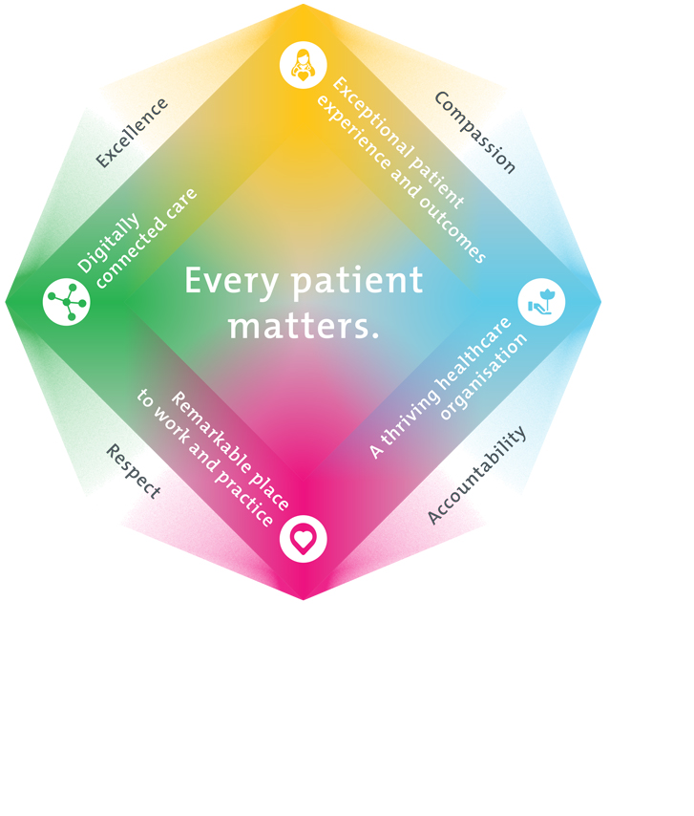
All roles are linked to the Epworth strategy and are fundamental in achieving its vision and purpose.
Exceptional patient experience and outcomes - To empower our patients and deliver compassionate, expert and coordinated care.
A thriving healthcare organisation - To adapt and grow in a changing healthcare landscape by delivering a unique private not-for-profit healthcare organisation.
Remarkable place to work and practice - To ensure Epworth is an outstanding place to work and practice through a culture of care
and investment in our people.
Digitally connected care - To innovate and improve the digital experience, interactions and outcomes for our patients, staff and doctors.
4. Purpose of the Position
The Project Manager – Epworth at Home is responsible for developing and implementing a transformative healthcare initiative that enables patients to receive hospital-level care in their homes through enhanced technology and service delivery model changes. This role acts as a critical link between clinical teams, IT, and external vendors to deliver a scalable, patient-centric service model. The Project Manager will drive the development, integration, and evaluation of new service models, ensuring alignment with strategic objectives and preparing a robust business case for future funding and expansion.

Reporting to the Group Director – Projects and Change, this role will have a matrix report to the Director – Epworth at Home to ensure alignment with the clinical team delivering care to our patients. This role will involve considerable collaboration with key stakeholders including the Digital, Network, Data, Applications, and Cyber Security teams, plus external vendors.
5. Clinical Governance Framework
This role is required to put into practice the Clinical Governance Framework at Epworth as every employee is accountable for ensuring that our patients and community receive safe, high quality and person-centred care in every interaction with Epworth. This is achieved through active participation in the five domains of clinical governance at Epworth:

Clinical Governance Domain | Role
Leadership and culture | Promote and participate in a supportive, fair and transparent culture where lessons from previous outcomes are learned and patient safety and quality is a priority at all levels of the organisation.
Consumer Partnerships | Understand and where relevant, ensure that each patient is actively involved in their own care and treatment including families/carers wherever possible.
Effective Workforce | Develop and maintain one’s own competency, skills and knowledge to ensure high quality service provision and care.
Clinical Safety and Effectiveness | Understand and where relevant, ensure, that the right care is provided to the right person at the right time, in the right place and patient outcomes are monitored and improved.
Risk Management | Be responsible for identifying and reporting risks, hazards and near misses for people in our care and participating in risk mitigation strategies.
6. Key Accountabilities
KEY RESPONSIBILITIES | MEASURES/KPIs TO BE ACHIEVED
Project Planning and Scoping  Develop detailed project plans, define scope, objectives, timelines and resource needs. | Project plans completed and approved  Project scopes align with organisational priorities and budget allocation
Service delivery design  Design and implement new service models for at home services; including remote patient monitoring; incorporating clinical input, technology capabilities, and operational feasibility. | Service design adheres to Epworth clinical standards and is in line with IT Architecture principles
Stakeholder Engagement  Collaborate with clinical, operational, change, analysts and IT stakeholders to ensure project alignment, meet user needs and align changes to Epworth’s IT Architecture Principles and change process (e.g. Change Approval Board). | Positive stakeholder feedback  Engagement activities documented
Risk and Issue Management  Identify, assess and mitigate project risks and issues, escalate when necessary, with recommended resolutions. | Risk registers maintained and updated
Vendor management  Oversee relationships with external vendors, including vendor selection, contract negotiation, performance monitoring, and delivery assurance. | Vendor selection is in line with Epworth’s procurement policies.
Budget and Resource Management  Monitor project budgets and resource allocations, engaging with our finance team and vendor partners to gain clarity. | Budget variances within +/- 5%  Resource plans adhered to
Governance and Reporting  Provide regular project status updates, reporting into project boards and steering committees where required within approved Epworth HealthCare documentation requirements. | Timely submission of project status reports  Accurate reporting of key project milestones and metrics
Compliance and Documentation  Ensure all project documentation is maintained and stored. | Documentation developed and stored as part of a knowledge-base.
Customer Service  Epworth is committed to the provision of excellent customer service to all of our people, customers and stakeholders including patients and external suppliers.  Superior patient service leads to improved healing in a trusting, caring environment and creates a safe environment for patients and employees.  - Provide excellent, helpful service to patients, visitors and staff  - Communicate with clear and unambiguous language in all interactions, tailored to the audience  - Build customer relationships and greet customers and patients promptly and courteously  - Actively seek to understand patients' and their family's (customers) expectations and issues | - Patient and customer service satisfaction surveys within agreed targets  - Use AIDET principles in all interactions  - Issues are escalated to the manager and resolved in a timely manner
Safety and Wellbeing  Participate actively and positively in the area of health and safety to reduce all hazards and incidents within the workplace  - Report all hazards, incidents, injuries and near misses immediately to your manager and log them in RiskMan | - Adhere to infection control/personal hygiene precautions  - Implement and adhere to Epworth OHS policies, protocols and safe work procedures  - Mandatory training completed at agreed frequency

7. Position Requirements/Key Selection Criteria
COMPONENT
Qualifications | Essential  - Relevant Project Management qualifications and/ or IT qualifications
Previous Experience | Essential  - Demonstrated experience in managing IT Projects, including application enhancements and/ or system implementations  - Experience in a hospital or healthcare setting  - Proven ability to manage multiple projects concurrently and deliver within scope, time and budget and effortlessly switch contexts  - Proven experience in designing digital healthcare services, particularly in the context of patient-centric services  - Experience in leading projects that require cross-disciplinary collaboration (clinical, digital, design, logistics)  - Strong understanding of patient journeys, clinical workflows and hospital care processes  - Proven track record of managing projects that involve the design or integration of digital solutions (apps, portals, remote monitoring tools) into healthcare services  - Experience engaging stakeholders across diverse teams, including clinical, technical and operational areas  - Demonstrated ability to manage vendor relationships, including coordinating deliverables, service expectations and issue resolution  - Experience with solution design aligning with broader IT architecture, considering data flows, system integrations and reporting impacts  - Experience preparing and maintaining project documentation, such as project plans, risk registers and status reports  Desirable  - Familiarity with clinical or enterprise systems  - Proven ability to guide teams in the application of human-centered design principles to service design, ensuring optimal outcomes for patients, caregivers and healthcare providers  - Experience with integration frameworks, data governance, or digital health standards  - Exposure to change management and user adoption practices in IT projects  - Previous involvement in projects requiring compliance with data privacy or clinical safety standards
Required Knowledge & Skills | Essential  - Understanding of enterprise system architecture and how applications interact across data flows, interfaces and reporting systems  - Maintains accuracy through a detail-orientated and structured approach to managing interrelated system requirements, with clear and consistent documentation  - Ability to manage project documentation, risks, issues and status reporting  - Ability to interpret technical information and collaborate with IT and business stakeholders to ensure mutual understanding of scope and timeframes  - Strong organisational skills with the ability to manage projects to allocated schedule  - Strong communication and interpersonal skills, with the ability to engage clinical, technical and operational stakeholders  - Sound problem-solving ability, with a methodical and analytical approach to troubleshooting and decision-making  - Skills in preparing project documentation such as status reports, risk registers, business cases  Desirable  - Awareness of data privacy principles, clinical safety considerations and digital health compliance standards  - Understanding of change management practices and user adoption strategies  - Ability to facilitate smooth transitions for staff, patients and healthcare providers as the new services are introduced
Personal Attributes & Values  All employees are expected to consistently work in accordance with Epworth’s values and behaviours  - Compassion  - Accountability  - Respect  - Excellence | - Strives for excellence by delivering quality outcomes and continuous improvement  - Able to work independently while contributing collaboratively within a team  - Demonstrates strong attention to detail to ensure accuracy and quality in project deliverables  - Exhibits excellent organisational skills to manage concurrent tasks and timeframes effectively  - Exhibits a methodical and process-driven approach to managing projects and tasks  - Demonstrates an analytical mindset to understand complex issues and support problem-solving  - Approaches challenges with a positive, solution-focussed attitude  - Demonstrates adaptability and resilience in a dynamic work environment  - Demonstrates compassion and empathy in interactions with colleagues and stakeholders  - Engages with others in a professional and considerate manner  - Communicates clearly, respectfully and with integrity  - Builds and maintains positive relationships with diverse stakeholders, managing expectations and facilitating cooperation  - Actively fosters a positive, inclusive and supportive culture  - Maintains a curious mindset, interest in learning and developing new skills  - Open to feedback and committed to ongoing professional growth

Document Control
Date Developed: | Date Last Reviewed: | Developed and Reviewed By (Position Title):
July 2025 | July 2025

8. Employee Position Declaration
I have read and understand the requirements and expectations of the above Position Description. I agree that I have the physical ability to fulfil the inherent physical requirements of the position, and accept my role in fulfilling the Key Accountabilities. I understand that the information and statements in this position description are intended to reflect a general overview of the responsibilities and are not to be interpreted as being all-inclusive.
Employee Signature:
Print Name: | Date:

