- General Information

Position Title: | Business Operations and Innovation Director
Division/Department: | Epworth Freemasons Cell Therapies Business Unit (a part of the Epworth Centre for Immunotherapies & Snowdome Laboratories (ECISL)
Position Reports to: | Executive General Manager, Epworth Freemasons
Enterprise/Individual Agreement: | Individual Agreement
Classification/Grade: | NA
Location: | Level 1, 185-187 Hoddle St, Richmond and Epworth Freemasons, East Melbourne
Employment Status: | 0.6 FTE, Fixed Term Two Years
Resource Management  (for Management positions only)  Number of Direct Reports:  Budget under management: | 1 (Laboratory Manager, CTU)
Key Relationships – internal and external | - ECISL Management Team (Medical Leadership, clinical, finance and research management teams)  - Epworth group and Division leadership and finance teams  - Haematology Clinical Trials manager  - Epworth Freemasons executive and clinical teams (including cryo laboratory)  - Laboratory Manager, CTU  - Third-party providers such as Peter McCallum Cancer Centre (PMCC), Slade pharmacy, Epworth Medical Imaging (EMI), Melbourne Pathology, Cell Therapies Pty Ltd  - Pharmaceutical companies affiliated with industry-sponsored clinical trials and standard of care CAR T-cell clinical care  - Academic and Medical Services (AMS) and Epworth IT
- Overview of Epworth HealthCare

Epworth HealthCare is Victoria’s largest not-for-profit private health care group, renowned for excellence in diagnosis, treatment, care and rehabilitation. Epworth is an innovator in Australia’s health system, embracing the latest in evidence-based medicine to pioneer treatments and services for our patients.

Epworth’s values define our approach and our delivery. We pride ourselves on communicating our values and delivering on them in a real and meaningful way. Our Values are Compassion, Accountability, Respect and Excellence. More information can be found on the Epworth website.

Epworth’s purpose is Every Patient Matters.
Our Vision is Delivering another 100 years of exceptional healthcare and innovation to the Victorian community.

Epworth HealthCare Strategy

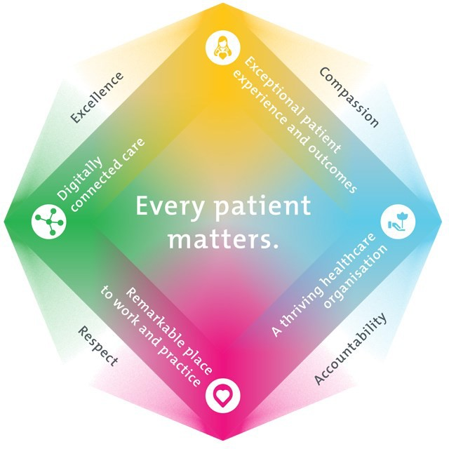

All roles are linked to the Epworth strategy and are fundamental in achieving its vision and purpose.
Exceptional patient experience and outcomes - To empower our patients and deliver compassionate, expert and coordinated care.
A thriving healthcare organisation - To adapt and grow in a changing healthcare landscape by delivering a unique private not-for-profit
healthcare organisation.
Remarkable place to work and practice - To ensure Epworth is an outstanding place to work and practice through a culture of care
and investment in our people.
Digitally connected care - To innovate and improve the digital experience, interactions and outcomes for our patients, staff and doctors.

- Purpose of the Position
ECISL (Centre) comprises a number of key clinical and research units, including Cellular Therapies Unit (CTU), Molecular Oncology and Cancer Immunology Unit (MOCI) and Haematology Clinical Trials Unit. This role is the key interface between the Centre, Epworth Freemasons and the wider Epworth Group. In particular, this role will support the development and maintenance of existing, and implementation of new, services within the CTU and across Epworth Freemasons. Working within a well-established framework, the Business Operations and Innovation Director will ensure that these existing and new services meet clinical, financial and performance expectations. This role will work closely with existing Centre Leadership and internal and external stakeholders to ensure;
  - Regular cost-effective and efficient provision of all necessary goods and services.
  - Ensuring cost-effective patient care from supporting teams.
  - High quality academic and research output and profile as well as implementation of cutting-edge innovation.
  - Strong relationships with partner organisations, government and internal and external philanthropic endeavours.
  - All statutory and management reporting and reconciliations are performed on a timely basis.

The Business Operations and Innovation Director will also support CTU operational and financial reporting requirements, both internally to the Epworth Executive, and to funding bodies and donors, including the Epworth Medical Foundation and the Snowdome Foundation as key partners.
- Clinical Governance Framework
This role is required to put into practice the Clinical Governance Framework at Epworth as every employee is accountable for ensuring that our patients and community receive safe, high quality and person-centred care in every interaction with Epworth. This is achieved through active participation in the five domains of clinical governance at Epworth:

Clinical Governance Domain | Role
Leadership and culture | Promote and participate in a supportive, fair and transparent culture where lessons from previous outcomes are learned and patient safety and quality is a priority at all levels of the organisation.
Consumer Partnerships | Understand and where relevant, ensure that each patient is actively involved in their own care and treatment including families/carers wherever possible.
Effective Workforce | Develop and maintain one’s own competency, skills and knowledge to ensure high quality service provision and care.
Clinical Safety and Effectiveness | Understand and where relevant, ensure, that the right care is provided to the right person at the right time, in the right place and patient outcomes are monitored and improved.
Risk Management | Be responsible for identifying and reporting risks, hazards and near misses for people in our care and participating in risk mitigation strategies.

Key Accountabilities

KEY RESPONSIBILITIES | MEASURES/KPIs TO BE ACHIEVED
Contract management  - Acts as the contract manager for contracts supporting the CTU service  - Build strong relationships with key internal and external stakeholders  - Measure the performance of third parties service delivery to ensure the cost-effective running of the service  - Ensure the provision of excellent customer service across all operations  - Successfully identify and manage ad hoc projects as requested  - Provide oversight of project workplans and appropriate allocation of resources  - Working with industry and Epworth teams to develop commercial contracts for delivery of commercial CAR T-cell products  - Ability to work proactively and co-operatively with both divisional and Group corporate, clinical and operational areas | - Monitor performance of third-party providers against agreed service agreement KPIs  - Commercial Contracts and Service Agreements are renegotiated within required timeframes to ensure uninterrupted service delivery
Centre reporting & development  - Working with Epworth Freemasons and Centre leadership team, undertake regular market analysis and benchmarking activities to identify opportunities to expand and develop the service  - Raise the profile of service by coordinating opportunities and messaging  - Coordinate the Centre reporting requirements to philanthropic partners and funders, including Epworth Medical Foundation and the Snowdome Foundation | - Centre reports are prepared and submitted as determined by the Centre Funding Agreement  - Continue to develop measurement tools to ensure the achievement of strategic and operational objectives  - Work with the communications team to raise the profile of the Centre and blood cancer awareness
Financial Management and Reporting  - Operational leadership of the CTU  - Ensure relevant Annual Operational and Capital Expenditure budgets are completed in conjunction with the Epworth Finance teams and Centre Management Team  - Undertake the completion of Business Cases for the introduction of new services and allocation of major items of Capex  - Develop business cases for creation of new roles in the Centre  - Review of monthly performance against budget with CTU managers  - Identify strategies and corrective actions to manage budget deficits  - Undertake financial risk assessments and develop mitigation strategies  - Coordinate and undertake a post implementation review for all approved business cases  - Working with the Centre leadership team, identify additional revenue and funding opportunities to support sustainability  - Manage key relationships and negotiate with third parties such as health funding order to ensure the cost-effective running of the service | - Monthly reporting against agreed KPIs, including patient activity and revenue, and operational expenditure, and budget variances  - Undertake regular analyses identifying variances to budget and changes in mix to assist future planning  - Develop annual CTU budget in conjunction with cost centre managers  - Self-funded CAR T clinical care packages are developed as appropriate

Customer Service  Epworth is committed to the provision of excellent customer service to all of our people, customers and stakeholders including patients and external suppliers.  Superior patient service leads to improved healing in a trusting, caring environment and creates a safe environment for patients and employees.  - Provide excellent, helpful service to patients, visitors and staff  - Communicate with clear and unambiguous language in all interactions, tailored to the audience  - Build customer relationships and greet customers and patients promptly and courteously  - Actively seek to understand patients' and their family's (customers) expectations and issues | - Epworth employee engagement surveys  - Patient and customer service satisfaction surveys within agreed targets  - Issues are escalated to the manager and resolved in a timely manner
Safety and Wellbeing  - Participate actively and positively in the area of health and safety to reduce all hazards and incidents within the workplace  - Report all hazards, incidents, injuries and near misses immediately to your manager and log them in RiskMan | - Adhere to infection control/personal hygiene precautions  - Implement and adhere to Epworth OHS policies, protocols and safe work procedures  - Mandatory training completed at agreed frequency

Position Requirements/Key Selection Criteria

COMPONENT
Qualifications | Essential  - Tertiary qualification in management or business, or relevant Clinical field  Desirable  - Post Graduate qualification in business, finance or accounting
Previous Experience | Essential  - Senior management experience in healthcare and/or pharmaceutical industry  - Strong customer focus  Desirable  - Senior experience in a commercial and/or philanthropic organisation previously  - Government (State and/or Federal) affairs and advocacy
Required Knowledge & Skills | Essential  - Substantial relationship and people management skills  - Advanced financial management and business management skills  - Excellent analytical skills and the ability to develop strong business case submissions to support new initiatives/changes  - Ability to challenge current practices and develop and promote new innovative systems  - Knowledge of health fund contracts, contract management, Trade Practice Act provisions  - Ability to set and achieve goals and objectives  - Ability to support & educate others to develop and expand financial management skills within the healthcare environment  - Highly developed written and verbal communication skills  - Excellent time management, interpersonal and organisational skills  - Demonstrated ability to implement and manage change  - Excellent computer skills including all MS Office products

Personal Attributes & Values  All employees are expected to consistently work in accordance with Epworth’s values and behaviours  - Compassion  - Accountability  - Respect  - Excellence | Essential  - Belief in patient centred care  - Ability to maintain professional relationships with key stakeholders / organisational political astuteness  - Self-motivated and self-directed  - Committed to providing a safe environment for patients & staff  - Committed to the development of staff and practices that engage and value the contributions of staff  - Professional work ethic  - Demonstrates responsibility for own professional development  - Practices within the ethos of the Epworth HealthCare Values & Behaviours

Document Control
Date Developed: | Date Last Reviewed: | Developed and Reviewed By (Position Title):
March 2020 | January 2026 | Jo Goodridge, EGM Freemasons

Employee Position Declaration
I have read and understand the requirements and expectations of the above Position Description. I agree that I have the physical ability to fulfil the inherent physical requirements of the position and accept my role in fulfilling the Key Accountabilities. I understand that the information and statements in this position description are intended to reflect a general overview of the responsibilities and are not to be interpreted as being all-inclusive.

Employee Signature:
Print Name: | Date:

