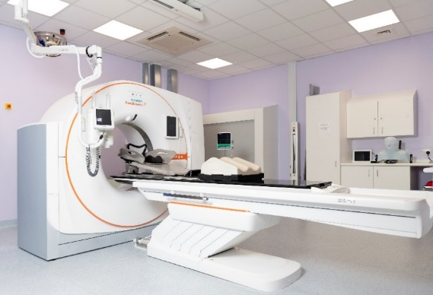
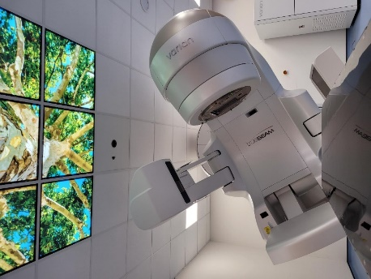
Title: Senior Therapeutic Radiographer
Band: 6
Reports to: Team Leader
Accountable to: Radiotherapy Service Manager
Job Summary:
- Undertake radiotherapy treatment and planning, on a rotational basis, using ionising radiation to treat patients with cancer or benign disease, with both curative and palliative intent
- Carry out radiotherapy procedures using a variety of specialised high energy radiation equipment, operating in conjunction with radiotherapy IT systems and various imaging systems
- Provide supervision and support to junior staff and students in training
- Make confident decision-making as the Senior Radiographer

Key Responsibilities:
- To undertake routine quality assurance checks of department equipment.
- Report and record all equipment faults in a timely fashion, according to departmental procedures
- The post holder, in absence of a team leader, manages the administrative and patient workload of a defined area, and manages the complexities of a treatment course, supervises and teaches staff in a work base, providing an efficient and high quality radiation treatment service
- The post holder, assists the Team Leaders in maintaining the highest professional and technical standards in the department
- When assigned to do so, lead a small team undertaking radiotherapy treatment, and rotate through the radiotherapy CT planning section, performing tasks accurately and effectively, and providing a safe and efficient service to patients
- Interpret complex technical data, utilising professional judgment in the practical application of treatment plans and in accordance with local protocols
- Provide high standard of patient care and support through all stages of the patient pathway, ensuring patients receive timely and accurate information regarding planning and treatment
- Responsible for daily clinical evaluation of the patient before, during and after treatment, assessing their fitness for treatment, ensuring the safe delivery of the patient’s radiation exposure and the accurate recording of treatment data
- Possess a detailed knowledge of radiotherapy equipment, keep abreast of new trends, technologies and techniques
- Responsible for own and team’s compliance with quality assurance protocols within the department and IR(ME)R (2017) , IRR17 regulations, pertaining to the radiotherapy treatment and pre- treatment equipment
- Assist the Team Leader in charge of area with supervisory and management duties/tasks as required, ensuring that they are kept fully informed of issues impacting on the effective and efficient delivery of the radiotherapy service
- Supervise radiotherapy treatment techniques; ensuring that the team maintains professional standards of work and are trained in and follow agreed protocols. Be responsible for proper and safe use of radiotherapy equipment and all facilities provided to carry out tasks and duties.
- Demonstrate ability to communicate to a high level, including the ability to provide and receive technical information in understandable language, manage highly sensitive information and deal with anxious cancer patients and their families, using exemplary diplomacy and persuasion, overcoming barriers when necessary
- Provide advice on the management of radiotherapy side effects and instruct patients in necessary aftercare following radiotherapy. Evaluate emotional and medical needs, and deal with appropriately, referring patients, when necessary, to the wider multi-disciplinary team
- Perform patient positioning and marking techniques, to conform to a high degree of accuracy, requiring a high level of patient compliance, and post holder persuasion
- Operate record & verification system, electronic treatment imaging and in vivo dosimetry equipment and use these facilities to undertake independent analysis and approval of results, and to make necessary adjustments to a patient’s treatment
- Perform radiotherapy dosimetric calculations, and record for use by self and others, for the course of a patient’s treatment
- Participate in the ongoing audit and development of the Quality Assurance Programme. Participate in the development, maintenance and review of quality control procedures
- Deal with aggressive pathologies and unpleasant bodily fluids produced as a result of the specificity of the disease, or as a result of treatment
- Work as part of the multi-disciplinary team on all issues affecting the area of responsibility, which may include research and development activities such as working groups to develop and implement new techniques, equipment acquisition and working practices
- Agree and maintain a personal structured continuous professional development programme to maintain HCPC registration and meet the needs of the service
- Participate in the clinical education and assessment, both formal and informal, of student radiographers and assist in their daily supervision

Additional Duties and Expectations

- To participate in the departmental shift pattern between the hours of 07:00-20:00, 7 days a week.
- To participate in the department on-call system as specified in local agreement.
- Be accountable for own professional actions and limitations within own scope of practice.
- Abide by HCPC and College of Radiographers code of practice and maintain HCPC registration.

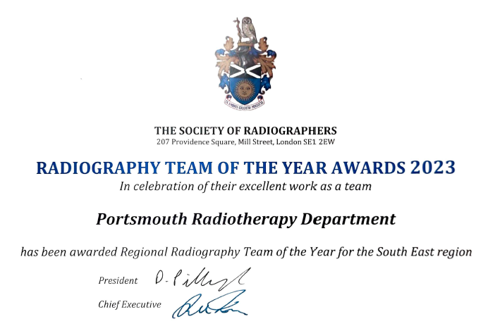

Radiotherapy Service Manager
Organisational Chart

Operational Lead for RT
Consultant Radiographers

Lead Radiographers

Advanced Practitioners

Practice Educators
Team Leaders

Senior Radiographers (This Post)
Enhanced Practice Senior Radiographers

Apprentice Radiographers
Radiographers

Admin & Clerical Team
Oncology Assistants

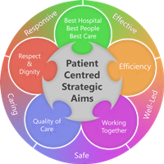
Person Specification
Qualifications (Essential)
- BSc Therapeutic Radiography or equivalent
- HCPC registration to practice as a Therapeutic Radiographer
- Post-graduate education (or be willing to take part in Level 7 education)

Skills and Knowledge
- Effective at working independently and within a team
- Ability to deal with emotive and confrontational situations using conflict resolution skills
- Ability to deal with and respond to interruptions in the working environment
- Strong personal resilience and ability to act appropriately in stressful and/or emotive situations
- Demonstrable competency in the use of all aspects of complex radiotherapy treatment and planning equipment
- Ability to successfully problem-solve and trouble-shoot treatment and planning related patient setup issues
- Ability to understand own limitations and when to ask for help
- Demonstrable skills in teaching and supervising student radiographers
- Understand the benefits of and how to work within an ISO9001:2015 quality system
- Awareness of national cancer agenda and how it relates to own practice
- Current knowledge of developments in radiotherapy practice
- Evidence of CPD

Experience
- Appropriate level of post qualification experience, working across both treatment and pre-treatment areas, using a range of modern equipment
- Experience of working in orthovoltage & brachytherapy is desirable
- Experience of a range of radiotherapy treatment techniques
- Previous experience of working within the NHS as a Therapeutic Radiographer

Working Together for Patients with Compassion as One Team Always Improving
Strategic approach (clarity on objectives, clear on expectations)

Relationship building (communicate effectively, be open and willing to help, courtesy, nurtures partnerships)

Personal credibility (visibility, approachable, back bone, courage, resilience, confidence, role model, challenge bad behaviour, manage poor performance, act with honesty and integrity)

Passion to succeed (patient centred, positive attitude, act, take pride, take responsibility, aspire for excellence)

Harness performance through teams (champion positive change, develop staff, create a culture without fear of retribution, actively listen and value contribution, feedback and empower staff, respect diversity)

Job holders are required to always act in such a way that the health and wellbeing of children and vulnerable adults is safeguarded. Familiarisation with and adherence to the Safeguarding Policies of the Trust is an essential requirement for all employees. In addition, all staff are expected to complete essential/mandatory training in this area.
Print Name:
Date:
Signature:

