**Title: *Senior Occupational Therapist***

**Band: 6**

**Staff Group: Allied Health Professions**

**Reports to: *Occupational Therapy Team Leader, CSRT***

**Job Purpose:**

1. To be responsible for providing specialist, evidence based Occupational Therapy service within CSRT, adapting interventions to meet patient and CSRT needs, using advanced clinical reasoning skills, investigative and analytical skills as an autonomous practitioner.
2. Provide support to the Senior OT and other seniors within CSRT.

**Key Responsibilities:**

**a. Budgets** **–** N/A

1. **Staff –** Demonstrate own activities and workplace routines to new or less experienced employees.

**Other Statistics** – To provide Occupational Therapy within the specialist Community Stroke Rehabilitation Team. Contribute to resource management and to work within the Trust and CSRT Policies and Procedures.

***Patient Safety, Patient Experience and Use of Resources***

* Ensure all possible steps are taken to safeguard the welfare, safety and security of patients, visitors, and staff in accordance with Trust policies.
* Meet the needs of neurological rehabilitation patients under the direction of a registered health care professional and acting within the scope of competence.
* In a therapeutic manner provide high standards of personal care to patients to maintain their personal hygiene, appearance, diet, promote their independence and physical comfort ensuring that their privacy and dignity is maintained. Work in partnership with patients to respect their rights and choices.
* Recognise patient’s needs and changing condition and respond and report appropriately and effectively.
* To ensure that rehabilitation goals, strategies and procedures are implemented and reinforced throughout the patient’s journey.
* To work as an effective member of the interdisciplinary team and to participate in the care plan process in providing key feedback regarding progression and participation.
* While working with the interdisciplinary team, ensure optimum cognitive, social, emotional, physical, and functional recovery.
* To be responsible for undertaking personal development relevant to this role
* To complete dynamic risk assessment of the home environment on each visit to ensure safety for patients.
* To interpret and adapt Trust Policy regarding Infection Control and Prevention in the community.
* Report adverse incidents in accordance with Trust policy.
* Record and report information onto patient administration systems in written and electronic format, including assisting generic admin duties to assist the team.
* Always promote and demonstrate effective verbal and non-verbal communication with patients, relatives and colleagues recognising the need for tact, consideration, and confidentiality.

***Team working***

* Undertake specific organisational and administrative duties as required.
* As part of the team, working alongside other professions contributing to the delivery of individualised care, upholding the vision of the service.
* Assist other clinical areas within the Trust as the clinical situation and staffing levels require.
* Participate in innovation and quality of healthcare by attending team or department meetings, participate in projects, including audit and quality initiatives pertinent to the role.
* Encourage, initiate, and participate in individual and group activities appropriate to the patient’s rehabilitation.
* Act as a link or associate link for a specific area of practice, e.g. health and safety, infection control.
* Assist with the supervision and support of students to enable their skills and knowledge development.
* Treat all patients and colleagues with respect in accordance with Trust values and Equality and Diversity Policy.

***Professional Education and Development Role***

* Complete the Trust Competency Framework for HCSW’s and achieve the minimum skill set (list of competencies as defined in generic competency framework). Maintaining own learning record of evidence. To also achieve the competencies required for the RA role.
* Develop skills relevant to role in clinical speciality as identified by ward/department leader and in accordance with Trust Policies.

Recognise the need to participate in ongoing personal development by attending essential training for the role. Participate fully in the Appraisal and Development Review Process

**Organisational Chart**

Head of Nursing (MOPRS)

Stroke Matron

CSRT Operational Lead

Senior OT

Senior Physio

Senior Sister

Admin Supervisor

Occupational Therapist

Physiotherapist

Sister

Registered Nurse

Associate Practitioner

Team Admin

Rehab Assistant

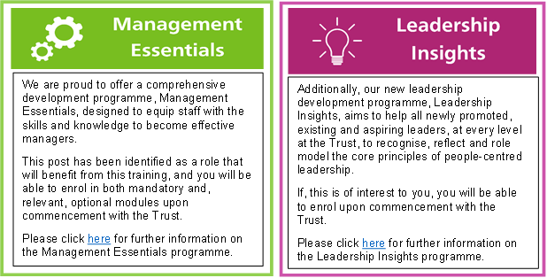

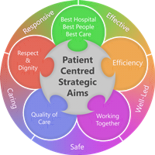**Person Specification**

**Qualifications and Experience**

* ***Essential***
* Professional knowledge acquired through degree or equivalent, plus short specialist courses, experience to post-graduate equivalent diploma level.
* Current HPC registration
* Evidence of recent relevant CPD
* ***Desirable***
* Computer literate
* Experience of community working

**Skills and Knowledge**

* ***Essential***
* An awareness of research and evidence-based practice within stroke care
* Knowledge and application of OT assessment process
* Knowledge of OT outcome measures
* Knowledge of OT models of practice
* Knowledge and application of standardized assessment
* Good communication skills
* Ability to prioritise workload, working autonomously with ability to instruct and direct others.
* Good Organisational Skills
* Articulate and knowledgeable of current professional issues, specifically relating to stroke.
* Advocacy Skills
* ***Desirable***
* Ability to adapt to change within working situations.
* Experience of working in stroke care
* Experience of managing other staff/students
* **Personal Qualities**
* Good interpersonal skills
* Skill in working in an interdisciplinary team.
* Ability to act and ensure delivery of evidence based and timely service.
* Responsive and flexible attitude/approach with clear decision making skills.
* To be able to take responsibility for other staff across professions.
* Commitment to lifelong learning
* Confident car driver, with access to car within working hours

**Working Together for Patients with Compassion as One Team Always Improving**

**Strategic approach** (clarity on objectives, clear on expectations)

**Relationship building** (communicate effectively, be open and willing to help, courtesy, nurtures partnerships

**Working Together For Patients with Compassion as One Team Always Improving**

**Strategic approach** (clarity on objectives, clear on expectations)

**Relationship building** (communicate effectively, be open and willing to help, courtesy, nurtures partnerships)

**Personal credibility** (visibility, approachable, back bone, courage, resilience, confidence, role model, challenge bad behaviour, manage poor performance, act with honesty and integrity)

**Passion to succeed** (patient centred, positive attitude, take action, take pride, take responsibility, aspire for excellence)

**Harness performance through teams** (champion positive change, develop staff, create a culture without fear of retribution, actively listen and value contribution, feedback and empower staff, respect diversity)

Job holders are required to always act in such a way that the health and wellbeing of children and vulnerable adults is safeguarded. Familiarisation with and adherence to the Safeguarding Policies of the Trust is an essential requirement for all employees. In addition, all staff are expected to complete essential/mandatory training in this area.

**Print Name:**

**Date:**

**Signature:**

