**SINGLE CORPORATE SERVICES**

Governance and Risk

Legal

|  |  |  |
| --- | --- | --- |
| **Job title:** | Paralegal | ***To be completed by HR***  *Job Reference Number* |
| **Reporting to:** | Legal Services Manager |
| **Accountable to:** | Director of Governance and Risk |
| **Pay Band:** | 5 |

As part of the Single Corporate Service, the role provides a service across both Isle of Wight NHS Trust and Portsmouth Hospitals University NHS Trust.

As the single corporate service will be delivered across both organisations, individuals may be required to undertake business travel between sites. The frequency and arrangements will be discussed on an individual basis and the staff mobility local agreement will apply.

For our leaders managing staff across multi-site locations, they will need to be visible and provide in person leadership. The arrangements and frequency will be agreed locally.

**Job purpose**

To ensure both Trusts meet their legal and regulatory obligations associated with legal services requirements and management and to ensure that there are robust arrangements in place to continue to be well led organisations. This includes assurance and escalation as necessary.

**Job summary**

1. To manage an allocated caseload and actively participate in the delivery of the Inquest management services provided by the Legal Services Team.
2. Organise and conduct investigations into Employer’s Liability (EL) and Public Liability (PL) claims against the Trust in compliance with the National Health Service Litigation Authority (NHSR) requirements and Guidelines.
3. Organise and conduct preliminary investigations into Clinical Negligence Claims and Inquests in which the Trust is involved.
4. In Clinical Negligence Claims, ensure compliance with the National Health Service Resolution Authority (NHSR) requirements and Guidelines.

**Organisational Chart**

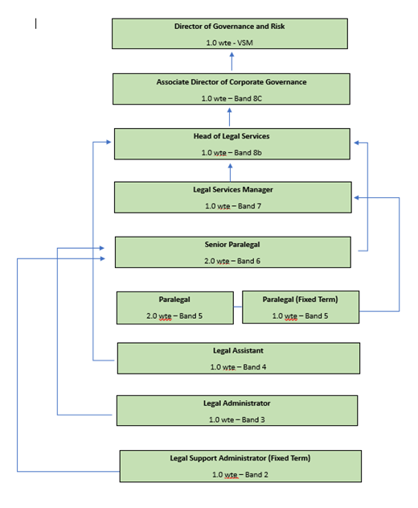

**Specific Core Functions**

1. Liaising with Occupational Health and the Resource Team where necessary;
2. Obtaining and analysing the Claimant’s Personnel file and medical records where necessary;
3. Interviewing staff and obtaining statements and photographs where necessary and analysing this information ;
4. Reporting the claim to the NHSR where appropriate;
5. Liaising with the NHSR and Panel solicitors to further investigate the claim as it progresses;
6. Identifying and reporting on trends and risk management issues and liaising with risk management/health and safety advisors as appropriate.
7. Escalating risk management/health and safety issues and trends to the Head of Legal Services and/or Senior Paralegal as appropriate and drafting trend reports to support learning from claims and inquests.
8. Generating reports for approval by Head of Legal Services as appropriate.
9. Obtaining and analysing the medical records;
10. Gathering other relevant information e.g. photographs, the PALS file, the Risk team file, relevant Trust Policies and Protocols etc.
11. Identifying the Lead Consultant and other potential witnesses and obtaining reports/witness statements from them. This will include meeting with witnesses to take detailed witness statements from them, cross checking reports for consistency and quality assuring reports from clinicians and other witnesses to ensure that these are fit for purpose.
12. Reporting claims against the Trust to the NHSR (or Trust insurers as appropriate);
13. Ensure that central spreadsheets and Risk Management systems are updated and claims reported to the NHSR within the timescales specified. Escalating any delays immediately to the Head of Legal Services and Senior Legal Paralegal.
14. Liaising with the NHSR and Panel solicitors to further investigate the claim as it progresses;
15. Drafting Claim Outcome Reports;
16. Supporting the Legal Services Manager and/or Senior Paralegal in all matters pertaining to clinical negligence claims as requested;
17. Manage and maintain caseload of Inquest files as per Trust Claims and Inquest Policy;
18. Support the Head of Legal Services , Legal Services Manager, Senior Paralegal and/or Paralegal in all matters pertaining to inquests as requested;
19. Organise multi-agency pre-inquest meetings;
20. Meet with witnesses ahead of the inquest hearing to prepare them for giving oral evidence;
21. Liaise with the Coroner and their officers as and when necessary;
22. Attend inquest hearings on a watching brief on occasions;
23. Draft Inquest Outcome Reports when requested to do so;
24. Ensure compliance with the Trust Guidelines on Handling Coroner’s Inquests;
25. To provide support and supervision to more junior staff within the team.
26. This is not an exhaustive list of duties and responsibilities, and the post holder may be required to undertake other duties, which fall within the grade of the job, in discussion with the manager.
27. This job description will be reviewed regularly in the light of changing service requirements and any such changes will be discussed with the post holder.

**Key Responsibilities**

***Communication and Working Relationships***

Provide and receive complex information requiring persuasive skills; agreement and co-operation is required.

***Analytical and Judgement***

Judgements involving a range of facts or situations, which require analysis or comparison of a range of options.

***Planning and organising***

Plan and organise activities or programmes.

***Physical Skills***

Physical skills obtained through practice over a period of time.

***Patient Client Care***

Assist patients/clients/relatives during incidental contacts/provide non-clinical advice, information directly to patients, clients, relatives or carers.

***Policy and Service Development***

The post holder is responsible for implementing policies within a team/department and proposes changes to working practices or procedures for own work area.

***Financial Management***

Personal duty of care in relation to equipment and resources.

***Management/Leadership***

Responsible for day-to-day supervision; Regularly responsible for providing training in own discipline.

***Information Resources***

Responsible for data entry, text processing, storage of data.

***Research and development***

Undertakes surveys or audits, as necessary to own work; may occasionally participate in R&D, clinical trials or equipment testing.

***Freedom to Act***

Is guided by clearly defined policies and procedures, work is managed rather than supervised.

***Physical effort***

A combination of sitting, standing, and walking with little requirement for physical effort. There may be a requirement to exert light physical effort for short periods.

***Mental effort***

There is a frequent requirement for concentration where the work pattern is predictable with few competing demands for attention, or there is an occasional requirement for concentration where the work pattern is unpredictable.

***Emotional Effort***

Frequent indirect exposure to distressing or emotional circumstances/occasional indirect exposure to highly distressing or highly emotional circumstances.

***Working conditions***

Occasional exposure to unpleasant working conditions, or occasional requirement to use road transportation in emergency situations, or frequent requirement to use road transportation, or frequent requirement to work outdoors, or requirement to use Visual Display Unit equipment more or less continuously on most days.

**Person Specification**

| **Criteria** | **Essential** | **Desirable** | ***How criteria will be assessed*** |
| --- | --- | --- | --- |
| **Qualifications** | Relevant degree or equivalent experience | Experience of working in the Health or Legal sectors |  |
| **Experience** | Ability to communicate information to individuals/groups/committees in a comprehensive way.  Confident in preparing and delivering basic written reports.  Confident to deliver training, presentations and/or reports to individuals, groups and or committees.  Ability to work autonomously, and as part of a team with integrity and confidentiality, managing own workload and demands  Ability to handle difficult or complex situations with compassion and sensitivity. | Experience of legal processes, including coronial and claims management. |  |
| **Knowledge** | Knowledge of law and legal practice.  Competent in the use of a wide range of software eg: Micrsoft office, Risk Management system, Sharepoint. |  |  |

**Compliance statement to expected organisational standards.**

To comply with all Trust Policies and Procedure, with particular regard to

• Risk Management

• Health and Safety

• Confidentiality

• Data Quality

• Freedom of Information

• Equality Diversity and Inclusion

• Promoting Dignity at Work by raising concerns about bullying and harassment

• Information and Security Management and Information Governance

• Counter Fraud and Bribery

The Trust has designated the prevention and control of healthcare associated infection (HCAI) as a core patient safety issue. As part of the duty of care to patients, all staff are expected to:

* Understand duty to adhere to policies and protocols applicable to infection prevention and control.
* Comply with key clinical care policies and protocols for prevention and control of infection at all time; this includes compliance with Trust policies for hand hygiene, standards (universal) infection precautions and safe handling and disposal of sharps.
* All staff should be aware of the Trust’s Infection Control policies and other key clinical policies relevant to their work and how to access them.
* All staff will be expected to attend prevention and infection control training, teaching and updates (induction and mandatory teacher) as appropriate for their area of work, and be able to provide evidence of this at appraisal.
* To perform your duties to the highest standard with particular regard to effective and efficient use of resources, maintaining quality and contributing to improvements.
* Ensure you work towards the Knowledge and Skills Framework (KSF) requirements of this post. KSF is a competency framework that describes the knowledge and skills necessary for the post in order to deliver a quality service.
* Your behaviour will demonstrate the values and vision of the Trust by showing you care for others, that you act professionally as part of a team and that you will continually seek to innovate and improve. Our vision, values and behaviours have been designed to ensure that everyone is clear about expected behaviours and desired ways of working in addition to the professional and clinical requirements of their roles.
* Ensure you adhere to and work within local and national safeguarding children legislation and policies including the Children Act 1989 & 2004 , Working Together to Safeguard Children 2013, 4LSCB guidance and the IOW Safeguarding Policy.
* Ensure you adhere to and work within the local Multiagency safeguarding vulnerable adults policies and procedures
* Ensure that you comply with the Mental Capacity Act and its Code of Practice when working with adults who may be unable to make decisions for themselves.
* Ensure that you maintain personal and professional development to meet the changing demands of the job, participate in appropriate training activities and encourage and support staff development and training.
* Respect the confidentiality of all matters that they may learn relating to their employment and other members of staff.  All staff are expected to respect conform to the requirements of the Data Protection Act 1998, including the responsibility to ensure that personal data is accurate and kept up to date.
* If your employment is to a post that requires you to be registered with a professional body, the continuation of your employment is conditional upon you continuing to be registered with the appropriate professional body. The Trust will require evidence of current registration.
* Proactively, meaningfully and consistently demonstrate the Trust Values in your every day practice, decision making and interactions with patients and colleagues.
* Perform any other duties that may be required from time to time.

This job description may be altered, from time to time, to meet changing needs of the service, and will be reviewed in consultation with the post holder.