REF CODE:

PORTSMOUTH HOSPITALS UNIVERSITY NHS TRUST
JOB DESCRIPTION

Job Group: ATO | FOR OFFICE USE ONLY
Job Title: Production Assistant Techinical Officer (ATO) | Position No:
Division/Care Group: Clinical Support | Approved Matching Classification
Existing Grade: 2 | Job Analysis
Unit: Pharmacy Manufacturing Unit | Job Evaluation
Base Location: Farlington | Pay Band code:
Reports to: Priccipal Technican
Accountable to: Operations Manager | Entered By:

Job Purpose

- To assist in the day to day operational work of the Pharmacy Manufacturing Unit; and under supervision assemble, prepare and supply aseptic and non-sterile products for Portsmouth Hospitals University NHS Trust (PHU), and its external customers.
- To work in accordance with Good Manufacturing Practice in order to maintain the standards required by the Medicines and Healthcare products Regulatory Agency (MHRA), and keep the department’s manufacturing licence and reputation with customers

Key Dimensions

- Budgets – Contributes to the effective manufacture and distribution of pharmaceuticals and to the effective management of the PMU full trading account

b. Staff – Demonstrate own activities and workplace routines to new or less experienced employees

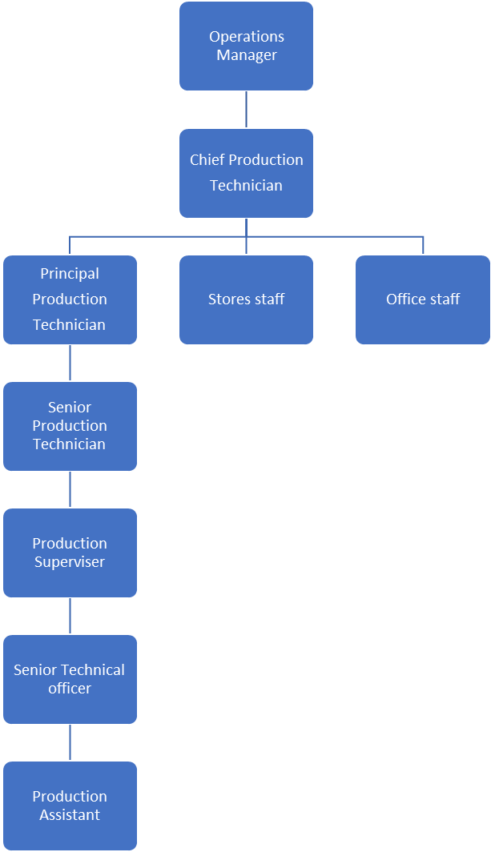

ORGANISATIONAL CHART

Trust Organisational Expectations
The post holder will:
- Proactively and positively contribute to the successful overall performance of the Trust.
- Deliver excellent levels of customer service to all patients/visitors and staff at the Trust.
- Develop effective ways of working and create strong partnerships and relationships with all stakeholders to support the implementation of the Government’s policies on Health.
- Develop an organisational culture that fosters collaborative working among all staff groups, to ensure a focused commitment to delivering quality services and outcomes.
- Act as an advocate for the Trust & its contribution to the Health Service arena through creating effective partnerships and relationships with internal and external stakeholders.
- Comply with corporate governance structure in keeping with the principles and standards set out by the Trust.
- Support the Trust culture of collaborative, flexible cross-team working and commitment to delivering quality services and outcomes, which support the Government’s policies on public health
- If your employment is to a post that requires you to be registered with a professional body, the continuation of your employment is conditional upon you continuing to be registered with the appropriate professional body. The Trust will require evidence of current registration.
- In compliance with the Trust's practices and procedures associated with the control of infection, you are required to:
- Adhere to Trust Infection Control Policies assuring compliance with all defined infection control standards at all times.
- Conduct hand hygiene in accordance with Trust policy, challenging those around you that do not.
- Challenge poor practice that could lead to the transmission of infection.

Proactively, meaningfully and consistently demonstrate the Trust Values in your every day practice, decision making and interactions with patients and colleagues.


Shared Core Functions
- Proactively and positively contribute to the achievement of deliverables through individual and team effort. Manage the production of the required deliverables and control risks,
- Support team members to deliver on their functionally relevant objectives through offering advice, guidance and support as appropriate.
- Ensure that approved budgets are spent effectively and in accordance with agreed procedures
- Liaison with Senior Professionals and related functions to ensure that work is neither overlooked nor duplicated
- Build and sustain effective communications with other roles involved in the shared services as required
- Maintain and continuously improve specialist knowledge in an aspect of Health Service which significantly contributes to the Trust’s stated objectives & aims
- Establish and maintain strategic links with a range of external partners/stakeholders or manage the links made through the team. Engage with external partners/stakeholders to gain their necessary level of contribution & commitment to the successful delivery of your work.
- Undertake proactive horizon scanning for either developments relating to Trust work or opportunities for Trust involvement around health issues
- Increase the level of knowledge & skills within the Trust through documenting key learning and supporting others to develop their professional abilities.
- Dissemination of knowledge through engagement in report writing, and reviewing, taking full responsibility for technical accuracy and reliability and being sensitive to the wider implications of that dissemination.
- Ensure that expertise is seen as a resource within and outside the Trust and form working partnerships with government departments, national agencies and key stakeholders.
- Develop structures, systems, ways of working and personal values that will support the Trusts sustainable development objectives with regard to issues such as Carbon reduction and waste minimisation; and to encourage all stakeholders of the Trust to act as enthusiastic agents of change.

Specific Core Functions

- Undertaking the day-to-day activities required to ensure all deadlines are met and that work is completed according to written work instructions and Good Manufacturing Practice, Health and Safety at work act and any other legislation where applicable.
- Working in accordance of quality management systems within the department including completion of documentation, maintenance of quality indicators and compliance with the results of audits to ensure the standards of GMP required by the MHRA are met at all times.
- Liasing with appropriate staff to carry out daily role and ensure the most efficient use of staffing resources, escalating concerns as appropriate to senior staff.
- Assembling raw materials according to details recorded on batch sheets for products prepared within the Unit
- Under supervision performing simple aseptic manipulations and automated fills as required on aseptic products used by patients within and outside the Trust.
- Undertaking surface disinfection of raw materials and packaging components and passing into the aseptic suite, according to the WI, including undertaking initial and ongoing assessments of competence to undertake this duty
- Labeling of manufactured products using dedicated computer-based labelling equipment under the direction of a suitably qualified member of staff, in accordance with written instruction sheets for each product
- Undertaking daily, weekly and monthly cleaning duties within and outside the aseptic suite as directed by Senior Technician Production, including familiarity with spillage procedures and dealing with hazardous chemicals
- Undertaking various environmental monitoring duties as directed by Senior Production Staff including waste removal and dealing with hazards and spillages
- Ensuring that pharmaceutical stock is stored with due regard to storage requirements and stock rotation, to include ambient, refrigerated, controlled drugs, unlicensed and hazardous items.
- Undertaking house keeping duties and stock checks of production area equipment and disposables, i.e. gloves, masks, syringes to ensure there are continuous supplies for use, according to established minimum levels
- Identifying stock/supply problems and working with senior staff to resolve them, communicating problems and progress to the appropriate person to minimise risk to patient care.
- Disposing of waste packaging materials, clinical waste, hazardous waste and confidential waste in accordance with the Trust’s waste management policy.
- Assisting in the training of other members of staff under the guidance and supervision of senior staff, using written training programmes to ensure trainees are fully competent and ready for assessment by suitably qualified staff
- Maintaining the security of the PMU facilities to ensure that unauthorised entry and risk of theft or damage is minimised, this includes consideration of drugs in transit and issue of deliveries only to recognised carriers.
- Contributing to the overall housekeeping and efficiency of the department including maintaining supplies of non-drug consumables such as stationery and packaging.
- Working within safe working practices in the unit to ensure compliance with Health and Safety at Work Act and NHS guidance.
- Treating all customers with courtesy to project a professional, caring image for the pharmacy service.
- Co-operating with managers to ensure that the department meets all necessary deadlines
- Participating in monitoring the quality of services to ensure that customer needs are met.
- Contributing to the maintenance of environmental and clerical records.
- Undertake in-house training and all necessary academic, practical and portfolio building work in order to achieve internal and or external accreditation in areas of work.
- Providing services at weekends & Bank holidays as required to ensure continuity of supply of medicines.

Other
Job Holders are required to:
- Maintain personal and professional development to meet the changing demands of the job, participate in appropriate training activities and encourage and support staff development and training.
- Always keep requirements in mind and seek out to improve, including achieving customer service performance targets.
- Adhere to Trust policies and procedures, e.g. Health and Safety at Work, Equal Opportunities, and No Smoking.
- Act in such a way that at all times the health and well being of children and vulnerable adults is safeguarded. Familiarisation with and adherence to the Safeguarding Policies of the Trust is an essential requirement for all employees. In addition all staff are expected to complete essential/mandatory training in this area.
- Respect the confidentiality of all matters that they may learn relating to their employment and other members of staff. All staff are expected to respect conform to the requirements of the Data Protection Act 1998, including the responsibility to ensure that personal data is accurate and kept up to date

Job Description Agreement
Job Holders name:
(print)

Job Holders signature: Date:

Senior Officer/ Chief of Service

Name (print)

Signature: Date:

Title:

PERSON SPECIFICATION

CRITERIA | How criteria will be assessed:  Application  Interview  Assessment  Reference
Qualifications
Essential

- Level 2 qualification/GCSE higher pass or above including maths and English or equivalent qualifications, or work experience that demonstrates comparable ability in a similar field.
- Demonstrated ability to work to set procedures and follow written instructions

Desirable
- Previous experience in a similar role: a Clean room or pharmaceutical background

Skills and Knowledge

Essential

- Ability to work using own initiative and without supervision
- Clear literate handwriting and numeracy skills
- Good communication skills
- Good interpersonal skills and ability to work as part of a team
- Computer skills
- Able to maintain high concentration for long periods
- Ability to work safely under pressure
- Ability to work flexibly and prioritise workload
- Health & Safety/security awareness
- Able to investigate problems logically
- Demonstrated ability to handle hazardous materials safely and according to local work instructions
- Proactive attitude to ongoing training and assessment

Desirable
- Previous experience working with aseptics/ pharmaceuticals
- Knowledge of principles of GMP (good manufacturing practice) and Quality Management Systems
- Good understanding of principles of aseptic manufacturing
- Customer care skills

PERSONAL QUALITIES:

- Punctual and reliable
- Self-motivated
- Trustworthy
- Careful and attentive to detail
- Able to manipulate heavy weights (up to 25kg)
- Able to manoeuvre heavy weights (over 25kg)
- Able to use initiative whilst knowing when to refer
- Able to work in cold environment - i.e. refrigerated hold of vehicle, cold stores
- Able to work outdoors when necessary to load and unload vehicles in all weather conditions
- Willingness to be flexible in working hours
- Ability to remain calm and courteous at all times
Ability to work alone and as part of a small team
Working Together (Trust Values)

For Patients

- Priorities safety
- Focus on the quality of patient care
- Deliver great customer care and experiences
- Act with professionalism
- Pursue the best outcome
- Take personal responsibility and make no excuses

With Compassion

- Compassionate and kind
- Friendly and courteous
- Attentive and helpful
- Protective of patient dignity

As One Team

- Listen and hear
- Break down silos and work in partnership internally and externally
- Explain and involve patients and staff in decisions
- Respect everyone’s time

Always Improving

- Seek and give feedback
- Identify and make improvements to how we do things, however big or small
- Work efficiently, and keep things simple
- Live within our means
- Develop through learning
- Engage, innovate and improve

