Title: Manufacturing Assistant (ATO)
Band: 2
Staff Group: Clinical Support
Reports to: Chief Technician

Job Purpose:
To assist in the day to day operational work of the Pharmacy Manufacturing Unit; and under supervision assemble, prepare and supply aseptic and non-sterile products for Portsmouth Hospitals University NHS Trust (PHU), and its external customers.
To work in accordance with Good Manufacturing Practice in order to maintain the standards required by the Medicines and Healthcare products Regulatory Agency (MHRA), and keep the department’s manufacturing licence and reputation with customers.

Key Responsibilities
Specific Core Functions
- Undertaking the day-to-day activities required to ensure all deadlines are met and that work is completed according to written work instructions and Good Manufacturing Practice, Health and Safety at work act and any other legislation where applicable.
- Working in accordance of quality management systems within the department including completion of documentation, maintenance of quality indicators and compliance with the results of audits to ensure the standards of GMP required by the MHRA are met at all times.
- Liasing with senior staff to carry out daily role and ensure the most efficient use of staffing resources, escalating concerns as appropriate to senior staff.
- Assembling raw materials according to details recorded on batch sheets for products prepared within the Unit
- Under supervision performing simple aseptic manipulations and automated fills as required on aseptic products used by patients within and outside the Trust.
- Undertaking surface disinfection of raw materials and packaging components and passing into the aseptic suite, according to the WI, including undertaking initial and ongoing assessments of competence to undertake this duty
- Labeling of manufactured products using dedicated computer-based labelling equipment under the direction of a suitably qualified member of staff, in accordance with written instruction sheets for each product
- Undertaking daily, weekly and monthly cleaning duties within and outside the aseptic suite as directed by Senior Production Staff, including familiarity with spillage procedures and dealing with hazardous chemicals
- Undertaking various environmental monitoring duties as directed by Senior Production Staff including waste removal and dealing with hazards and spillages
- Ensuring that pharmaceutical stock is stored with due regard to storage requirements and stock rotation, to include ambient, refrigerated, controlled drugs, unlicensed and hazardous items.
- Undertaking house keeping duties and stock checks of production area equipment and disposables, i.e. gloves, masks, syringes to ensure there are continuous supplies for use, according to established minimum levels
- Identifying stock/supply problems and working with senior staff to resolve them, communicating problems and progress to the appropriate person to minimise risk to patient care.
- Disposing of waste packaging materials, clinical waste, hazardous waste and confidential waste in accordance with the Trust’s waste management policy.
- Assisting in the training of other members of staff under the guidance and supervision of senior staff, using written training programmes to ensure trainees are fully competent and ready for assessment by suitably qualified staff
- Maintaining the security of the PMU facilities to ensure that unauthorised entry and risk of theft or damage is minimised, this includes consideration of drugs in transit and issue of deliveries only to recognised carriers.
- Contributing to the overall housekeeping and efficiency of the department including maintaining supplies of non-drug consumables such as stationery and packaging.
- Working within safe working practices in the unit to ensure compliance with Health and Safety at Work Act and NHS guidance.
- Treating all customers with courtesy to project a professional, caring image for the pharmacy service.
- Co-operating with managers to ensure that the department meets all necessary deadlines
- Participating in monitoring the quality of services to ensure that customer needs are met.
- Contributing to the maintenance of environmental and clerical records.
- Undertake in-house training and all necessary academic, practical and portfolio building work in order to achieve internal and or external accreditation in areas of work.
- Providing services at weekends & Bank holidays as required to ensure continuity of supply of medicines.
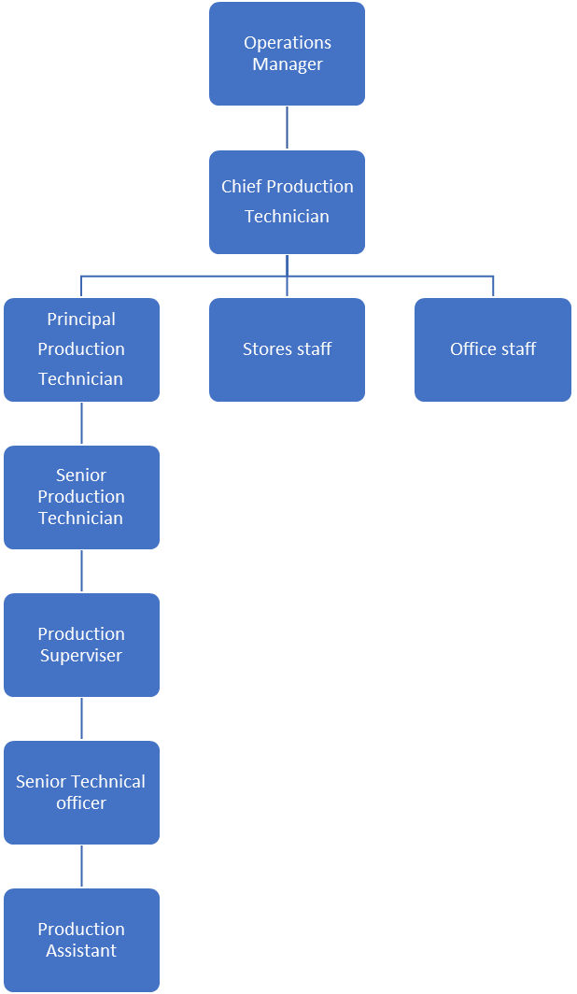
Organisational Chart

Other
This job description does not purport to cover all aspects of the job holder’s duties but is intended to be indicative of the main areas of responsibility.


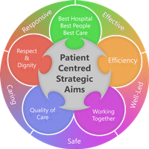
Person Specification
Qualifications
Essential
- Level 1 qualification/GCSE higher pass or above including maths and English or equivalent qualifications, or work experience that demonstrates comparable ability in a similar field.
Experience
Essential
- Demonstrated ability to work to set procedures and follow written instructions

Desirable
- Previous experience in a similar role: a Clean room or pharmaceutical background

Skills & Knowledge
Essential
- Ability to work using own initiative and without supervision
- Clear literate handwriting and numeracy skills
- Good communication skills
- Good interpersonal skills and ability to work as part of a team
- Computer skills
- Able to maintain high concentration for long periods
- Ability to work safely under pressure
- Ability to work flexibly and prioritise workload
- Health & Safety/security awareness
- Able to investigate problems logically
- Demonstrated ability to handle hazardous materials safely and according to local work instructions
- Proactive attitude to ongoing training and assessment

Desirable
- Previous experience working with aseptics/ pharmaceuticals
- Knowledge of principles of GMP (good manufacturing practice) and Quality Management Systems
- Good understanding of principles of aseptic manufacturing
- Customer care skills

Working Together For Patients with Compassion as One Team Always Improving
Strategic approach (clarity on objectives, clear on expectations)

Relationship building (communicate effectively, be open and willing to help, courtesy, nurtures partnerships)

Personal credibility (visibility, approachable, back bone, courage, resilience, confidence, role model, challenge bad behaviour, manage poor performance, act with honesty and integrity)

Passion to succeed (patient centred, positive attitude, take action, take pride, take responsibility, aspire for excellence)

Harness performance through teams (champion positive change, develop staff, create a culture without fear of retribution, actively listen and value contribution, feedback and empower staff , respect diversity)

Job holders are required to act in such a way that at all times the health and well being of children and vulnerable adults is safeguarded. Familiarisation with and adherence to the Safeguarding Policies of the Trust is an essential requirement for all employees. In addition all staff are expected to complete essential/mandatory training in this area.
Print Name:
Date:
Signature:

