**SINGLE CORPORATE SERVICES**

**INFECTION PREVENTION & CONTROL**

|  |  |  |
| --- | --- | --- |
| **Job title:** | IPC Data Analyst | ***To be completed by HR***  *Job Reference Number* |
| **Reporting to:** | IPC Quality Manager & Analyst |
| **Accountable to:** | IPC Quality Manager & Analyst |
| **Pay Band:** | 4 |

As part of the Single Corporate Service, this role is a designated site-based role however the post holder will be part of the Corporate Service team which provides a service across both Isle of Wight NHS Trust and Portsmouth Hospitals University NHS Trust.

As the single corporate service will be delivered across both organisations, individuals may be required to undertake business travel between sites. The frequency and arrangements will be discussed on an individual basis and the staff mobility local agreement will apply.

**Job purpose**

1. To support the Infection Prevention and Control team with the effective use of data, information, knowledge, and technology to improve service delivery across the trust

**Job summary**

1. To provide data analysis and support for the Infection Prevention and Control team
2. Maintain and provide regular reports on a routine and ad hoc basis
3. To support governance processes and production of papers for the Infection Prevention and Control Committee

**Organisational Chart**

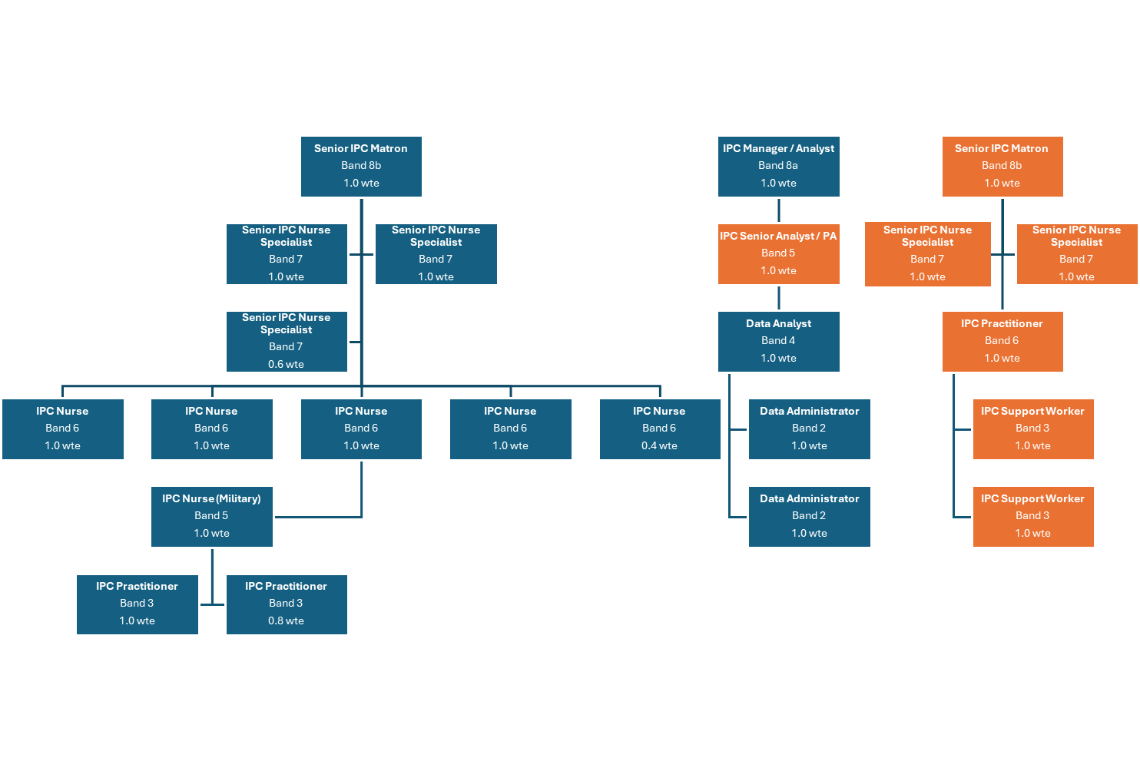

**Specific Core Functions**

1. To provide high quality accurate data to the Infection Prevention and Control Team to enable accurate reporting and monitoring of Trust performance.
2. The post holder is responsible for the production of routine internal information reports for key stakeholders, and for the production of information to support external statutory and mandatory returns to Public Health England, the Department of Health, NHS England and Improvement, Clinical Commissioning Groups, and other external organisations.
3. To support, with supervision, the development of key information systems and processes to improve the handling and processing of data and availability of management information.
4. To produce, with supervision, key datasets in line with NHS Information Standards Board guidelines and the needs of the Trust, and to support key Trust metrics and performance indicators.
5. To work with key stakeholders and assist in the development of new KPI reports and dashboards as required to monitor indicators that represent risks related to the trust’s performance and SLA contract monitoring.
6. To ensure the data produced makes best use of ICT systems and software, to work to improve the efficiency of the processes used and that the resultant information provided is viewed as best practice in terms of content and presentation.
7. To provide high quality, efficient and robust data to the Infection Prevention and Control Team to support the delivery of patient care by ensuring all existing and new reporting requirements are adhered to and implemented within stipulated timescales.
8. To provide statutory information and transmission of minimum data sets, according to nationally agreed standards and within defined timescales.
9. Using extensive knowledge of existing processes, ensure data is quality checked and investigate and resolve discrepancies and communicate these to the IPC Quality Manager & Principal Analyst.
10. To utilise tools available to the team as appropriate, for example, the use of benchmarking data.
11. To ensure the Trust’s surgical site surveillance is completed accurately and adheres to the PHE deadlines, with timely escalation of any foreseen issues.
12. To support the IPC Quality Manager & Principal Analyst in managing the Infection Prevention and Control Committee.
13. To create and disseminate IP&C reports for performance management processes to an agreed timetable and distribution list.
14. To line manage Data Administrators as per Team structure. Act as the first point of call before escalation to the IPC Quality Manager & Principal Analyst.
15. To provide administration for key departmental meetings/committees, including identification and booking of venues, the generation of timely agendas and the production of minutes. Ensure there is an accurate audit trail of committee/group activity
16. To ensure the robust administration of the IPC Link Practitioners Scheme. This includes making arrangements for training events and meetings, keeping accurate records of current link practitioners, managing the MS Teams Link Practitioner ‘team’, and ensuring information packs are produced as necessary.
17. To provide effective and efficient administrative support to the Infection Prevention and Control Team.
18. To ensure that telephone enquiries and visitors are dealt with promptly and efficiently in a courteous, professional, and informed manner.
19. To ensure the stock of all everyday stationary/computer equipment is regularly maintained ordering replacements when appropriate.
20. To undertake the procurement of any other items as necessary following authorisation, for example, conferences, booking of travel etc.

**Key Responsibilities**

***Communication and Working Relationships***

* The post holder will be providing and receiving routine information orally, in writing or electronically to inform work colleagues, patients, clients, carers, the public or other external contacts. The communication will include;

(a) Providing and receiving routine information which requires tact or persuasive skills or where there are barriers to understanding

(b) providing and receiving complex or sensitive information,

(c) providing advice, instruction, or training to groups, where the subject matter is straightforward.

***Analytical and Judgement***

* Judgements involving a range of facts or situations, which require analysis or comparison of a range of options.

***Planning and organising***

* Planning and organisation of straightforward tasks, activities, or programmes, some of which may be ongoing.

***Physical Skills***

* The post requires developed physical skills to fulfil duties where there is a specific requirement for speed or accuracy. This level of skill may be required for advanced or high-speed driving; advanced keyboard use; advanced sensory skills or manipulation of objects or people with narrow margins for error, or the post requires highly developed physical skills, where accuracy is important, but there is no specific requirement for speed. This level of skill may be required for manipulation of fine tools or materials.

***Patient Client Care***

* Assists patients/clients/relatives during incidental contacts.

***Policy and Service Development***

* The post holder is responsible for implementing policies within a team/department and proposes changes to working practices or procedures for own work area.

***Financial Management***

* The post holder is responsible for maintaining stock control and/or security of stock,

***Management/Leadership***

* The post holder is responsible for day-to-day management of staff within Infection Prevention & Control Data Team. The post holder will deal with the initial stages of grievance and discipline; appraisal; acting as an interview panel member; responsible for monitoring mandatory training compliance with their team. The post holder will be responsible for reviewing work performance and progress and manage the allocation of work.

***Information Resources***

* The post holder will regularly use computer software to develop or create statistical reports requiring formulae, query reports or detailed drawings /diagrams using desktop publishing (DTP) or computer aided design (CAD), or (c) responsible for maintaining one or more information systems where this is a significant job responsibility.

***Research and development***

* Undertakes surveys or audits, as necessary to own work; may occasionally participate in R&D, clinical trials or equipment testing.

***Freedom to Act***

* The post holder is guided by precedent and clearly defined occupational policies, protocols, procedures or codes of conduct. Work is managed, rather than supervised, and results/outcomes are assessed at agreed intervals.

***Physical effort***

* There is a frequent requirement for sitting or standing in a restricted position for a substantial proportion of the working time,

***Mental effort***

* There is a frequent requirement for concentration where the work pattern is unpredictable, or there is an occasional requirement for prolonged concentration.

***Emotional Effort***

* Exposure to distressing or emotional circumstances is rare, or occasional indirect exposure to distressing or emotional circumstances.

***Working conditions***

* Occasional exposure to unpleasant working conditions, or occasional requirement to use road transportation in emergency situations, or frequent requirement to use road transportation, or frequent requirement to work outdoors, or requirement to use Visual Display Unit equipment more or less continuously on most days.

**Person Specification**

|  |  |  |  |
| --- | --- | --- | --- |
| **Criteria** | **Essential** | **Desirable** | ***How criteria will be assessed*** |
| **Qualifications** | Good standard of education; GCSE Maths and English grade C or above, or equivalent  BTEC Level 2 Business Administration, or equivalent  ECDL, or equivalent experience |  | Application |
| **Experience** | NHS experience an advantage, but not essential  Data analysis experience  Experience of data manipulation and interrogation of databases | Experience of hospital computer systems | Application  Interview |
| **Knowledge** | Good literacy, numeracy, and communication skills  Good organisational skills and ability to work with minimal supervision using own initiative  Ability to prioritise workload and be able to work under pressure to tight deadlines  Ability to achieve a high level of accuracy  Ability to analyse numerical and written data  Ability to interpret guidance and policy requirements  Knowledge of database systems and/or data warehouse systems |  | Application  Interview |

**Compliance statement to expected organisational standards.**

To comply with all Trust Policies and Procedure, with particular regard to

• Risk Management

• Health and Safety

• Confidentiality

• Data Quality

• Freedom of Information

• Equality Diversity and Inclusion

• Promoting Dignity at Work by raising concerns about bullying and harassment

• Information and Security Management and Information Governance

• Counter Fraud and Bribery

The Trust has designated the prevention and control of healthcare associated infection (HCAI) as a core patient safety issue. As part of the duty of care to patients, all staff are expected to:

* Understand duty to adhere to policies and protocols applicable to infection prevention and control.
* Comply with key clinical care policies and protocols for prevention and control of infection at all time; this includes compliance with Trust policies for hand hygiene, standards (universal) infection precautions and safe handling and disposal of sharps.
* All staff should be aware of the Trust’s Infection Control policies and other key clinical policies relevant to their work and how to access them.
* All staff will be expected to attend prevention and infection control training, teaching and updates (induction and mandatory teacher) as appropriate for their area of work, and be able to provide evidence of this at appraisal.
* To perform your duties to the highest standard with particular regard to effective and efficient use of resources, maintaining quality and contributing to improvements.
* Ensure you work towards the Knowledge and Skills Framework (KSF) requirements of this post. KSF is a competency framework that describes the knowledge and skills necessary for the post in order to deliver a quality service.
* Your behaviour will demonstrate the values and vision of the Trust by showing you care for others, that you act professionally as part of a team and that you will continually seek to innovate and improve. Our vision, values and behaviours have been designed to ensure that everyone is clear about expected behaviours and desired ways of working in addition to the professional and clinical requirements of their roles.
* Ensure you adhere to and work within local and national safeguarding children legislation and policies including the Children Act 1989 & 2004, Working Together to Safeguard Children 2013, 4LSCB guidance and the IOW Safeguarding Policy.
* Ensure you adhere to and work within the local Multiagency safeguarding vulnerable adults policies and procedures
* Ensure that you comply with the Mental Capacity Act and its Code of Practice when working with adults who may be unable to make decisions for themselves.
* Ensure that you maintain personal and professional development to meet the changing demands of the job, participate in appropriate training activities and encourage and support staff development and training.
* Respect the confidentiality of all matters that they may learn relating to their employment and other members of staff.  All staff are expected to respect conform to the requirements of the Data Protection Act 1998, including the responsibility to ensure that personal data is accurate and kept up to date.
* If your employment is to a post that requires you to be registered with a professional body, the continuation of your employment is conditional upon you continuing to be registered with the appropriate professional body. The Trust will require evidence of current registration.
* Proactively, meaningfully, and consistently demonstrate the Trust Values in your everyday practice, decision making and interactions with patients and colleagues.
* Perform any other duties that may be required from time to time.

This job description may be altered, from time to time, to meet changing needs of the service, and will be reviewed in consultation with the post holder.