SINGLE CORPORATE SERVICES

Improvement Team

Job title: | Improvement Facilitator | To be completed by HR  Job Reference Number
Reporting to: | Improvement Practitioner | To be completed by HR  Job Reference Number
Accountable to: | Senior Improvement Coach | To be completed by HR  Job Reference Number
Pay Band: | 6 | To be completed by HR  Job Reference Number

As part of the Single Corporate Service, this role is a designated site-based role however the post holder will be part of the Corporate Service team which provides a service across both Isle of Wight NHS Trust and Portsmouth Hospitals University NHS Trust.

As the single corporate service will be delivered across both organisations, individuals may be required to undertake business travel between sites. The frequency and arrangements will be discussed on an individual basis and the staff mobility local agreement will apply.

For our leaders managing staff across multi-site locations, they will need to be visible and provide in person leadership. The arrangements and frequency will be agreed locally.

Job purpose

Portsmouth Hospitals University NHS Trust and the Isle of Wight NHS Trust have a vision that drives the ambition of the organisations:

“Working together to deliver excellence in care for our patients and communities”

Developed as part of our ‘Working Together, Improving Together’ Strategies developed in 2023 and 2024 respectively, the Trusts have been actively working towards the achievement of their vision through organisational improvement and change initiatives. Central to these ambitions is the Trusts’ ability to deliver that excellence through their day-to-day actions, functions, processes and behaviours.

This approach, Delivering Excellence, seeks to embed a whole organisation operating model based on operational excellence, that provides a clear approach to the planning, delivery, control and continuous improvement of the quality of all our services. Building on the improvements made so far this approach is expected to develop and embed a mature approach to quality assurance that moves away from a compliance and inspection approach. Developing beyond standalone quality improvement activities, this will connect all staff, every day, to a shared vision for excellence in care.

The ambition for Delivering Excellence is that all staff are developed and supported to be able to say:

- I know what is expected of me and why
- I know how I am doing today and how to fix things in my workplace
- I am able to make improvements

This role will be as a lead in the Improvement Team, at the forefront of this transformation.
Job summary

The Improvement Facilitator will be a member of the Improvement team, as part of the Delivery Unit, and will support and facilitate improvement activities across the organisation in line with the Trust’s strategic priorities. This role will be primarily focused on activities at the Isle of Wight NHS Trust and will be expected to be on site at least 3 days per week.

Working closely with colleagues across clinical and corporate functions, they will support the development, implementation and application of continuous improvement methodologies to support the Trusts’ operational, clinical and financial priorities, supported by the direction and leadership of the Senior Improvement Coaches. They will support the Trusts to build capability and capacity for improvement throughout the workforce through the delivery of formal and informal methods of training, mentoring and coaching. They will contribute to the development of the Delivering Excellence methodology to ensure that it reflects ongoing best practice in improvement and reflects national, regional and local changes in healthcare policy and strategy.

Organisational Chart

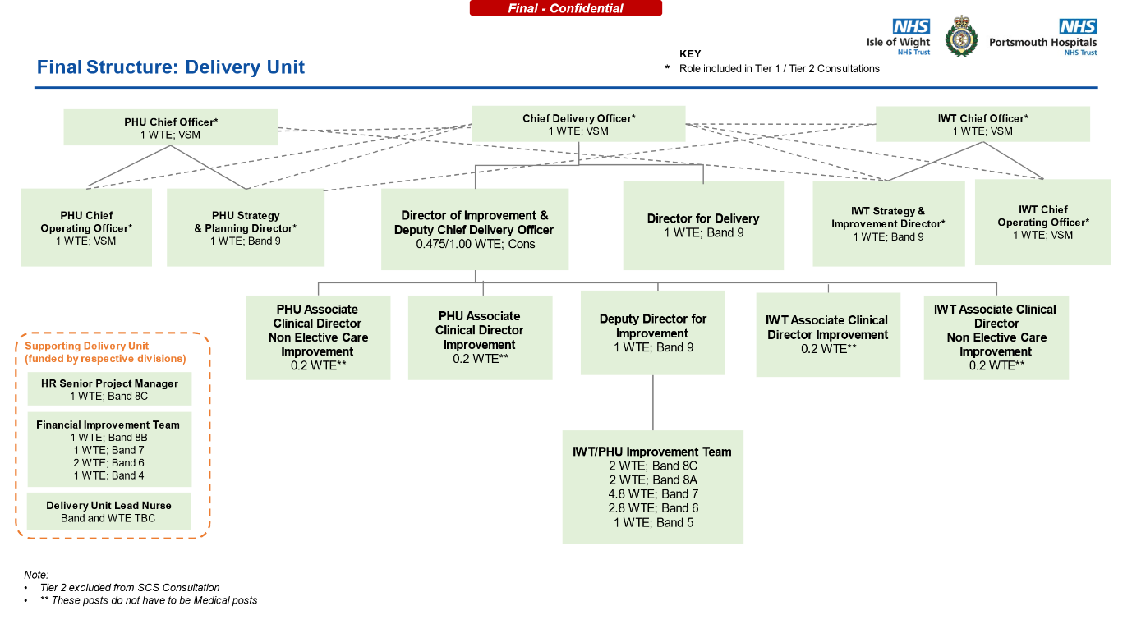

Specific Core Functions
Improvement facilitation – developing capability
- Work across the organisations to support the delivery of improvement and transformational change activities, programmes and projects in line with the Trusts’ strategic priorities.
- Provide direct expert improvement coaching and facilitation to programme teams and to multi-disciplinary teams to deliver excellent services to their patients and carers.
- Support the design, co-ordination and facilitation of rapid improvement events, providing a structured approach to value stream mapping, problem solving, creative/design thinking, iterative testing and evaluation of solutions and practical implementation into operational services.
- Support teams to translate care pathways or service delivery processes into detailed process maps and use them as catalysts for transformation and communication.
- Support teams to identify the optimal patient pathways or service delivery processes, by working with them to identify and eliminate waste and maximise quality efficiency and effectiveness.
- Evaluate, analyse and synthesise highly complex quantitative and qualitative data using tested and credible tools, including lean and other quality improvement techniques, and support teams to use this data to identify improvement priorities and to drive the delivery of measurable improvements.
- Support teams to use robust problem-solving skills to find and understand root causes of problems.
- Using sound communication and facilitation skills, support teams to identify solutions, ideas and experiments that can be applied and tested through robust application of improvement science.
- Ensure improvement changes are driven by the needs of the patient, their families and other stakeholders through the use of participative and design methods to incorporate their views and experiences.
- Support with establishing key performance indicators and ensure robust tracking and reporting of milestones, deliverables and improvement measures and benefits using a 30,60,90-day rapid improvement approach. This will include using a counter-measure approach to ensure risks and issues are addressed and do not affect project progress.
- Role-model improvement principles and provide coaching of teams throughout the improvement activities to build sustainable improvement skills and understanding across staff and leaders, creating the cultural conditions for improvement.
- Build trust and confidence through effective relationships across the Trust with clinical leaders, service managers and support staff.

Improvement facilitation – using capability
- Provide front-line improvement coaching to support operational teams to reach high standards of daily continuous improvement.
- Support front-line teams to communicate effectively through improvement huddles, supporting the processes and behaviours that enforce continuous improvement.
- Provide expertise to support the identification of waste, improve process flow and establish an effective workplace using improvement tools & techniques (e.g. 5S, Gemba walks, waste observation, A3 thinking etc).
- Directly apply some improvement tools to support teams’ understanding of their own service where those skills or capacity does not exist.
- Support the training of staff to develop standard work for core processes that reduce waste and reinforce sustainability.
- Support the establishment of systems for assuring adherence to standard work, visual management and workplace communication.
- Support teams to actively manage their service delivery daily, including providing frameworks for rapid problem solving, countermeasures and escalation where needed.
- Provide expert advice to support teams to understand, interpret and present their own data and information, including patient experience feedback. This will include providing support to gather data where this is not readily available.
- Engage and motivate staff in daily activities to encourage and build a culture of continuous improvement within the workplace.
- Coach and mentor teams in daily continuous improvement, role-modelling the values of the Trust and the improvement principles of Delivering Excellence. This may include providing robust challenge and feedback at times.

Key Responsibilities

Communication and Working Relationships
- The post holder will be providing and receiving complex, sensitive or contentious information, where persuasive, motivational, negotiating, training, empathic or re-assurance skills are required. This may be because agreement or cooperation is required or because there are barriers to understanding and/or providing and receiving highly complex information.

Analytical and Judgement
- Judgements involving complex facts or situations, which require the analysis, interpretation, and comparison of a range of options.

Planning and organising
- Planning and organisation of complex activities or programmes, which require the formulation and adjustment of plans.

Physical Skills
- The post has minimal demand for work related physical skills.

Policy and Service Development
- The post holder is responsible for the implementation of policies for a team/department and proposes policy or service changes which impact beyond own area of activity.

Financial Management
- The post holder will observe a personal duty of care in relation to equipment and resources used in the course of their work.

Management/Leadership
- The post holder is responsible for day-to-day supervision or co-ordination of staff within the Improvement Team. They will deal with work allocation and daily responsibility for the monitoring or supervision of one or more groups of staff.

Information Resources
- The post holder records personally generated information.

Freedom to Act
- The post holder is guided by precedent and clearly defined occupational policies, protocols, procedures or codes of conduct. Work is managed, rather than supervised, and results/outcomes are assessed at agreed intervals.

Physical effort
- A combination of sitting, standing, and walking with little requirement for physical effort. There may be a requirement to exert light physical effort for short periods.
Mental effort
- There is a frequent requirement for concentration where the work pattern is predictable with few competing demands for attention, or there is an occasional requirement for concentration where the work pattern is unpredictable.

Emotional Effort
- Exposure to distressing or emotional circumstances is rare, or occasional indirect exposure to distressing or emotional circumstances.

Working conditions
- Exposure to unpleasant working conditions or hazards is rare.

Person Specification

Criteria | Essential | Desirable | How criteria will be assessed
Qualifications | - Degree Level or equivalent experience.  - Completion of QI awareness level training or equivalent level of knowledge/experience.  - Evidence of additional on-going training and development in-line with the specific requirements of this role. | - Improvement training/education at foundation level or equivalent experience (e.g. Lean Yellow Belt, QSIR Fundamentals, IHI Model for Improvement, PHUT Advanced Improvement Leader training).  - Degree in a health-related subject or equivalent experience working in a healthcare setting.
Experience | - Experience of improving workplace processes and ways of working.  - Experience of coaching or facilitating others to improve and develop.  - Experience of co-ordinating a project / programme / workstream with delivery of outputs to required time, quality and cost.  - Experience in presenting to groups and facilitating workshops, meetings and engagement sessions.  - Experience of working in a multi-disciplinary environment/complex organisation. | - Experience of working successfully with colleagues/service leads/managers in continuous improvement and service re-design.  - Experience in delivering training.  - Experience of using NHS information, benchmarking data and hospital information systems.
Knowledge | - Ability to plan, manage and implement work activities in a time constrained environment.  - Good analytical and problem solving skills.  - Ability to gather data, compile information logically and prepare draft reports.  - Skills in using and developing improvement documentation/standard work.  - Strong interpersonal skills and ability to work effectively with staff at all levels in the Trust.  - Effective communication skills, both orally and in writing. | - Evidence of influencing skills in complex and highly contentious situations.  - Able to present with confidence to a variety of audiences.  - Good IT skills with experience of using Excel for analysing and producing data, collating PowerPoint presentations, Word for producing professional briefing documents and Visio for process-mapping.

Compliance statement to expected organisational standards.

To comply with all Trust Policies and Procedure, with particular regard to:
• Risk Management
• Health and Safety
• Confidentiality
• Data Quality
• Freedom of Information
• Equality Diversity and Inclusion
• Promoting Dignity at Work by raising concerns about bullying and harassment
• Information and Security Management and Information Governance
• Counter Fraud and Bribery

The Trusts have designated the prevention and control of healthcare associated infection (HCAI) as a core patient safety issue. As part of the duty of care to patients, all staff are expected to:
- Understand duty to adhere to policies and protocols applicable to infection prevention and control.

- Comply with key clinical care policies and protocols for prevention and control of infection at all time; this includes compliance with Trust policies for hand hygiene, standards (universal) infection precautions and safe handling and disposal of sharps.

- All staff should be aware of the Trust’s Infection Control policies and other key clinical policies relevant to their work and how to access them.

- All staff will be expected to attend prevention and infection control training, teaching and updates (induction and mandatory teacher) as appropriate for their area of work and be able to provide evidence of this at appraisal.

- To perform your duties to the highest standard with regard to effective and efficient use of resources, maintaining quality and contributing to improvements.

- Ensure you work towards the Knowledge and Skills Framework (KSF) requirements of this post. KSF is a competency framework that describes the knowledge and skills necessary for the post in order to deliver a quality service.

- Your behaviour will demonstrate the values and vision of the Trust by showing you care for others, that you act professionally as part of a team and that you will continually seek to innovate and improve. Our vision, values and behaviours have been designed to ensure that everyone is clear about expected behaviours and desired ways of working in addition to the professional and clinical requirements of their roles.

- Ensure you adhere to and work within local and national safeguarding children legislation and policies including the Children Act 1989 & 2004, Working Together to Safeguard Children 2013, 4LSCB guidance and the IOW Safeguarding Policy.

- Ensure you adhere to and work within the local Multiagency safeguarding vulnerable adults policies and procedures.

- Ensure that you comply with the Mental Capacity Act and its Code of Practice when working with adults who may be unable to make decisions for themselves.

- Ensure that you maintain personal and professional development to meet the changing demands of the job, participate in appropriate training activities and encourage and support staff development and training.

- Respect the confidentiality of all matters that they may learn relating to their employment and other members of staff. All staff are expected to respect conform to the requirements of the Data Protection Act 1998, including the responsibility to ensure that personal data is accurate and kept up to date.

- If your employment is to a post that requires you to be registered with a professional body, the continuation of your employment is conditional upon you continuing to be registered with the appropriate professional body. The Trust will require evidence of current registration.

- Proactively, meaningfully and consistently demonstrate the Trust Values in your every day practice, decision making and interactions with patients and colleagues.

- Perform any other duties that may be required from time to time.

This job description may be altered, from time to time, to meet changing needs of the service, and will be reviewed in consultation with the post holder.

