Title: Emergency Practitioner (EP)
Band: 7
Staff Group: Nursing and Midwifery
Reports to: Clinical Lead/Lead ACP

Job Purpose:
- A lead specialist and clinical expert who is expected to provide high quality patient assessment and management of minor injury and illness within the ED, ECC and UTC
- Accountable for own professional actions in the assessment and management of minor injury and illness.
- Practice autonomously, encompassing the skills of assessment, diagnosis, and treatment, discharge and referral of patients, presenting to the Adult Urgent Care in of the ED, ECC and the MIU with undifferentiated injury and illness.
- Manage the ECC/UTC on a day-to-day basis

Key Responsibilities
- Budget on which the post will impact: Directly and indirectly up to £5 million
- Staff Number supervised: all staff working within ECC / UTC including junior ENPs, trainee ENPs, See and Treat nurses, Registered Nurses and Medical technicians
- Manage own workload within ECC and the UTC, working autonomously to assess, manage, refer and discharge adult and paediatric patients presenting with undifferentiated minor injury and illness. The UTC currently sees >45,000 patients per annum and the ECC primarily assesses in excess of 20,000 patients per annum
- Lead in the development of the ECC and UTC service and extension of scope of practice to other areas.

Organisational Chart
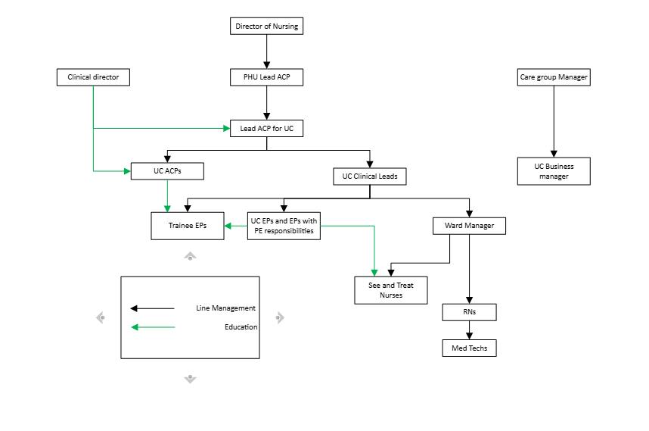

Specific Core Functions
Clinical Practice

- To deliver and participate in the clinical care of patients presenting to ED, ECC and the UTC

- Use highly developed skills to prioritize clinical need and organize workload of self and others

- Provide a level of advanced and comprehensive assessment based on specialist knowledge for adult and paediatric patients presenting with undifferentiated presentations to the ED, ECC and UTC

- To assess, examine, investigate, diagnose and treat adult and paediatric patients, resulting in the safe management and appropriate referral or discharge

- Autonomously and independently make the decision to discharge or refer the patient presenting with minor injury / illness without medical intervention within scope of practice

- Able to assess, analyse, interpret and compare a range of complex clinical information and take appropriate action to ensure that individual patients needs are met

- Have direct responsibility for the management of patients within their own case load

- Maintain own clinical development by keeping abreast of new treatments and technologies within emergency and unscheduled care

- Lead the ECC and UTC service as an expert, advanced practitioner and professional role model.

- Work autonomously and independently, without supervision, utilizing advanced specialist knowledge and highly developed analytical and decision-making skills.

- Utilizing advanced clinical skills, promote clinical excellence and ensure an optimum standard of nursing and medical care is delivered from admission to discharge within the ED, ECC and the UTC.

- Accountable and responsible for own actions and highly complex decisions in the assessment, examination, diagnosis, treatment and discharge or referral of patients.

- Responsible and totally accountable for the management, treatment and care delivery to the patient.

- Effectively assess the nature and extent of injuries and illness by conducting an initial and ongoing physical and psychological assessment utilizing highly developed analytical decision making and highly developed advanced clinical assessment skills to establish a correct diagnosis.

- Use advanced training and a patient focused approach request and interpret relevant diagnostic tests to establish a correct diagnosis

- Using a patient focused approach lead in the setting of standards of care.

- Communicates using high level skills, highly complex, sensitive information with patients and carers on condition related information to ensure their active involvement in treatment plans

- Acknowledges and accommodates barriers to communication and understanding including speech, hearing, language and emotion

- Develop and take the lead in planning and implementing specialized programs of care.

- Provide highly specialized advice concerning the nursing care of patients with minor injuries and illness.

- Work within defined departmental and trust protocols.

- Develop evidence-based protocols to continually increase scope of practice.

- Act as a competent and efficient clinical and managerial decision-maker within and on behalf of the emergency care team, taking responsibility for those decisions and seeking expert help when necessary

- Administer medication to patients following Patient Group Directives as appropriate or prescribe medications within scope of practice after completing a recognized non-medical prescribing qualification

- Be responsible for providing specialist clinical and relevant patient information and develop a system to deliver health education within the clinical area and beyond own area.

- Able to undertake highly developed skills where a degree of dexterity and precision are essential eg. Venipuncture, cannulation, advanced wound closure techniques, administration of medicines, use of stethoscope, tendon hammer and advanced keyboard skills

- Ensure Trust and Professional standards of documentation and record keeping are maintained.

- To accurately record personally generated clinical patient records and notes

- Establish effective communication and relationships with the multi-disciplinary team.

- Directly supervise members of the multidisciplinary team, including junior EPs, junior doctors, senior and junior nursing staff

- Provide and receive highly complex, sensitive information, regarding patients and their relatives.

- Present specialist information, take the lead and establish the role of being a highly advanced clinical specialist resource within your field

- Be responsible for the implementation, maintenance and evaluation of evidence based clinical standards.

- Undertake and participate in relevant specialist research at Masters level, establishing a commitment to evidence based practice.

- Highlight areas for change, then initiate and evaluate evidence to improve and develop patient care. Present, disseminate and communicate research findings locally within trust and nationally through publication.

- Develop and lead internal clinical audit in the specialist field

Management and organizational Role

- Manage the ECC and UTC and junior staff to ensure patient flow is maintained

- Delegate workload to the multi-disciplinary team when appropriate and ensure efficient, effective patient care is delivered at the highest standard.

- Manage staffing levels within the EP group, ensuring that absence and sickness is covered appropriately

- Participate in the recruitment and selection of departmental staff.

- Be responsible for service development, planning and implementation of specialist policies and procedures relevant to ECC and UTC

- Create an environment of collaboration, integration and co-operation between the ED and the ECC/UTC

- Participate and advise on HR issues pertaining to leave/absence, disciplinary/grievance issues or any other management issues that may arise within minors and UTC.

- Support the Clinical Leads and inform change by representing the ECC and UTC service at care group level

- Work in partnership with the ED team to influence clinical and managerial decision making

- Co-ordinate and supervise the management and planning of nursing care to meet service demand/patient dependencies in relation to minor injuries and illness

- Ensure the safe custody, maintenance and administration of drugs within Trust policy.

- Influence and take responsibility for audits and quality monitoring to improve patient care and service delivery.

- Influence, interpret and implement organizational change at local and organizational levels.

- Continuously deliver practice and evaluate improvements in line with the Clinical Governance Strategy.

- Initiate and lead Individual Performance Reviews for a designated group of staff and support them to define their own personal and educational development needs using a personal development plan.

- Understand and influence the ward budget. Monitor the use of resources when prescribing, implementing care and treatments. Inform the Senior Nurse of deviations from the budget and initiate action plans to maintain financial control.

- Utilize patient/carer feedback to improve the quality of service

- Participate in strategic and operational developments and contribute to the organizational objectives.

- Ensure the ward team are aware of and work to Trust Policies.

- Demonstrate awareness of and comply to Health and Safety regulations and procedures.

- Provide advice and support in the advanced planning and crisis management of off duties to maintain optimum staffing levels.

Professional development and Education role

- Support the departmental education team and assist with the management of education within the department.

- Supervise newly qualified, junior nursing and medical staff, trainee ENPs and junior EP colleagues when they work within the ECC and UTC

- To provide specialist training and education for the multi-disciplinary team in the specialist field of Minor injuries and illness.

- Act as an assessor and mentor for post registration nurses, trainee EPs, students and all disciplines of health care professionals.

- Guide practice and assess competence, enabling and supporting learning.

- Demonstrate and maintain awareness of current advances and changes in clinical practice and initiate change accordingly.

- Take responsibility for and identify any practice development needs to maintain own specialist knowledge and meet service need. Attend statutory training.

- Maintain an up to date record of professional development.

- Participate in formal review/appraisal of own performance with designated appraiser and ensure all staff receives the same. Liaise with the Senior Nurse with the training/educational requirements.

- Provide a positive learning environment, participate in teaching and act as a clinical resource/role model. Liaise with internal and external educational and training providers to develop, motivate and retain staff.

- Lead and evaluate professional development programmes to improve the delivery of patient care. Adopt a strategic approach to the development of education, training and clinical services.

- Provide and manage induction and support programmes within the clinical area.

- Adhere to professional codes of conduct and maintain patient confidentiality/Data protection Act at all times.

- Critically reflect own performance through audit and clinical supervision.

Communications and working relationships.

- Initiate, develop and strengthen interpersonal relationships with all members of the multi-disciplinary team ensuring good team working, collaborative working practices and professionalism through the department.

- Demonstrate expertise in dealing with interpersonal conflict and be responsible for the resolution of any adverse situations/incidents.

- Ensure effective communication systems are in place for all members of the health care team and visitors. Disseminate, act upon and relay organisational information.

- Liaise with Senior Nurse and Senior Medical staff as appropriate.

- Participate in department meetings as appropriate.

- Provide and maintain up to date evidence based systems of care and treatment to ensure staff work in partnership with the patients and their carers to enable them to make informed choices

- Provide a supportive environment for all staff ensuring work practices comply with the Improving Working Lives Strategy.

- Network with nurses and health care professionals locally and nationally to share and disseminate good practice.

Working Conditions and Effort

- Be exposed on a daily basis with distressed relatives and patients.

- Daily exposure to highly unpleasant conditions, dealing with body fluids such as blood, faeces and urine

- There is the potential for exposure to situations where patients have challenging behaviour, including violent and verbally aggressive patients, and those under the influence of alcohol/drugs

- Physical effort required is a combination of moderate to fast pace of work

- Mental effort required is a high level of concentration in the autonomous decision making process, highly complex patient assessments and procedures. Being able to respond to frequent unpredictable changes in workload and activity

Other
This job description does not purport to cover all aspects of the job holder’s duties but is intended to be indicative of the main areas of responsibility

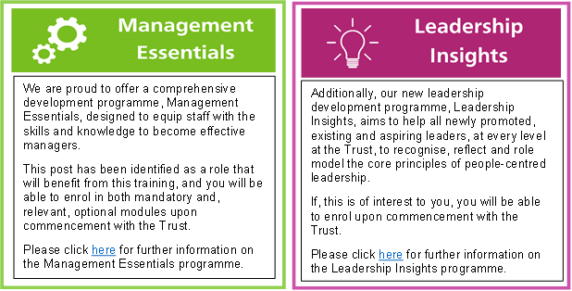
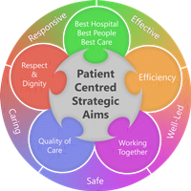
Person Specification
Qualifications
Essential
- Healthcare Professional registered with either the NMC, the HCPC or the GPhC
- Completion of an EP Course to degree level or equivalent, or, an appropriate advanced Allied Health professional program of study
- ENB 998 or C&G 7307 or equivalent teaching/mentorship course
- Evidence of highly developed specialist knowledge in Minor Injuries underpinned by theory and evidence

Desirable
- Degree or willing to work towards
- Evidence of developing practice and continual learning
- Evidence of teaching
- Evidence of research and audit
- Articulate and knowledgeable in current health issues
- ALS provider
Experience
Essential
- Significant experience (circa >4years) in an acute emergency setting, and some (circa >1year) as a band 6 working in an autonomous practitioner role
Skills & Knowledge
Essential
- Ability to work autonomously and within a team
- Advanced roles and procedures- advanced X-ray interpretation, ECG interpretation, biochemical requesting and interpretation, venepuncture, cannulation, I.V Drug therapy, plastering, advanced suturing skills, minor invasive operative procedures, manipulation of limbs under LA, Male and Female catheterisation
- Advanced clinical decision making skills
- Excellent communication skills
- Critical appraisal skills
- Organizational skills
- Inter-personal and team building skills

Desirable
- IT skills
- Research and audit skills
- Ability to act and serve and take the lead on special interest groups/committees
PERSONAL QUALITIES
• Strong interpersonal skills
• Effective communicator both verbally and written
• Motivating
• Proactive in taking both personal and professional development forward
• Organizational and management skills
• Responsive and flexible
• Well developed influencing skills across hierarchies and multi disciplines
• Ability to work under pressure
• Energetic and confident
Working Together For Patients with Compassion as One Team Always Improving
Strategic approach (clarity on objectives, clear on expectations)

Relationship building (communicate effectively, be open and willing to help, courtesy, nurtures partnerships)

Personal credibility (visibility, approachable, back bone, courage, resilience, confidence, role model, challenge bad behaviour, manage poor performance, act with honesty and integrity)

Passion to succeed (patient centred, positive attitude, take action, take pride, take responsibility, aspire for excellence)

Harness performance through teams (champion positive change, develop staff, create a culture without fear of retribution, actively listen and value contribution, feedback and empower staff , respect diversity)

Job holders are required to act in such a way that at all times the health and well being of children and vulnerable adults is safeguarded. Familiarisation with and adherence to the Safeguarding Policies of the Trust is an essential requirement for all employees. In addition all staff are expected to complete essential/mandatory training in this area.
Print Name:
Date:
Signature:

