Title: Patient Receptionist
Band: 2
Reports to: Patient Reception and Health Records Portering Admin Manager
Job Summary:
To project a modern, professional, capable and customer facing service in the corporate reception areas of the QA site.

To be the first point of contact for the majority of non-emergency patients, their carers and visitors: to provide information, give directions, offer advice and assistance either face-to-face or via telephone enquiries.

To offer support and empathy to our patients and the ability to defuse high emotional situations, professionally and discretely

To provide reception cover on the main reception on all corporate reception areas.

This role will be required to work over a 24/7 in line with the roster which includes relief week, where staff are requested to be available for last minute sickness if not rostered on shift.

Key Responsibilities:
- To be the first point of contact and provide customer assistance to patients, carers and business visitors to the Trust.
- The post-holder should recognise the importance of effective communication within the team and will strive to:
- Communicate effectively with team members
- Communicate effectively with patient and carers
- Recognise people’s needs for alternative methods of communication and respond accordingly.
- Show compassion and empathy

- Respond to enquiries by telephone and in person in a courteous, professional and informed manner.
- React calmly in high emotional situations, always showing empathy and compassion
- Deal with face-to-face and telephone enquiries in a courteous, professional and informed manner, ensuring adherence to Trust Policies regarding Confidentiality
- In the absence of portering staff, reception staff will be expected to take patients in wheelchairs to the appropriate area
- Work to standard procedures, using Trust and Local policies and procedures.
- Data entry, for example: accessing the Trust’s Patient Centre system to accurately record the admission, transfer and discharge of patients or entering feedback from patient surveys
- Access the Patient Centre system to answer patient related queries.
- In staff absence, staff maybe asked to assist in covering shifts on the rota to ensure that the service is covered.
- Staff will be requested to support portering to deliver casenotes to various areas within the QAH site.
- The post holder may be required to undertake other duties relevant to the service as may be determined by the Management Team.
- Staff are expected to work as a relief week where staff are requested to be available for last minute sickness if applicable. This will be once every 11 weeks.

Organisational Chart

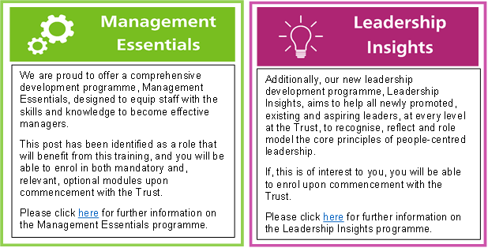

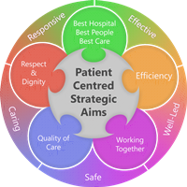
Person Specification
Qualifications
- NVQ 2 in Customer Service or relevant experience
- 2 years’ experience in a customer facing role

Skills and Knowledge
- Ability to communicate effectively with all visitors to the QAH site
- Ability to manage and resolve patient/visitor/carer related queries professionally
- Ability to use multiple computer programs
- Ability to work using own initiative
- Ability to balance competing priorities
- Confident in dealing with highly emotive situations, whilst remaining calm

Experience
- NHS experience – desirable but not essential.
- GCSE English and Maths
- Working with the general public in a customer facing role for at least 1 year
- Worked as part of a team

Working Together:
For Patients
With Compassion
As One Team
Always Improving

Job holders are required to act in such a way that at all times the health and well being of children and vulnerable adults is safeguarded. Familiarisation with and adherence to the Safeguarding Policies of the Trust is an essential requirement for all employees. In addition all staff are expected to complete essential/mandatory training in this area.

Print Name:
Date:
Signature:

