Radiotherapy Department Welcome Brochure

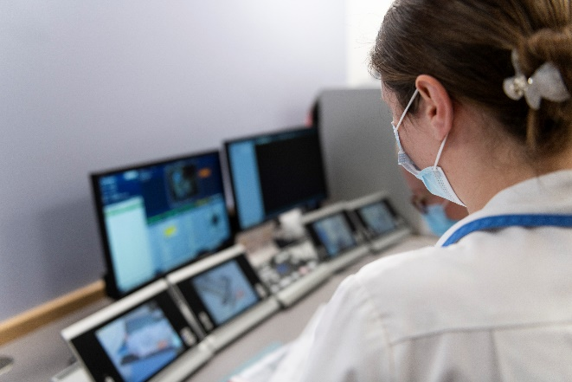
Technology & Service Development
Personal & Professional Development

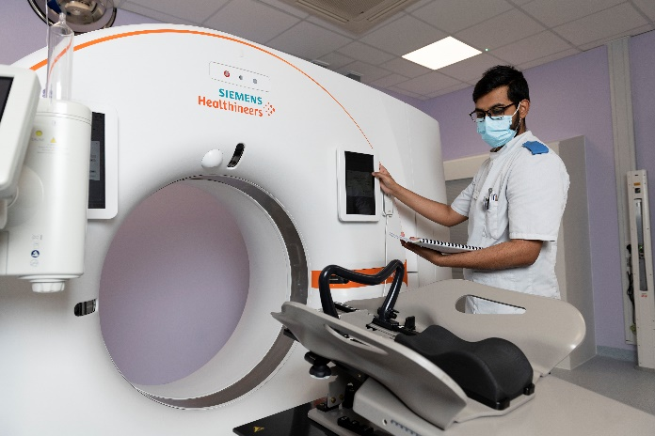

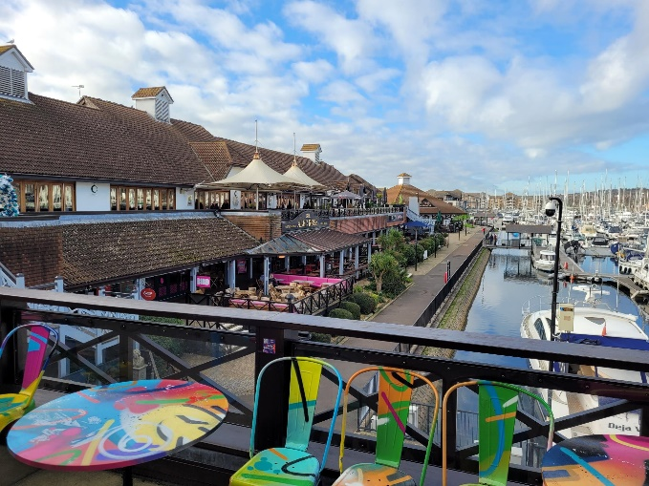

Portsmouth City Information

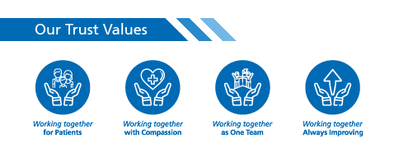
#ProudToBePHU

Service & Professional Development
We are a primary radiotherapy centre covering a wide area and treating patients from Portsmouth, Southampton, West Sussex, and the Isle of Wight. As well as a daily routine of scanning, planning, and treating patients, we also offer an out of hours service at the weekends.
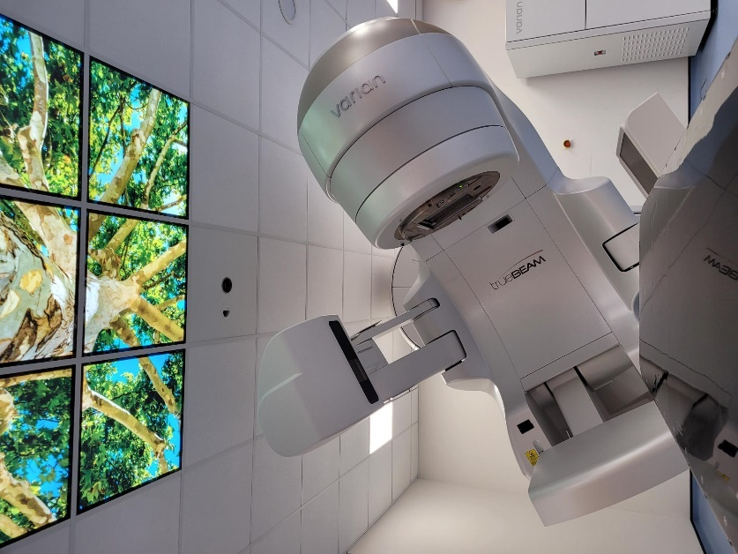
When working at Portsmouth Radiotherapy, you will have the opportunity to rotate round and experience all areas of the department, including CT planning, data input, treatment (Linacs), on-treatment review, Brachytherapy and on our newly installed Xstrahl superficial machine.
We have four newly installed TrueBeam 2.7 Linacs which are soon to have software upgrades to TrueBeam 3.0. Each of our Linacs have the advanced IGRT package meaning our imaging capabilities are top of the range regarding Linac based treatments. Linac 1 treats male urology and Lung SABR, Linac 2 all head and neck (inc. Brain), Linac 4 female urology and colo-rectal, and Linac 5 all thorax sites (inc. Breast). Each Linac has gated treatment options and visual coaching guidance. Two of our machines have the PerfectPitch© couch top to allow us to apply six degrees of freedom for increased accuracy of head and necks, upper and lower GI and SABR patients. Having advanced IGRT means our imaging capabilities are top of the range regarding Linac based treatments using 3D and 4D CBCT image verification. There are also triggered, gated and extended length CBCT options.
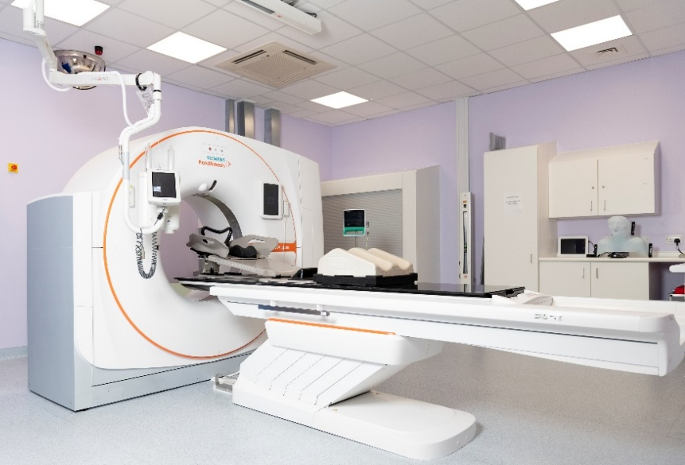
Radiotherapy is an ever-advancing specialism, in the last year we have introduced two gated treatment techniques for Lung SABR and our PHU specific Intramammary Chain technique for advanced breast cancer patients. We are committed to remaining current with all ongoing radiotherapy research, with abdominal compression being introduced for SABR and oligometastatic carcinomas. Band 6 and above are immediately provided with a SABR workbook and competency pack. As a department we value all our team and ensure practice opportunities depend on competency, with only a couple of exceptions, all radiographers, despite their band are encouraged to participate all aspects of the patient’s care path.
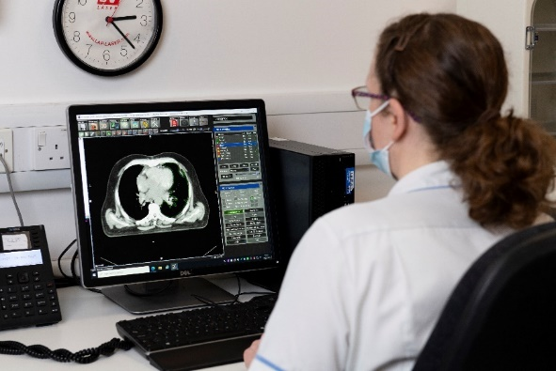
We have a newly installed Siemens (Sim-Go) CT scanner with RGSC connection, auto contouring capability, 4DCT, simultaneous contrast scanning, real time immobilisation, audio, and visual coaching for chest specific patients, auto connected software programs. As a rotational CT member, you would divide your skills into patient-facing CT scanning, focussing on using a variety of immobilisation equipment to create reproducible setups whilst maintaining patient comfort and dignity. With complex scanning comes complex planning, therefore dedicated time is spent completing radiographer-led Vsim planning, designing intended treatment setups and performing primary patient specific pre-assessment. Our Radiographers in CT are trained to contour all relevant organs at risk for all sites (excluding lymph nodes). There is also scope for virtual sim planning of all palliative and breast treatment sites.
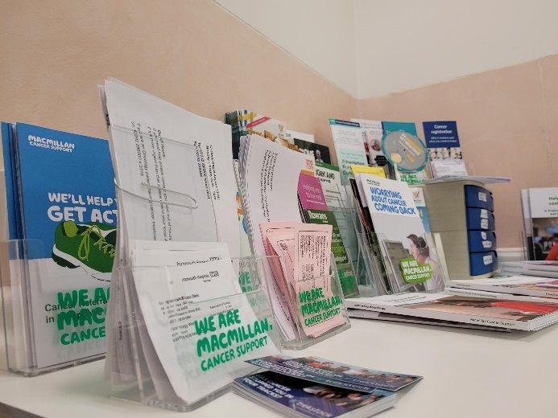
Data input is the “Central” hub where all radiotherapy treatment plans are imported and checked on Aria. Radiographers who rotate through Central will be able to cross check all plans for plan approval and then extend their responsibility to check all inputs for treatment approval.
Our on-treatment review team is managed by the Macmillan Support Superintendent Radiographer and Advanced Practitioner Radiographer. As part of this rotation, you will become accustomed to the radiation-induced specific toxicities and the advice we give to help our patients throughout their cancer journey. We have an array of supportive information to give to patients and our review team are critical in ensuring our patients side-effects are managed safely.
For our new recruits the Trust’s learning and development team provide a 4-day AHP preceptorship programme to support successful transition from student to professional. We provide an in-house preceptorship pack which you complete during the first 12 months. Our pack outlines the core professional principles of a therapy radiographer and mini objectives to be signed off by your personal mentor.
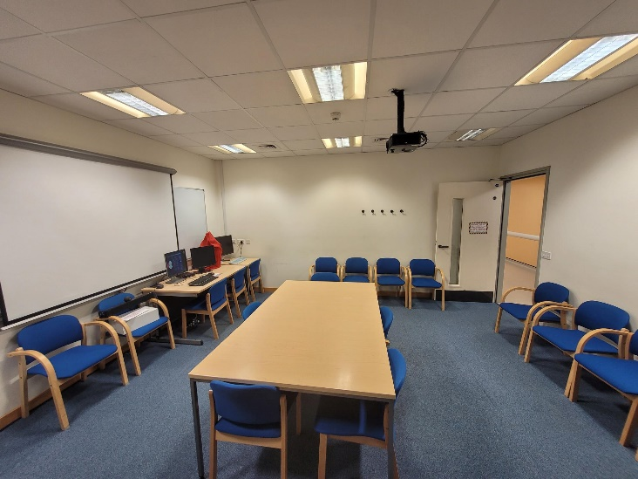
We have a Practice and Education Lead and Practice Educator committed solely to providing educational and training opportunities. Together they co-ordinate monthly internal education sessions, liaise with the Trust’s Learning & Development team, plan the annual training and education commitments and available to meet to discuss individualised career chats. All staff are invited to attend monthly supervision meetings, to discuss amongst their peers the achievements and challenges faced to benchmark approvements or ideas, to share experiences and provide one another peer support. All meetings are treated with the strictest of confidence and informal in nature. We do enjoy a visit to Costa on the ground floor as it is a good environment for one-to-catch-ups and appraisals. We find this helps to support staff health and wellbeing, which we believe is so important in modern healthcare.
Radiotherapy Services & Staff Diversity
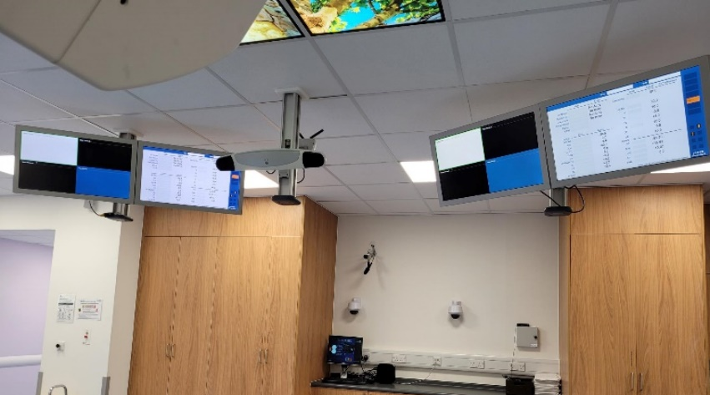
Moving towards a paperless department we are rapidly reducing a paper heavy workload, making the service more fluid and efficient and allowing our team to spend more time with the patient directly. The department has invested in software programs such as Aria 15.5, Brachyvision, PACs, CRIS, Prosoma, Invidos, and soon to include QPulse, to fully enable our paperless capabilities as well as maintain safety for patients and staff alike. Staff of all grades and backgrounds are working together to ensure a smooth transition to an electronic document management system. This is a great opportunity for everyone to be involved in managing and understanding Radiotherapy Quality systems.
There’s an amazing extended team, Including Oncologists, Physicists, Nurses, Dieticians, Oncology Assistants and Reception team all working together to provide the best standard of care to cancer patients. Staff progression is important to us, and we have expanded our radiotherapy team to encourage such progression and development:
Consultant Radiographers: - As specialists in a site-specific Radiotherapy procedure, the Consultant Radiographers work directly alongside the Oncologist to provide our patients with the best standard of care and minimised wait. They will consent and review patients in clinic, plan site specific treatment, provide certain medications, and support the radiotherapy team.
Advanced Practitioners: - An expert in a Radiotherapy procedure or process, the APs work under the direct supervision of the Oncologist and Technical Lead to support the service
Team Leaders: - As a highly skilled and experienced radiographer our Team Leaders work clinically to manage and support their designated radiotherapy team. Often, they co-ordinate the day-to-day activities, delegate duties, and provide first-hand mentorship to junior staff. To enable our Team Leaders, they complete a passport to manage level 1 certificate. To become a Team Leader, we offer a portfolio pack to support any Senior Radiographer wanting to progress toward the leadership level.
Senior Radiographers: - experienced and skill radiographers who clinically lead and supervise treatment activities. Most of our seniors have completed an internal ‘aspiring to Band 6’ portfolio.
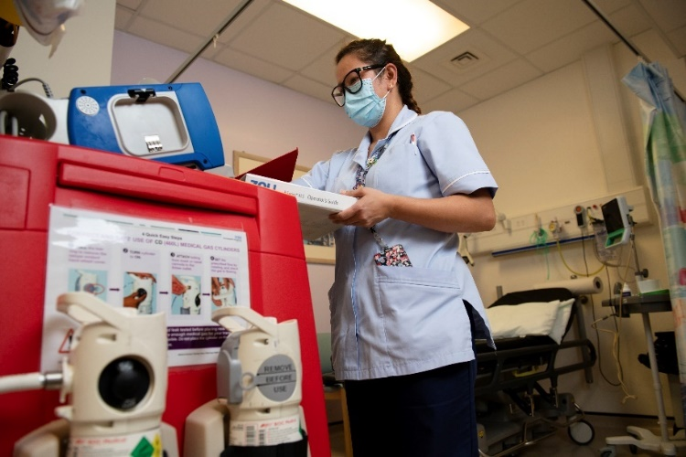
Therapy Radiographers: - a mix of newly qualified and competent radiographers who perform the day-to-day activities of radiotherapy. For our junior colleagues with offer preceptorship opportunities and a progress portfolio to support ongoing progression in their careers.
Oncology Assistants: - a valuable member of our radiotherapy team. We often rely heavily on our assistant colleagues to co-ordinate our patients, organise the patients notes and perform basic nursing duties. There are very much appreciated.
Career progression
Professional development is one of our core objectives and we want to support and facilitate each person’s progression based on an individualised development plan, personal goals, promotional opportunities, and service enhancements.
Our growing advanced practitioner team often lead the way in introducing new techniques with the full support of the superintendent and management team. All advanced practitioners are supported in obtaining the necessary education and experience to achieve their professional goals, including Masters level apprenticeships.
We have advanced practitioners for Image Guided Radiotherapy (IGRT), SABR (Lung), CT Planning, On-treatment Review, Brachytherapy and Skin treatments. Each one identifies changes to practice, works to implement highlighted change and support in-house training and education sessions for you, as part of your CPD requirements and professional development. As a band 5 or 6 Radiographer, you will have the opportunity to assist the advanced practitioner team in designing and collecting data for audit purposes which will go on to inform our future practice. A major factor in service provision is listening to staff feedback and acting on it. We welcome any ideas or suggestions for changing or introducing new procedures from all levels of staff.
To enhance patient care and service delivery we have been successful in achieving two Consultant Radiographers who lead our prostate and breast treatment services. They play an integral role as advocate for our profession and specialist to the largest groups of patients.
Individualised development plans: – all recruits have regular periodic one-to-one sessions with their assigned appraiser to identify progress and development opportunities to agree a 12-month plan. This is the perfect occasion to discuss future career goals, to reflect on personal growth and development, and to receive personalised support and advice.
Promotional opportunities: – our department offers prospects internally as well as from national adverts. For certain upcoming posts we ask for expression of interest followed by an interview. These posts can be ‘acting’ positions or rotational opportunities. It’s a great way for one of junior radiographers to acquire necessary experience to support long term advancement.
Service improvements: – to remain current and respond to changes in practice we offer relevant training to reflect additions to a radiographer’s roles and responsibilities.
Portsmouth City
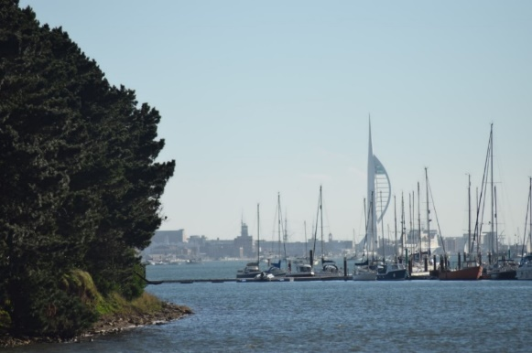
Portsmouth is a port city and naval base on England’s south coast, mostly spread across Portsea Island. It’s known for its maritime heritage and Portsmouth Historic Dockyard. The dockyard is home to the interactive National Museum of the Royal Navy, the wooden warship HMS Victory, where Nelson died in the Battle of Trafalgar, and HMS Warrior 1860. The Tudor ship Mary Rose is also conserved in a dockyard museum
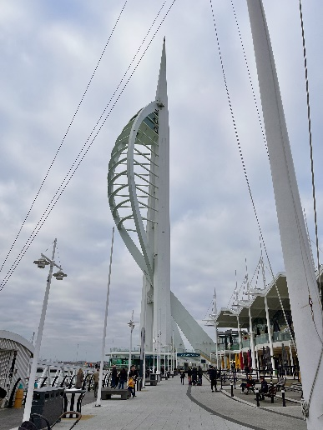
We are a positive and well-led department who like to promote health and wellbeing. We are a social group who like to mix outside of work through activities such as badminton, bowling, and pub quizzes. We tend to have our works Christmas party down in Southsea near the beachfront and integrate these with the physics team and the consultants. Just a stone’s throw from the hospital we have Port Solent, a marina with an array of restaurants, pubs, shops, and a cinema. A bit further afield is Gunwharf Quays, the South coasts leading designer shopping outlet and home to over 90 famous brands, restaurants, bars, clubs and bowling as well as the famous Spinnaker Tower.
