Title: Senior Medical Laboratory Assistant, Histopathology
Band: 3
Staff Group:
Reports to: Histopathology Operational Manager

Job Purpose:
To contribute to the provision histopathology to the service users and patients of Portsmouth Hospitals in the role of Senior Medical Laboratory Assistant by assisting with the delivery of high-quality, reliable and efficient histology, from a UKAS accredited laboratory.
The post holder will support a team of Biomedical Scientists, Associate Practitioners, other Medical Laboratory Assistants, Admin staff and medical staff in the day-to-day operation and maintenance of the histology laboratory premises and equipment.
The post holder will assist in performing routine laboratory duties and technical tasks under the supervision and direction of qualified scientific staff.

Key Responsibilities
- Specimen reception and maintaining accurate records.
- Handle enquiries (telephone and face-to-face) in an effective and efficient manner and according to departmental procedures.
- Booking on/requesting of cases on LIMS.
- Assist specimen dissection team and with the processing of specimens.
- Equipment maintenance.
- Stock and consumables management.
- Archiving of blocks and slides.
- Paratrimming and processor maintenance
- Embedding of blocks under the supervision of the BMS team
- Microtomy under the supervision of the BMS team
- Internal quality control under the supervision of the BMS team
- Complete all training and always follow standard operating procedures.
- Help the department maintain UKAS accreditation.
- Outsourcing of specimens
- Keep accurate records for samples which will act as an audit trail in the event of mistakes or problems.
- Perform general clerical duties, as required.
- Assist with specific tasks/projects (commensurate with experience) delegated by more senior staff.
- Participate in laboratory routine work as required under the direction and supervision of qualified staff in line with standard operating procedures.
- Organise and prioritise their own workload and inform colleagues of any outstanding tasks

Organisational Chart
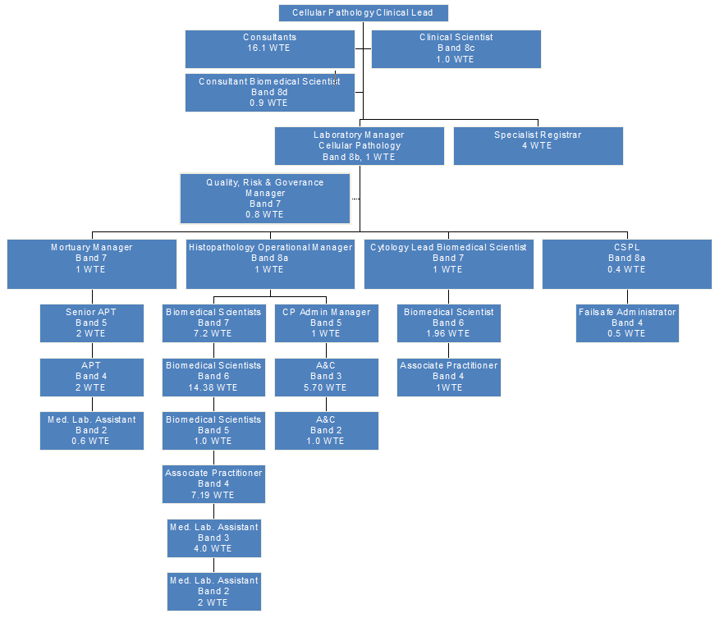

Other
This job description does not purport to cover all aspects of the job holder’s duties but is intended to be indicative of the main areas of responsibility


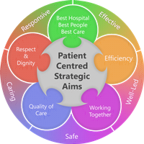
Person Specification
Qualifications
Essential:
- Education including a minimum of GCSEs in English and Mathematics or equivalent
- Experience with electronic handling of data and keyboard skills

Desirable:
- Previous laboratory experience
- GCSE in Science (either Biology, Chemistry or Combined Science) or equivalent
- BTEC or NVQ 2 (Pathology Support) or equivalent.

Skills and Knowledge

Essential:
- Evidence of ability to work using own initiative and without direct supervision.
- Excellent verbal and written communication skills.
- Demonstration of manual dexterity through previous employment/interests.
- Demonstration of excellent numeracy skills through previous experience or employment.
- Good hand to eye co-ordination
- Conscientious, methodical approach to duties with attention to detail
- Demonstration of good interpersonal skills.

Experience / Personal Qualities:

Essential:
- An understanding of the political sensitivities of the Trust
- Ability to demonstrate confidentiality and trustworthiness.
- A willingness to be flexible and part of a team.
- Ability to demonstrate a high degree of concentration and attention to detail
- Deal calmly and politely with members of hospital staff who are working in areas of extreme pressure
- Ability to juggle many priorities at one time, whilst remaining calm.
- Prepared to handle clinical samples.

Working Together For Patients with Compassion as One Team Always Improving

Strategic approach (clarity on objectives, clear on expectations)

Relationship building (communicate effectively, be open and willing to help, courtesy, nurtures partnerships)

Personal credibility (visibility, approachable, back bone, courage, resilience, confidence, role model, challenge bad behaviour, manage poor performance, act with honesty and integrity)

Passion to succeed (patient centred, positive attitude, take action, take pride, take responsibility, aspire for excellence)

Harness performance through teams (champion positive change, develop staff, create a culture without fear of retribution, actively listen and value contribution, feedback and empower staff , respect diversity)

Job holders are required to act in such a way that at all times the health and well being of children and vulnerable adults is safeguarded. Familiarisation with and adherence to the Safeguarding Policies of the Trust is an essential requirement for all employees. In addition all staff are expected to complete essential/mandatory training in this area.
Print Name:
Date:
Signature:

