Title: Specialist Research Clinical Trail Pharmacist
Band: 7
Staff Group: Pharmacy
Reports to: Pharmacy Clinical Trails Manager

Pharmacy’s Vision
A Happy, Fulfilled workforce that provides outstanding care to the local community.
Pharmacy’s Mission
The role we play is as Medicines experts providing safe, effective, and timely access to medicines and medication advice to Portsmouth Hospital University and other NHS providers utilising advances in digital technology. Working with multi-disciplinary team within PHU and across the Integrated Care System (ICS) we work to improve the information available to staff, patients and their carers to optimise and personalise patient care.

Job Purpose:
1.To provide pharmaceutical advice and support development of the clinical trials pharmacy service, in order to optimise patient benefit from treatment with medicines and ensure the safe, efficacious, and cost-effective use of medicines.
2.To assist the Pharmacy Clinical Trials Manager in all aspects of clinical trials and ensure compliance with current national guidance, the International Conference of Harmonisation Good Clinical Practice (ICH GCP) guidance and the Research Governance framework (2005).
3.To support the Trust vision for clinical research delivery and the provision of a quality pharmaceutical service to the Research & Innovation (R&I) team and trial participants.
Key Responsibilities

Trust Organisational Expectations
The post holder will:
- Proactively and positively contribute to the successful overall performance of the Trust.
- Deliver excellent levels of customer service to all patients/visitors and staff at the Trust.
- Develop effective ways of working and create strong partnerships and relationships with all stakeholders to support the implementation of the Government’s policies on Health.
- Develop an organisational culture that fosters collaborative working among all staff groups, to ensure a focused commitment to delivering quality services and outcomes.
- Act as an advocate for the Trust & its contribution to the Health Service arena through creating effective partnerships and relationships with internal and external stakeholders.
- Comply with corporate governance structure in keeping with the principles and standards set out by the Trust.
- Support the Trust culture of collaborative, flexible cross-team working and commitment to delivering quality services and outcomes, which support the Government’s policies on public health
- If your employment is to a post that requires you to be registered with a professional body, the continuation of your employment is conditional upon you continuing to be registered with the appropriate professional body. The Trust will require evidence of current registration.
- In compliance with the Trust's practices and procedures associated with the control of infection, you are required to:
- Adhere to Trust Infection Control Policies assuring compliance with all defined infection control standards at all times.
- Conduct hand hygiene in accordance with Trust policy, challenging those around you that do not.
- Challenge poor practice that could lead to the transmission of infection.

Proactively, meaningfully and consistently demonstrate the Trust Values in your every day practice, decision making and interactions with patients and colleagues.

Shared Core Functions
- Proactively and positively contribute to the achievement of deliverables through individual and team effort. Manage the production of the required deliverables and control risks,
- Support team members to deliver on their functionally relevant objectives through offering advice, guidance and support as appropriate.
- Ensure that approved budgets are spent effectively and in accordance with agreed procedures
- Liaison with Senior Professionals and related functions to ensure that work is neither overlooked nor duplicated
- Build and sustain effective communications with other roles involved in the shared services as required
- Maintain and continuously improve specialist knowledge in an aspect of Health Service which significantly contributes to the Trust’s stated objectives & aims
- Establish and maintain strategic links with a range of external partners/stakeholders or manage the links made through the team. Engage with external partners/stakeholders to gain their necessary level of contribution & commitment to the successful delivery of your work.
- Undertake proactive horizon scanning for either developments relating to Trust work or opportunities for Trust involvement around health issues
- Increase the level of knowledge & skills within the Trust through documenting key learning and supporting others to develop their professional abilities.
- Dissemination of knowledge through engagement in report writing, and reviewing, taking full responsibility for technical accuracy and reliability and being sensitive to the wider implications of that dissemination.
- Ensure that expertise is seen as a resource within and outside the Trust and form working partnerships with government departments, national agencies and key stakeholders.
- Develop structures, systems, ways of working and personal values that will support the Trusts sustainable development objectives with regard to issues such as Carbon reduction and waste minimisation; and to encourage all stakeholders of the Trust to act as enthusiastic agents of change.

Specific Core Functions

General
- Deliver and co-ordinate pharmacy support to the Research & Innovation team at Portsmouth Hospitals University NHS Trust.
- Work within the pharmacy clinical trial team to enable the delivery of the Trust research strategy ensuring operational implementation is in line with local key performance initiatives and the R&I project planning schedule.
- Ensure that pharmacy procedures relating to clinical trials involving Investigational Medicinal Products (IMPs) are in accordance with appropriate national and international legislation (ICH/ GCP, EU directive 2001/20/EC, GMP) Research Governance Framework (2005).
- Provide highly specialised professional expertise to the PHU research team in the development of clinical trial protocols involving medication regarding the application for Clinical Trial Authorisation (CTA) certification from the MHRA.
- Deputise for the Lead Pharmacist for Clinical Trials at key research meetings.
- Support the Lead Clinical Trial Pharmacy Technician and Pharmacy Clinical Trial Assistant.

Standards in Clinical Research
- Ensure compliance with relevant standards for the operation and management of clinical trials.
- Advise and support researchers in complexities and feasibility of clinical trial design and logistical delivery of Clinical Trials for Investigation Medicinal Products (IMPs) including risk assessment and stakeholder engagement.
- Train medical nursing and pharmacy staff in all aspects of handling drugs in clinical trials.
- Liaise with other centres for clinical research to ensure common standards of practice.
- Develop and maintain expertise and knowledge in all aspects of the use of medicines in research.
- Keep up to date with legislation relating to the conduct of clinical trials involving IMPs
- Assist in the development of Pharmacy policies and procedures to support the delivery of clinical trials involving medication and related substances.
- Implement and review written pharmacy guidance and SOP’s in liaison with pharmacy colleagues to ensure local engagement and uptake.
- Help maintain and update the clinical trials database on Trust activity.
- Supervise sponsor approved pack down arrangements for IMP with previously approved batch record documentation and labels (primary and secondary) in accordance with GMP.

Support to individual Clinical Trials
- Set up the specific study file with all necessary essential documentation, in preparation for supervised pharmacy sign off and eventually independent pharmacy sign off.
- Coordinate shipment and receipt of investigational medicinal product (IMP) in line with Clinical Trial SOP’s and ensure compliance with Good Manufacturing Practice legislation.
- Support the clinical trials pharmacy technicians as required in multidisciplinary team meetings with investigators to initiate, manage and close down trials hence ensuring pharmacy participation.
- Adhere to correct quarantine /disposal procedures for trial medications.
- Liaise with the specialist clinical pharmacists when assessing, approving, or initiating new projects, and update dispensary leads on newly set up studies.
- Act as a source of Research expertise to advise on complex issues such as trial design, procurement, randomisation, blinding, and documentation for in-house clinical trials and defend the opinions or decisions if the advice is challenged.
- Provide cost quotations for pharmacy activity in clinical trials following review of the protocol

Clinical Practice Role
- Where necessary provide a ward-based clinical pharmacy service according to Trust agreed standards including:
- Individual prescription review to optimise therapy.
- Confirmation of the patient’s medication history
- Advise on dosage, side effects, cautions and monitoring required
- Advise on administration of medicines
- Appropriate and clear endorsing of prescriptions to ensure safe practice
- Monitor the effect and appropriateness of medication
- Education of patients on their medications
- Ensure medicines are used appropriately, safely and cost effectively in accordance with Trust policy, standard operating procedures and medicines legislation.
- Monitor medicine use within the ward area. This includes recording of significant clinical interventions and risk management:
- Participation in investigating clinical incidents
- Recording significant clinical incidents/ near misses
- Ensuring compliance with medicines legislation and local policies.
- Use available information to influence prescribers and ensure the most cost-effective choice of therapy.
- With the rest of the members of the clinical pharmacy team to support strategic developments of the service e.g. electronic prescribing, discharge process improvements etc.
- Supervise, train and support new members of staff
- Participation in weekend and bank holiday working according to the rota

Professional Role
- Participate in Continuous Professional Development
- To be professionally accountable for actions and advice
- To ensure confidentiality is maintained at all times.
- To be aware of training and competency assessment of pre-registration pharmacist trainees, diploma pharmacists and student pharmacy technicians and to participate in their training and competency assessment as required.
- To support inpatient/ outpatient dispensary cover according to the rota.
- Participation in weekend and bank holiday working according to the rota.
- To attend clinical trial specific training courses and maintain up to date knowledge including web-based learning.
Any other reasonable duties as requested by the Chief Pharmacist.

This job description does not purport to cover all aspects of the job holder’s duties but is intended to be indicative of the main areas of responsibility.

Organisational Chart
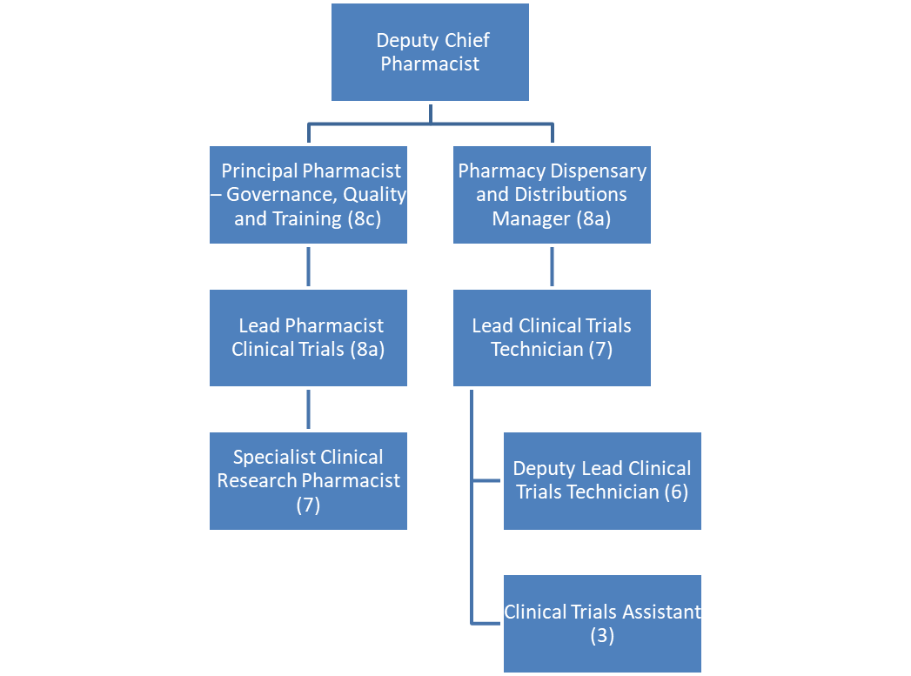
Other
This job description does not purport to cover all aspects of the job holder’s duties but is intended to be indicative of the main areas of responsibility

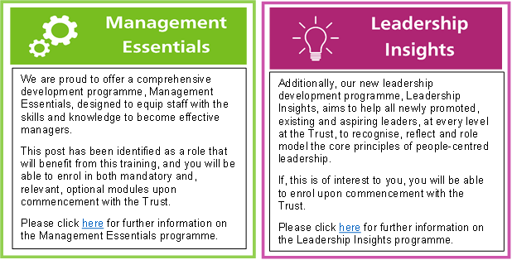
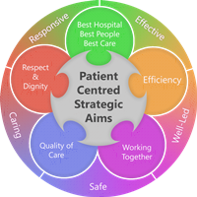
Person Specification
Qualifications

Essential
• Masters or Bachelor’s Degree in Pharmacy
• Member of General Pharmaceutical Council
• Completed or studying for diploma in Clinical Pharmacy or equivalent

Desirable
• Non-Medical Prescribing.
• Oncology Experience.

Experience
Essential
• Good understanding of the role of a hospital pharmacist, gained through demonstrable experience of working in a UK hospital pharmacy.
• Clinical experience in a range of clinical specialities
• Excellent knowledge of general clinical pharmacy and drug use.

Desirable
• Previous experience of teaching, training and staff development
• Experience of developing pharmacy services.
• Previous experience in clinical trials/research
• Previous experience of EPMA
• Previous experience of EDGE

Skills and Knowledge

Essential
- Good interpersonal skills
- Good communication skills, written and verbal, with ability to demonstrate fluency, clarity and effectiveness at all levels.
- Demonstrable confidence as a clinical pharmacist
- Demonstrable ability to work in a team
- Demonstrable ability to motivate self and others
- Demonstrable ability to organise and manage workload
- Demonstrable ability to use initiative
- Demonstrable ability to maintain quality standards
Desirable
- Sound knowledge of therapeutics across all clinical specialties
- Good presentation skills
- Clinical appraisal skills
- Word and data processing ability
- Analytical skills
- Understanding of NHS priorities
- Good understanding of clinical research process including good clinical practice (GCP)
- Experience of working in clinical trials
- Good knowledge of “A Guide to good manufacturing practice and Aseptic Dispensing for NHS patients”
- Clinical appraisal skills and experience of writing up research publications in scientific and pharmaceutical journals.
- Previous Oncology experience.

Working Together For Patients with Compassion as One Team Always Improving
Strategic approach (clarity on objectives, clear on expectations)

Relationship building (communicate effectively, be open and willing to help, courtesy, nurtures partnerships)

Personal credibility (visibility, approachable, back bone, courage, resilience, confidence, role model, challenge bad behaviour, manage poor performance, act with honesty and integrity)

Passion to succeed (patient centred, positive attitude, take action, take pride, take responsibility, aspire for excellence)

Harness performance through teams (champion positive change, develop staff, create a culture without fear of retribution, actively listen and value contribution, feedback and empower staff , respect diversity)

Job holders are required to act in such a way that at all times the health and well being of children and vulnerable adults is safeguarded. Familiarisation with and adherence to the Safeguarding Policies of the Trust is an essential requirement for all employees. In addition all staff are expected to complete essential/mandatory training in this area.
Print Name:
Date:
Signature:

