**Title:** Endoscopy Decontamination Technician

**Band: Band 2**

**Staff Group:** Nursing and Midwifery/MTO

**Reports to:** Endoscopy Decontamination Lead

**Job Purpose:**

* Manual cleaning of all endoscopes and associated accessories following current guidelines.
* Disinfecting endoscopes using auto-disinfector (in accordance with manufactures, BSG, JAG and National guidelines)
* Documenting all daily maintenance of all machines and equipment.
* Ensure tracking of each endoscope is up to date and correct for each patient
* Comply with the daily documentation of the decontamination of all equipment.
* Cleaning and high level disinfection of all endoscopes.
* Cleaning and maintenance of all drying/storage cabinets.
* Ensure that the right scopes are cleaned for each procedure list and there is adequate supply to ensure that the lists run efficiently.
* Maintenance and upkeep of all endoscopes and all equipment in the Unit.
* Assist with the organizing of general and periodic service contracts and action accordingly.
* Daily equipment checks to adhere to health and safety regulations, and organizing the repair of all defects to be dealt with promptly.
* Ensure compliance with correct protocols is adhered to.
* To transport scopes between clinical areas, and decontamination areas within the Trust, liaising to maintain the service in the event of technical breakdown.
* Ensuring that at all times you act within your sphere of competence.
* Working across QAH and GWMH sites, 7 days per week 0600-2200 as part of a flexible shift pattern to meet the services needs.

**Key Responsibilities**

#### *Patient Safety, Patient Experience and Use of Resources*

* Ensure all possible steps are taken to safeguard the welfare, safety and security of patients, visitors and staff in accordance with Trust policies.
* Acting within your sphere of competence at all times.
* Maintain a clean and safe environment for patients and ensure follow Trust Policy regarding Infection Control and Prevention.
* Report adverse incidents in accordance with Trust policy
* Record and report information on decontamination tracking systems
* Promote and demonstrate effective verbal and non-verbal communication at all times with colleagues recognising the need for tact, consideration and confidentiality.
* Requirement to work in environment with unpleasant working conditions e.g. bodily fluids.
* To assist with the running of the Endoscopy Decontamination services and assist in the maintenance and up-keep of all equipment.
* Liaise with outside services to ensure contracts are adhered to.
* The post holder will be proactive in problem solving when equipment fails, and be competent and confident to contact maintenance for speedy repair.
* The post holder will act as a liaison between the other endoscopy users in the Trust, (Urology, Respiratory, Theatres, Radiology and HSDU) to enable maintenance and continuation of services in each area in the event of technical breakdown.

#### *Team working*

* Undertake specific organisational and administrative duties as required.
* Assist other clinical areas within the Trust as the clinical situation and staffing levels require
* Participate in innovation and quality of healthcare by attending ward or department meetings, participate in projects, including audit and quality initiatives pertinent to the role.
* Act as a link or associate link for a specific area of practice, e.g. health and safety, infection control
* Take part in the orientation/induction of new recovery associates and provide support and development to enable them to develop the skills and knowledge required for their role.
* Treat all patients and colleagues with respect in accordance with Trust values and Equality and Diversity Policy.

#### *Professional Education and Development Role*

* Complete the Trust Competency Framework and achieve the minimum skill set (list of competencies as defined in generic competency framework). Maintaining own learning record of evidence.
* Develop skills relevant to role in clinical speciality as identified by ward/department leader and in accordance with Trust Policies.
* Recognise the need to participate in ongoing personal development by attending essential training for the role. Participate fully in the Appraisal and Development Review Process.

**Organisational Chart**

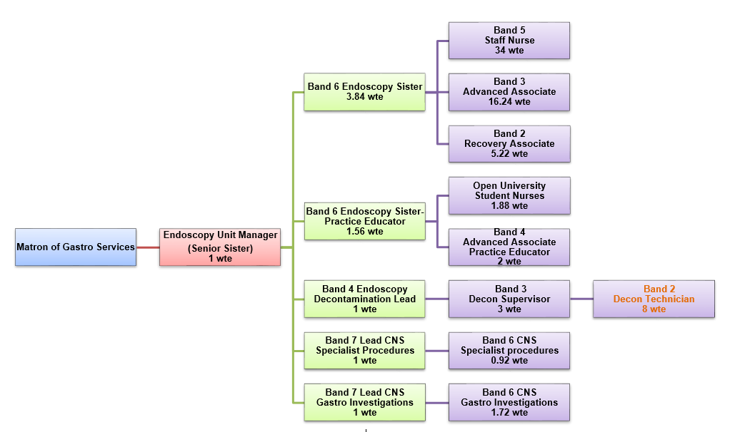

**Other**

This job description does not purport to cover all aspects of the job holder’s duties but is intended to be indicative of the main areas of responsibility

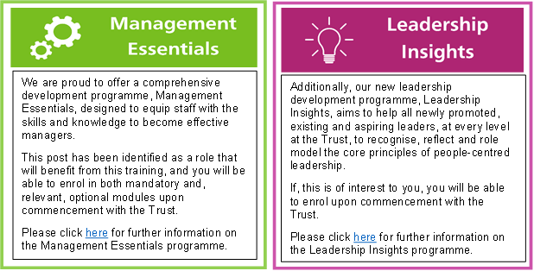

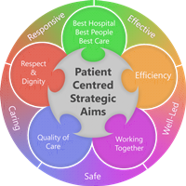**Person Specification**

**Qualifications**

*Essential*

* English and Maths qualification at Level 1

*Desirable*

* Level 2 English and Maths
* QCF Level 3 (or equivalent) in care or modules relevant to the area

**Experience**

*Desirable*

* Experience of working with people in a caring setting

**Skills & Knowledge**

*Essential*

* Ability to work as part of a team
* Effective patient/client care skills
* Excellent verbal and written communication skills.
* Able to meet the minimum skill set within first 6 months of appointment with support and development where required (list of skills as defined in generic competency framework).

*Desirable*

* IT skills
* European Computer Driving Licence (ECDL)

**Working Together For Patients with Compassion as One Team Always Improving**

**Strategic approach** (clarity on objectives, clear on expectations)

**Relationship building** (communicate effectively, be open and willing to help, courtesy, nurtures partnerships)

**Personal credibility** (visibility, approachable, back bone, courage, resilience, confidence, role model, challenge bad behaviour, manage poor performance, act with honesty and integrity)

**Passion to succeed** (patient centred, positive attitude, take action, take pride, take responsibility, aspire for excellence)

**Harness performance through teams** (champion positive change, develop staff, create a culture without fear of retribution, actively listen and value contribution, feedback and empower staff , respect diversity)

Job holders are required to act in such a way that at all times the health and well being of children and vulnerable adults is safeguarded. Familiarisation with and adherence to the Safeguarding Policies of the Trust is an essential requirement for all employees. In addition all staff are expected to complete essential/mandatory training in this area.

**Print Name:**

**Date:**

**Signature:**

