
Title: Highly Specialised Renal Pharmacist
Band: 8a
Staff Group: Pharmacy Care Group
Reports to: Lead Pharmacist for Specialities

Job Summary:
- To be a Specialist Clinical Pharmacist for Wessex Kidney Centre (WKC) utilising specialist clinical knowledge to provide a high quality pharmaceutical service to patients
- To practice as a non medical prescriber within the renal pharmacy service with specific expertise of renal medicines
- To provide highly specialised clinical pharmacy services to WKC to optimise patient benefit from treatment and ensure safe, efficacious, cost-effective use of medicines
- Play an integral role in supporting the MDT in the development and day to day running of the renal service
- Respond and action clinical queries regarding renal patient management
- Development of comprehensive renal guidelines and generation of patient supportive materials
- Work with key stakeholders across the WKC region to ensure the effective and safe delivery of the renal pharmacy service
- Provide expert advice on pharmaceutical matters when carrying out clinical pharmacy services
- Clinical screening and generation of renal homecare prescriptions

Key Responsibilities:
- Provide highly specialised clinical pharmacy expertise in use of medicines for patients within Renal Services during an inpatient hospital stay or on an outpatient or day case basis

- Participate in renal ward rounds and provide specialised medicines information for renal patients and services

- Monitor the performance, efficiency and quality of the renal pharmacy service

- Provide clinical support to the renal anaemia and immunosuppression homecare service including generation and clinical screening of homecare prescriptions
- Undertake the role of non medical prescriber, with the appropriate qualifications according to the needs of the service

- Monitor patients on anaemia treatment to ensure individual optimisation within the appropriate target range

- Identify potential and clinical developments to the renal services and implement to continue to meet service users requirements and ensure income is sufficient to fund development

- Liaise with NHSE about specific clinical issues affecting renal patients

- Interpret budgetary information for Renal divisional staff at agreed intervals to ensure that significant variances are highlighted together with proposals for appropriate action

- Assist the Team Leader for Specialities in evaluating the costs and benefits of new drug developments and present evaluated information to division and directorate lead clinicians and managers to aid them in deciding if new products or approaches to treatment should be used in the division

- Support the clinicians in the preparation of business case applications for the District Prescribing Formulary to the Formulary and Medicines Group and/or Area Prescribing Committee, and where necessary taking cases of need to purchasers to ensure that funding for new products or approaches to treatment is secured in contracts

- Contribute to the production of prescribing guidelines to ensure that medicines are used safely and in such a way as to maximize benefits to patients within available resources

- Ensure patients meet the criteria for use of NHSE funded treatments using Blue-teq . Liaise with the NHSE commissioning pharmacist to monitor / highlight changes of practice regarding prescribing of NHSE funded treatments

- Provide training, teaching and support to underpin CPD in the Pharmacy department and deliver general and specialist renal pharmaceutical education to other healthcare professionals

- Act as a line manager or joint manager for other pharmacy staff including band 7 renal anaemia pharmacist, rotational pharmacists and medicine management technicians

- Contribute to clinical audit to ensure that national and local prescribing guidelines are implemented and followed. When required liaise and support the pharmacy clinical trials team with renal research

- Actively participate in renal clinical governance meetings and ensure all relevant pharmaceutical issues are addressed

- Supervising the dispensing of medicines within legal and ethical requirements and in accordance with local work instructions to ensure that patients receive the correct medication in a timely manner

- Participates in the pharmacy 7 day working pattern and the Bank Holiday Rota as required

- Participates in dispensary cover for up to 4 hours per week (10% of working time) to maintain basic pharmacy services and personal competency

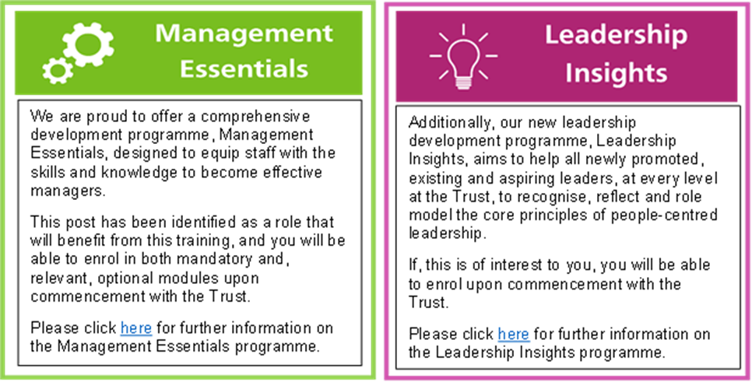

Organisational Chart

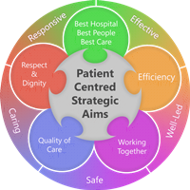
Person Specification
Qualifications
Essential
- Masters or Bachelors Degree in Pharmacy
- Registered with the General Pharmaceutical Council
- Completed or studying for Diploma/MSc in Clinical Pharmacy

Desirable
- Member of Royal Pharmaceutical Society
- NMP qualification or working towards and eligible for training
- Member of specialist pharmacist practice group e.g. UKCPA

Desirable

Skills and Knowledge
- Sound knowledge of renal medicine
- Strong interpersonal skills
- Excellent verbal and written communication skills, including the ability to build rapport with colleagues at all levels
- Ability to cope with constant interruptions and maintain a professional approach
- Ability to present with a high level of personal credibility
- Demonstrate ability to concentrate, prioritise and manage an unpredictable workload
- Demonstrate ability to motivate self and others
- Demonstrate ability to work in a team
- Demonstrate confidence as a clinical pharmacist
- Demonstrate ability to use initiative and be proactive
- Demonstrate ability to maintain quality standards
- Confidence to deliver training sessions to members of the multidisciplinary team
- Demonstrate strong presentation skills and ability to use standard office software applications
- Experience of writing guidelines, policies and procedures and putting them into practice
- Clinical appraisal skills
Experience
- Minimum 3 years pharmacy experience in clinical pharmacy services
- Previous experience as a pharmacist in a leading role (team, service or directorate responsibilities)
- Previous experience of renal clinical pharmacy

Working Together For Patients with Compassion as One Team Always Improving
Strategic approach (clarity on objectives, clear on expectations)

Relationship building (communicate effectively, be open and willing to help, courtesy, nurtures partnerships)

Personal credibility (visibility, approachable, back bone, courage, resilience, confidence, role model, challenge bad behaviour, manage poor performance, act with honesty and integrity)

Passion to succeed (patient centred, positive attitude, take action, take pride, take responsibility, aspire for excellence)

Harness performance through teams (champion positive change, develop staff, create a culture without fear of retribution, actively listen and value contribution, feedback and empower staff, respect diversity)

Job holders are required to act in such a way that at all times the health and well being of children and vulnerable adults is safeguarded. Familiarisation with and adherence to the Safeguarding Policies of the Trust is an essential requirement for all employees. In addition all staff are expected to complete essential/mandatory training in this area.
Print Name:
Date:
Signature:

