Grade: Consultant in Infection (Microbiology and Virology)
Department: Clinical Microbiology
Reports to: Clinical Lead for Microbiology

Job Summary:
This is a full time post consisting of 10 Programmed Activities (PAs) per week for a Consultant in Infection (Microbiology and Virology) based at Queen Alexandra hospital, Portsmouth. This includes 7 PAs direct clinical care (DCC), 2 PAs for supporting professional activities (SPA) and 1PA per week for out-of-hours work shared equally between the consultant medical microbiologists of Portsmouth Hospitals University NHS Trust and the Isle of Wight NHS Trust.

Key Responsibilities:
Consultant clinical duties
Direct clinical care (DCC) will consist of providing an advisory infection service covering bacteriology, mycology and virology to the Trust and our community partners during weekday working hours of 09:00-17:00 for a total of 28 hours per week (7PAs per week), including one week day as duty consultant in the laboratory and leading antimicrobial stewardship ward rounds and clinical consults across the Trust.
The out-of-hours work covering clinical queries and urgent infection advice for both Portsmouth Hospitals University NHS Trust and Isle of Wight NHS Trust will be shared equally among the consultant medical microbiologists. Remote access for both Trusts will be provided to facilitate out-of-hours work.
The post-holder will be expected to participate in teaching of laboratory staff, junior doctors, and other healthcare staff including pharmacists, to undertake professional development, participate in clinical audit, and comply with essential skills training and to undertake annual appraisal for revalidation purposes.
Applicants must be registered Medical Practitioners (with a licence to practise) and on the Specialist Register of the GMC or be eligible to be on the Specialist Register within 6 months of the date of the Advisory Appointments Committee (AAC) as it is a legal requirement for all doctors to be on the GMC Specialist Register before they can take up a consultant appointment. It is expected that they will have obtained fellowship of the Royal College of Pathologists or have equivalent experience and training.
The consultant will be managerially accountable to the Chief Executive and Medical Director of Portsmouth Hospitals University Trust through the Clinical Lead, Clinical Director of Pathology, and Care Group Director. All consultants within the Microbiology Department are members of the Microbiology Management Team.
The Department of Clinical Microbiology at Portsmouth Hospital University NHS Trust (PHU)
The laboratory currently offers a wide range of bacteriological, virological, mycological, and parasitological investigations performing over 700,000 tests per year, of which acute hospital diagnostic work accounts for about 70% with work for General Practitioners about 20% and work for Solent Sexual Health and neighbouring Trusts the remaining 10%. The laboratory has a dedicated molecular suite and two Category 3 laboratories. The department participates in all relevant external quality assessment schemes, has active internal quality assurance and audit programmes and has recently regained full UKAS accreditation.

Clinical Microbiology and Virology Workforce
Dr. Helen Chesterfield, Consultant Microbiologist (0. 7 WTE), Clinical Lead, specialist interest in orthopaedic infections and community infection prevention and control
Dr. Andrew Flatt, Consultant Microbiologist (1.0 WTE), specialist interest in paediatrics, neonatology, and gastroenterology specifically supporting the national faecal transplant service for treatment of patients with relapsing C difficile infection
Dr. Ruan Simpson, Consultant Microbiologist (1.0 WTE), Divisional Director, specialist interest in surgical patients and virology
Dr. Helen Umpleby, Consultant Microbiologist (0.8 WTE), infection control lead, specialist interest in haematology and oncology.
Dr. Harjeet Virk, Consultant in Microbiology and Infectious Diseases (1.0 WTE), specialist interest in respiratory and imported infection
Kelly Bicknell, Consultant Clinical Scientist in virology and clinical lead for virology
Microbiology SpR x2 on Wessex deanery Infection training rotation, Trust registrar x1 and FY2 doctor x1
Scientific workforce
The laboratory is funded for 57 WTE staff including 1 x band 8b (laboratory manager), 1 x band 8a (operational manager and clinical scientist), 9.1 x band 7 (senior BMS), 13.6 x band 6, 5 x band 5, 7 x band 4, 4 x band 3 and 9.5 x band 2
Infection prevention and control team (IPCT)
The IPCT reports to the Director of Infection Prevention and Control (DIPC), chief nurse via the deputy DIPC, senior nurse for surgery. The lead IPC doctor is currently Helen Umpleby with some duties delegated throughout the rest of the team, however this can be reviewed on mutual agreement with the consultant microbiology team
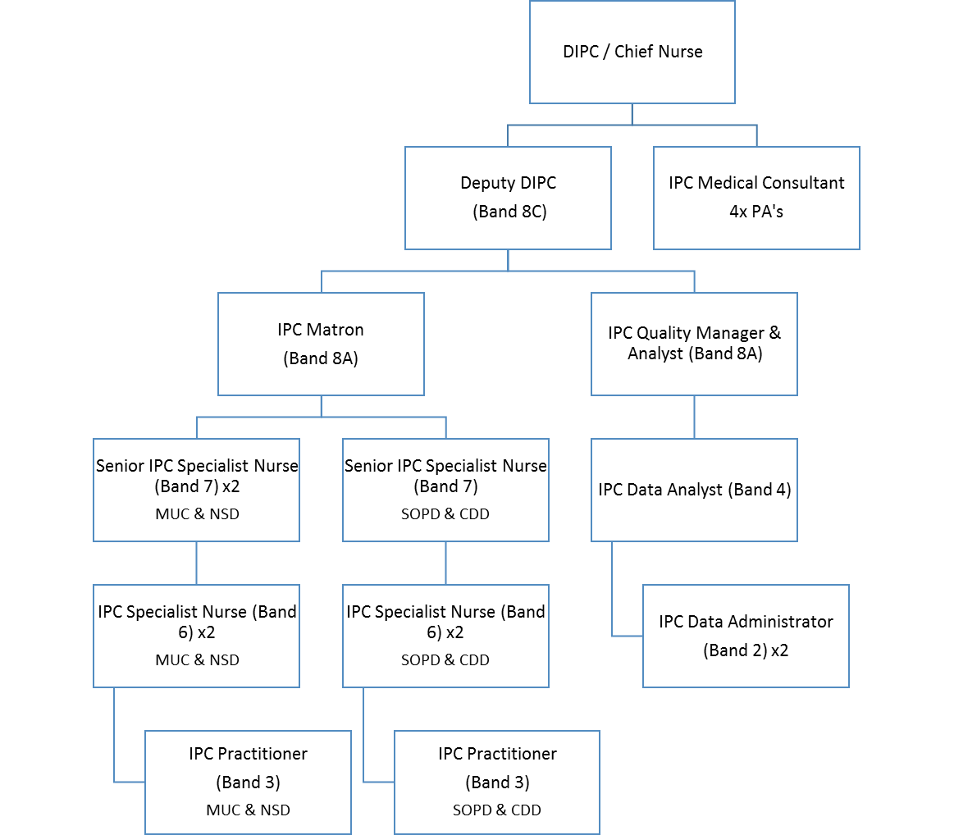

Postgraduate Facilities and Education
There is an active postgraduate centre with an attached library, facilities for centre based learning and regular clinical meetings and teaching sessions. The successful candidate will be expected to play their part in the postgraduate activities, teaching and clinical audit.
Additionally, as of Autumn 2024, the Trust shall be partnering with King’s College (Medical School) London to found a new medical school site. This shall bring new opportunities for ward and lecture-based teaching.
The Trust is committed to continuing professional development (CPD) with funding allocated to each doctor on an annual basis. This post allocates 2.0 SPA per week to continuing professional development, audit, teaching and governance duties.
Appraisal/Job Planning
The Responsible Officer of the Trust overseas appraisal and revalidation. Job planning is undertaken as a department under the Care Group Leadership team with sign off by the Care Group Director on an annual basis.
Office Accommodation and Secretarial Support
The post holder will be provided with office space and will share secretarial support with consultant colleagues. The post-holder will have their own desk-top computer connected to the laboratory network, giving access to the laboratory computer system (currently Clinysis WPE), the hospital patient administration system, Trust standard software packages, Trust intranet, email and Internet. The laboratory uses SGSS for reporting certain specified infections to the local Health Protection team and UKHSA.

Main Conditions of Service
The Terms and Conditions of the Consultant Contract (England) 2003 will apply to this post.
In particular, candidates should note the following:-
1. The post is remunerable on the appropriate consultant salary scale plus seniority, merit awards, discretionary points and/or clinical excellence awards depending on previous consultant level experience.
2. The Trust normally expects the successful candidate to live within 10 miles (or 30 minutes by road) of Queen Alexandra Hospital. Candidates are reminded that it is their professional responsibility to ensure appropriate availability for clinical duties. In the event of failure to reach an agreement the matter should be referred to the Medical Director for a decision. The post-holder must be able to travel to meet the requirements of the post and their private residence must be maintained in contact with the public telephone service.
3. The successful applicant will be required to have a Disclosure and Barring check before taking up their appointment.
A consultant is accountable to the Trust for the provision of services as required. The contractual arrangement with the Portsmouth Hospitals University NHS Trust is exercised through the Medical Director, who provides support and advice to the Consultant Medical Staff in both professional and contractual matters. All doctors in the Trust are ultimately professionally accountable to the Medical Director.
It is expected that consultants normally will cover each other’s absences for annual and study leave and that the appointee will normally comply with the Trust and department’s policies on the number of consultants who may be on leave from a clinical service at any one time, so that the delivery of service to patients may be maintained.
The Trust expects all Medical and Dental staff to work within the guidelines of the GMC ‘Guide to Good Medical Practice’ which can be viewed on the GMC website www.gmc-uk.org.
Where the post holder manages employees of the Trust, they will be expected to follow the local and national employment and personnel policies and procedures.
Study leave
30 days within a three-year period, subject to national and local policies will be allowed.
Status of Post
This is a full-time post although candidates wishing to work less than full time may still apply.
Residence
Residence within either 10 miles or 30 minutes by road from Queen Alexandra Hospital is usually required unless alternative arrangements agreed with the Trust management. The post holders private residence must be maintained in contact with the public telephone service.
Safe-Guarding
The post holder will be expected to act in such a way that at, all times the health and wellbeing of children and vulnerable adults is safeguarded. Familiarisation with and adherence to the Safeguarding Policies of the Trust is an essential requirement for all employees. In addition to all staff are expected to complete essential/mandatory training in this area.
Infection Prevention and Control
You are required to adhere to Trust Infection Control Policies at all times and to challenge poor practice that could lead to the transmission of infection. Any non-compliance with Infection Control policies may be subject to disciplinary action.
Rehabilitation of Offenders
Because of the nature of the work for which you are applying, this post is exempt from the provisions of Section 4(2) of the Rehabilitation of Offenders Act, 1974 by virtue of the Rehabilitation of Offenders Act, 1974 (exceptions) order 1975. Applicants are therefore not entitled to withhold information about convictions. This could result in dismissal or disciplinary action from the Trust.
Any information given will be completely confidential and will be considered only in relation to an application for positions to which the order is applied.
Health and Safety
The Trust has a Health and Safety Policy and all staff are required to be familiar with, and comply with, the policy to ensure a safe working environment.
Clinical Governance
All consultants are required to participate actively in clinical audit and consultant appraisal. The Clinical Lead will usually conduct an initial appraisal, and time is allocated by the Trust for preparation and the appraisal meeting within the job plan. The post-holder will also be expected to take an active part in the evidence-based practice and risk management programmes. He/she will also participate in the Trust-wide continuous quality improvement programme, involving patients and users of the service as appropriate.
Risk Assessment
All managers have a responsibility to assess risks and implement the necessary actions to minimise these within their sphere of responsibility. They must enable staff to attend statutory and essential training. All staff have a personal responsibility to be familiar with the Risk Management Strategy, follow policies and procedures and take all actions necessary to reduce risk. Staff must ensure that they attend appropriate statutory and essential training.
Continuing Professional Development
The post-holder is required to participate in a programme of Continuing Professional Development in line with the guidelines of the Royal College of Pathologists / Physicians.
Data Protection Act 1998
It is a requirement of the post holder to maintain the confidentiality of information about patients, staff and other health service business, in accordance with the Code of Confidentiality of Personal Health Data, the Korner Report on confidentiality and the Data Protection Act 1998.
General Medical Council Registration
The post holder shall be a medical practitioner, properly registered with the General Medical Council. It is the post holder’s responsibility to ensure they are registered for the duration of the appointment.

Medical Indemnity
The post holder will be indemnified by the Trust for all NHS work undertaken as part of the post holder’s Contract of Employment in accordance with HC (89)34. The post holder is encouraged to take out adequate defence cover as appropriate to cover them for any work which does not fall within the scope of the indemnity scheme (as per their Contract of Employment).
Complaints
In the event of any investigation into any complaint, the post holder should fully co-operate with the Trust and the legal advisors (including, but not limited by allegation of negligence or misconduct) and should agree to provide a full written statement concerning the incident/complaints within a reasonable time.
Principles of conduct in the NHS
Appointees are expected to adhere to the Standard of Business Conduct as laid down in HSG(93)5.
It is the responsibility of Trust staff to ensure that they are not placed in a position which risks, or appears to risk, conflict between their private interests and their NHS duties. Staff are expected to ensure that the interest of patients remains paramount at all times and to be impartial and honest in the conduct of their official business and in the use of public funds entrusted to them to the best advantage of the service, always ensuring value for money. It is also the responsibility of staff to ensure that they do not abuse their official position for personal gain or to benefit their family or friends. The Trust standing orders require any post-holder to declare any interest, direct or indirect, with contracts involving the Trust. Post holders are respectfully requested not to further their private interests in the course of NHS duties. Please note that it is the post holder’s duty to consult a senior colleague should they encounter any difficulties during the course of their duties.
Accommodation
The post of Consultant is designated as non-resident. If the post-holder chooses to live in temporary hospital accommodation, it is Trust policy that all charges relating to the accommodation will be deducted from salary. The post may qualify for removal expenses which should be discussed with the Employee Resourcing Manager after interview. Short-term accommodation may be available if necessary.
Superannuation
The post is subject to the provision of the NHS Superannuation Scheme which is contributory. Membership of the scheme is automatic unless the post holder opts out at any time in favour of provision under a Personal Pension Plan. After opting out of the Scheme, the post holder will assume full responsibility for pension provision and compliance with the Social Security Act 1986.
References
The appointment is subject to receipt of satisfactory references. These are requested from the applicant’s nominees and also from recent educational supervisors and Chief Executives/Medical Directors as appropriate.
Appointment
The appointee will be required to take up the post no later than three months from the date of the offer of an appointment, unless a special agreement has been made between the appointee and Portsmouth Hospitals University NHS Trust.

If you consider it unlikely that you will be able to take up the appointment within such a period, you are advised to point this out at the time of your application.
Equal Opportunities
Portsmouth Hospitals University NHS Trust is committed to becoming an equal opportunity employer. The aim of our policy is to positively promote equality of opportunity and in particular to ensure that no job applicant or employee receives less favourable treatment on the grounds of ethnicity, disability, culture, nationality, religion, sexual orientation, gender, age or marital status.
Information for Candidates
Candidates are asked to note that the canvassing of any member of the Advisory Appointments Committee, or the Portsmouth Hospitals NHS Trust Board, will disqualify the candidate (see Statutory Instrument 1996 No 701 Paragraph 9[2]). This should not deter candidates from approaching any person for further information about the post.
Candidates wishing to visit the hospital may do so and should make their own arrangements directly with the microbiology department on 02392 286000 ext 1718. The Trust will reimburse expenses for one pre-interview visit for short listed candidates.

Please note that due to the high volume of recruitment and our desire to treat all applicants fairly it is not possible to meet with the Chief Executive, Penny Emeritt, prior to the Appointments Advisory Committee. However, arrangements to meet with Dr John Knighton, Medical Director, or with Dr Mark Roland, deputy Medical Director, can be made by contacting Emily Wainwright on 023 9228 6959. Both Dr Knighton and Penny Emeritt are extremely committed and supportive of this appointment and to appointing the right candidate and, as part of the induction programme the successful applicant will have an opportunity to meet with them.

PERSON SPECIFICATION / SELECTION CRITERIA
CONSULTANT IN INFECTION (Joint Microbiology and Respiratory)
Requirements | Essential | Desirable
Qualifications | Full and specialist registration in microbiology or microbiology and infectious diseases (and a licence to practise) with the General Medical Council (GMC) (or eligible for registration within six months of interview)
Clinical Experience | Applicants that are UK trained, must also be a holder of a Certificate of Completion of Training (CCT), or be within six months of award of CCT by date of interview.  Applicants that are non-UK trained, will be required to show evidence of equivalence to the UK CCT  Fellowship of the Royal College Pathologists or evidence of equivalent qualification  Membership of the Royal College of Physicians or evidence of equivalent qualification | Virology experience  Infection Control experience  Experience in the rationalisation and control of antimicrobial prescribing
Clinical Skills | Understanding of clinical risk management  Ability to foster and promote the delivery of the clinical diagnostic services of the laboratory  Enthusiasm for ward-based clinical liaison | Demonstration of evidence-based medicine
Knowledge | Reasonable computer literacy to include word processing and basic spreadsheets  Able to demonstrate appropriate level of clinical knowledge | Breadth of experience in and outside speciality
Interests | Active interest in research and developments in medical microbiology and respiratory infection  Nosocomial infection and rational use of antimicrobials | Other outside interests
Quality of care  (Trust Value) | Able to organise oneself and prioritise clinical need.  Understanding of the NHS,  Clinical Governance and  the principles of research.  Evidence of participation in audit.  Good communication skills  Probity.  Logical thinking, good problem-solving skills and decision-making | A good record of peer-reviewed publications
Respect and Dignity  (Trust Value) | Non-judgemental approach to patients  Respects the privacy and dignity of individuals  Demonstrate an understanding of equal opportunities
Working Together  (Trust Value) | Experience and ability to work in multi-professional teams.  Evidence of teaching experience – particularly junior medical staff. Willingness to contribute to teaching.  Leadership skills  Interpersonal skills. | Evidence of managerial skills, including training and courses attended
Efficiency  (Trust Value) | Decisiveness/accountability,  flexibility, thoroughness and resilience.  Initiative/ drive/ enthusiasm  Evidence of understanding of constraints on resources | Appropriate progression of career to date

Working Together for Patients with Compassion as One Team Always Improving
Strategic approach (clarity on objectives, clear on expectations)

Relationship building (communicate effectively, be open and willing to help, courtesy, nurtures partnerships)

Personal credibility (visibility, approachable, back bone, courage, resilience, confidence, role model, challenge bad behaviour, manage poor performance, act with honesty and integrity)

Passion to succeed (patient centred, positive attitude, take action, take pride, take responsibility, aspire for excellence)

Harness performance through teams (champion positive change, develop staff, create a culture without fear of retribution, actively listen and value contribution, feedback and empower staff , respect diversity)

Job holders are required to act, in such a way that at all, times the health and well-being of children and vulnerable adults is safeguarded. Familiarisation with and adherence to the Safeguarding Policies of the Trust is an essential requirement for all employees. In addition to all staff are expected to complete essential/mandatory training in this area.
Print Name:
Date:
Signature:

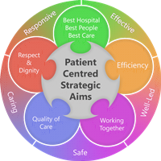
Job plan
Duties are worked flexibly to meet the needs of the service and to respond to urgent priorities.
Duties undertaken include
a. Direct Clinical Care: 8 programmed activities (PAs)
• The provision of clinical advice to health care staff in both primary and secondary care on the investigation, management and prevention of infection including review and validation of laboratory reports plus support of the laboratory staff, two duty sessions per week to be mutually agreed (4 PAs)
• Ward rounds and ad hoc visits to wards/departments to assist in patient management, two sessions to be mutually agreed (2 PAs)
• Meetings and visits to investigate monitor and manage clusters and outbreaks of infection working with the Infection prevention team and community teams as appropriate for the situation
• Out-of-hours work providing an on-call service to Portsmouth Hospital University NHS Trust and the Isle of Wight NHS Trust (1 PA). This work is shared equally between all consultant / senior medical staff on both sites
• Service development and patient-related correspondence and administration (1 PA)

b. Supporting Professional Activities (total 2PAs)
• Continuing Professional Development
• Audit (clinical and departmental)
• Clinical Governance and quality assurance
• Teaching and training
• Job planning and appraisal
• Research
• Departmental Management meetings

c. Additional Responsibilities may in the future include duties as Clinical Lead in Infection Prevention and Control (by agreement with DIPC, Care Group Director and MD), duties as Clinical Lead (by agreement with CD and MD) and duties as Audit or Clinical Governance lead

Example job plan
Categorisation | Work | Hours
Direct Clinical Care  Supporting professional activities | Ward Rounds/visits/clinical liaison | 17
Direct Clinical Care  Supporting professional activities | Investigative, diagnostic or laboratory work | 8
Direct Clinical Care  Supporting professional activities | Infection Prevention and Control (PHU) | 2
Direct Clinical Care  Supporting professional activities | Predictable Emergency Work (average/week) taken as TOIL | 4
Direct Clinical Care  Supporting professional activities | Unpredictable Emergency Work (average/week) | 1
Direct Clinical Care  Supporting professional activities | Total | 32 (8 PAs)
Direct Clinical Care  Supporting professional activities | Continuous Professional Development | 2
Direct Clinical Care  Supporting professional activities | Teaching & training | 2
Direct Clinical Care  Supporting professional activities | Audit/Clinical Governance | 1
Direct Clinical Care  Supporting professional activities | Job Planning/Appraisal | 0.5
Direct Clinical Care  Supporting professional activities | Research | 0.5
Direct Clinical Care  Supporting professional activities | Clinical Management | 2
 | Total | 8 (2 PAs)

On-Call availability supplement
Agreed on-call rota: 1 in 8
Agreed category: A
On-call supplement: 5%

