
Our vision for Pharmacy is....
A happy, fulfilled workforce that provides outstanding care to the local community.
Title: Oncology Pharmacist
Band: 7 (Progression role)
Staff Group: Healthcare Scientist
Reports to: Lead Oncology Pharmacist
Job Summary:
Here at Portsmouth Hospitals University NHS Trust, we are proud to provide expert, compassionate care for our local population. We are ranked as the third in the country for research, embedding education and training across the organisation. Our main hub is the Queen Alexandra Hospital, which is one of the largest hospitals on the south coast employing over 8,700 staff.
Our patients come from all walks of life and so do we. We hire great people from a wide variety of backgrounds because it makes our hospital stronger. If you share our values and our enthusiasm for getting it right for patients, colleagues, and our community, you will find a home at Portsmouth Hospitals University NHS Trust
We are looking for an experienced Oncology Pharmacist with a passion for patient care. You will be joining a supportive and driven Oncology Team, that hold patient care and safety at the heart of what they do.
This role will require you to provide a clinical pharmacy service to the Oncology / Haematology area, to optimise patient benefit from treatment with medicines and ensure the safe and cost-effective use of medicines.

Key Responsibilities:
Shared Core Functions
- Participate in the provision and development of clinical pharmacy services to divisions under the leadership of the Lead pharmacist for the Oncology area.
- Provide a patient focused pharmacy service to the Oncology / Haematology area, which may include individual patient counselling, patients own drug schemes and other medicines optimisation initiatives.
- Independently evaluate the clinical appropriateness of medicines prescribed for patients, using critical appraisal skills and professional judgement and support formulary work within specialities.
- Assisting the clinicians in the preparation of business case applications for the District Prescribing Formulary to the Formulary and Medicines Group and/or Area Prescribing Committee, and where necessary taking cases of need to purchasers to ensure that funding for new products or approaches to treatment is secured in contracts.
- Supporting on the production of prescribing guidelines (e.g. local / shared care / PGDs) to ensure that medicines are used safely and in such a way as to maximize benefits to patients within available resources.
- Advise medical staff in non-formulary requests, Individual funding requests or equivalent to ensure correct funding income from relevant commissioner.
- Providing training, teaching, and support to underpin CPD in the Pharmacy department and deliver general and specialist pharmaceutical education to other healthcare professionals.
- Provide competency-based assessments of band 6 pharmacists, pre-registration trainees and pharmacy technicians, using work-based assessment tools.
- When required contact General Practitioners, community pharmacists, practice nurses and other healthcare workers in the community to ensure the seamless pharmaceutical care of patients and to reduce re-admissions due to pharmaceutical issues.
- To anticipate, recognise and report Adverse Drug Reactions appropriately.
- To support effectively managing performance related issues with junior / rotational staff.
- To act as a tutor and mentor for students enrolled onto various post-graduate diploma programmes.
- To act as a pre-registration tutor if required.
- Professional input into Dispensary
- To assist in the training of all grades of pharmacy staff and other professions within the MDT to nurture both clinical and practical knowledge and expertise within the Trust.
- To carry out pharmaceutical duties associated with the dispensing of in-patient, discharge, and Out-Patient prescriptions.
- To supervise supporting staff including pharmacy technicians and assistants under the direction of a senior pharmacist
- To participate in the departmental weekend, late night and Bank Holiday services rotas.
- To maintain security of medication at all times in line with departmental and Trust policy including nondisclosure of appropriate pharmacy security codes and advising on the safe and secure storage of medicines within clinical areas. To undertake other reasonable duties, within the framework of the post, as directed by the Pharmacy Senior management team.
- Carry out professional duties in accordance with GPhC standards for practice, including the requirement to undertake continuing professional development (CPD) in line with statutory requirements.
- To act as a role model in clinical practice for all other pharmacists
- Ensure clarity in all communication and choose the most appropriate form of communication for each situation.

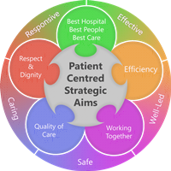
Organisational Chart of role.

Chief Pharmacist
Band 9

Deputy - Chief Pharmacist
Band 8d

Lead Oncology Pharmacist
Band 8b

Oncology Pharmacist
Band 7

Person Specification
Qualifications
Essential
- Masters or Bachelor’s Degree in Pharmacy.
- Registered with General Pharmaceutical Council.
- Diploma in Clinical Pharmacy.
- Practice Certificate in Non-medical Prescribing.
Desirable
- Member of specialist pharmacist practice group e.g. UKCPA

Skills and Knowledge

Essential
- Strong interpersonal skills
- Excellent verbal and written. Communication skills, including the ability to build rapport with colleagues at
- all levels.
- Ability to cope with constant interruptions and maintain professional approach.
- Ability to present with a high level of personal credibility.
- Demonstrate ability to concentrate, prioritise and manage an unpredictable workload.
- Demonstrate ability to motivate self and others.
- Demonstrate ability to work in a team.
- Demonstrate confidence as a clinical pharmacist.
- Demonstrate ability to use initiative and be proactive.
- Demonstrate ability to maintain quality standards.
- Confidence to deliver training sessions to members of the multidisciplinary team.
- Demonstrate strong presentation skills and ability to use standard office software applications.
- Advanced knowledge of all medicines related to prevention, management, and treatment.
- Experience of writing guidelines, policies and procedures and putting them into practice.

Desirable

- Experience of leading service development.

Personal Qualities
- Role Model
- Prepared to work flexibly in multidisciplinary environment
- Ability to remain calm and work under pressure

Working Together For Patients with Compassion as One Team Always Improving
Strategic approach (clarity on objectives, clear on expectations).

Relationship building (communicate effectively, be open and willing to help, courtesy, nurtures partnerships).

Personal credibility (visibility, approachable, back bone, courage, resilience, confidence, role model, challenge bad
behavior, manage poor performance, act with honesty and integrity).

Passion to succeed (patient centered, positive attitude, take action, take pride, take responsibility, aspire for
excellence).

Harness performance through teams (champion positive change, develop staff, create a culture without fear of
retribution, actively listen and value contribution, feedback and empower staff, respect diversity)
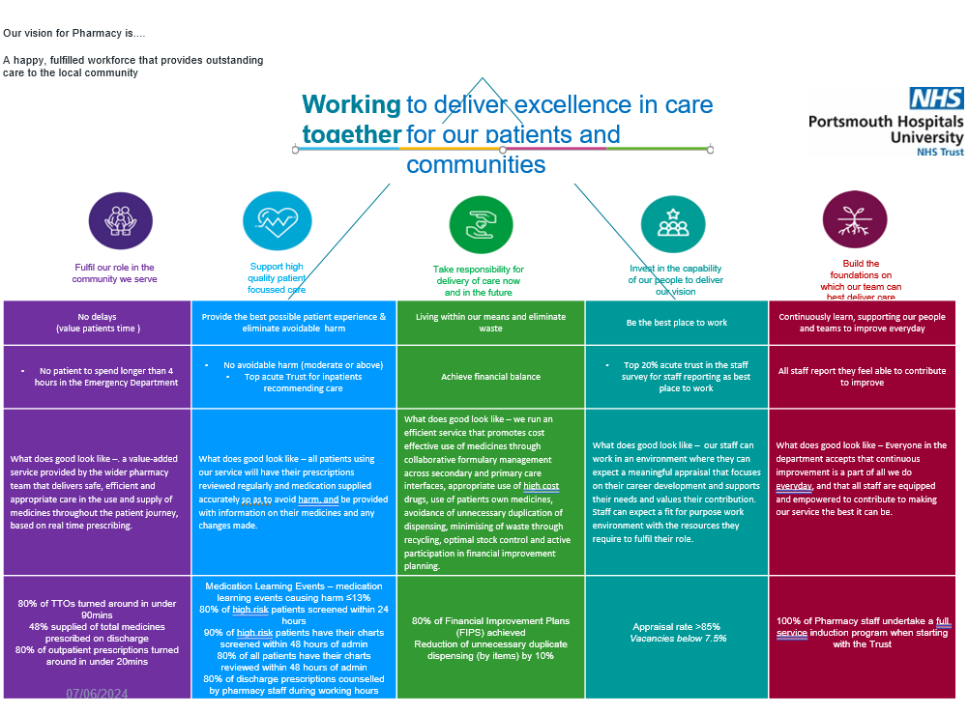

Pharmacy Mission:
The role we play is as Medicines experts providing safe, effective, and timely access to medicines and medication advice to PHU and other NHS providers utilising advances in digital technology. Working with the multidisciplinary team within PHU and across the Integrated Care System (ICS) we work to improve the information available to staff, patients and their carers to optimise and personalise patient care.

Job holders are required to always act in such a way that the health and well-being of children and vulnerable adults is safeguarded. Familiarisation with and adherence to the Safeguarding Policies of the Trust is an essential requirement for all employees. In addition, all staff are expected to complete essential/mandatory training in this area.
Print Name:
Date:
Signature:

